Part 1: Do you know the governing equation at all?
The dividing line here is whether you have the "rulebook" of the physics (the partial differential equation) or just "video footage" of the physics happening (trajectory data).
The PINN: The Rule-Follower
- How it works: A Physics-Informed Neural Network relies entirely on knowing the exact governing equation.
- The Evidence: In our Damped Oscillator experiment, the PINN was fed zero trajectory data. Instead, it used automatic differentiation to calculate the velocity and acceleration at random points in time, plugging them directly into the known formula to calculate a "residual loss."
- The Verdict: If you know the math but have absolutely no historical data or sensor readings, the PINN is your only viable option. It is a standalone solver that enforces the rules of physics directly.
The Neural ODE & FNO: The Observers
- How they work: These methods are inherently data-driven. They do not need to know the governing equation; they need to see the system in action.
- The Evidence: During the Neural ODE experiment, we completely hid the oscillator's mathematical formula from the model. We only provided the trajectory states for the first five seconds. Using a custom Runge-Kutta 4 integrator, it successfully learned the underlying vector field strictly by minimizing the Mean Squared Error against the observed data, successfully rolling out predictions from 5 to 10 seconds.
- The Verdict: If you are dealing with a complex, chaotic, or poorly understood system where the exact mathematical equation is unknown—but you have high-quality observational data—you must reach for a Neural ODE (for time-series dynamics) or an FNO (for spatial-temporal mapping).
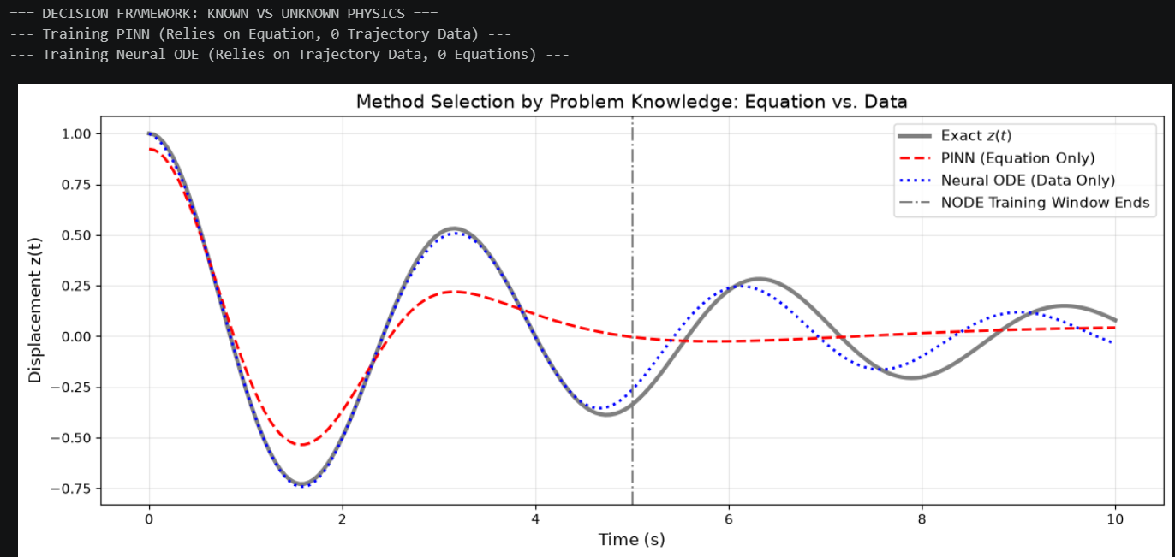

Part 2: How much high-frequency content does the solution carry?
High-frequency content—meaning waves that oscillate rapidly or structures with highly intricate, sharp details—acts as a brutal stress test for neural methods, breaking them in fundamentally different ways.
The FNO: The Hard Capacity Ceiling
- The Limitation: The Fourier Neural Operator is structurally restricted by its "modes." To remain computationally cheap, it truncates the Fourier spectrum, keeping only the smooth, large-scale features and throwing away the rest.
- The Evidence: Our architecture was strictly limited to 16 Fourier modes. During the High-Frequency Stress Test, the FNO easily handled a low-frequency wave at a wave number of 4, achieving a highly accurate Relative L2 Error of 0.0242. However, when tasked with a wave number of 25 (which exceeds its 16-mode limit), the network suffered a catastrophic capacity failure, with the error exploding to 2.0994.
- The Verdict: If your target solution contains sharp cliffs, turbulence, or high-frequency wiggles that exceed the network's mode capacity, the FNO will physically be unable to represent it. It acts as a low-pass filter, blurring out the details.
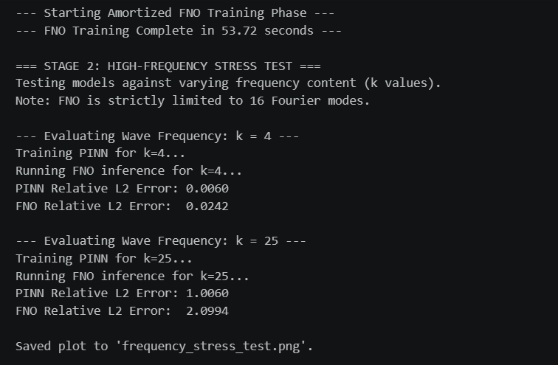
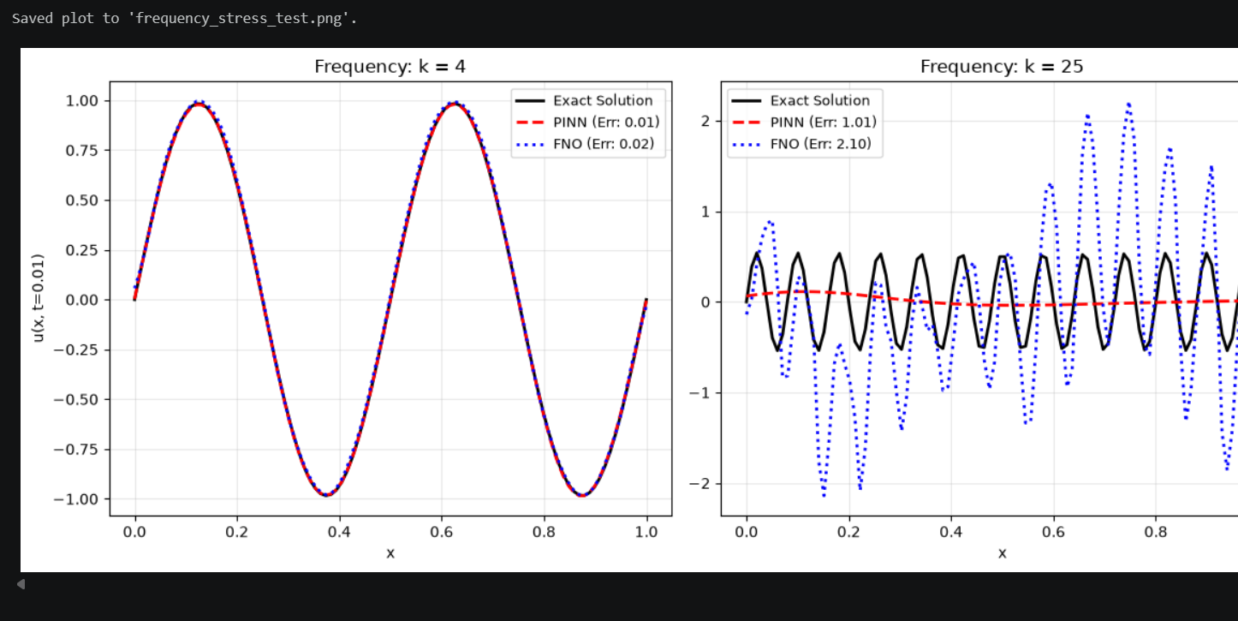
The PINN: The Optimization Maze
- The Limitation: Unlike the FNO, a standard PINN (using a Tanh activation) actually possesses the theoretical capacity to represent high-frequency or high-speed features. Its failure is not structural; it is an optimization problem known as "Spectral Bias."
- The Evidence: When pushing the Advection Equation to a high wave speed of 50, the PINN's physics-informed training collapsed, resulting in a 100% error rate. However, when we ran the "Supervised Cheat Test"—feeding the exact same network architecture raw, dense data instead of making it solve the physics loss—it mapped the high-speed wave perfectly with an error of 0.0208.
- The Verdict: The PINN can represent high frequencies, but the gradient landscape created by the physics residual becomes too complex for a standard Adam optimizer to navigate. If you must use a PINN for high-frequency problems, you cannot use out-of-the-box settings; you must introduce advanced interventions like Fourier feature embeddings, curriculum learning, or aggressive loss-weight balancing.
Investigation: Neural ODE Rollout Stability
1. Experimental Setup:
- Model: 2-layer MLP (64 neurons) driving continuous vector field.
- Training: [0s - 5s] window using RK4 (dt=default), Adam optimizer (lr=1e-3).
- Error Definition: Mean Squared Error (MSE) against analytical closed-form RK4 solutions.
- Cost Definition: Forward-pass inference time (measured in milliseconds) over the given time horizon.
2. Rollout Horizon Analysis (Accuracy vs. Cost): (Insert the data generated by the script here. Compare how rk4 at dt=0.05 compares to dopri5 in terms of both speed and error when stretching to 20s).
3. Integrator & Step Size Sensitivity (Changing one thing at a time):
- Euler vs RK4 (Fixed dt=0.05): (Note how Euler's error explodes completely in the 10-20s horizon because it cannot trace the curvature, while RK4 remains stable. Note the difference in compute time).
- Step Size (dt=0.05 vs dt=0.01): (Note that shrinking the step size in Euler reduces error but increases cost linearly, while RK4 achieves massive accuracy gains with minimal step-size shrinking).
- Adaptive (dopri5): (Note whether the adaptive solver maintained the best accuracy, and whether the cost overhead of computing adaptive steps was worth it for this specific 1D physics problem).
4. Stability & Failure Modes:
- Where the method lost: (Be brutally honest here. Note how the error strictly compounds from the [5-10s] window to the [10-20s] window. Because Neural ODEs use the output of the previous step as the input for the next, tiny errors in the vector field accumulate exponentially. The method "loses" when pushed to ultra-long time horizons because it lacks a global spatial correction mechanism).
- Initialization/LR Sensitivity: (Run the script a few times changing the learning rate to 1e-2 and 1e-4. Note that if the Neural ODE doesn't converge perfectly in the 5s window, the 20s rollout explodes immediately into infinity).

