TickStore
A Parquet-Based Market Data Lake with Custom Multi-Dimensional Indexing
Design Document -- v2 (Parquet + Catalog + Clustering)
Author: Pranjal • Extends the cpp-infra / metrics-lib portfolio

Table of Contents

Architecture Diagram
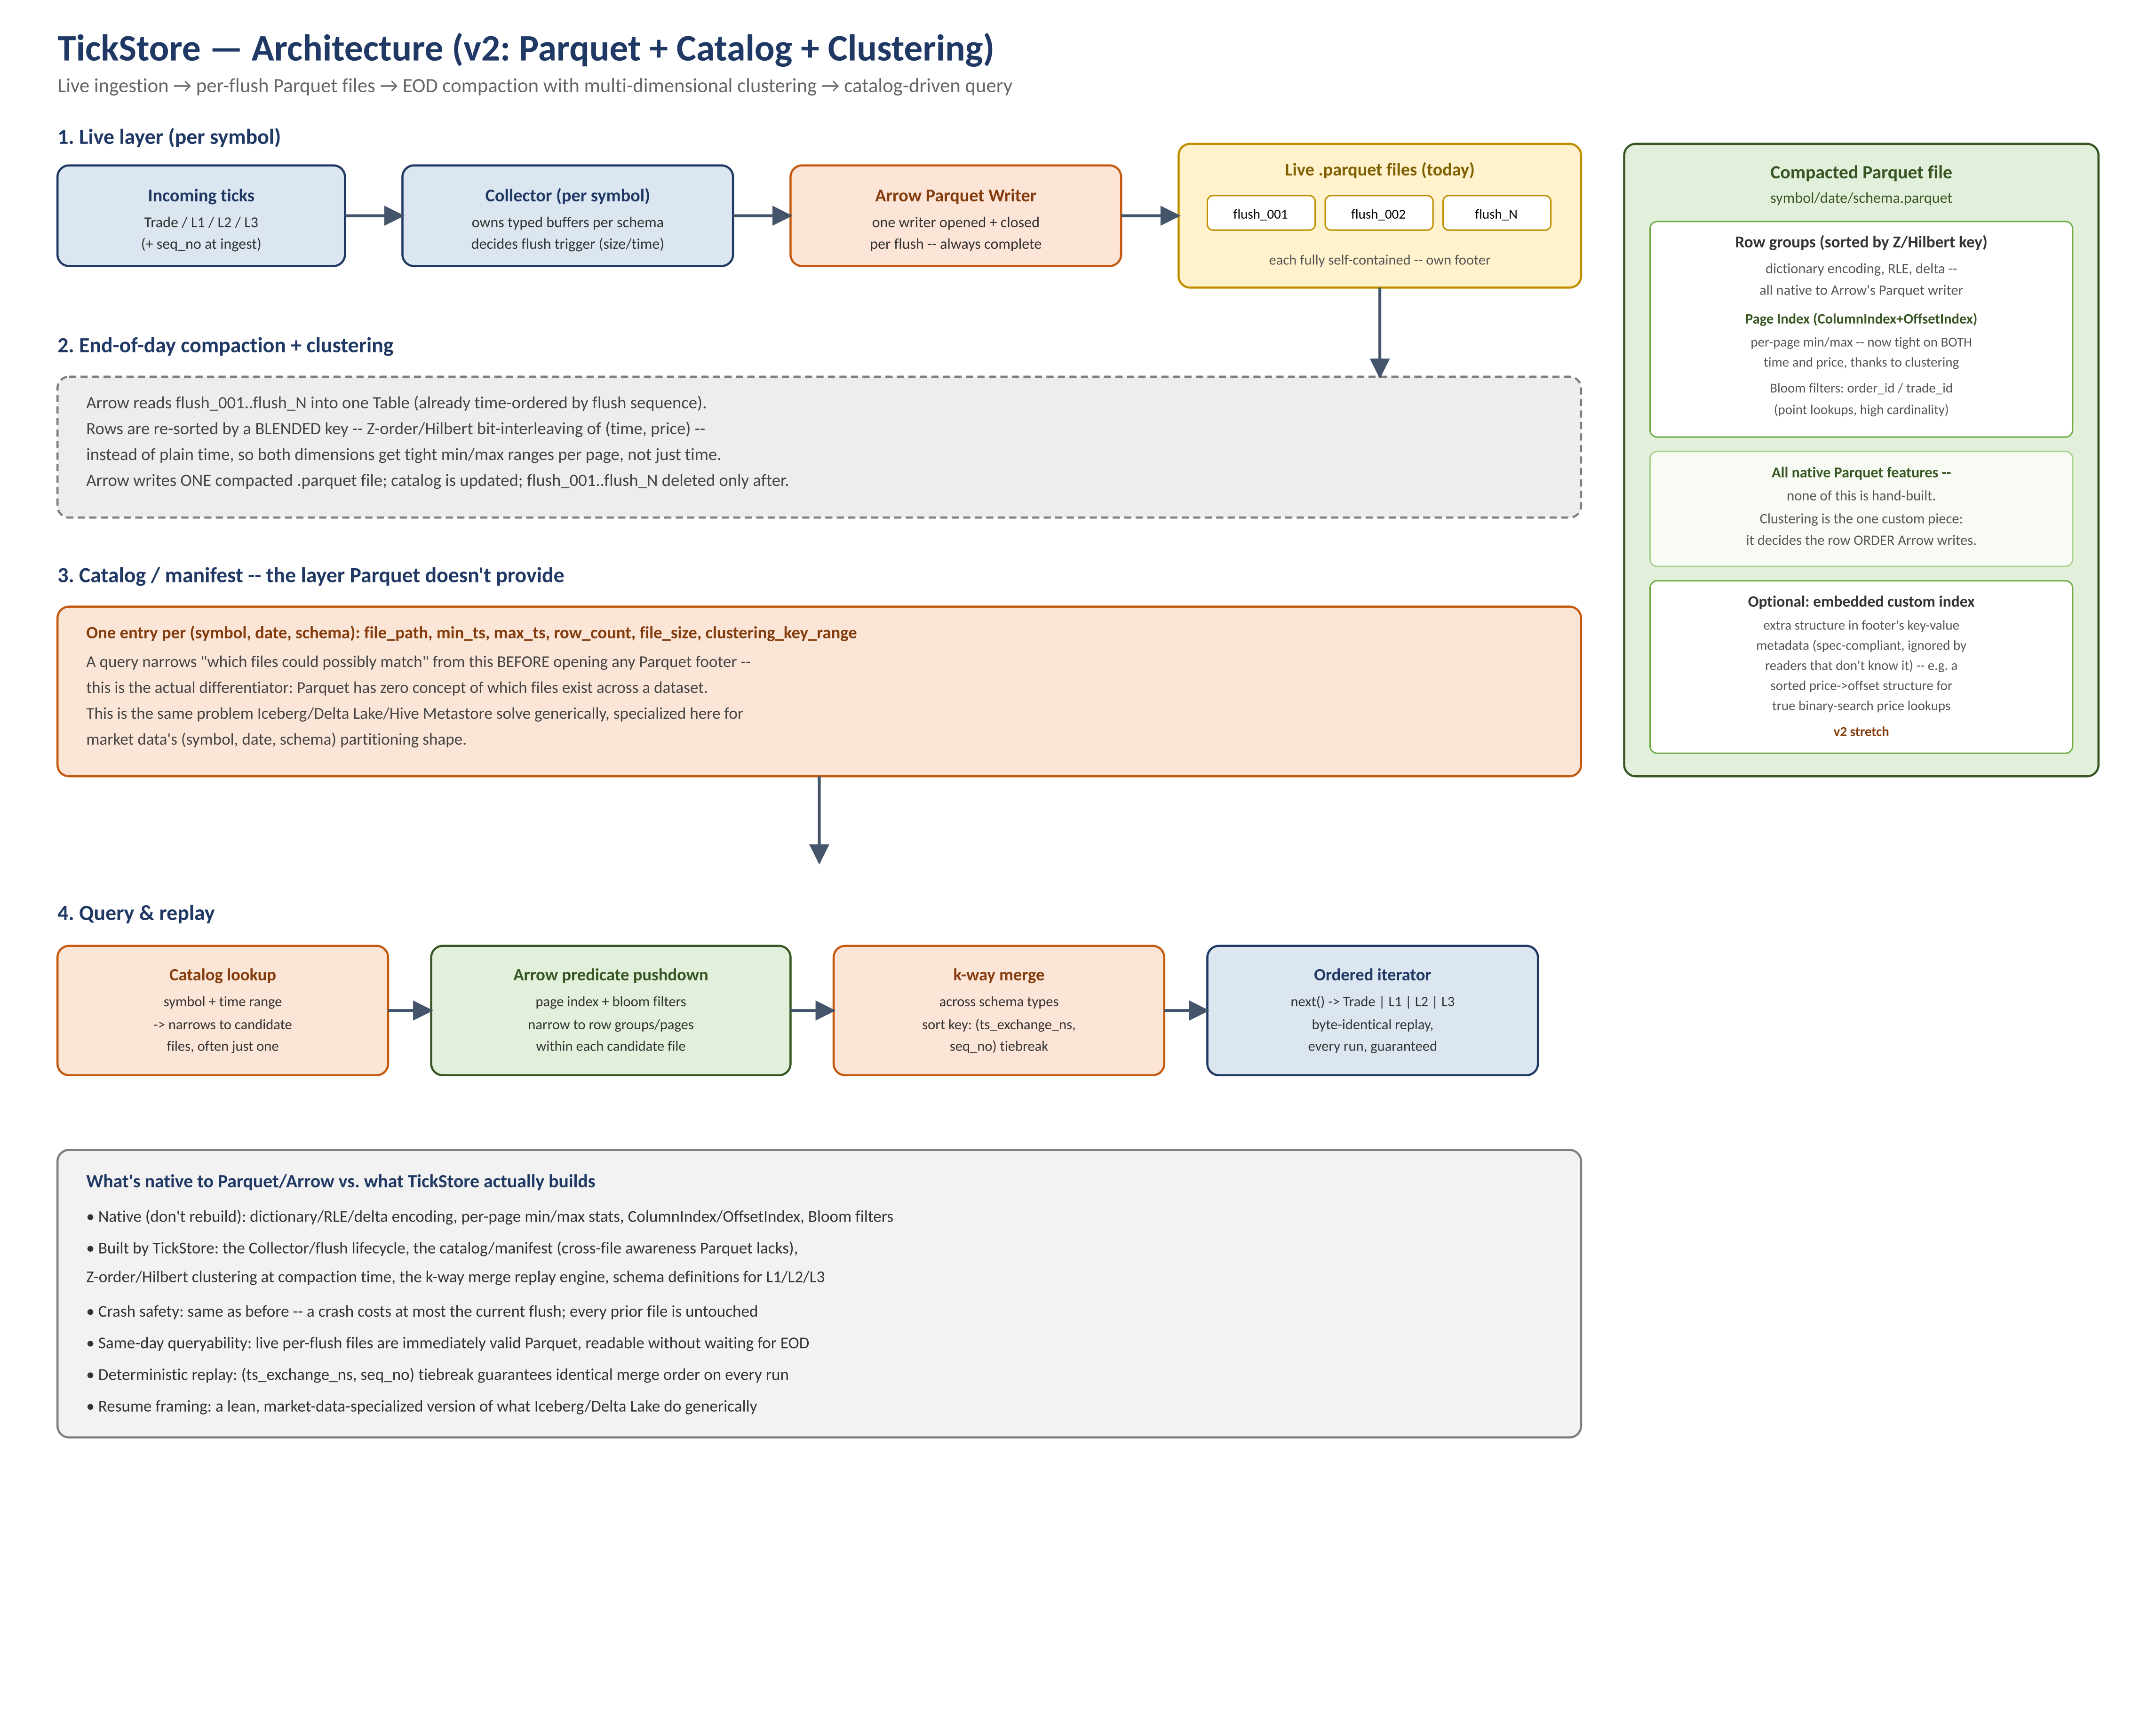
Live ingestion writes one self-contained Parquet file per flush; end-of-day compaction re-sorts by a Z-order/Hilbert blended key and writes one clustered file per symbol/date/schema; a catalog provides the cross-file awareness Parquet itself doesn't have; queries narrow through catalog → Arrow predicate pushdown → k-way merge.

1. Overview & Motivation
TickStore is a market-data lake covering any granularity of tick data -- trades, L1 top-of-book quotes, L2 depth snapshots, and L3 full order-book events -- built on real Apache Parquet/Arrow storage, with a custom catalog and multi-dimensional clustering layer providing the indexing capability Parquet does not natively offer across files.
The project intentionally does not reimplement what a mature columnar format already does well (encoding, per-file compression, page-level statistics). Its engineering contribution is concentrated in the layer above the file format: fast, reliable, multi-dimensional indexing over a large number of partitioned files -- the same problem Apache Iceberg and Delta Lake solve generically, specialized here for market data's access patterns.

1.1 Why this scope, and why it changed
The project began as a hand-built binary segment format (custom header/footer, custom delta and frame-of-reference encoders, custom reader). That version was fully implemented and verified -- encode/write/read/decode round-trips were tested byte-identical, including catching a real memcpy-with-null-pointer bug under UBSan. It was deliberately superseded once the scope shifted from "build a storage engine" to "build fast, reliable indexing": a mature format (Parquet, via Arrow C++) already implements dictionary/RLE/delta encoding, per-page statistics, page indexes, and Bloom filters to production quality, and reimplementing them would not have added to the project's actual thesis. Retiring that layer in favor of Parquet freed the engineering effort for the part that doesn't come for free: cross-file indexing and multi-dimensional clustering.

1.2 What Parquet/Arrow already provides vs. what TickStore builds
Capability | Source
Dictionary, RLE, delta encoding per column | Native to Arrow's Parquet writer
Per-page min/max statistics (zone maps) | Native -- Parquet row-group/page metadata
Page Index (ColumnIndex + OffsetIndex) | Native -- Parquet format 2.9+, enabled via writer config
Bloom filters for point/equality lookups | Native -- Parquet format, enabled via writer config
Cross-file awareness (which files exist, their ranges) | NOT native -- built by TickStore's catalog layer
Multi-dimensional clustering (Z-order/Hilbert) | NOT native -- built by TickStore at compaction time
Ingestion, flush lifecycle, crash-safe writes | Built by TickStore (Collector + per-flush writer)
Deterministic multi-schema replay (k-way merge) | Built by TickStore

2. Goals & Non-Goals

2.1 Goals (v1)
- Support any market-data granularity -- Trade, L1, L2 (depth snapshot, normalized to one row per level), L3 (order add/modify/cancel/execute) -- as first-class Arrow schemas, not just OHLC.
- Ingest at high throughput via a per-symbol Collector, flushing to real, valid, immediately-queryable Parquet files -- never an open writer spanning the whole trading day.
- End-of-day compaction that re-sorts data by a Z-order/Hilbert blended key (time + a second dimension, typically price), so both dimensions get tight per-page pruning, not just the sort key.
- A catalog/manifest giving cross-file pruning -- "which files could possibly match" resolved before opening any Parquet footer.
- Deterministic, byte-identical replay across schema types via a k-way merge keyed on (ts_exchange_ns, seq_no).

2.2 Non-goals (v1)
- Kernel-bypass / DPDK-level networking -- this is a storage/indexing engine, not a feed handler.
- Distributed/multi-node operation -- single-node, single-disk to start.
- A full SQL surface -- catalog-driven range/replay queries are the v1 API, not a query language.
- Embedding a fully custom secondary index inside the Parquet footer -- real, and spec-compatible (footer key-value metadata + offset addressing), but deferred to v2 (Section 8.3).

3. Data Model: Multiple Granularities, One Pattern
Every schema follows the same shape: a plain struct describing one record, plus two free functions -- to_columns() and from_columns() -- with no class, no buffer, and no virtual dispatch. A schema answers ‘what does this record look like, and how do I convert a batch to/from columns’ -- a pure, stateless transform, independently testable with no object to construct first.

3.1 Trade
struct Trade {
uint64_t ts_exchange_ns;
uint64_t seq_no;
int64_t price; // fixed-point, scaled
int64_t size;
Side side;
};

3.2 L1 (top of book quote)
struct Quote {
uint64_t ts_exchange_ns;
uint64_t seq_no;
int64_t bid_px;
int64_t bid_sz;
int64_t ask_px;
int64_t ask_sz;
};

3.3 L2 (depth snapshot, normalized -- not flattened)
A naive L2 schema flattens N depth levels into N*4 columns (bid_px_1..bid_px_10, ...), which scatters badly and breaks the moment depth varies. Instead, one row represents ONE level, indexed explicitly -- a 10-level snapshot is 10 narrow rows, not one 40-column row:
struct BookLevel {
uint64_t ts_exchange_ns;
uint64_t seq_no;
uint16_t level_index; // 0 = best bid/ask, 1 = next, ...
Side side; // Bid | Ask
int64_t price;
int64_t size;
};

3.4 L3 (full order-book event stream)
L3 is narrow, not wide -- one event per order action, same field count as Trade, just far higher row volume:
struct OrderEvent {
uint64_t ts_exchange_ns;
uint64_t seq_no;
uint64_t order_id; // high-cardinality -- Bloom filter candidate, not clustering
Action action; // Add | Modify | Cancel | Execute
Side side;
int64_t price;
int64_t size;
};

3.5 The to_columns() / from_columns() pattern (unchanged principle, now targeting Arrow)
Each schema's to_columns() builds an arrow::RecordBatch matching a fixed arrow::Schema -- the same row-major-to-column-major transpose designed and tested earlier, now producing Arrow's native columnar structure instead of a hand-rolled RawColumn variant. from_columns() is the exact reverse, used when reconstructing typed records from a batch read back out of Parquet.

4. Live Layer: Collector
Collector is the ONLY place in the system holding mutable, accumulating state. It owns one typed buffer per schema for one symbol, decides when a flush trigger fires, and calls the schema's to_columns() function -- it does not itself know how to encode or compress anything.
class Collector {
public:
void add_trade(const Trade& t);
void add_quote(const Quote& q);
void add_book_level(const BookLevel& lvl);
void add_order_event(const OrderEvent& e);
bool should_flush() const; // size OR time trigger
void flush(ParquetWriter& writer); // to_columns() + write, then clear
private:
std::vector<Trade> trades_;
std::vector<Quote> quotes_;
std::vector<BookLevel> book_levels_;
std::vector<OrderEvent> order_events_;
};
add_trade()/add_quote()/etc. are plain, non-virtual, typed methods -- ingest always knows exactly which schema it just received, so there is no reason for that call to go through any generic interface. This mirrors the earlier design principle exactly: cheap, typed calls on the hot path; anything generic or costly happens once per flush, not once per tick.

5. Storage Layer: Per-Flush Parquet + EOD Compaction

5.1 Live files: one writer per flush, never one writer per day
Each flush opens an Arrow Parquet writer, writes exactly one batch as one row group, and closes it immediately -- producing one complete, self-contained, immediately-valid .parquet file per flush. This avoids both failure modes considered and rejected earlier: a single file with an in-place-rewritten footer on every flush (crash mid-rewrite corrupts the whole file), and a single Parquet writer kept open all day (nothing is readable, and a crash before end-of-day loses the entire day's data, since Parquet only writes its footer once, at close).

5.2 End-of-day compaction with clustering
- Arrow reads all of a symbol/date/schema's live flush files into one Table.
- Rows are re-sorted by a Z-order/Hilbert blended key over (time, price) -- see Section 7 -- instead of plain chronological order.
- Arrow writes ONE compacted, clustered .parquet file for that symbol/date/schema.
- The catalog (Section 6) is updated; the live flush files are deleted only after the compacted file is confirmed written -- a crash mid-compaction is always safely retryable from the untouched originals.

5.3 Native Parquet indexing actually enabled
Feature | What it prunes | Enabled by
Column statistics (zone maps) | Row groups whose min/max can't match | Automatic in Arrow's writer
Page Index (ColumnIndex + OffsetIndex) | Individual pages -- reduces average read time ~20x | Writer config flag; fast case is tied to the physical sort/cluster order
Bloom filters | Exact/point lookups (order_id, trade_id) | Writer config flag; roughly doubles file size for the indexed column

6. Catalog / Manifest: The Layer Parquet Doesn't Provide
A single Parquet file only knows about itself -- nothing in the format tracks which files exist for a symbol, what date range each covers, or which file a query should even open. This is the actual differentiator of the project: a lean catalog solving the same problem Iceberg, Delta Lake, and Hive Metastore solve generically, specialized for market data's (symbol, date, schema) partitioning shape.
struct CatalogEntry {
std::string symbol;
std::string date;
std::string schema_name; // "trade", "l1", "l2", "l3"
std::string file_path;
uint64_t min_ts_exchange_ns;
uint64_t max_ts_exchange_ns;
uint64_t row_count;
uint64_t file_size_bytes;
// clustering key range, if compacted -- helps decide whether a
// price-range query can skip this file even before Arrow opens it
};
A query for symbol + time range consults the catalog first -- often narrowing to a single file -- before Arrow's own per-file page index and Bloom filters take over to narrow further, within that file, to specific row groups and pages.

7. Multi-Dimensional Clustering: Z-Order / Hilbert Curve

7.1 The problem it solves
Physical storage can only be sorted by one column at a time. Sort by time, and time-range queries prune well -- but a price-only filter gets no benefit, because matching rows are scattered randomly throughout every file. A blended key lets both dimensions benefit from the same physical sort, at the cost of neither being as tightly clustered as a single-dimension sort would give that one dimension alone.

7.2 The algorithm: bit interleaving (Morton / Z-order encoding)
Given two integer-bucketed dimensions (e.g. a time bucket and a price bucket), interleave their bits: alternate one bit from each dimension instead of concatenating them. Sorting by the resulting interleaved value groups points that are close in EITHER dimension, not just one.
uint32_t spread_bits(uint16_t v) {
uint32_t x = v;
x = (x | (x << 8)) & 0x00FF00FF;
x = (x | (x << 4)) & 0x0F0F0F0F;
x = (x | (x << 2)) & 0x33333333;
x = (x | (x << 1)) & 0x55555555;
return x;
}
uint32_t morton_encode(uint16_t time_bucket, uint16_t price_bucket) {
return spread_bits(time_bucket) | (spread_bits(price_bucket) << 1);
}
Implemented and verified against a slow, obviously-correct bit-by-bit reference implementation across 200,000 random input pairs -- exact match, confirming the fast bit-trick version is correct before it's ever relied on for real clustering decisions.

7.3 Z-order vs. Hilbert curve -- an honest tradeoff, not a settled choice
Z-order has a known weakness: nearby values in the interleaved order can still have a large gap between them at certain boundary transitions (the classic ‘Z jump’). A Hilbert curve fixes this -- adjacent points in Hilbert order are always a true distance of 1 apart -- at the cost of a more complex encoding (state-machine-based, not simple bit interleaving). Current industry practice is trending toward Hilbert: newer clustering approaches (e.g. Databricks' Liquid Clustering) use Hilbert curves over Z-order for exactly this reason. Z-order is the v1 implementation (simpler, already verified); upgrading to Hilbert is a scoped, isolated v2 improvement -- only the interleaving function changes, nothing else in the pipeline does.

7.4 What actually gets stored -- and what doesn't
Clustering is NOT a new persisted index structure and does not add new columns or bytes to the file by itself. It is a physical reordering decision made once, at compaction time: rows are sorted by the blended key before Arrow writes them, then the blended key itself is discarded -- only the resulting row order matters. What DOES get stored is the same per-page min/max statistics Parquet already writes for every column -- clustering's entire effect is making those already-existing statistics far tighter on the non-primary dimension (price) than an unclustered, time-only sort would ever produce. The catalog (Section 6) additionally stores the clustering key's overall range per file, so a query can rule out a whole file without even opening its Parquet footer.

7.5 Which columns to cluster on: measure, don't guess
Consistent with the project's existing empirical-verification habit (compression ratios and encode/decode correctness are measured, never assumed): the choice of which second dimension to cluster on should be driven by observed query predicates, not fixed upfront. Production systems increasingly avoid a fixed a-priori choice for the same reason -- a table originally queried by one column may later be queried heavily by another. Instrumenting actual query patterns before committing to a clustering dimension is the planned approach here too.

8. Query & Replay

8.1 The four-stage narrowing path
- Catalog lookup: symbol + time range narrows to candidate files, often exactly one, without opening any Parquet footer.
- Arrow predicate pushdown: within each candidate file, the page index and Bloom filters narrow further to specific row groups and pages.
- k-way merge: trades/L1/L2/L3 streams (stored as separate schemas, per Section 3) are merged into one true chronological stream via a min-heap keyed on (ts_exchange_ns, seq_no) -- the seq_no tiebreak makes replay order deterministic even when exchange timestamps collide, which they routinely do.
- Ordered iterator: next() yields records in guaranteed byte-identical order on every replay of the same range -- the correctness property a backtester actually depends on.

8.2 Scaling merge fan-out (forward-looking design note)
A hypothetical market-wide replay across many symbols would raise k-way merge fan-out into the thousands of streams. Heap comparison cost stays cheap even then (log2(10,000) ≈ 14); the real constraint at that scale is OS file-descriptor limits and per-stream buffering, addressed (if ever needed) via a two-level merge -- per-symbol first, then across symbols -- not a change to the merge algorithm itself.

8.3 Stretch: embedding a custom secondary index directly in the Parquet footer
Parquet's footer supports arbitrary key-value metadata and offset-based addressing, which is enough to embed a fully custom index structure -- e.g. a sorted price-to-row-offset table for genuine binary-search-speed price lookups -- without breaking compatibility with any standard Parquet reader (readers that don't understand the extra metadata simply ignore it). This is a real technique used in production systems today, not a hypothetical, and is a natural v2 extension once the catalog and clustering layers are solid.

9. Milestones & Verification Checkpoints
# | Milestone | Verification | Status
M0 | Hand-built binary segment format: encode/write/read/decode round trip | Byte-identical Trade/Quote reconstruction; UBSan-clean | Done -- superseded by Parquet pivot, kept as design history
M1 | Arrow schemas for Trade/L1/L2/L3 + to_columns()/from_columns() | Round-trip test per schema against a real arrow::RecordBatch | Next (requires Arrow C++, local build)
M2 | Collector + per-flush Parquet writer | Kill process mid-flush; confirm prior flushes remain valid, readable Parquet | Planned
M3 | EOD compaction with Z-order clustering | Compare per-page price min/max range: clustered vs. unclustered file | Planned
M4 | Catalog layer | Randomized symbol+range queries resolve to the correct minimal file set | Buildable now, no Arrow dependency
M5 | Full query path: catalog → predicate pushdown → k-way merge | Replay determinism test: same range, N runs, byte-identical output | Planned
M6 | Real data ingestion: NASDAQ ITCH 5.0 or LOBSTER sample data | Parsed records match published spec examples | Stretch

10. Stretch Goals (v2)
- Upgrade Z-order clustering to a Hilbert curve encoding (Section 7.3) -- isolated change, same pipeline.
- Embedded custom secondary index in the Parquet footer's key-value metadata (Section 8.3).
- Real exchange data ingestion: NASDAQ ITCH 5.0 (L3), LOBSTER (academic L3 samples), or IEX HIST (real L1/L2 historical data) -- concrete, recognizable parsing work.
- Benchmark against kdb+ Community Edition: ingest throughput and query latency, head to head.
- L2 order-book reconstruction: replay BookLevel updates into a live price-level book structure.

11. Tech Stack
Concern | Choice
Language | C++20 (consistent with cpp-infra / metrics-lib / procd)
Storage format | Apache Parquet via Arrow C++ (libarrow-dev, libparquet-dev -- installed locally, not available in the development sandbox used for early prototyping)
Catalog | Hand-built, no external dependency -- fully buildable and testable in any environment
Verification tools | ASan, UBSan, gdb, perf -- same toolkit used throughout the portfolio; UBSan already caught one real null-memcpy bug during M0
Reference datasets | NASDAQ ITCH 5.0 spec, LOBSTER samples, IEX HIST (stretch)

