**CLASS: T.E. E &TC SUBJECT: MC**

**ROLL NO.: 32233**

**EXPT. NO.: 4 DATE: 28/09/20**

**TITLE: Interfacing DAC with 89C51**

**PROBLEM STATEMENT:**

1. Draw the interfacing diagram of DAC 808 and explain all the pin connections in the figure.
2. Write a program to interface DAC 808 to 8051. Apply the digital input to obtain a square wave.
3. Write a program to interface DAC 808 to 8051. Apply the digital input to obtain a triangular wave.
4. Write a program to interface DAC 808 to 8051. Apply the digital input to obtain a sine wave.

**OBJECTIVE:**

1. To understand the Keil IDE.
2. To study interfacing of DAC0808 with 8051
3. To study DAC 0808 working
4. To study generation of triangular, square, sine wave generation using DAC0808

**S/W PACKAGES USED:**

Keil IDE, Windows 7

**1. THEORY**

**1.1 Digital-to-analog (DAC) converter**

* The digital-to-analog converter (DAC) is a device widely used to convert digital pulses to analog signals.
* two methods of creating a DAC: binary weighted and R/2R ladder.
* (DAC0808) uses the R/2R method
* The number of data bit inputs decides the resolution of the DAC since the number of analog output levels is equal to 2^n, where *n*is the number of data bit inputs
* 8-input DAC such as the DAC0808 provides 256 discrete voltage (or current) levels of output.

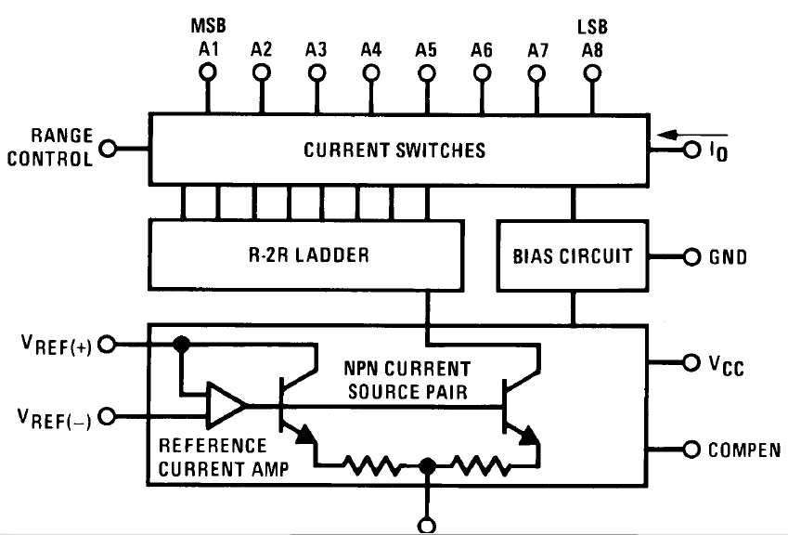

**Fig.:** Block Diagram of DAC0808

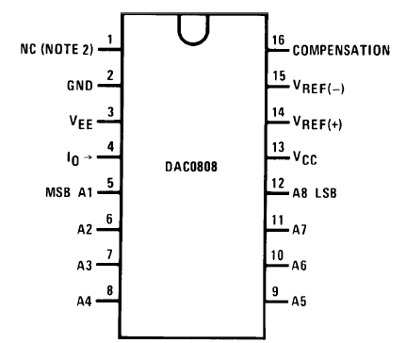

**Fig.:** Pin Diagram of DAC0808

* the digital inputs are converted to current (Iout), and by connecting a resistor to the Iout pin, we convert the result to voltage.
* The total current provided by the Iout pin is a function of the binary numbers at the DO - D7 inputs of the DAC0808 and the reference current (Iref), and is as follows
* where DO is the LSB, D7 is the MSB for the inputs
* The Iref current is generally set to 2.0 mA

Converting Iout to voltage in DAC0808, Ideally we connect the output pin Iout to a resistor, convert this current to voltage, and monitor the output on the scope. In real life, however, this can cause inaccuracy since the input resistance of the load where it is connected will also affect the output voltage. For this reason, the Iout current output is isolated by connecting it to an op-amp such as the 741.

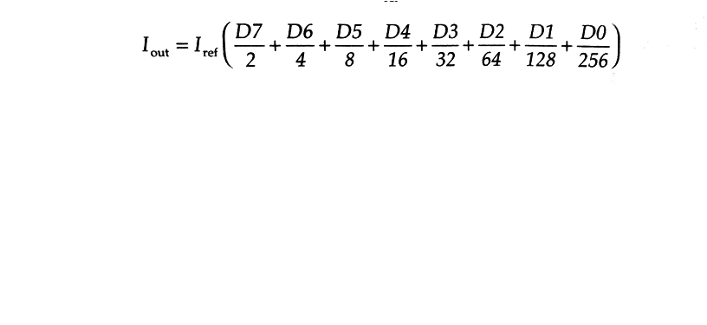

**1.2 Interfacing of DAC0808 with 8051:**

**Explanation of pin connections:**

(+Vref, -Vref, Comp, D0-D7, OUT )

|  |  |
| --- | --- |
| **Pin No. / Name** | **Specification / Explanation** |
| **+ Vref** | +10V |
| **- Vref** | 0V |
| **Comp** | -12V |
| **D0 – D7** | P1.0 – P1.7 |
| **Out** |  |

* 1. **To generate square wave:**

Square wave is wave in which the amplitude alternates at a steady frequency between fixed minimum and maximum values, with the same duration at minimum and maximum. The ratio of the high period to the total period of any rectangular wave is called the duty cycle. A true square wave has a 50% duty cycle (equal high and low periods).  To generate a square wave, we first need a send high value (0FFh or 255) to port on which DAC is connected and hold the high status for some time and for same time send value low (00h)to port.

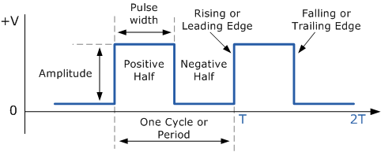

**Fig.** Square wave

* 1. **To generate triangular wave:**

Triangular wave is wave in which the amplitude increases from low logic value to high logic value forming positive-going ramp or slope (rise) and then amplitude decreases from high value logic to low value logic forming negative-going ramp (decay).  To generate a Triangular wave, we first need a send incrementing value from 00h (0) to 0FFh (255) to port on which DAC is connected and then decrementing value from 0FFh (255) to 00h (00).

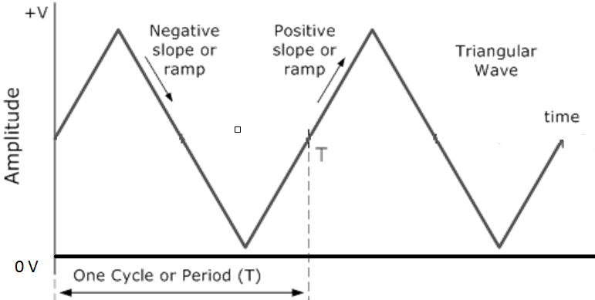

**Fig.** Triangular wave

**1.2 To generate sine wave:**

To generate a sine wave, we first need a table whose values represent the magnitude of the sine of angles between 0 and 360 degrees. The values for the sine function vary from -1.0 to +1.0 for 0- to 360-degree angles. Therefore, the table values are integer numbers representing the voltage magnitude for the sine of theta. This method ensures that only integer numbers are output to the DAC by the 8051 microcontroller.

 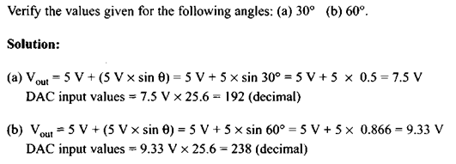

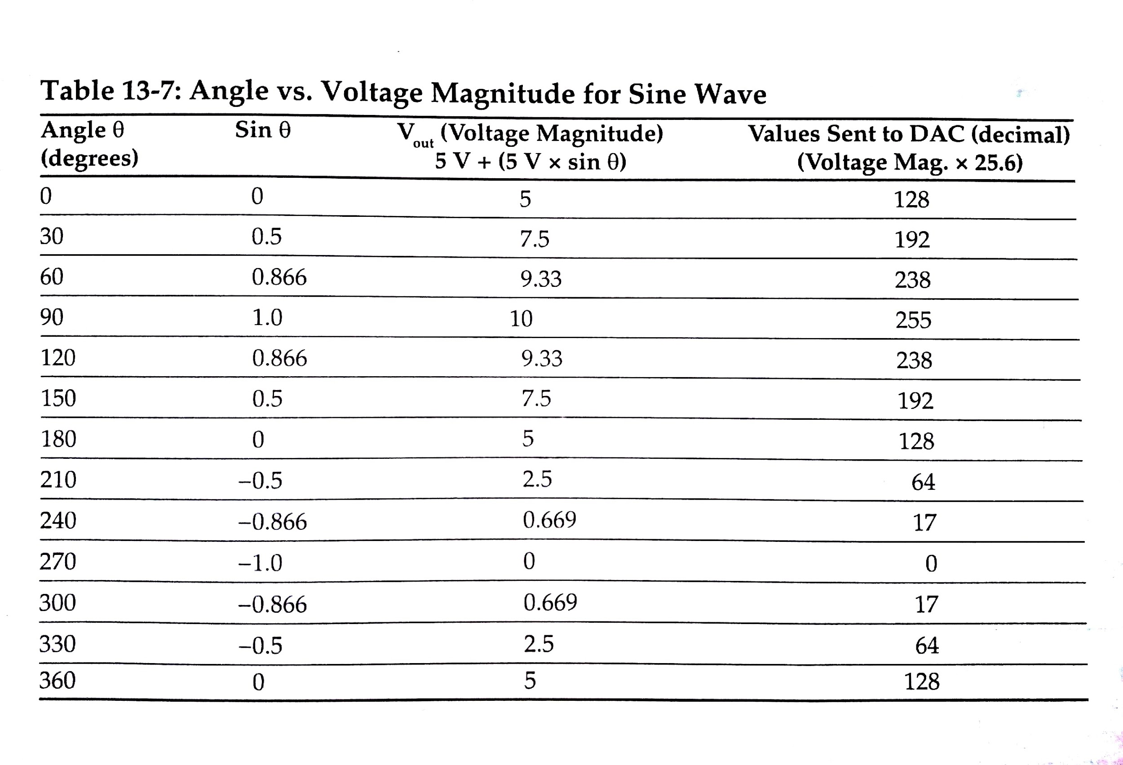

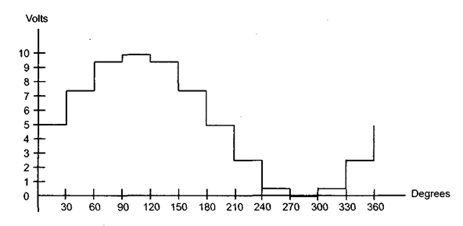

**Fig.** Sine wave

**2. Algorithm:**

* 1. **To generate square wave**

1. Start
2. Send high logic data (0FFh) on port pins.
3. Call delay subroutine
4. Send low logic data (00h) on port pins.
5. Call delay subroutine
6. Repeat step 2 – 5 to generate continuous wave
7. Stop
   1. **To generate triangular wave**
8. Start
9. Send the value incrementing from 00h to 0FFh on port pins.
10. Send the value decrementing from 0FFh to 00h on port pins.
11. Repeat step 2- 4 to generate continuous wave
12. Stop
    1. **To generate sine wave**
13. Start
14. Set the counter register value to number of entries in DB
15. Use MOVC instruction to read value from DB
16. Send the value on port pins.
17. Decrement counter register value and jump to step 2 if not zero
18. Repeat step 2- 4 to generate continuous wave
19. Stop

**3. Source code (Attach separate Sheet)**

Square Wave

Triangular Wave

**4. References:**

1. Mazidi, 8051 microcontroller & embedded system 3rd Edition, Pearson
2. Datasheet of 8051 microcontroller

**5. Result & Conclusion**

Square Wave, Triangular Wave and Sinusoidal wave can be generated in analog form from digital inputs with Keil IDE. This imitates the function of DAC (Digital to analog convertor) hardware, we can also verify the code’s output with simulation of DAC or hardware circuit. The output analog voltage from OP-AMP is in linear relation with input digital value. The waveforms were observed in logic analyzer in Keil IDE.