**BLOOD DONATION MANAGEMENT SYSTEM**

1. **Login Page**

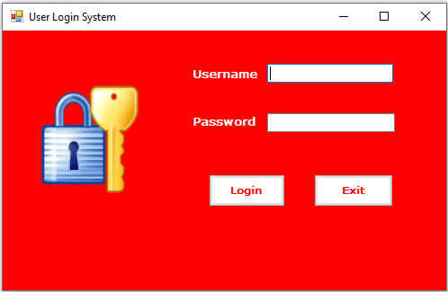

1. **Main Page**

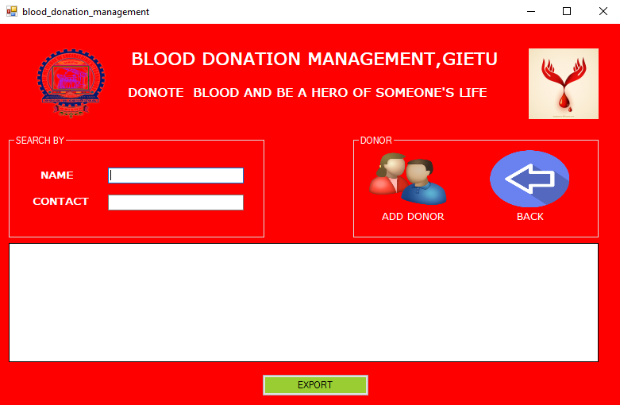

1. **Add Donor Page**

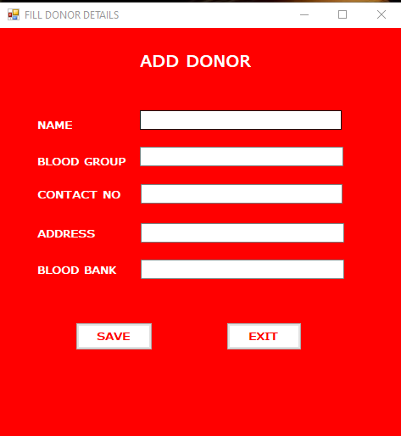

1. **Grid View Of Donor**

