ASSIGNMENT -2

1. Create a Node.js program that prints 'Hello, World!' to the console.

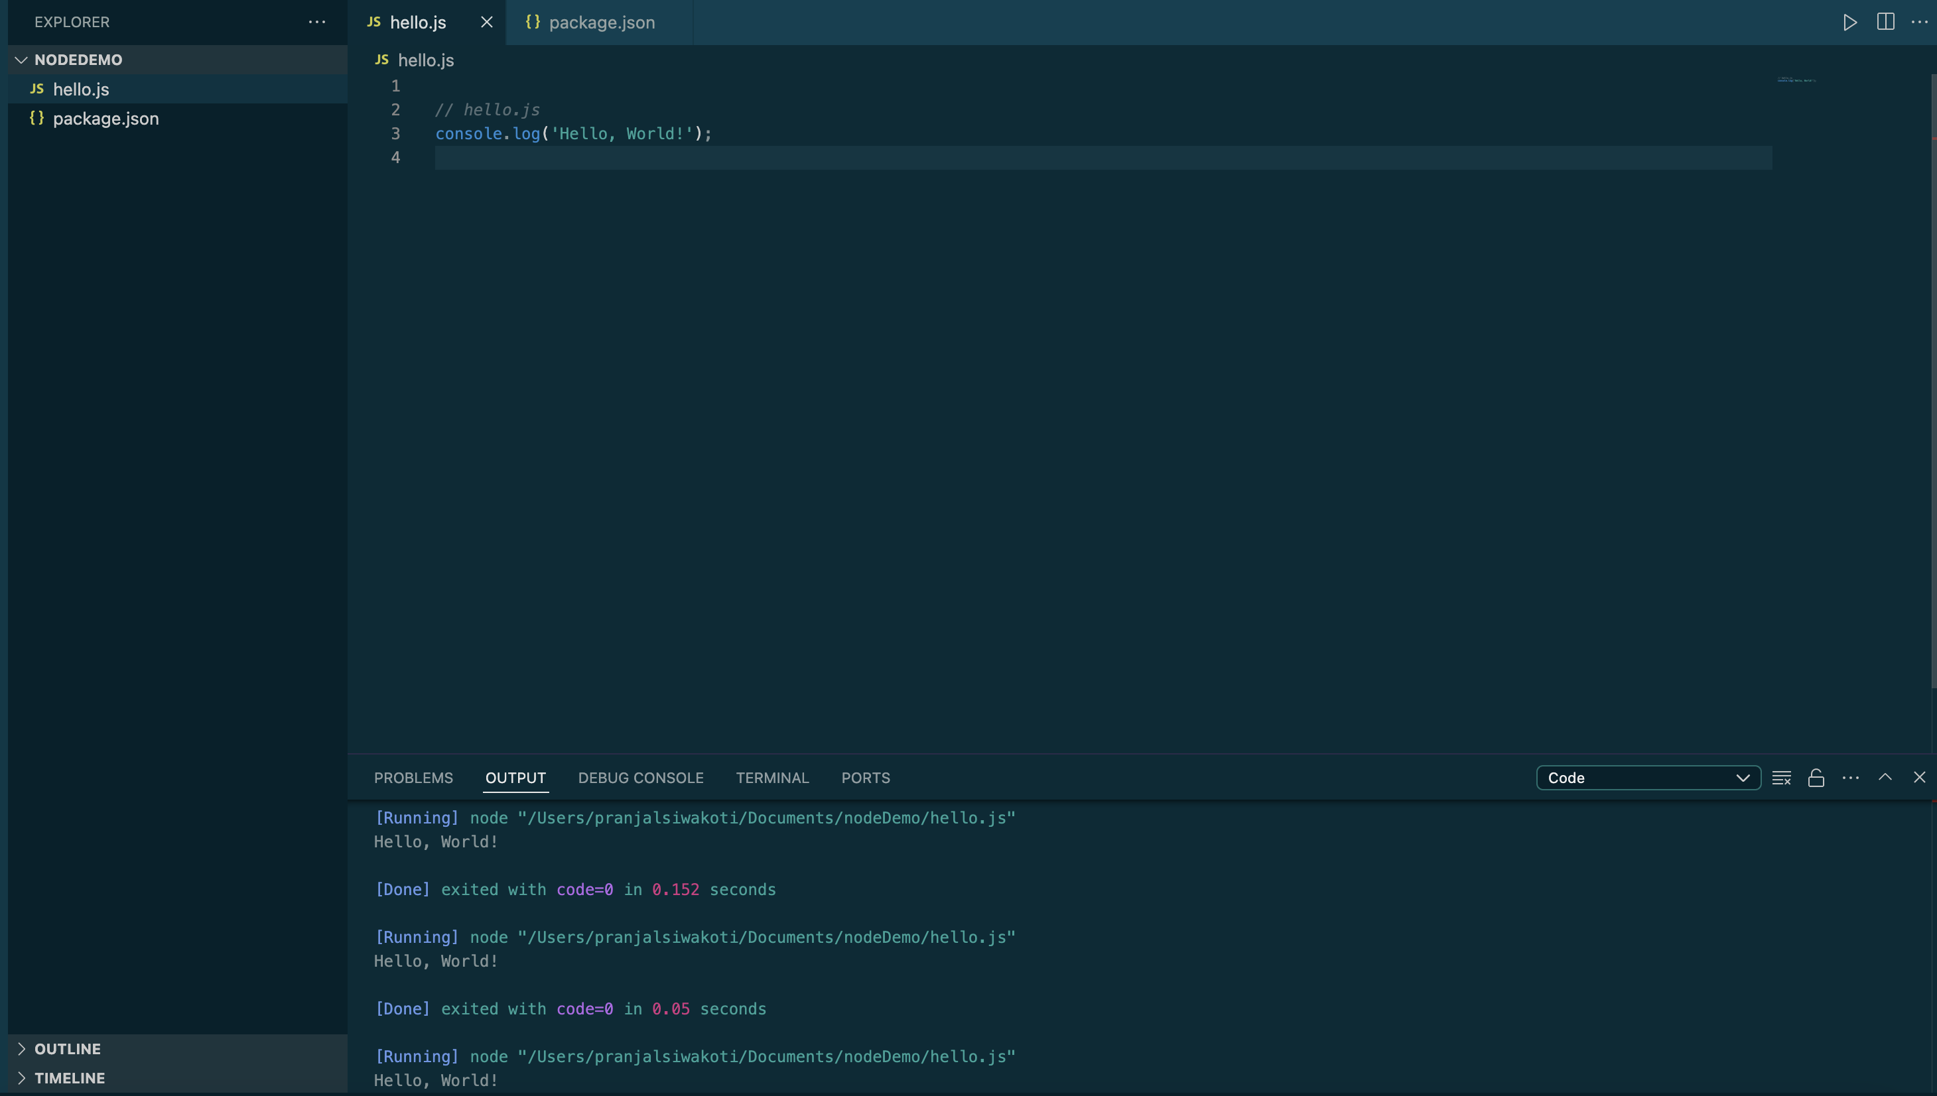

1. Create a Node.js program to read user inputs of two numbers and print their sum to console.

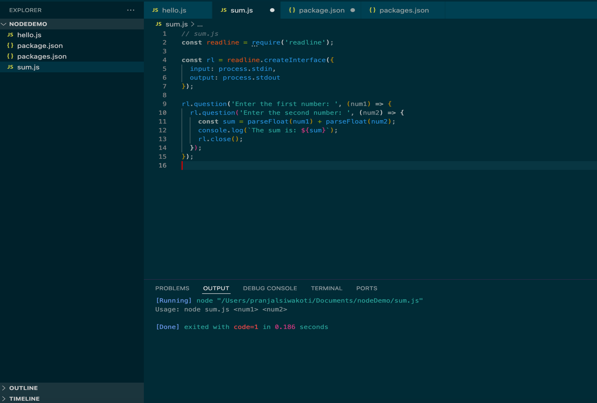

1. Create a Node.js application that reads a text file named 'data.txt' and prints its contents to the console.

