**Assignment :1( Word Count)**

**Step1: Input file: input_word_count.txt**

peter piper picked a peck of pickled pepper if peter piper picked

**Step2: Running the job:-**

hadoop jar /usr/hdp/current/hadoop-mapreduce-client/hadoop-streaming.jar \

-input /user/root/input_word_count.txt \

-output /user/root/output_word_count \

-mapper mapper.py \

-reducer reducer.py \

-file /root/code/mapper.py \

-file /root/code/reducer.py

**Step3: Job run successfully**

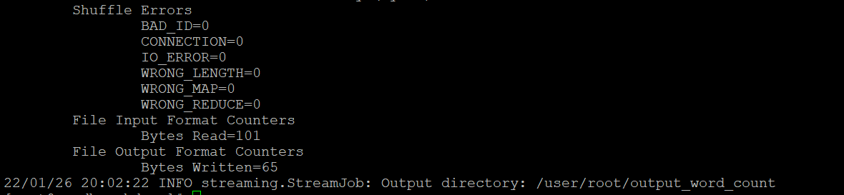

**Step4: Output**

