­

Pranjal Kumari

O

hvuualsj

**Project Team Members**

o

hvuualsj

Deewan Kumar

o

hvuualsj

Qussain Raza

o

hvuualsj

Muhammad Furqan

O

Hvuualsj

**FOTOLAB**

**Faculty:** Miss Ifra hashim

O

Hvuualsj

**Batch:** 2401A

O

Hvuualsj

*Documentation*



***TABLE OF CONTENT***

*CERTIFICATE OF COMPLETION --------------------------------------------------------- 3*

*ACKNOWLEDGEMENT ---------------------------------------------------------------------- 4*

*PROBLEM DEFINATIONS ------------------------------------------------------------------- 5*

*CUSTOMER REQUIREMENTS SPECIFICATIONS----------------------------------- 6*

*PROJECT PLAN ------------------------------------------------------------------------------- 7*

*HRDWARE/SOFTWARE REQUIREMENTS ------------------------------------------- 8*

*PROJECT INFORMATION -------------------------------------------------------------- 9-10*

* *TASKSHEET --------------------------------------------------------------------------------------------9*
* *VALIDATIONS ---------------------------------------------------------------------------------------- 10*
* *SUBMISSIONS --------------------------------------------------------------------------------------- 10*

*SNAPSHOT -------------------------------------------------------------------------------- 11-16*

***CERTIFICATE OF COMPLETION***

*This is to certify:*

*DEEWAN KUMAR (Student1544719)*

*QUSSAIN RAZA (Student1546710)*

*MUHAMMAD FURQAN (Student1547321)*

*PRANJAL KUMARI (Student1548532)*

*Student of* ***APTECH GARDEN CENTER,*** *batch* ***2401A*** *has successfully designed and developed required web Application*

***TITLE: “****FOTOLAB****”***

***Project submitted:*** *24-June -2024*

***ACKNOWLEDGEMENT***

*I would like to acknowledge all those who have given moral support and helped in making the project a success.*

*I wish to express my gratitude to “E-Project” Team of Head Office who guided and helped me. Also, I would like to express my gratitude to all the faculty members of my center for not only providing me opportunity to work with them on this project, but also for their support and encouragement throughout the process.*

# *I also express my sincere gratitude to e-Project Team from aptech Head Office and my project guide at the organization for his valuable guidance and support for completion of this project.*

# *Final, I would like to offer many thanks to all my colleagues for their valuable suggestions and constructive feedback.*

# Problem Definition

FOTOLAB was established in 1991 with the objective of providing sales service for Digital Camera, SLR Camera, Handycam, their accessories and all other related products.

They allot top priority to innovation & upgradation of technology in the avenues of Distribution of All kinds and brands of Digital Camera and their related accessories.

The customers get the benefit of Undivided Attention, Expert Analysis, Innovative Ideas, Commitment and Comprehensive Hardware & Software Solution.

You are supposed to create a website for them with the below mentioned requirement specifications.

The website is to be developed for the Windows Platform using HTML5, JavaScript and Geolocation. The site should work well in all leading browsers including Chrome, IE, Firefox etc.

Requirement Specification:

The Web site is to be created based on the following requirements.

1) The Home Page should be created making use of Sections with a suitable logo, the header section can be added which will show images of related products.

2) The site must contain the links to navigate through any category for the information.

3) The site should display a menu which will have categories of all products.

Few products expected to be included are mentioned below, however more can be added.

• Cameras: all types of cameras should be included

• Camera lenses : varieties of lenses to be included

• Pro audio: related audio accessories options to be included

• Memory cards & media : related products

• Tripods & supports

• Lighting & Studio

• Camera bags & cases

• Miscellaneous accessories

4) The site should contain the options for brief introduction about the various products available, location of the shop and any other information if required.

5) The information should be categorized according to the brand names of the products like if a User wants to see only “yashica” cameras or any other company products then he/she can click on a Link/button/menu etc and can see only that Brand products.

6) When a user selects any particular brand, a list of products for that brand will be displayed

7) A brief summary of features of the respective item should be displayed on the Web Page along with the picture but detailed Features should be stored in Individual Word documents which can be downloaded or viewed by the User who wishes to see the same.

8) The user should also be able to compare the various products of different as well as similar brands.

9) There should be a “Contact Us” page which will have the Address of the Company which should be displayed using GeoLocation API (eg. GoogleMaps) and the email address which when clicked will invoke the local mail client from where they can send an email.

***HARDWARE/SOFTWARE REQUIREMENTS***

**Hardware:**

* A minimum computer system that will help you access all the tools in the courses is a Pentium 166 or better.
* 64 Megabytes of RAM or better

**Software:**

* Notepad/HTML editor/CoffeeCup
* Angular / Angular JS / React / BootStrap
* Dreamweaver / Figma
* MS IE / Chrome / FireFox / Netscape /MS Edge

|  |  |  |  |  |
| --- | --- | --- | --- | --- |
| # | *TASK* | *DONE BY* | *DAYS* | *STATUS* |
| 1 | Design | PRANJAL KUMARI | 4 | Completed |
| 2 | Collect Info | QUSSAIN RAZA | 2 | Completed |
| 3 | Redesign & Code | MUHAMMAD FURQAN | 8 | Completed |
| 4 | Write Documents | PRANJAL KUMARI | 4 | Completed |
| 5 | Review Web App | DEEWAN KUMAR | 3 | Completed |

***PROJECT INFORMATION***

**Tasksheet:**

**Validations & Submissions:**

* **Validations**

|  |  |
| --- | --- |
| *VALIDATIONS* | *OPTIONS* |
| *Input mask are consistent* | *Yes* |
| *All page have forward link and to homepage* | *Yes* |
| *The site name for publishing is unique* | *Yes* |

* **Submissions:**

|  |  |  |  |
| --- | --- | --- | --- |
| **PARTICULARS** | **YES** | **NO** | **COMMENTS** |
| Do all the pages open | **✔** | **-** | **-** |
| Are all hyperlinks working? | **✔** | **-** | **-** |
| Are the web page contents devoid of spelling mistakes | **✔** | **-** | **-** |
| Are the page color as per | **✔** | **-** | **-** |

***SNAPSHOTS***

* 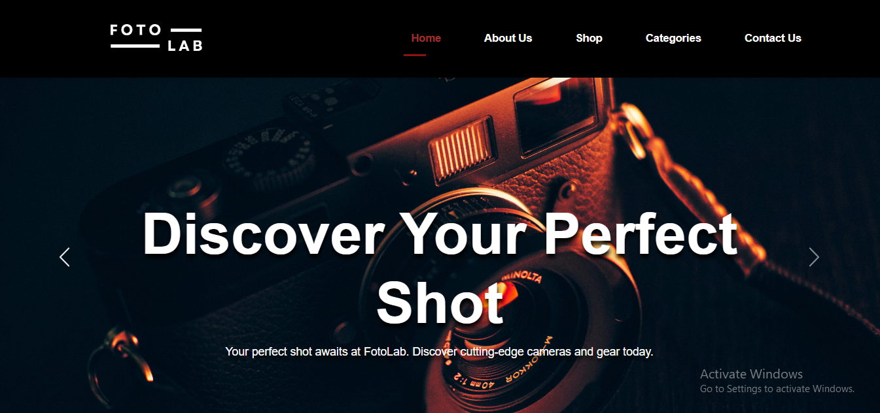**Home:**
* 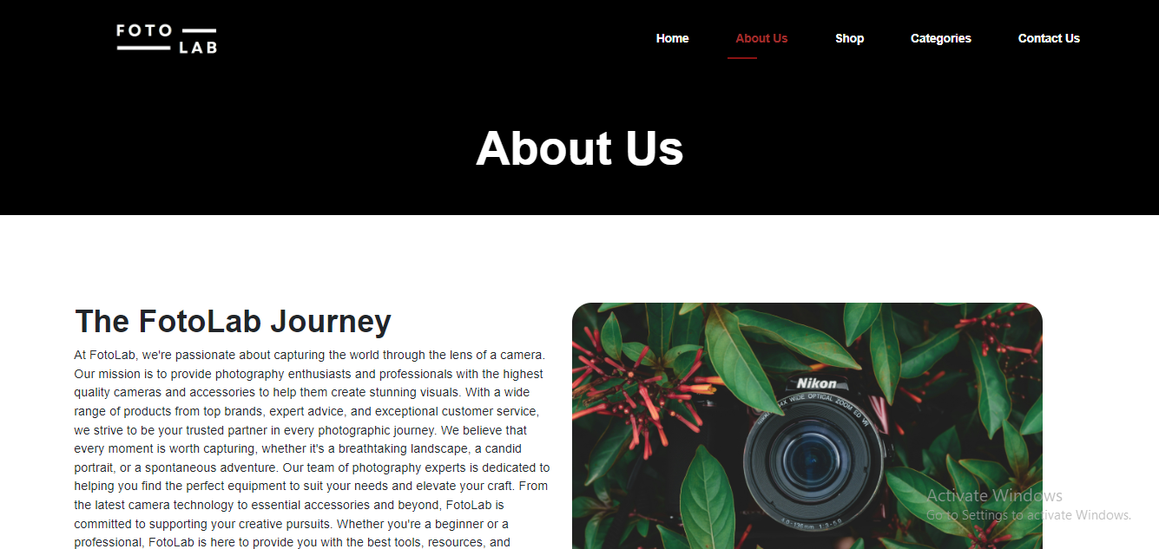**About Us**
* 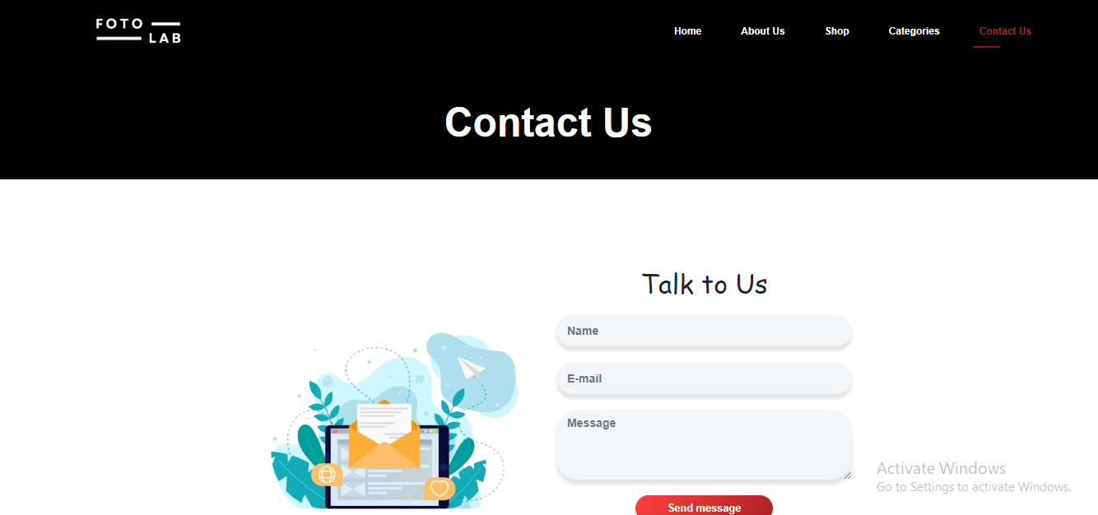**CONTACT US**
* 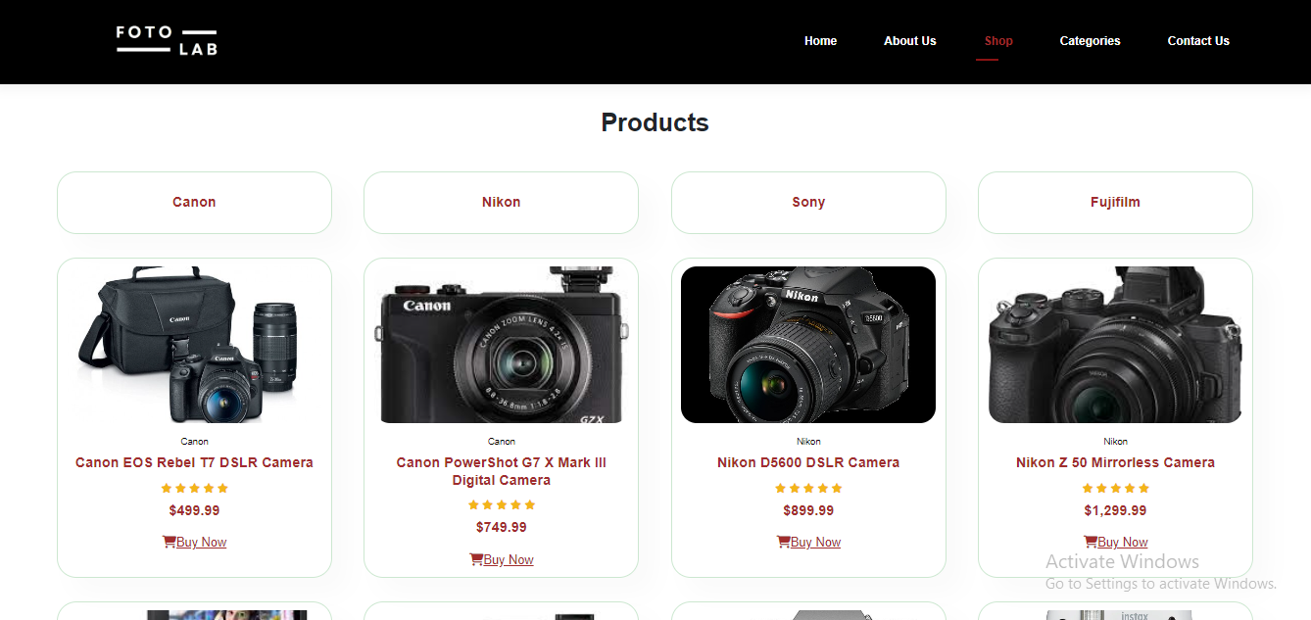**Shop:**

