**RESUME**

**RAJENDRA NAGPURE** 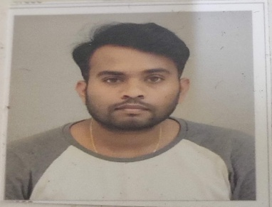

Ward no.-1 ITI Colony,Budi,

BALAGHAT (M.P.) 481001

Mob. No. 7509588877

E-mail Id: rnagpure88@gmail.com

**O0bjective**

Seeking for a position to utilize my skills and abilities in the industry that offers professional while being resourceful, innovative and flexible.

**Professional Qualifications**

|  |  |  |  |  |  |
| --- | --- | --- | --- | --- | --- |
| **Degree/**  **Examination** | **University/Board** | **Year of Passing** | | **Percentage** | |
| ITI | Govt. ITI  Balaghat (M.P.) | 2011 | | 82.2% | |
| XII | M.P Board of  Education | | 2010 | | 61% |
| X | M.P Board of  Education | 2008 | | 67% | |

**T0echnical Skills**

* **Computer Proficiency : MS Word, Power Point, Excell**

**Personal Skills**

* Hard-worker,
* Positive and Motivational Attitud.
* Good listener.
* Optimistic in nature.
* Leadership Quality.
* Self motivated.
* Quick learner.

**Experience**

* 6 Years experience as Plumber at Sparsh Enterprises Bhopal.
* Supervise the installation, repair and maintenance of water, plumbing and heating systems; maintain records and files; prepare reports.
  + - Plan, schedule and assign the activities of plumbers.
    - Supervise the installation and repair of hot and cold water, oil, steam or gas pipes and necessary connections.
    - Prepare and analyze reports and charts concerning worker utilization and job time rates.
    - Establish work standards, production control, job priorities and preventative maintenance teams.
    - Make sketches for plumbing layouts and determine types and quantities of materials necessary.
    - Determine time and cost estimates for plumbing jobs.
    - Aid in obtaining materials necessary to complete the job.
    - Supervise plumbing shop and perform plumbing shop work and related jobs.
    - Assist staff with more difficult and complex projects.
    - Assist skilled workers of related trades in general plumbing maintenance work.

**Personal Details**

**1 Date of Birth : 19 MAY 1992**

1. **Father’s Name : Mr. ROOPCHAND NAGPURE**
2. **Sex : Male**
3. **Marital Status : Single**
4. **Language Known : English & Hindi**

**I hereby declare that the above information is true to best of my knowledge.**

Date:

Place: BALAGHAT (RAJENDRA NAGPURE)