**A Project Report and Requirement**

**on**

**Medical Image Analysis Using Deep Learning**

**(CSE 5th Semester Mini project )**

**2021-2022**



**In**

**COMPUTER SCIENCE AND TECHNOLOGY**

**Submitted to: Submitted by:**

Dr. Vijay Singh Pranjal Agarwal

Roll. No.: 2015301

ML-5th sem

Session: 2021-2022

**Department of computer science and engineering**

**Graphic Era deemed to be University, DEHRADUN**

**CERTIFICATE**

### Certified that Pranjal Agarwal (Roll No. 2015301) has developed mini project on “Medical Image Analysis Using Deep Learning” for the ML V Semester Mini Project Lab in Graphic Era Deemed to be University, Dehradun. The project carried out by Students is their own work as best of my knowledge.

Dr. VijaySingh

**Project Resource Person**

(CSE Department)

**ACKNOWLEDGMENT**

I have taken efforts in this project. However, it would not have been possible without the kind support and help of many individuals and organizations. I would like to extend my sincere thanks to all of them.

I am highly indebted to Graphic Era, for their guidance and constant supervision as well as for providing necessary information regarding the project & also for their support in completing the project.

I would like to express my gratitude towards my parents & our Mentor Dr. Vijay Singh for their kind co-operation and encouragement which help me in completion of this project.

I would like to express my special gratitude and thanks to industry persons for giving me such attention and time.

My thanks and appreciations also go to my colleague in developing the project and people who have willingly helped me out with their abilities

**Pranjal Agarwal**

**Roll No.- 2015301**

**Branch- ML**

**Session: 2021-2022**

**GEU, Dehradun**

**Introduction:**

In this project, I have deployed a model that detects whether a person is having Pneumonia or not. The image classification is done by using Convolution Neural Network (CNN). CNN is an artificial neural network that has the ability to detect patterns in the images.

Medical image analysis is a deep learning project in which medical images are analysed using CNN. CNN helps us to classify the images on the basis of certain patterns. In this model I have chosen a dataset having Chest X-Ray images.

**Motivation:**

Pneumonia is an acute respiratory infection that affects the lungs. It is a fatal illness in which the air sacs get filled with pus and other liquid . There are mainly two types of pneumonia: bacterial and viral. Generally, it is observed that bacterial pneumonia causes more acute symptoms. The most significant difference between bacterial and viral pneumonia is the treatment. Treatment of bacterial pneumonia is done using antibiotic therapy, while viral pneumonia will usually get better on its own . It is a prevalent disease all across the globe. Its principal cause includes a high level of pollution. Pneumonia is ranked 8 in the list of the top 10 causes of death in the United States . Due to pneumonia, every year, 3.7 lakh children die in India, which constitutes a total of fifty percent of the pneumonia deaths that occur in India . Children can be protected from pneumonia. It can be prevented with simple interventions and treated with low-cost, low-tech medication and care” .

Therefore, there is an urgent need to do research and development on computer-aided diagnosis so that the pneumonia-related mortality, especially in children, can be reduced.

One of the following tests can be done for pneumonia diagnosis: chest X-rays, CT of the lungs, ultrasound of the chest, needle biopsy of the lung, and MRI of the chest . Currently, chest X-rays are one of the best methods for the detection of pneumonia

**Objective:**

* To capture X-Ray images to analyse the presence of Pneumonia using deep learning techniques.
* To classify X-Ray images as a Pneumonia cases or Normal cases with accuracy.
* To detect the presence of Pneumonia.

**Problem  Statement:**

In the medical field , Pneumonia is detected by Doctors by referring the X-Ray images which is very time consuming. Therefore , to overcome this problem , an alternative way is to design the system that will automatically identify the presence of Pneumonia in X-Ray images using Convolutional Neural Network and also provide faster and accurate solutions.

**Software Requirements:**

* Language used: Python 3.7 or above
* Operating system: Windows 10
* Tool used: Google Collaboratory Notebook

**Hardware Requirements:**

* Processor: Intel core i5 or above.
* 64-bit, quad-core, 2.5 GHz minimum per core
* Ram: 4 GB or more
* Hard disk: 10 GB of available space or more.
* Display: Dual XGA (1024 x 768) or higher resolution monitors
* Operating system: Windows

**Technology Used**

**Python**- It is an interpreted, high-level, general-purpose programming language. Created by Guido van Rossum and first released in 1991, Python's design philosophy emphasizes code readability with its notable use of significant whitespace. Its language constructs and object-oriented approach aim to help programmers write clear, logical code for small and large-scale projects. Python is dynamically typed and garbage-collected. It supports multiple programming paradigms, including procedural, object-oriented, and functional programming. Python is often described as a "batteries included" language due to its comprehensive standard library.

**Deep learning!**

Deep learning is a subset of machine learning, which is essentially a neural network with three or more layers. These neural networks attempt to simulate the behavior of the human brain—albeit far from matching its ability—allowing it to “learn” from large amounts of data. While a neural network with a single layer can still make approximate predictions, additional hidden layers can help to optimize and refine for accuracy.

Deep learning drives many artificial intelligence (AI) applications and services that improve automation, performing analytical and physical tasks without human intervention. Deep learning technology lies behind everyday products and services (such as digital assistants, voice-enabled TV remotes, and credit card fraud detection) as well as emerging technologies (such as self-driving cars).

**Algorithm Used**

**Convolutional neural networks(ConvNet/CNN)**

A Convolutional Neural Network is a Deep Learning algorithm which can take in an input image, assign importance (learnable weights and biases) to various aspects/objects in the image and be able to differentiate one from the other. The pre-processing required in a ConvNet is much lower as compared to other classification algorithms. While in primitive methods filters are hand-engineered, with enough training, ConvNets have the ability to learn these filters/characteristics.

The architecture of a ConvNet is analogous to that of the connectivity pattern of Neurons in the Human Brain and was inspired by the organization of the Visual Cortex. Individual neurons respond to stimuli only in a restricted region of the visual field known as the Receptive Field. A collection of such fields overlap to cover the entire visual area.

Convolutional neural networks are distinguished from other neural networks by their superior performance with image, speech, or audio signal inputs. They have three main types of layers, which are:

**Convolutional layer-**

* Convolutional Layer
* Pooling layer
* Fully-connected (FC) layer

The **convolutional layer** is the core building block of a CNN, and it is where the majority of computation occurs. It requires a few components, which are input data, a filter, and a feature map. Let’s assume that the input will be a color image, which is made up of a matrix of pixels in 3D. This means that the input will have three dimensions—a height, width, and depth—which correspond to RGB in an image. We also have a feature detector, also known as a kernel or a filter, which will move across the receptive fields of the image, checking if the feature is present. This process is known as a convolution.

The feature detector is a two-dimensional (2-D) array of weights, which represents part of the image. While they can vary in size, the filter size is typically a 3x3 matrix; this also determines the size of the receptive field. The filter is then applied to an area of the image, and a dot product is calculated between the input pixels and the filter. This dot product is then fed into an output array. Afterwards, the filter shifts by a stride, repeating the process until the kernel has swept across the entire image. The final output from the series of dot products from the input and the filter is known as a feature map, activation map, or a convolved feature.

**Pooling Layer**

Pooling layers, also known as downsampling, conducts dimensionality reduction, reducing the number of parameters in the input. Similar to the convolutional layer, the pooling operation sweeps a filter across the entire input, but the difference is that this filter does not have any weights. Instead, the kernel applies an aggregation function to the values within the receptive field, populating the output array. There are two main types of pooling:

**Max pooling:** As the filter moves across the input, it selects the pixel with the maximum value to send to the output array. As an aside, this approach tends to be used more often compared to average pooling.

**Average pooling:** As the filter moves across the input, it calculates the average value within the receptive field to send to the output array.

While a lot of information is lost in the pooling layer, it also has a number of benefits to the CNN. They help to reduce complexity, improve efficiency, and limit risk of overfitting.

**Fully-Connected Layer**

The name of the full-connected layer aptly describes itself. As mentioned earlier, the pixel values of the input image are not directly connected to the output layer in partially connected layers. However, in the fully-connected layer, each node in the output layer connects directly to a node in the previous layer.

This layer performs the task of classification based on the features extracted through the previous layers and their different filters. While convolutional and pooling layers tend to use ReLu functions, FC layers usually leverage a softmax activation function to classify inputs appropriately, producing a probability from 0 to 1.

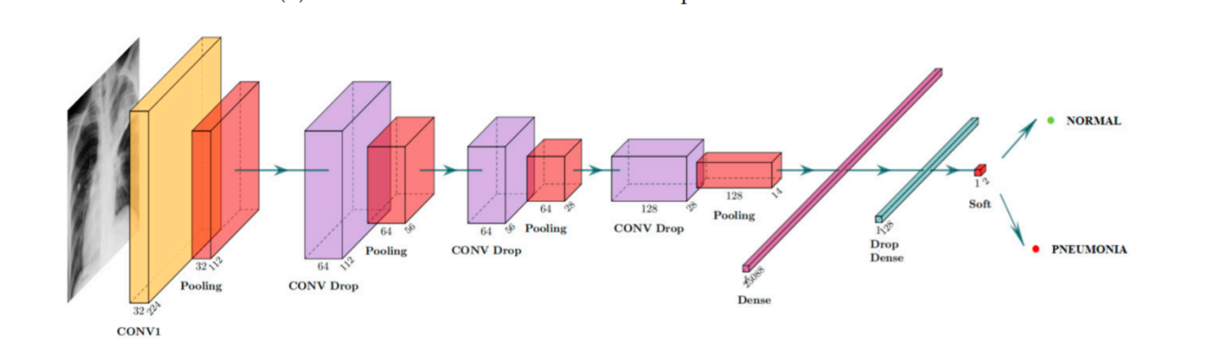

**Types of convolutional neural networks**

* **AlexNet**
* **VGGNet**
* **GoogLeNet**
* **ResNet**
* **ZFNet**

However, **LeNet-5** is known as the classic CNN architecture.

**Some common applications of CNN:**

**Marketing**: Social media platforms provide suggestions on who might be in photograph that has been posted on a profile, making it easier to tag friends in photo albums.

**Healthcare:** Computer vision has been incorporated into radiology technology, enabling doctors to better identify cancerous tumors in healthy anatomy.

**Retail:** Visual search has been incorporated into some e-commerce platforms, allowing brands to recommend items that would complement an existing wardrobe.

**Automotive:** While the age of driverless cars hasn’t quite emerged, the underlying technology has started to make its way into automobiles, improving driver and passenger safety through features like lane line detection.

**Process involved:**

**Step1:** Loading the Dataset.

**Step 2:** Initializing the data Now, Here I imported some important libraries and define directory path.

**Step 3:** Preparing the data:

**a) Data augmentation**

Image augmentation technique is used for increasing the size of image training dataset. This is done by flipping, horizontal or vertical shifting, zooming or adding some noises to the same images.

**b) Loading the images**: There is a class known as flow from directory offered by Image Data Generator which reads the images from folders.

**Step 4:** Applying CNN:

The CNN architecture has convolutional layers which receives inputs and transform the data from the image and pass it as input to the next layer. This transformation is known as the operation of convolutional. We need TensorFlow and necessary libraries for CNN.

**Step 5:** Fitting the model

a) Defining callback list I have used Early Stopping which is called to stop the epochs based on some metric and conditions. It helps to avoid overfitting the model. Reduce learning rate when a metric has stopped improving. This callback monitors a quantity and if no improvement is seen for a ‘patience’ number of epochs, the learning rate is reduced.

b) Assigning class weights

**Step 6:** Training the model:

The EarlyStopping has stopped at 10th epoch at val_loss =38.8% and val_accuracy = 75.8%.

**Step 7:** Evaluating the model:

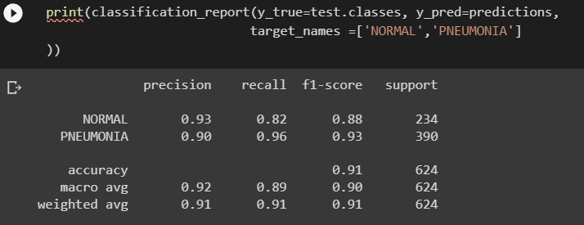

**Confusion matrix:**

The upper left (TP) denotes the number of images correctly predicted as normal cases and the bottom right (TN) denotes the correctly predicted number of images as cases of pneumonia. As Pneumonia case, the upper right denotes the number of incorrectly predicted images but were actually normal cases and the lower left denotes the number of incorrectly predicted Normal case images but were actually Pneumonia case.

**Classification Report**

The four metrics are given as follows:

|  |  |  |  |  |
| --- | --- | --- | --- | --- |
| accuracy = |  | TP+TN | | |
|  | |  |  |
| TP+TN+FP+FN | | | |
| precision = | |  | TP | |
|  | | |
|  | TP+FP |  |

|  |  |  |  |  |
| --- | --- | --- | --- | --- |
| recall = |  | TP | | |
|  | FP+FN |  |

Precision = True Positives / (True Positives + False Positives)

Recall = True Positives / (True Positives + False Negatives)

F1 = (2 * Precision * Recall) / (Precision + Recall)

At last, visualized the predicted images using percentages.

**CONCLUSION AND FUTURE SCOPE**

We proposed a computerized method for the segmentation and identification of a Pneumonia using the Convolution Neural Network. The input images are read from the local device using the file path and converted into grayscale images. These images are pre-processed for the elimination of noises that are present inside the original image. The proposed model had obtained an good accuracy and yields promising results without any errors and much less computational time.

In the future, we will continue the research to explore more accurate classification

architectures to diagnose two types of pneumonia, viruses, and bacteria.We can even deploy the model using flask, heroku and many more to make it a working model for industry. According to the description discussed above, the CNN-based model is a promising method to diagnose the disease through X-rays.

**References:**

* For dataset: https://kaggle.com
* For resolving errors: <https://stackoverflow.com/>
* For Understanding the topics :
* [www.google.com](http://www.google.com)
* [www.youtube.com](http://www.youtube.com)
* [www.medium.com](http://www.medium.com)