Week 4 Task: Machine Learning Model Development and Evaluation
1. Objective
The objective of this task is to develop and evaluate a machine learning classification model using Python. The model predicts whether an online retail transaction belongs to the high-revenue class or the low/median-revenue class. The task includes data preprocessing, feature selection, model training, performance evaluation, and visualization.
2. Dataset Description
The Online Retail dataset was used for this task. It contains transaction information such as invoice number, product description, quantity, invoice date, unit price, customer ID, and country. The original dataset contained 541,909 records and 8 columns.
3. Data Preprocessing
The dataset was prepared using Pandas. Duplicate records were removed, and records with missing product descriptions, invoice dates, or country values were excluded. Transactions with non-positive quantities or unit prices were also removed. The invoice date was converted to datetime format, and revenue was calculated by multiplying quantity by unit price.
To make model training manageable, a reproducible random sample of 100,000 records was selected. A binary target variable, HighRevenue, was created using the median transaction revenue of 9.95 as the threshold. Transactions above this threshold were labelled 1, while the remaining transactions were labelled 0.
4. Feature Selection and Algorithm
The input features were UnitPrice, Country, and Month. The target variable was HighRevenue. UnitPrice and Month were standardized using StandardScaler, while Country was converted into numeric features using OneHotEncoder.
Logistic Regression was selected because it is a commonly used classification algorithm suitable for predicting one of two classes. A Scikit-learn Pipeline combined preprocessing and model training to maintain a consistent workflow.
5. Training and Testing
The dataset was split into 80% training data and 20% testing data using train_test_split. The random_state was set to 42 for reproducibility, and stratify was used to maintain the class proportions in both sets. The model was trained on 80,000 records and evaluated on 20,000 records.
6. Model Evaluation Results
The model achieved the following results:
- Training accuracy: 62.01%
- Testing accuracy: 62.22%
- Precision: 68.79%
- Recall: 43.68%
- F1-score: 53.43%
- ROC-AUC: 66.71%
The training and testing accuracy values are close, suggesting that the model does not show an obvious large generalization gap. However, the overall performance is moderate. Precision of 68.79% indicates that a reasonable proportion of transactions predicted as high-revenue were actually in that class. Recall of 43.68% shows that the model identified fewer than half of all actual high-revenue transactions. The F1-score reflects the balance between precision and recall. The ROC-AUC score indicates some ability to distinguish the two classes, but there is significant room for improvement.
7. Visualizations
Two visualizations were generated as part of the evaluation.
Confusion Matrix: This chart compares actual classes with predicted classes. It helps identify correct predictions and the two types of classification errors.
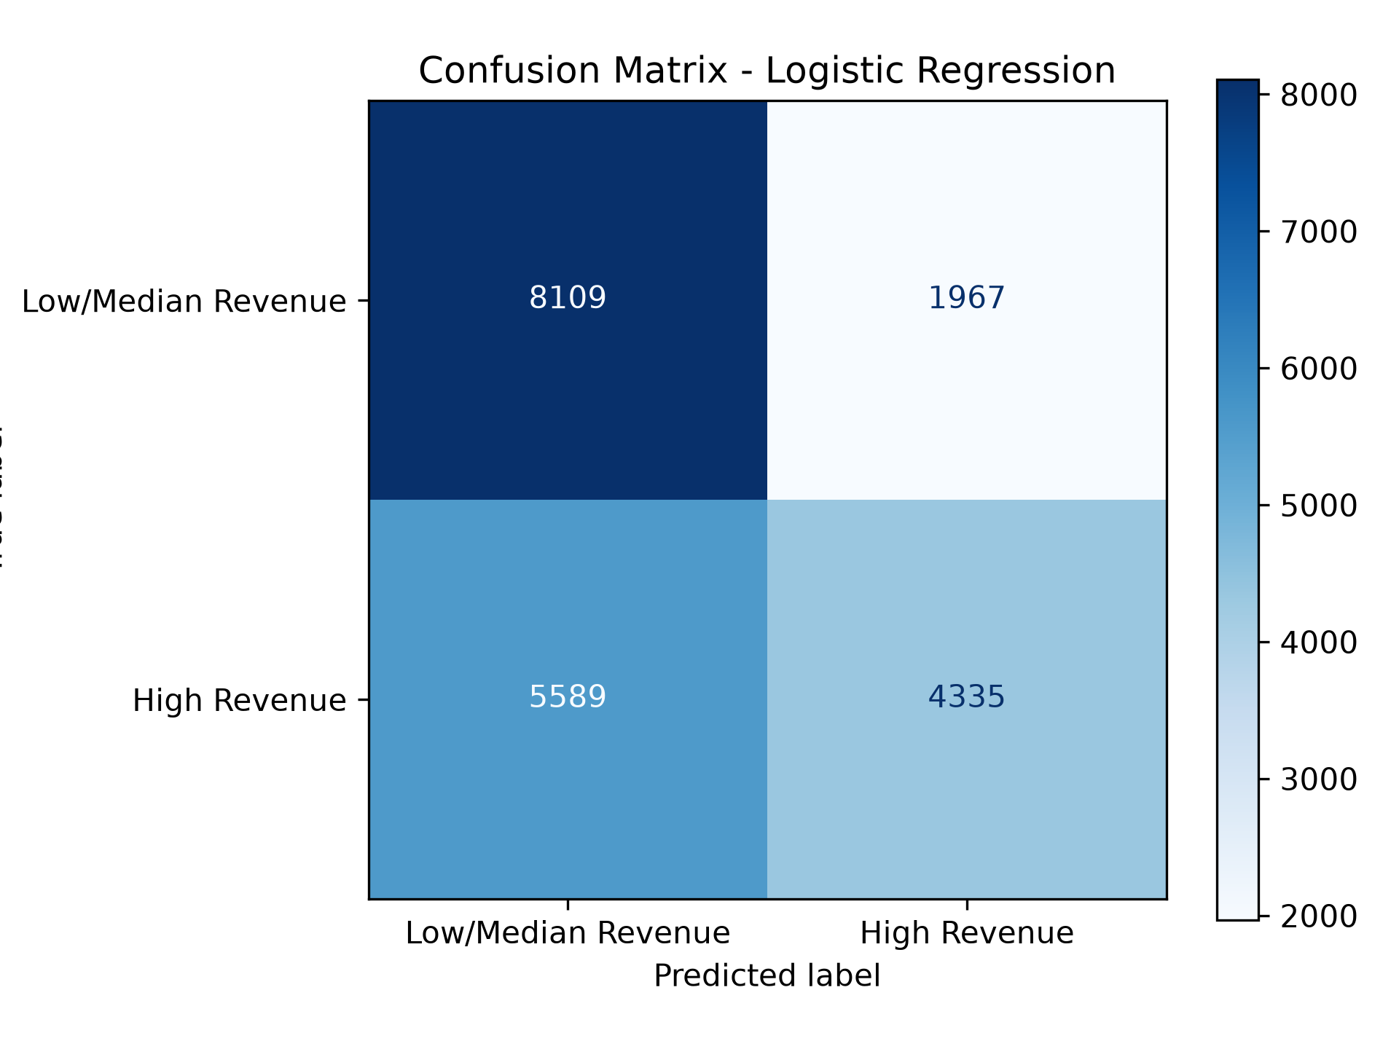
ROC Curve: This chart shows the trade-off between the true positive rate and the false positive rate at different classification thresholds. The ROC-AUC score summarizes the model's ability to distinguish between the classes.
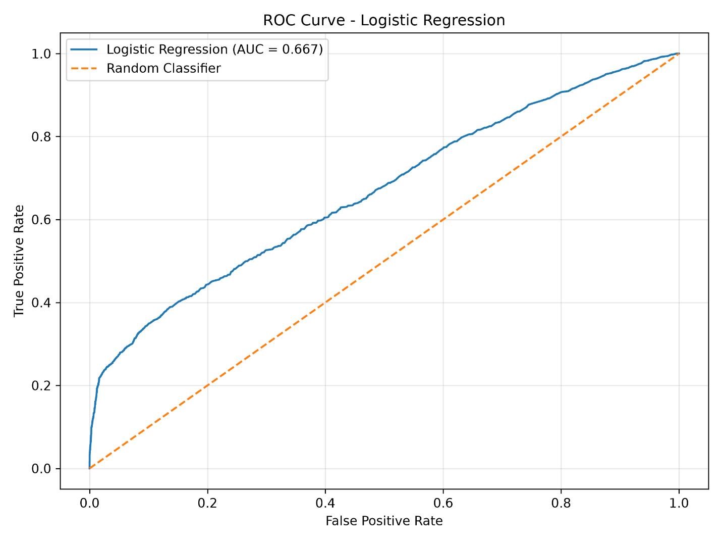

8. Error Analysis and Limitations
The model has a relatively low recall for the high-revenue class, so it misses many actual high-revenue transactions. This may limit its usefulness when identifying valuable transactions is the main goal. The close training and testing accuracy values do not indicate obvious severe overfitting, although additional validation would be required to assess generalization more reliably. The moderate scores may reflect the simplicity of Logistic Regression and the limited input features.
Another limitation is that UnitPrice contributes directly to the revenue calculation. It may therefore act as a strong proxy for the target. Also, the target threshold was calculated from the selected sample, so the results depend on the sample and target definition.
9. Possible Improvements
Performance could be improved by testing additional relevant features, comparing Logistic Regression with Decision Tree and Random Forest classifiers, and tuning hyperparameters with cross-validation. The classification threshold could also be adjusted according to the business objective. Future work should evaluate whether the model performs consistently on data from a different time period and should avoid using information that would not be available when making real predictions.
10. Conclusion
This task demonstrated a complete basic machine learning workflow using Python, Pandas, and Scikit-learn. The dataset was cleaned, features were preprocessed, a Logistic Regression model was trained, and multiple evaluation metrics and visualizations were produced. The model achieved 62.22% test accuracy and a ROC-AUC score of 66.71%. The evaluation also highlighted limitations, especially the low recall for high-revenue transactions, and identified several directions for future improvement.

