Report title:
Data Acquisition, Cleaning, and Exploratory Data Analysis of Online Retail Transactions

Subtitle:
YuvaIntern – Virtual Data Science with Python Apprentice Internship

Introduction:
Data preparation and exploratory data analysis are important steps in the data science process because raw datasets often contain missing values, duplicate records, inconsistent values, and other issues that can affect analysis. In this project, the Online Retail dataset was analyzed using Python to understand the data preparation process and identify useful business insights.
The analysis was performed using Pandas for data loading, cleaning, transformation, and statistical analysis, along with Matplotlib for data visualization. The project involved checking the structure of the dataset, identifying missing values and duplicate records, investigating invalid sales values, cleaning the data, calculating revenue, and performing exploratory analysis.
The cleaned dataset was then used to examine revenue patterns across countries, products, and months. Visualizations were created to make these patterns easier to understand and communicate. The analysis resulted in several useful observations, including the dominance of the United Kingdom in revenue and the identification of November 2011 as the highest-revenue month.

Dataset Description:
Dataset: Online Retail
The dataset contains transaction-level information from an online retail business. It includes the following important columns:
Column | Description
InvoiceNo | Invoice/transaction number
StockCode | Product/item code
Description | Product description
Quantity | Number of items purchased
InvoiceDate | Date and time of transaction
UnitPrice | Price per unit
CustomerID | Customer identification number
Country | Customer's country

The original dataset contained 541,909 records and 8 columns.

3. Data Cleaning and Preprocessing:
Data cleaning was performed to improve the quality and reliability of the dataset before conducting exploratory analysis. The dataset was first inspected for its structure, data types, missing values, duplicate records, and invalid numerical values.
1. Missing Values: Missing values were identified using Pandas. The Description column contained 1,454 missing values, while CustomerID contained a larger number of missing values. The missing Description records were removed because the product description was important for product-level analysis. The missing CustomerID values were retained because customer identification was not required for the revenue analysis.
2. Duplicate Records: The dataset contained 5,268 duplicate rows. These exact duplicate records were removed using Pandas drop_duplicates() to avoid counting the same transaction more than once.
3. Invalid Quantity Values: Records with quantity less than or equal to zero were identified. Negative quantities can represent returns or cancellations in transaction data. For this sales-focused analysis, records with non-positive quantities were excluded so that the revenue calculations represented positive sales.
4. Invalid Unit Prices: Records with a unit price less than or equal to zero were also identified. Since revenue is calculated using quantity multiplied by unit price, these records were excluded from the positive-sales analysis.
5. Revenue Calculation: A new Revenue column was created using the formula:
Revenue = Quantity × UnitPrice
After preprocessing, the resulting dataset contained 524,878 records and was used for further exploratory data analysis.

4. Exploratory Data Analysis:
Exploratory Data Analysis (EDA) was performed to understand the major patterns, trends, and relationships present in the cleaned Online Retail dataset. Summary statistics were calculated for numerical variables such as Quantity, UnitPrice, and Revenue. Grouping and aggregation were then used to analyze revenue across countries, products, and months. Three visualizations were created to communicate the main findings clearly.

4.1 Summary Statistics:

The cleaned dataset contains 524,878 transaction records. The total quantity sold was 5,572,420 units, and the total calculated revenue was 10,642,110.80. The dataset contains 4,026 unique product descriptions across 38 countries.
The revenue distribution is right-skewed because the mean revenue per transaction is higher than the median, indicating that a relatively small number of transactions have substantially higher revenue values.
4.2 Visualization 1 — Top 10 Countries by Revenue

Top 10 Countries by Revenue
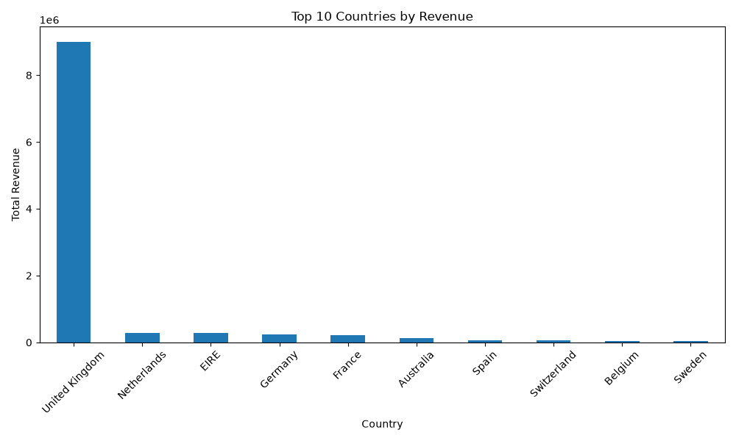
This bar chart compares the total revenue generated by the ten highest-revenue countries. The United Kingdom is clearly the leading country by revenue, generating approximately 9.00 million in revenue. The Netherlands, EIRE, Germany, and France follow at considerably lower levels. This indicates that the business's revenue was highly concentrated in the United Kingdom.

4.3 Visualization 2 — Monthly Revenue Trend
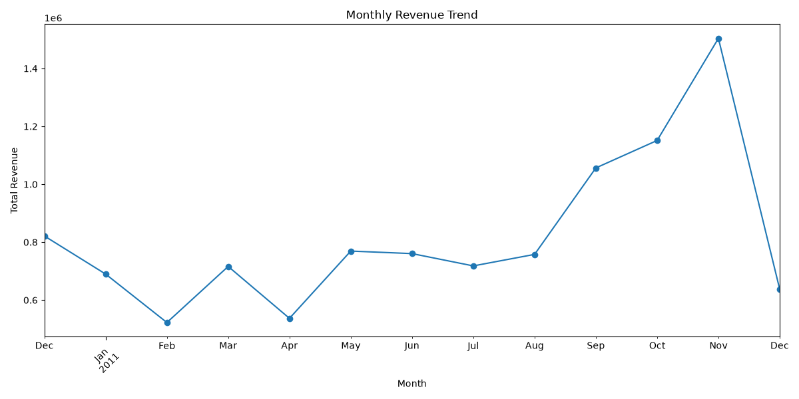
The line chart shows how revenue changed across the months represented in the dataset. The trend helps identify periods of higher and lower sales activity. The analysis shows that November 2011 was the highest-revenue month. Monthly analysis can help a business identify seasonal patterns and plan inventory and marketing activities accordingly.

4.4 Visualization 3 — Top 10 Products by Revenue
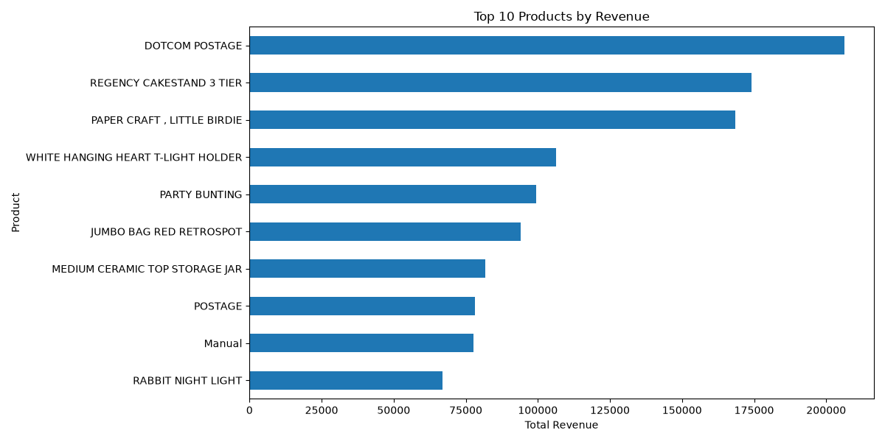
This chart presents the ten descriptions generating the highest total revenue. DOTCOM POSTAGE appears as the highest-revenue description. However, this should not be interpreted as an ordinary retail product because it represents a postage-related transaction. Other high-revenue descriptions include products such as the REGENCY CAKESTAND 3 TIER and PAPER CRAFT, LITTLE BIRDIE. This demonstrates why understanding the meaning of categorical values is important when interpreting business datasets.

5. Key EDA Insights
The exploratory analysis produced several important findings:
- Strong concentration of revenue: The United Kingdom generated the highest revenue, at approximately 9.00 million, indicating that it was the dominant market in the dataset.
- Large product variety: The cleaned dataset contains 4,026 unique product descriptions, showing a broad range of products and transaction types.
- Seasonal revenue pattern: November 2011 recorded the highest monthly revenue, suggesting increased sales activity during this period.
- Transaction-value variation: The revenue distribution is right-skewed, meaning that most transactions have relatively smaller revenue values while a smaller number of transactions contribute substantially higher amounts.
- Importance of categorical interpretation: DOTCOM POSTAGE appears as the highest-revenue description. Since this is a postage-related transaction rather than a conventional product, categorical values should be interpreted according to their business meaning rather than treated blindly as products.

6. Conclusion:
This project demonstrated the complete basic workflow of data acquisition, cleaning, preprocessing, and exploratory data analysis using Python. The Online Retail dataset was examined for missing values, duplicate records, and non-positive sales values before conducting the analysis.
After cleaning, the dataset contained 524,878 records. Revenue was calculated from quantity and unit price, allowing the analysis to identify important patterns across countries, products, and months. The visualizations made these patterns easier to interpret and communicate.
Overall, the analysis demonstrates that proper data cleaning and exploratory analysis are essential before making conclusions from business data.

7. Future Scope:
Further analysis could include customer segmentation, customer purchasing behavior, return and cancellation analysis, country-level customer analysis, and predictive modeling. Advanced techniques such as clustering and machine learning could also be applied to identify customer groups and predict future purchasing patterns. Additional analysis could distinguish ordinary products from postage, manual transactions, and other non-product descriptions to obtain more precise product-level insights.

8. Tools and Technologies:
Python: Programming language used for data analysis.
Pandas: Used for loading the Excel dataset, inspecting data, handling missing values, removing duplicates, filtering records, grouping data, and calculating revenue.
Matplotlib: Used to create the visualizations for the EDA, including bar charts and line charts.
Microsoft Excel: The original dataset was provided in Excel format and loaded into Python for analysis.

9. Dataset Source
Dataset: Online Retail Dataset
Source: UCI Machine Learning Repository
File: Online Retail.xlsx

