1. Introduction
Statistical analysis and hypothesis testing are important techniques in data science for identifying patterns, comparing groups, and drawing evidence-based conclusions from data. This task uses Python to analyze transaction revenue in the Online Retail dataset and investigate whether the average transaction revenue differs between the United Kingdom and Germany.
The analysis includes data cleaning, calculation of descriptive statistics, an independent two-sample Welch's t-test, and a 95% confidence interval for the difference in mean transaction revenue. Two visualizations are also used to compare the average revenue and examine the distribution of transaction values in the two countries.
The main objective is to apply statistical methods to a real-world dataset, interpret p-values and confidence intervals, and communicate the findings clearly. The results can help illustrate geographical differences in transaction revenue while recognizing that statistical significance does not necessarily imply causation.

2. Dataset Description
The dataset used for this task is the publicly available Online Retail dataset from the UCI Machine Learning Repository. It contains transaction records from an online retail business, including invoice numbers, product descriptions, quantities, invoice dates, unit prices, customer identification numbers, and countries.
The original dataset contains 541,909 records and 8 columns. The data was loaded into Python using Pandas and prepared for statistical analysis.
The preprocessing steps included removing duplicate records, removing rows with missing product descriptions, and retaining transactions with positive quantities and positive unit prices. A new Revenue column was calculated by multiplying Quantity by UnitPrice.
The analysis focused on transactions from two countries: the United Kingdom and Germany. After preprocessing, 479,985 transactions were available for the United Kingdom and 9,025 transactions for Germany.
These two groups were selected to compare their mean transaction revenue using statistical hypothesis testing.
Dataset source: UCI Machine Learning Repository — Online Retail dataset.

3. Hypothesis and Methodology
3.1 Research Question
Is the mean transaction revenue significantly different between the United Kingdom and Germany in the cleaned Online Retail dataset?
3.2 Hypotheses
- Null Hypothesis (H₀): The mean transaction revenue is equal in the United Kingdom and Germany.
- Alternative Hypothesis (H₁): The mean transaction revenue differs between the United Kingdom and Germany.
3.3 Significance Level
The significance level was set to 0.05 (5%). If the p-value is less than 0.05, the null hypothesis is rejected.
3.4 Data Preprocessing
The dataset was loaded using Pandas. Duplicate records and rows with missing product descriptions were removed. Transactions with non-positive quantities or unit prices were excluded from the positive-sales analysis. Transaction revenue was calculated as Quantity multiplied by UnitPrice
3.5 Statistical Test
An independent two-sample Welch's t-test was used to compare the mean transaction revenue of the two countries. This test was selected because it compares the means of two independent groups without requiring their population variances to be equal.
The test was performed using the ttest_ind() function from the SciPy library, with equal_var=False.
3.6 Confidence Interval
A 95% confidence interval was calculated for the difference in mean transaction revenue, defined as the United Kingdom mean minus the Germany mean. The interval was calculated using Welch's method.
The confidence interval helps estimate the plausible range for the difference between the two population means. An interval that excludes zero supports the conclusion that the mean revenues differ statistically.

4. Statistical Results
4.1 Descriptive Statistics
After data cleaning and preprocessing, the following results were obtained:
Metric | United Kingdom | Germany
Number of transactions | 479,985 | 9,025
Mean transaction revenue | 18.75 | 25.34
The average transaction revenue in Germany was higher than in the United Kingdom. The observed difference in mean revenue (UK minus Germany) was approximately -6.58.
4.2 Welch's Two-Sample t-Test
The independent two-sample Welch's t-test produced the following results:
- T-statistic: -11.9002
- P-value: 1.3316721985417746 × 10⁻³²
- Significance level: 0.05
Since the p-value is much smaller than 0.05, the null hypothesis was rejected. The result provides strong statistical evidence that the mean transaction revenues differ between the United Kingdom and Germany.
4.3 95% Confidence Interval
The 95% confidence interval for the mean difference (UK minus Germany) was approximately:
Lower bound: -7.67
Upper bound: -5.50
The interval does not include zero, supporting the conclusion that the two mean transaction revenues differ statistically. The estimated mean revenue in the United Kingdom was approximately 6.58 units lower than in Germany.
4.4 Interpretation
Both the hypothesis test and the confidence interval support the same conclusion. The observed difference is statistically significant at the 5% significance level. However, this analysis describes the cleaned transactions in the dataset and does not establish that the country itself causes the difference.

5. Visualizations and Interpretation
5.1 Visualization 1: Mean Transaction Revenue Comparison
Chart type: Bar chart
File name: mean_revenue_comparison.png
Purpose:
The bar chart compares the average transaction revenue in the United Kingdom and Germany. A bar chart was selected because it provides a simple and clear comparison between two categories.
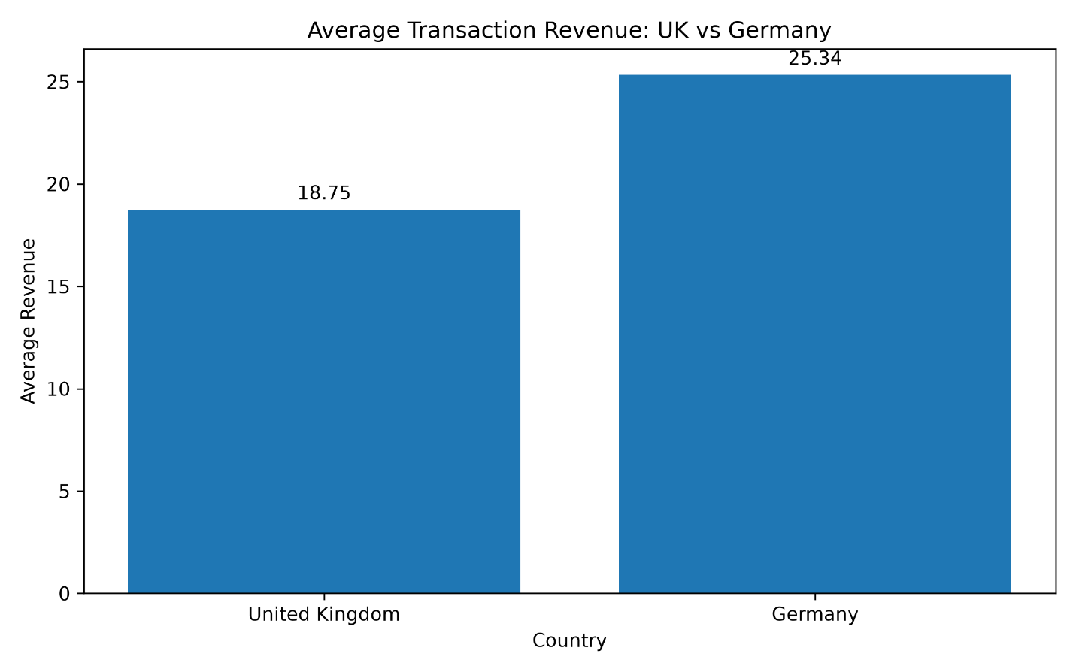
Interpretation:
The chart shows that the mean transaction revenue was approximately 18.75 in the United Kingdom and 25.34 in Germany. Therefore, Germany had the higher average transaction revenue in the cleaned dataset.
Business Implication:
The business can investigate differences in transaction values between these two markets. Further analysis of product mix, pricing, and purchase quantities may help explain the observed difference.
5.2 Visualization 2: Transaction Revenue Distribution by Country
Chart type: Box plot
File name: revenue_distribution_by_country.png
Purpose:
The box plot compares the distribution of transaction revenue in the United Kingdom and Germany. It helps show the median, spread, and variation in transaction values.
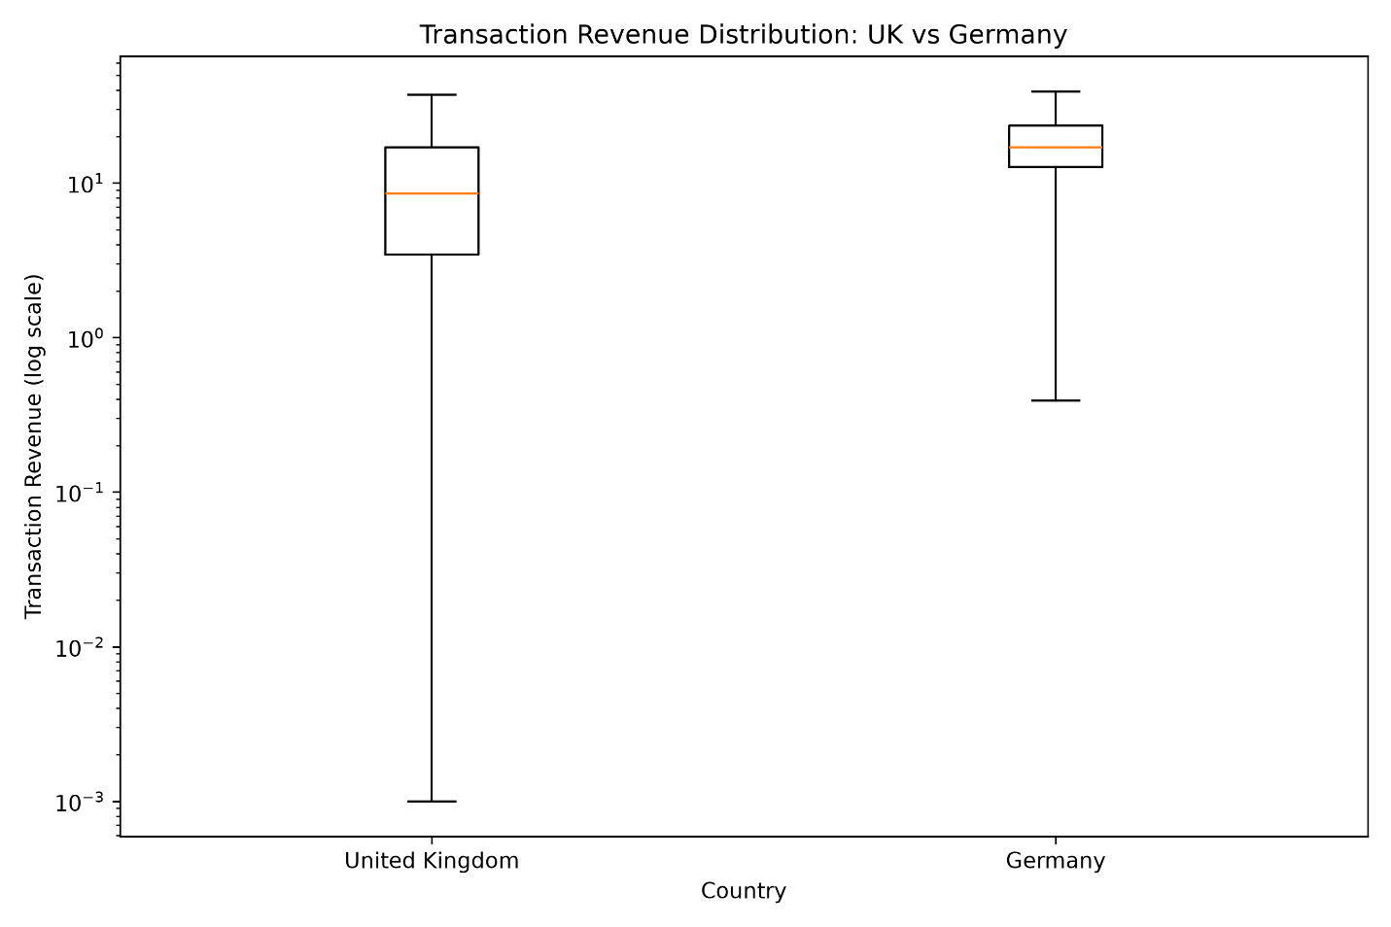
Interpretation:
The box plot provides information about how transaction revenues vary within each country. The logarithmic vertical axis helps make differences across a wide range of revenue values easier to view. Individual points beyond the whiskers are hidden to improve readability, but they remain included in the statistical analysis.
Business Implication:
Understanding the spread of transaction revenue can help the business investigate differences in typical transaction values and identify whether a small number of high-value transactions influence overall results. Further analysis may be required to understand the reasons for these differences.
Overall Interpretation:
The two visualizations complement the statistical test. The bar chart compares the means, while the box plot provides additional information about the distributions. Together, they help communicate the findings more clearly than a table of numbers alone.

6. Conclusion
This task applied statistical analysis and hypothesis testing to the Online Retail dataset to investigate whether mean transaction revenue differed between the United Kingdom and Germany.
After cleaning the data, an independent two-sample Welch's t-test was performed. The mean transaction revenue was approximately 18.75 for the United Kingdom and 25.34 for Germany. The test produced a t-statistic of -11.9002 and a p-value of approximately 1.33 × 10⁻³².
Since the p-value was below the 0.05 significance level, the null hypothesis was rejected. The 95% confidence interval for the mean difference (UK minus Germany) was approximately -7.67 to -5.50, which did not include zero.
These findings provide strong statistical evidence that the mean transaction revenues differed between the two countries in the cleaned dataset. The visualizations supported the interpretation by comparing the means and showing the distributions of transaction revenue.
Overall, this task improved my understanding of data preprocessing, hypothesis testing, p-values, confidence intervals, and the communication of statistical findings using Python.

7. Limitations and Future Scope
Limitations
- The analysis focused on only two countries.
- The number of transactions differed substantially between the United Kingdom and Germany.
- Transaction revenue can be highly skewed, and extreme values may influence mean-based comparisons.
- The analysis identifies a statistical difference but does not establish its cause.
- The results apply to the cleaned transactions analyzed and may not represent every retail market or time period.
Future Scope
Future work could compare additional countries, examine monthly or seasonal patterns, and investigate product-level differences. Additional statistical methods, such as non-parametric tests, could also be considered to examine whether the conclusions remain consistent when distributional assumptions are different.

8. Tools and Technologies
- Python: Programming language used for the analysis.
- Pandas: Used for data loading, cleaning, filtering, and descriptive analysis.
- SciPy: Used to perform Welch's two-sample t-test and calculate statistical values.
- NumPy: Used for numerical calculations, including the standard error.
- Matplotlib: Used to create the bar chart and box plot.
- Microsoft Word: Used to prepare the final report.

