Comprehensive Data Science Project Report
Online Retail Data Analysis, Visualization, Statistical Testing, and Machine Learning

Final Week Project Report
Virtual Data Science with Python Internship
Tools: Python, Pandas, Matplotlib, and Scikit-learn
Dataset: Online Retail

Executive Summary
This report consolidates the work completed across the internship using the Online Retail transaction dataset. The project followed an end-to-end data science workflow: data acquisition, cleaning, exploratory data analysis (EDA), visualization, statistical comparison, machine learning model development, and strategic recommendation. The original dataset contained 541,909 rows and 8 columns. Data preparation removed duplicate records, excluded records with missing essential fields, and filtered out transactions with non-positive quantities or unit prices for revenue-focused analysis.
Exploratory analysis examined revenue patterns across countries, products, and months. A statistical comparison of UK and Germany transaction revenue found average transaction revenue of 18.75 for the UK and 25.34 for Germany. Welch's t-test returned t = -11.9002 and p ≈ 1.33 × 10⁻³², indicating a statistically significant difference in the observed sample. This result should be interpreted alongside the substantial difference in sample sizes and the possibility that unusually large transactions affect means.
A Logistic Regression classifier was also developed to classify transactions as high-revenue or low/median-revenue. On a reproducible sample of 100,000 records, the model achieved 62.22% test accuracy, 68.79% precision, 43.68% recall, 53.43% F1-score, and 66.71% ROC-AUC. The results show a useful baseline but not a production-ready predictive system. Recommended next steps include validating insights over time, investigating revenue drivers, comparing additional models, and testing recommendations through controlled business experiments.

1. Introduction
Retail organizations generate transaction data that can help them understand sales performance, product demand, geography, and customer purchasing patterns. However, raw transaction data may contain duplicate rows, missing fields, and invalid quantities or prices. Data science techniques can transform this information into evidence that supports business decisions.
The project goal was to practice the complete data science process with a public Online Retail dataset and communicate findings in a clear, reproducible report. The work was organized into four connected stages: cleaning and EDA, visualization, statistical analysis, and a baseline machine learning classification model.

2. Project Objectives
- Prepare a transaction dataset for analysis by identifying duplicates, missing values, and invalid records.
- Explore sales patterns by month, country, and product using visualizations.
- Use a statistical test to compare transaction revenue between the United Kingdom and Germany.
- Build and evaluate a baseline binary classification model using a reproducible training and testing process.
- Translate the findings into cautious, practical recommendations for retail stakeholders.
- Document limitations and propose improvements for future analysis.

3. Dataset and Tools
The Online Retail dataset includes InvoiceNo, StockCode, Description, Quantity, InvoiceDate, UnitPrice, CustomerID, and Country. The original file contained 541,909 records and 8 columns. The dataset is transaction-level rather than a complete customer profile; therefore, conclusions about individual customer lifetime value or customer-level behaviour would require additional work.
Tool | Purpose
Python | Main programming language for the analysis.
Pandas | Reading, cleaning, transforming, and summarizing tabular data.
Matplotlib | Creating charts for trends, comparisons, and model evaluation.
Scikit-learn | Preprocessing, train/test split, Logistic Regression, and evaluation metrics.
openpyxl | Reading the Excel dataset through Pandas.

4. Methodology

4.1 Data cleaning and preparation
The original dataset was inspected for missing values and duplicate rows. Duplicate records were removed. Records without a product description, invoice date, or country were excluded from the revenue analysis, and transactions with quantity ≤ 0 or unit price ≤ 0 were filtered out. The invoice date was converted to a datetime type. Revenue was calculated as Quantity × UnitPrice. CustomerID missingness was noted as a limitation; it was not necessary for the transaction-level revenue calculations used here.
df = df.drop_duplicates()\ndf = df.dropna(subset=["Description", "InvoiceDate", "Country"])\ndf = df[(df["Quantity"] > 0) & (df["UnitPrice"] > 0)].copy()\ndf["Revenue"] = df["Quantity"] * df["UnitPrice"]
The cleaning process reduced the dataset to 535,187 rows after duplicate removal and removal of rows missing Description, before the additional positive quantity/price and date-validity filters. These intermediate counts describe the Week 1 cleaning workflow; the final row count can differ when all filters are applied.

4.2 Exploratory data analysis and visualization
EDA was used to inspect sales trends and compare categories. Visual analyses included monthly revenue trends, revenue by country, top product descriptions, the distribution of revenue, and the relationship between quantity and revenue. These views help identify seasonality, concentration in important markets or products, and skewed transaction values. Because retail revenue is often highly skewed, totals and averages should be interpreted with distributions and transaction counts in mind.
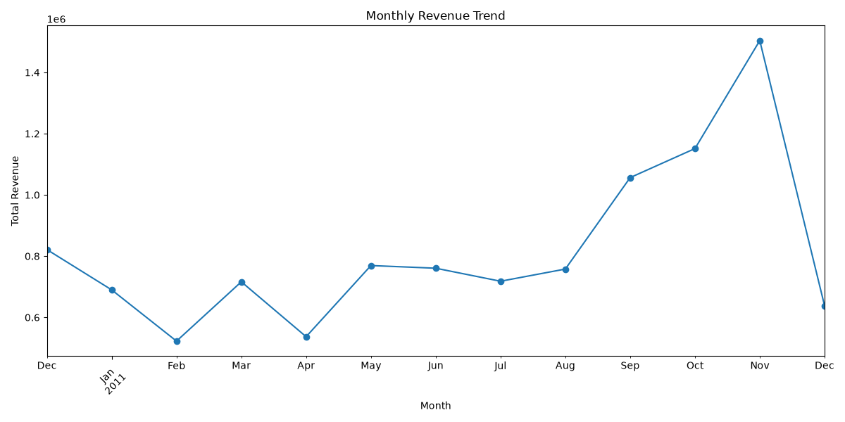
Figure 1. Monthly revenue can reveal seasonal peaks and quieter periods.
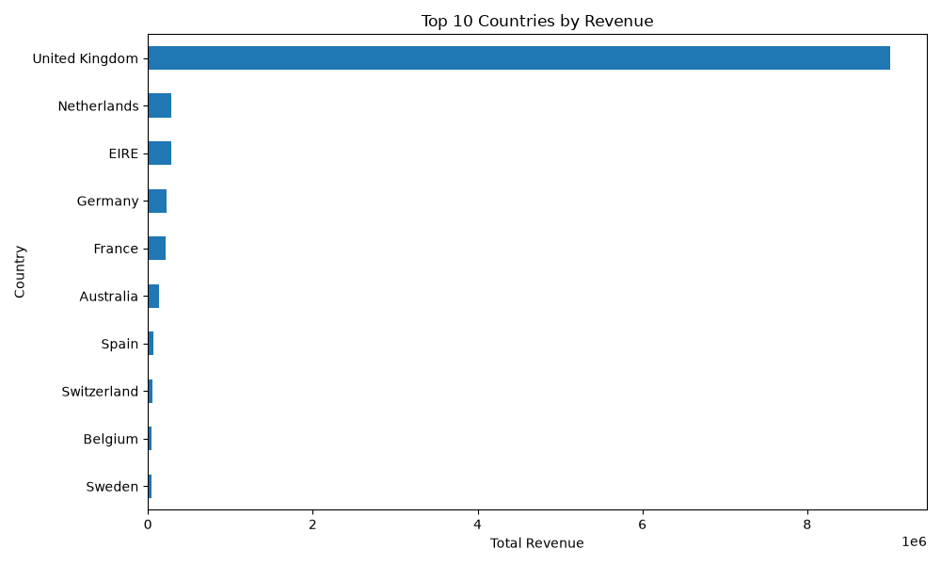
Figure 2. Country-level revenue highlights markets that contribute substantially to recorded sales.
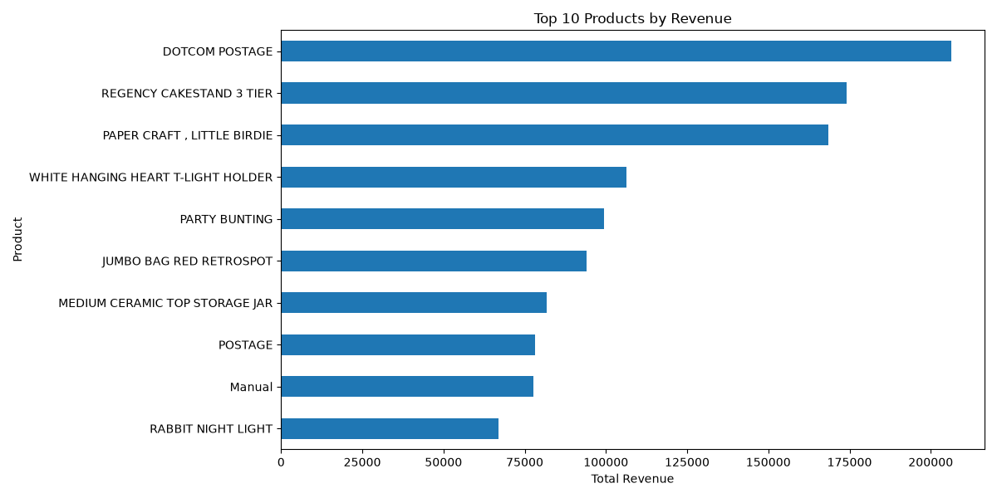
Figure 3. Product and distribution views help identify concentration and skew.

4.3 Statistical analysis: UK versus Germany
A Welch independent-samples t-test compared mean transaction revenue in the United Kingdom and Germany. Welch's test was chosen because it does not assume equal population variances. The reported UK sample contained 479,985 transactions and the Germany sample contained 9,025 transactions. Mean transaction revenue was 18.75 for the UK and 25.34 for Germany. The test statistic was -11.9002 with p ≈ 1.3317 × 10⁻³². At a significance level of 0.05, the null hypothesis of equal means was rejected for this comparison.
The estimated 95% confidence interval for the UK-minus-Germany mean difference was approximately [-7.67, -5.50]. This suggests that the mean transaction revenue in the sampled German transactions was higher than the UK mean. Statistical significance does not by itself establish a business cause or prove that every German transaction is larger. Differences in product mix, order size, currency handling, time period, and the much larger UK sample should be examined before making a market decision.
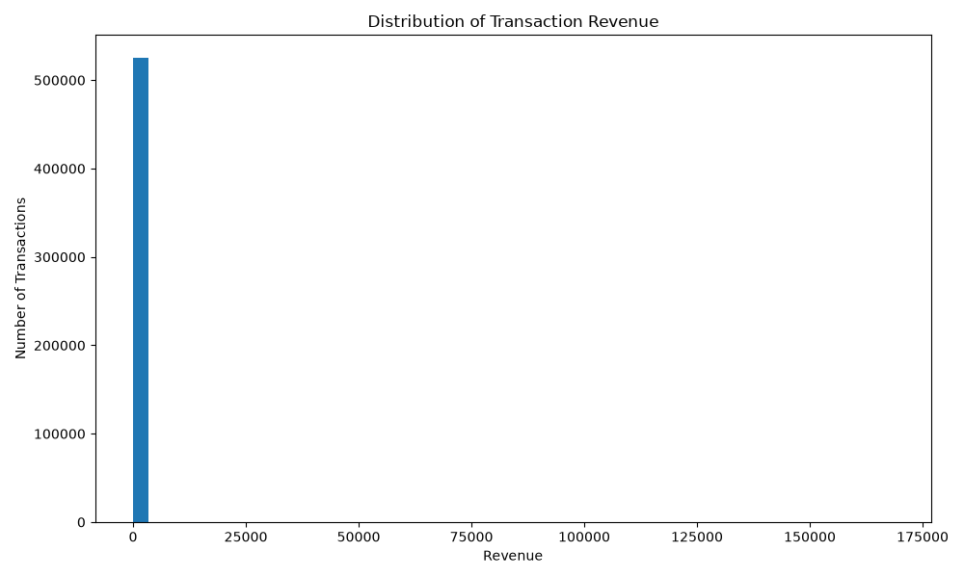
Figure 4. Pair a mean comparison with a distribution plot to show both average differences and variation.

4.4 Machine learning model development
A Logistic Regression model was built to classify whether a transaction's revenue was above the median revenue threshold. For this stage, a reproducible sample of 100,000 cleaned records was used. The threshold was 9.95. The binary target HighRevenue was 1 for transactions above the threshold and 0 otherwise. Input features were UnitPrice, Country, and Month. Numerical inputs were standardized with StandardScaler, while Country was one-hot encoded. The data was split into 80,000 training records and 20,000 testing records, using random_state=42 and stratification to preserve class proportions.
df["Revenue"] = df["Quantity"] * df["UnitPrice"]\ndf["Month"] = df["InvoiceDate"].dt.month\ndf["HighRevenue"] = (df["Revenue"] > df["Revenue"].median()).astype(int)\nX = df[["UnitPrice", "Country", "Month"]]\ny = df["HighRevenue"]\n# Split data, preprocess features, fit LogisticRegression, then evaluate on held-out data
The target definition is a modelling choice, not a universal business definition of a high-value transaction. UnitPrice is part of the revenue formula and can be a strong proxy for the target; therefore, the model should be treated as a learning baseline rather than a fully validated prediction tool. Quantity was not included as an input feature in this implementation.
Metric | Result
Training accuracy | 62.01%
Testing accuracy | 62.22%
Precision | 68.79%
Recall | 43.68%
F1-score | 53.43%
ROC-AUC | 66.71%
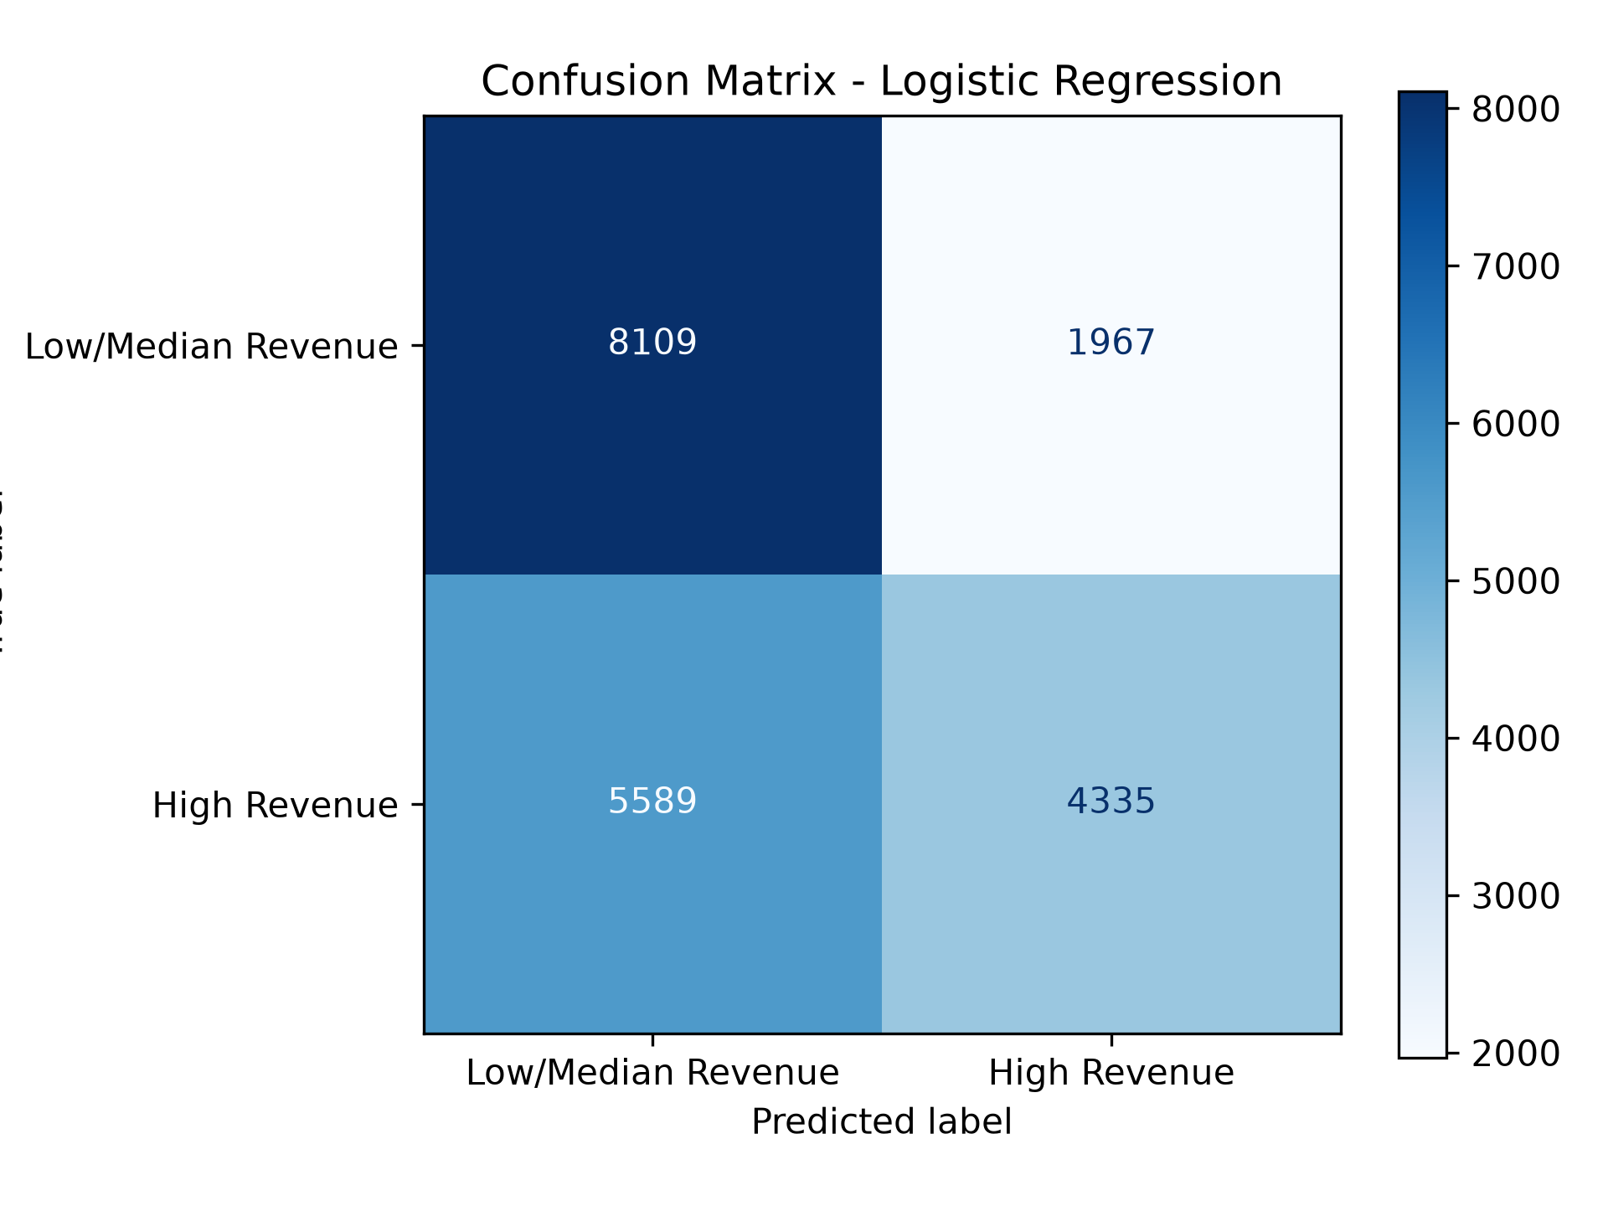
Figure 5. The confusion matrix shows correct classifications and false positives/false negatives.
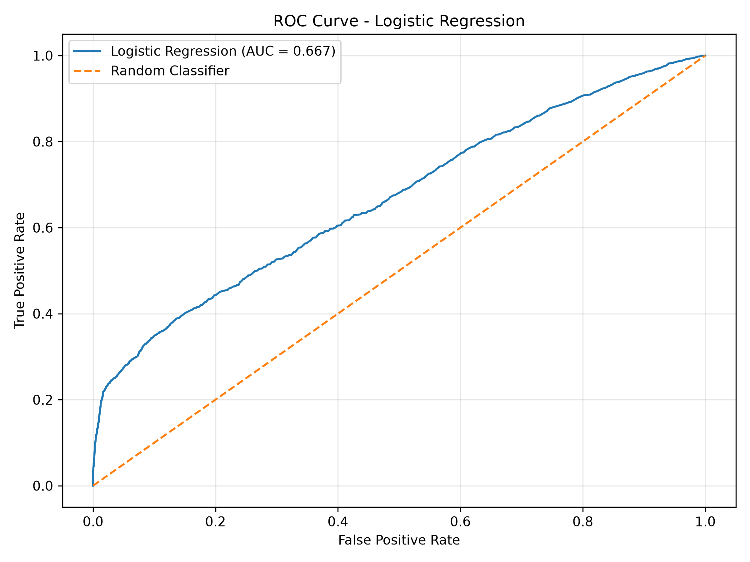
Figure 6. The ROC curve illustrates discrimination across classification thresholds; the measured ROC-AUC was 0.6671.

5. Key Findings
- Data cleaning is necessary before analysis: duplicate rows, missing essential fields, and non-positive quantities or prices can distort revenue summaries.
- Monthly, country, and product-level visualizations provide complementary views of retail performance; no single chart is sufficient to explain business performance.
- In the UK–Germany comparison, the observed mean transaction revenue was higher in Germany (25.34) than in the UK (18.75), with a statistically significant Welch test. This is an association in the analyzed data, not evidence of causation.
- The baseline Logistic Regression model achieved 62.22% test accuracy and 66.71% ROC-AUC, indicating modest predictive discrimination rather than high-confidence performance.
- The model's recall for the high-revenue class was 43.68%, meaning it missed many actual high-revenue transactions at the default decision threshold.

6. Strategic Recommendations

6.1 Use market-level analysis to guide further investigation
Investigate why mean transaction revenue differs between Germany and the UK by comparing product mix, quantity per transaction, seasonality, and order composition. Do not immediately shift budget or inventory based on mean revenue alone. Review both total revenue and transaction counts, then test any proposed market-specific change on a limited scale.

6.2 Improve inventory and campaign planning
Use monthly revenue and top-product patterns to prepare for periods of higher demand and to identify products that contribute strongly to sales. Before changing stock levels, validate patterns across multiple years or periods and account for returns, cancellations, availability, and profit margin if those fields become available.

6.3 Treat the classifier as a baseline, not an automated decision-maker
The current model's low recall means it should not be used alone to identify all high-revenue transactions. Compare Logistic Regression with tree-based models, tune the decision threshold according to the cost of missed high-revenue transactions versus false alarms, and evaluate precision–recall trade-offs. Use a time-based holdout test if the intended use is to predict future transactions.

6.4 Add business-relevant measures
Future analysis should incorporate profit margin, returns/cancellations, shipping costs, and reliable customer-level history where available and appropriate. Revenue alone does not equal profit. Recommendations should be judged by measurable outcomes such as gross margin, stock availability, campaign conversion, and forecast error.

6.5 Monitor data quality and model performance
Create a repeatable pipeline that records row counts, missingness, filtering decisions, and metric values each time the analysis runs. Monitor whether product mix, countries, prices, or purchasing patterns change over time, and retrain only after validation shows that the new model performs reliably.

7. Business Impact and Research Outcomes
The analysis demonstrates how transaction records can support evidence-based retail planning. Country and monthly summaries can help stakeholders ask better questions about market contribution and demand timing. Product-level analysis can help prioritize further investigation of popular items. The statistical comparison provides a quantitative method for evaluating differences between groups, while the classifier demonstrates how machine learning metrics can be used to assess a predictive approach.
Potential business impacts include improved planning, more focused market research, and better identification of where additional data collection or experiments are worthwhile. These impacts are potential outcomes, not measured savings or proven improvements: the project did not run a live intervention or measure business KPIs after implementing recommendations.

8. Limitations
- The dataset is historical and may not represent current retail behaviour or future demand.
- Missing CustomerID values limit customer-level analysis; transaction-level results should not be treated as complete customer insights.
- Revenue is not profit and does not account for costs, discounts, returns, or operational constraints.
- The UK and Germany samples differ greatly in size, and mean revenue may be affected by skewed or unusually large transactions.
- The machine learning task defines high revenue relative to the sample median, so results depend on that threshold and sample.
- UnitPrice is part of the revenue calculation and may make the target easier to infer; this limits how the model should be interpreted.
- A single train/test split is not enough to establish long-term reliability. No live deployment or business-impact experiment was performed.
- The model has moderate accuracy and low recall for the high-revenue class, so many actual high-revenue transactions are missed.

9. Future Improvements
- Validate trends across different time periods and use a time-based test set for future prediction.
- Use robust summaries such as medians, quantiles, and distribution plots alongside means and totals.
- Investigate the causes of country-level differences through product mix and order composition analysis.
- Compare Logistic Regression with Decision Tree, Random Forest, and other appropriate models using cross-validation.
- Tune hyperparameters and classification thresholds, and report precision–recall curves as well as ROC-AUC.
- Define a target that matches a real business question and ensure all input features would be available at prediction time.
- Add cost, margin, return, and cancellation information if available, and assess business value using measurable KPIs.
- Make the workflow reproducible with documented dependencies, clear file paths, and saved evaluation outputs.

10. Conclusion
The internship project integrated data acquisition, cleaning, exploratory visualization, statistical testing, machine learning, and business-oriented reporting. The Online Retail dataset provided an opportunity to practice preparing real-world data and interpreting results critically. The UK–Germany comparison found a statistically significant difference in observed mean transaction revenue, while the Logistic Regression classifier provided a baseline with 62.22% test accuracy and 66.71% ROC-AUC. Both findings require careful interpretation and further validation before they guide operational decisions. The most important outcome is a reproducible analytical workflow and a set of testable recommendations, rather than a claim that the current model is ready for production.

Appendix A. Reproducibility and Code Documentation
The Week 1–4 Python scripts and charts are maintained in the project GitHub repository. The core revenue calculation used in the analysis is shown below. The model workflow used a Scikit-learn Pipeline to apply preprocessing and fit Logistic Regression consistently.
df["Revenue"] = df["Quantity"] * df["UnitPrice"]\ndf["Month"] = pd.to_datetime(df["InvoiceDate"]).dt.month
Pipeline(steps=[("preprocessing", preprocessor),\n ("classifier", LogisticRegression(max_iter=1000))])
Repository: https://github.com/pranjalipatil636-svg/virtual-data-science-python-internship

Appendix B. Visualization Checklist Before Submission
- Insert the monthly revenue trend chart.
- Insert the revenue-by-country chart.
- Insert a top-products chart or revenue histogram.
- Insert the Week 3 country comparison bar chart and/or boxplot.
- Insert the Week 4 confusion matrix.
- Insert the Week 4 ROC curve.
- Confirm every image has its figure number and descriptive caption.
- Save the final document as a .docx file and open it once to confirm formatting.

