E-Commerce Sales & Business Intelligence Dashboard
Project Report

1. Executive Summary
This project analyzes 500 orders and 336 customers from the supplied 2018 e-commerce dataset. Total sales are ₹437,771, total profit is ₹36,963, and the calculated profit margin is 8.44%. The dashboard converts these transactions into interactive KPIs, trends, product analysis, customer/geographic analysis, payment analysis, and evidence-based business actions.

2. Business Problem
Management needs a practical view of sales and profitability: what is happening, how performance changes over time, which products/categories and locations contribute, how customers and payment methods behave, and where management should investigate risks or opportunities.

3. Objectives
- Calculate core sales and profitability KPIs.
- Analyze monthly sales and profit trends.
- Compare categories and sub-categories.
- Analyze customers and geographic performance.
- Understand payment-mode distribution.
- Identify evidence-based profitability risks and opportunities.
- Translate findings into practical business actions without unsupported causal claims.

4. Data and Data Preparation
Orders.csv contains 500 rows and Details.csv contains 1500 rows. The two files are joined on Order ID. Order dates are parsed as dates and Amount, Profit, and Quantity are converted to numeric values. The supplied files contain no missing values, no duplicate Order IDs in Orders.csv, and no unmatched detail Order IDs.
Observed date range: 01 Jan 2018 to 31 Dec 2018.

5. KPI Results
KPI | Value
Total Sales | ₹437,771
Total Profit | ₹36,963
Total Orders | 500
Total Quantity | 5,615
Total Customers | 336
Average Order Value | ₹875.54
Profit Margin | 8.44%

6. Analysis and Findings
Electronics generated the highest category sales at ₹166,267, representing 38.0% of total sales. Clothing generated the highest category profit at ₹13,325.
Printers generated the highest sub-category profit at ₹8,606. The lowest-profit sub-category was Furnishings, with ₹-806 profit.
Maharashtra generated the highest state sales at ₹102,498. Rajasthan had the lowest total state profit at ₹-323.
COD was the largest payment mode by order count, with 347 orders. The monthly analysis shows December with negative profit of ₹-1,604, making it a useful period for deeper category and geography investigation.
Website Screenshots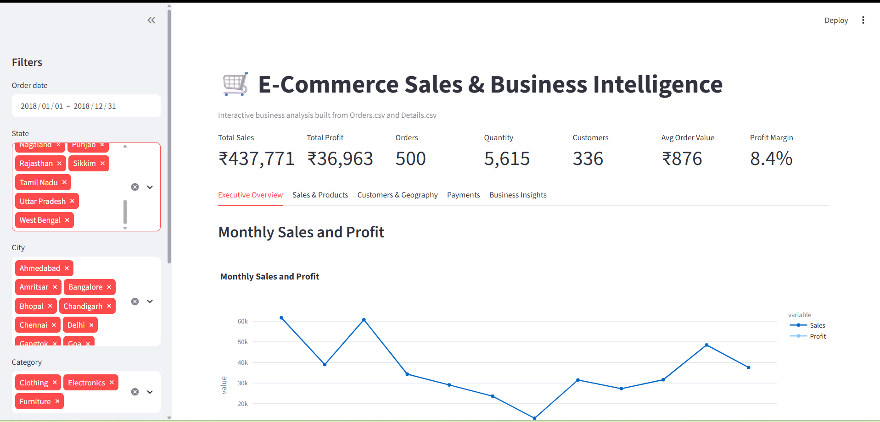
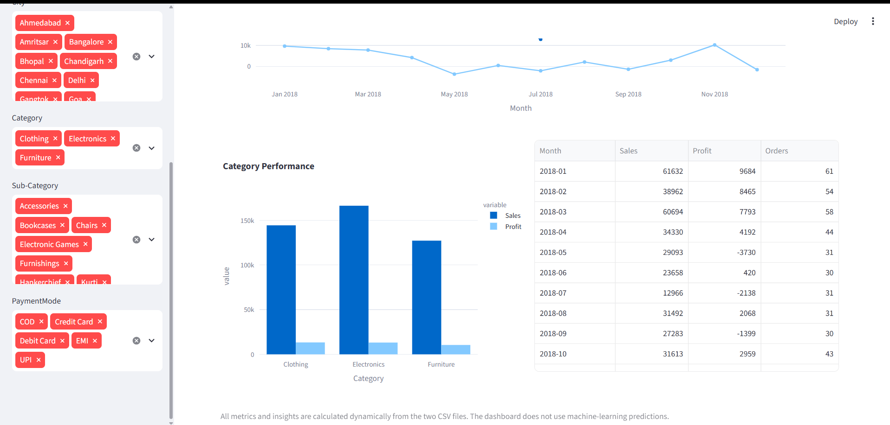

7. Risks, Opportunities and Actions

Profitability risk
Finding: Furnishings records the lowest sub-category profit (₹-806).
Business Impact: Continued weak contribution can reduce overall profitability.
Recommended Action: Review pricing, discounts, costs and product mix before increasing promotion.

Geographic risk
Finding: Rajasthan records negative total profit (₹-323).
Business Impact: Sales in a region do not automatically translate into profitable growth.
Recommended Action: Break down the state by sub-category and order economics before scaling regional campaigns.

Monthly risk
Finding: December has negative total profit in the supplied data.
Business Impact: A loss-making month can materially reduce annual profit.
Recommended Action: Compare December's product and state mix with stronger months to identify the measurable differences.

Category opportunity
Finding: Electronics has the highest sales contribution, while Clothing has the highest category profit.
Business Impact: Sales leadership and profit leadership are not identical.
Recommended Action: Manage category plans using both revenue and profit, rather than sales alone.

8. Dashboard Design
- Executive Overview — KPI cards, monthly trend, category performance.
- Sales & Product Analysis — category/sub-category sales and profit.
- Customers & Geography — customer contribution and state performance.
- Payments — payment-mode sales and order mix.
- Business Insights — dynamically generated findings, impacts and actions.
- Interactive filters — date, state, city, category, sub-category and payment mode.

9. Technology
Python, Pandas, Plotly and Streamlit. The dashboard is dynamically calculated from the supplied CSV files and does not require machine-learning prediction.

10. Limitations
The supplied dataset is limited to 2018 and does not contain discount, cost breakdown, marketing spend, returns, delivery time, or customer demographic fields. Therefore, the report describes observed patterns but does not claim causal explanations.

11. Dataset Source
Madhav E-Commerce Sales Dataset (public source):
https://www.kaggle.com/datasets/amitkumar209/madhav-e-commerce-sales-dataset

