
Sukkur Institute of Business Administration University
Department of Computer Science
ESE-201: Digital Logic Design Lab

Lab # 13: JK-Flip Flop

Note: Submit this lab hand-out in the next lab with attached solved activities and exercises

Submission Profile
Name: Pranjal Mandhan Submission date (16/12/2023):

________________________________________________________________________________
Instructor Signature

Lab Learning Objectives:

Upon successful completion of this experiment, the student will be able:
- To implement and verify JK flip flop operations using 74LS76 IC & Module KL-33001

Lab Hardware and Software Required:
- 74LS76 IC
- Module KL-33001
- Breadboard
- Connecting Wires

Background Theory:

JK-FLIP FLOP:
The JK-flip flop is very versatile and is perhaps the most widely used type of flip flops. The J and K designation for the inputs have no known significance except that they are adjacent letters in the alphabet. The functioning of the JK flip flop is identical to that of RS flip flops in the SET, RESET and no change condition of operation. The difference is that the JK flip flop has no invalid state as does the RS flip flop. Therefore the JK flip flop is a very versatile device that finds application in digital system. Fig 13.1 (a & b) shows a logic symbol and logic diagram for the JK flip flop.
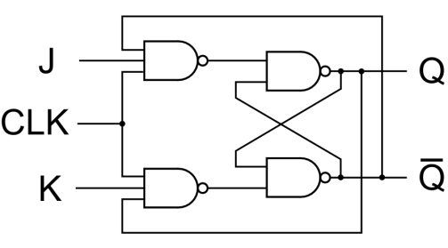
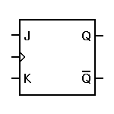

Fig 13.1: (a) logic symbol of JK-flipflop (b) logic diagram of JK-flip flop
The data at the J and K inputs of the JK flip flop controls its output. Notice that it differs from the RS flip flop in the output of the flip flop is coupled back to input. J and K inputs control the state of the flip flop in the same way as the S and R inputs do for the clocked RS flip flop except for one major difference; the J=K=1 condition does not result in ambiguous output. For this 1, 1 condition, the flip flop always go to its opposite state upon the arrival of the clock signal. This is called the toggle mode of states (toggle) for each of the clock pulse.
74LS76 JK Flip Flop IC:
The 74LS76 is a popular JK flip flop IC; having dual flip flops (two flip flops in each IC package). Its pin configuration is given in Fig 13.2. It has only asynchronous inputs (RD and SD) as well as synchronous inputs (CP, J, K) and is negative-edge triggered flip flop. The asynchronous inputs RD and SD are active low, that is low on SD (set) will set the flip flop (Q=1) and low on RD will reset the flip flop (Q=0). The asynchronous input will cause the flip flop to respond immediately without regard to the clock trigger input CP. For synchronous operation using J,K, and CP, the asynchronous inputs must be disabled by putting a high level on both.
Fig 13.2 pin configuration of 74LS76 JK flip-flop IC
Lab Examples:
Implementation of JK flip flop using 74LS76 IC:
- Carry out the circuits of Fig 13.2 by using IC 74LS76
- Make the circuit on breadboard present on the KL-33001 training kit
- Apply power supply to it
- Connect the inputs J & K of circuit to the switches
- Connect the terminal of clock to the input CK of the flip flop
- Connect the outputs Q and $\overline{Q}$ of both circuits to the LEDs
- Analyze the circuit’s behaviour by carrying out different combinations with the switches and fill the observation tables

Inputs |  |  | Outputs
CK | K | J | Q | $$\overline{Q}$$
0 | X | X | 0 | 0
1 | 0 | 0 | previous
1 | 0 | 1 | 1 | 0
1 | 1 | 0 | 0 | 1
1 | 1 | 1 | 1 | 1
Table 13.1: Observation table of JK flip flop
Lab Activities:
How can we convert J K flip into D flip flop?
A JK flip-flop can be converted to a D flip-flop by using the following connections:
- Connect the J input of the JK flip-flop to the D input of the D flip-flop.
- Connect the CLK (clock) input of the JK flip-flop to the CLK input of the D flip-flop.

Lab Exercises:
Implement JK flip flop in Multisim, attach circuit diagram and observed waveforms.

