
Sukkur Institute of Business Administration University
Department of Computer Science
ESE-201: Digital Logic Design Lab

Lab # 02: NAND & NOR Gates

Note: Submit this lab hand-out in the next lab with attached solved activities and exercises

Submission Profile
Name: Pranjal Mandhan Submission date (16/12/2023):

________________________________________________________________________________
Instructor Signature
Lab Learning Objectives:

Upon successful completion of this experiment, the student will be able:
- To implement and verify NAND gate operations using 74LS00 IC & Module KL-33001
- To implement and verify NOR gate operations using 74LS02 IC & Module KL-33001

Lab Hardware and Software Required:
- 74LS00 IC (NAND gate )
- 74LS02 IC(NOR gate)
- Module KL-33001
- Breadboard
- Connecting Wires

Background Theory:

NAND gate:
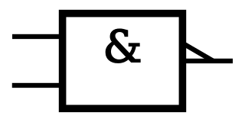
The logic symbols for NAND gate is shown in Fig 2.1 (a & b). It consists of AND symbol with inverter symbol added to output. The operation of NAND gate is same as the AND gate except that its output is inverted. NAND gates can also have two or more than two inputs and a single output. NAND gate produces a LOW output only when all the inputs are HIGH. When any of the inputs is LOW, the output will be HIGH.
X=A.B
A
X=A.B
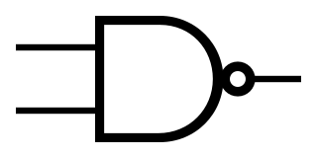
A

B
B

Fig 2.1: (a) Distinctive symbol of NAND gate (b) Standard NAND gate symbol
74LS00 2-Input NAND gate IC:
In order to implement the NAND gate operation using IC, the TTL 74LS00 2-input NAND gate IC can be used. This IC has 14 pin Dual Inline Package (DIP) configuration as shown in Fig 2.2. The power supply connections are made to pin 7 and 14. Pin 1 is identified by a small indented circle next to it or by a notch cut out between pin 1 and 14.
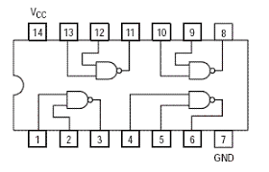

Fig 2.2: 74LS00 2-input NAND gate IC pin configuration
NOR gate:
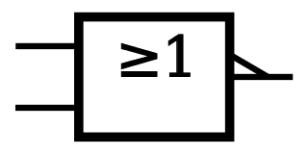
The operation of the NOR gate is same as that of the OR gate except that its output is inverted. You can think of a NOR gate as an OR gate with an inverter at its output. The logic symbol for NOR gate is shown in Fig 2.3 (a & b). NOR gates can also have two or more than two inputs and a single output. The NOR gate produces a low output, When any one of input is high and produces a high output, when all inputs are low.
X=A+B
X=A+B

A
A
B
B

Fig 2.3: (a) Distinctive symbol of 2-input NOR gate (b) Standard 2-input NOR gate symbol
74LS02 2-input NOR gate IC:
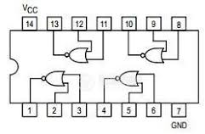
In order to implement the NOR gate operation using IC, the TTL 74LS02 2-input NOR gate IC can be used. This IC has 14 pin Dual Inline Package (DIP) configuration as shown in Fig 2.4. The power supply connections are made to pin 7 and 14. Pin 1 is identified by a small indented circle next to it or by a notch cut out between pin 1 and 14.

Fig 2.4: 74LS02 2-input NOR gate IC pin configuration

Lab Examples:
Implementation of NAND gate
- In order to implement the NAND gate operations with the help of ICs, take the 74LS00
- Pin Assignments for the ICs have been shown in Fig 2.2
- Take 74LS00 IC and insert it in the breadboard present on the KL-33001 training kit
- Connect its pin 14 to +5V and pin 7 to ground
- Use first gate (any one can be taken) from IC by connecting input pin 1 & input pin 2 to SW0 & SW1 respectively, and output pin3to LED and observe the AND gate operation
- Fill the following observation table

Input |  | Output
A | B | LED (on / off) | Level ( 1 / 0 )
0 | 0 | On | 1
0 | 1 | On | 1
1 | 0 | On | 1
1 | 1 | Off | 0
Table 2.1: Observation table of NAND gate

Lab Activities:
Implementation of NOR gate
- In order to implement the AND operations with the help of IC, take the 74LS02 IC
- Pin Assignments for the ICs have been shown in Fig 2.4
- Take 74LS02 IC and insert it in the breadboard present on the KL-33001 training kit
- Connect its pin 14 to +5V and pin 7 to ground
- Use first gate (any one can be taken) from IC by connecting input pin 1 & input pin 2 to SW0 & SW1 respectively, and output pin3to LED and observe the AND gate operation
- Fill the following observation table
Input |  | Output
A | B | LED (on / off) | Level ( 1 / 0 )
0 | 0 | On | 1
0 | 1 | Off | 0
1 | 0 | Off | 0
1 | 1 | Off | 0
Table 2.2: Observation Table of NOR gate

Lab Exercises:
NAND-NOR Universal Gates
NAND and NOR gates are known as Universal Gates as they can be used to construct an AND gate, an OR gate, an INVERTER, or any combination of these functions. The NAND Universal Gate can also be used to implement a NOR gate. Similarly, a NO

R gate can be used to implement a NAND gate.
- Implement NAND gate using NOR gates
- D
- raw the schematic Diagram
- Write the Boolean Expression
- Fill the Observation Table
Schematic Diagram:

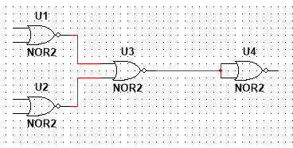
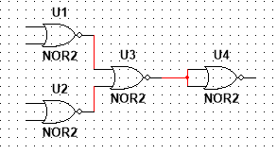

Boolean Expression:

Input |  | Output
A | B | LED (on / off) | Level ( 1 / 0 )
0 | 0 | On | 1
0 | 1 | On | 1
1 | 0 | On | 1
1 | 1 | Off | 0
Fig 2.3: Observation table for 2-input NAND gate using NOR gates

- Implement NOR gate using NAND gates
- Draw the schematic Diagram
- Write the Boolean Expression
- Fill the Observation Table
Schematic Diagram:

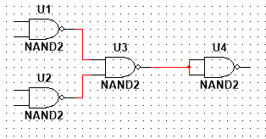
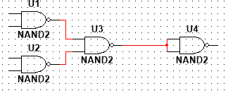

Boolean Expression:

Input |  | Output
A | B | LED (on / off) | Level ( 1 / 0 )
0 | 0 | On | 1
0 | 1 | Off | 0
1 | 0 | Off | 0
1 | 1 | Off | 0
Table 2.4: Observation table for 2-input NOR gate using NAND gates

