
Sukkur Institute of Business Administration University
Department of Computer Science
ESE-201: Digital Logic Design Lab

Lab # 04: Half Adder

Note: Submit this lab hand-out in the next lab with attached solved activities and exercises

Submission Profile
Name: Pranjal Mandhan Submission date (16/12/2023):

________________________________________________________________________________
Instructor Signature

Lab Learning Objectives:

Upon successful completion of this experiment, the student will be able:
- To implement and verify Half adder operations using 74LS83 IC & Module KL-33001
- To implement and verify Full adder operations using 74LS83 IC & Module KL-33001

Lab Hardware and Software Required:
- 74LS83 IC (4-bit Adder)
- Module KL-33001
- Breadboard
- Connecting Wires

Background Theory:

Half Adder:
Many logic circuits must be supplied with devices which can carry out the sum between two numbers, for this purpose the adder circuit is used. The basic rules for binary addition are:
Binary Addition:
0 + 0 = 0
0 + 1 = 1
1 + 0 = 1
1 + 1 = 0 and carry 1

These operations are performed by a logic circuit called a half adder. A half adder is a binary adder which adds on two bits, it accepts two binary digits on its inputs and produces two binary digits on its output, a sum bit and a carry bit. From the logical operation of the half adder as expressed by basic binary addition rules, we observe that the sum output is a1 only if the input bits are not equal. The sum can therefore be expressed as the exclusive-OR of the input variables. Notice that the carry output is 1 only when input bits are 1, therefore carry can be expressed as the AND of the input variables. A half adder is represented by the logic symbol and logic diagram as shown in Fig 4.1 (a & b).
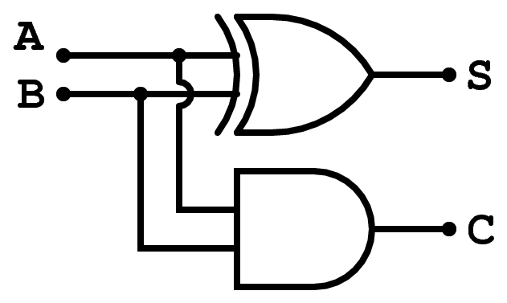
∑ =A⊕B=A$\overline{B}$+$\overline{A}$B
C=A.B
Fig 4.1: (a) Half Adder logic symbol (b) Half Adder logic diagram

FULL ADDER:
The second basic category of adder is the full adder. The full adder accepts three inputs including an input carry and generates a sum output and an output carry. The basic difference between a full adder and half adder is that the full adder accepts an input carry. The full adder must add the two input bits and the input carry. From the half adder we know the sum of the bits A and B is the X-OR of those two variables A B. For the input carry (Cin) to be added to the input bits., it must be exclusive ORed of those variables AB , yielding the equation for the sum output of the full adder as Σ = (A B) Cin. This means that to implement the full adder sum functions, the X-OR gates can be used. The output carry is a 1 when both inputs to the second X-OR gate are 1. The equation for the carry output can be developed as Cout=AB+(A B) Cin. The logic symbol and logic diagram for a full adder are given in Fig 4.2(a & b).
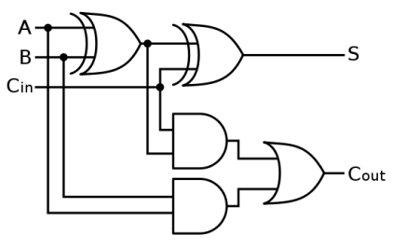
Fig 4.2: (a) Full Adder logic symbol (b) Full Adder logic diagram
74LS83 4-bit ADDER IC:
4-bit adder IC present on the module is an integrate of TTL family. Fig 4.3 shows a pin diagram of TTL 74LS83 adder IC. This IC contains four full adders inside; carry out of each adder is connected to carry in of next full adder. The C0 is basically a carry input for 4-bit full adder and C4 is a carry out from 4-bit full adder. A4, A3, A2, A1 and B4, B3, B2, B1 are the inputs and S4, S3, S2, S1 are output of a 4-bit adder. This IC can be used as Half Adder, 2-bit, 3-bit and 4-bit full adder. It can be connected in cascade to other similar circuits, to form adders with more than 4-bits.
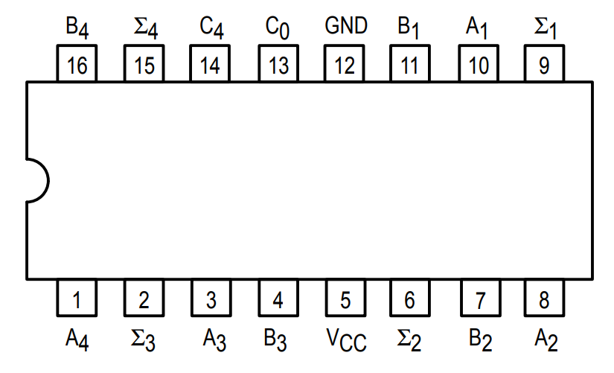
Fig 4.3: 74LS83 4-bit ADDER IC pin configuration
Lab Examples:
Implementation of Half Adder:
- Carry out the pin configuration of 74LS83 IC
- Take 74LS83 IC and insert it in the breadboard present on the KL-33001 training kit
- Apply power supply to it
- Connect inputs A1 and B1 to the data switches SW0 and SW1 respectively
- Connect the output sum (Σ) and carry out (C0) to the LEDs
- Analyse the circuit behaviour by carrying out different combinations with the data switches and fill the observation table for half adder

Input |  | Output (Sum ∑) |  | Output (Carry Cout)
A | B | LED (on / off) | Level ( 1 / 0 ) | LED (on / off) | Level ( 1 / 0 )
0 | 0 | OFF | 0 | OFF | 0
0 | 1 | ON | 1 | OFF | 0
1 | 0 | ON | 1 | OFF | 0
1 | 1 | OF | 0 | ON | 1
Table 4.1: Observation table of Half Adder
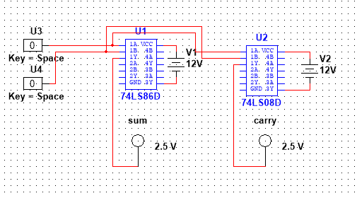
Lab Activities:

