
Sukkur Institute of Business Administration University
Department of Computer Science
ESE-201: Digital Logic Design Lab

Lab # 01: NOT, AND, OR Gate

Note: Submit this lab hand-out in the next lab with attached solved activities and exercises

Submission Profile
Name: Pranjal Mandhan Submission date (16/12/2023)

________________________________________________________________________________
Instructor Signature
Lab Learning Objectives:

Upon successful completion of this experiment, the student will be able:
- To implement and verify NOT gate operations using 74LS04 IC & Module KL-33001
- To implement and verify AND gate operations using 74LS08 IC & Module KL-33001
- To implement and verify OR gate operations using 74LS32 IC & Module KL-33001

Lab Hardware and Software Required:
- 74LS04 IC (Inverter )
- 74LS08 IC(AND gate)
- 74LS32 IC(OR gate)
- Module KL-33001
- Breadboard
- Connecting Wires

Background Theory:

NOT gate:
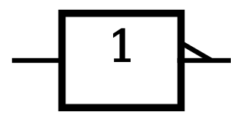
The NOT gate is an electronic circuit that produces an inverted version of input logic at its output. It is also known as inverter. If the input variable is A, the inverted output is known as NOT A. alternatively if the input is logic low (0), the output will be logic high (1) and if the input is logic high (1), the output will be logic low (0). NOT gate has only one input and one output, as shown in Fig 1.1 (a & b):
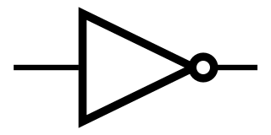
X=Ā
X=Ā
A
A

Fig 1.1 (a) Distinctive symbol of NOT gate (b) Standard NOT gate symbol
The Boolean equation for an inverter is written X=Ā (which is read as “X equals NOT A”). The bar over the A is an inverter bar, used to represent the NOT operation.

74LS04 Inverted IC:
In order to implement the NOT gate operation using IC, the TTL 74LS04 IC can be used. This IC contains six inverters. It has 14pin Dual Inline Package (DIP) configuration as shown in Fig 1.2. The power supply connections are made to pin 7 and 14. This supply the operating voltage for all six NOT gates on the IC. Pin 1 is identified by a small indented circle next to it or by a notch cut out between pin 1and 14.
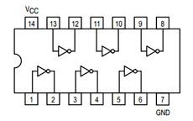

Fig 1.2: 74LS04 Inverter IC pin configuration
AND gate:
The AND gate is an electronic circuit that gives a high output (1) if all its inputs are high (1). When any one of its input is low (0), the output is low (0). The AND gates are composed of two or more inputs and a single output, as indicated by logic symbols in Fig 1.3 (a & b):
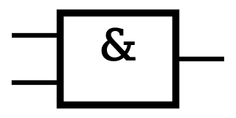
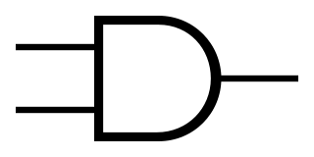
A
X=A.B
X=A.B
A

B
B
v
Fig 1.3: (a) Distinctive symbol of 2-input AND gate; (b) Standard 2-input AND gate symbol
There is no limit to the number of inputs that may be applied to an AND functions. However, for practical reasons, commercial AND gates are not most commonly manufactured with 2, 3 or 4 inputs. The Boolean expression for the AND operation is X=A.B (which is read as “X equals to A AND B”). The dot (.) sign is used to show the AND expression, however this sign is usually omitted. The key thing to remember is that the AND operation will produce a result of 1 only when all inputs (variables) are 1, just like ordinary multiplication.

74LS08 2-input AND gate IC:
In order to implement the AND operation using IC, the TTL 74LS08 2-input AND gate IC can be used. This IC contains four AND gates. It has 14 pin DIP configuration as shown in Fig 1.4:
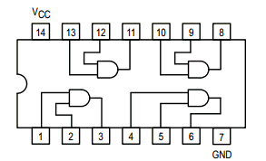
Fig 1.4: 74LS08 2-input AND gate IC pin configuration
OR Gate:
The OR gate produces output high when any one of inputs is high. The output is low when all of the inputs are low. The OR gate also has two or more inputs and a single output. The symbol for a two input OR gate is shown in Fig 1.5 (a & b):
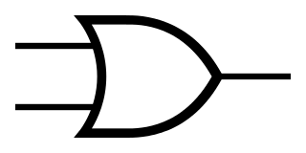
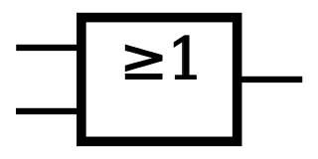
X=A+B
A
X=A+B
B
A
B

Fig 1.5: (a) (a) Distinctive symbol of 2-input OR gate; (b) Standard 2-input OR gate symbol
The Boolean expression for the OR operation is written as X=A+B (which is read as “X equals A OR B”). Notices the use of (+) symbol to represent the OR function.
74LS32 2-Input OR Gate IC:
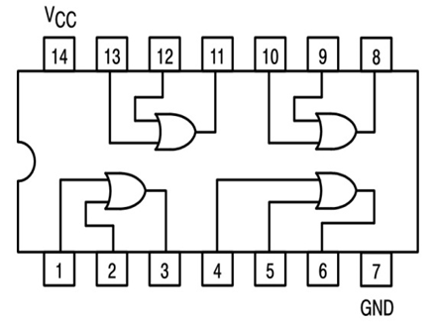
In order to implement the OR operation using IC, the TTL 74LS32 2-input OR gate IC can be used. It has four OR gates with in the package. This IC has 14 pin DIP configuration as shown in Fig 1.6

Fig 1.6: 74LS32 2-input OR gate IC pin configuration

Lab Examples:
Implementation of NOT gate
- In order to implement the NOT operations with the help of ICs, take the 74LS04
- Pin Assignments for the ICs have been shown in fig 1.2
- Take 74LS04 IC and insert it in the breadboard present on the KL-33001 training kit
- Connect its pin 14 to +5V and pin 7 to ground
- Use first gate (any one can be taken) from IC by connecting input pin 1 to switch and output pin2 to LED and observe the NOT gate operation
- Fill the following observation table

Input | Output
A | LED (on / off) | Level ( 1 / 0 )
0 | on | 1
1 | off | 0
Table 1.1: Observation table of NOT gate

Lab Activities:
1. Implementation of AND gate
- In order to implement the AND operations with the help of IC, take the 74LS08 IC
- Pin Assignments for the ICs have been shown in fig 1.4
- Take 74LS08 IC and insert it in the breadboard present on the KL-33001 training kit
- Connect its pin 14 to +5V and pin 7 to ground
- Use first gate (any one can be taken) from IC by connecting input pin 1 & input pin 2 to SW0 & SW1 respectively, and output pin3to LED and observe the AND gate operation
- Fill the following observation table

Input |  | Output
A | B | LED (on / off) | Level ( 1 / 0 )
0 | 0 | Off | 0
0 | 1 | off | 0
1 | 0 | off | 0
1 | 1 | on | 1
Table 1.2: Observation table of AND gate

2. Implementation of OR gate
- In order to implement the AND operations with the help of IC, take the 74LS32 IC
- Pin Assignments for the ICs have been shown in fig 1.6
- Take 74LS08 IC and insert it in the breadboard present on the KL-33001training kit
- Connect its pin 14 to +5V and pin 7 to ground
- Use first gate (any one can be taken) from IC by connecting input pin 1 & input pin 2 to SW0 & SW1 respectively, and output pin3to LED and observe the OR gate operation
- Fill the following observation table

Input |  | Output
A | B | LED (on / off) | Level ( 1 / 0 )
0 | 0 | Off | 0
0 | 1 | On | 1
1 | 0 | on | 1
1 | 1 | on | 1
Table 1.3: Observation table of AND gate

Lab Exercises:
- Design the circuit using 4 input AND Gate using one IC
- Draw the schematic Diagram
- Fill the Observation Table
Schematic Diagram:

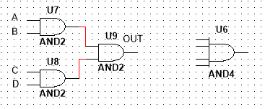

Input |  |  |  | Output
A | B | C | D | LED (on / off) | Level ( 1 / 0 )
0 | 0 | 0 | 0 | Off | 0
0 | 0 | 0 | 1 | Off | 0
0 | 0 | 1 | 0 | Off | 0
0 | 0 | 1 | 1 | Off | 0
0 | 1 | 0 | 0 | Off | 0
0 | 1 | 0 | 1 | Off | 0
0 | 1 | 1 | 0 | Off | 0
0 | 1 | 1 | 1 | Off | 0
0 | 0 | 0 | 0 | Off | 0
1 | 0 | 0 | 1 | Off | 0
1 | 0 | 1 | 0 | Off | 0
1 | 0 | 1 | 1 | Off | 0
1 | 1 | 0 | 0 | Off | 0
1 | 1 | 0 | 1 | Off | 0
1 | 1 | 1 | 0 | Off | 0
1 | 1 | 1 | 1 | on | 1

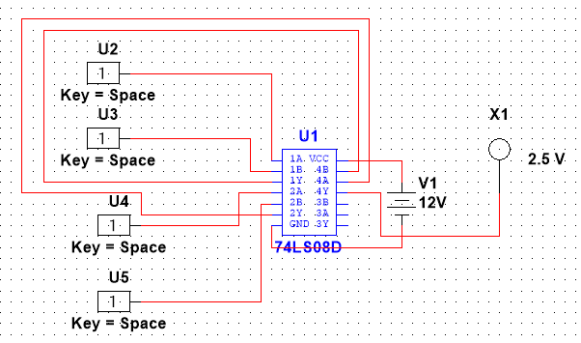
Table 1.4: Observation table of 4-Input AND gate

- Design the circuit using 4 input OR Gate using one IC
- Draw the schematic Diagram
- Fill the Observation Table
Schematic Diagram:
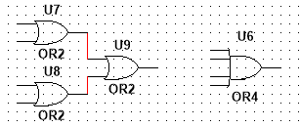

Input |  |  |  | Output
A | B | C | D | LED (on / off) | Level ( 1 / 0 )
0 | 0 | 0 | 0 | Off | 0
0 | 0 | 0 | 1 | On | 1
0 | 0 | 1 | 0 | On | 1
0 | 0 | 1 | 1 | On | 1
0 | 1 | 0 | 0 | On | 1
0 | 1 | 0 | 1 | On | 1
0 | 1 | 1 | 0 | On | 1
0 | 1 | 1 | 1 | On | 1
0 | 0 | 0 | 0 | On | 1
1 | 0 | 0 | 1 | On | 1
1 | 0 | 1 | 0 | On | 1
1 | 0 | 1 | 1 | On | 1
1 | 1 | 0 | 0 | On | 1
1 | 1 | 0 | 1 | On | 1
1 | 1 | 1 | 0 | On | 1
1 | 1 | 1 | 1 | On | 1

Table 1.5: Observation table of 4-Input OR gate

