
Sukkur Institute of Business Administration University
Department of Computer Science
ESE-201: Digital Logic Design Lab

Lab # 12: D Flip Flop

Note: Submit this lab hand-out in the next lab with attached solved activities and exercises

Submission Profile
Name: Pranjal Mandhan Submission date (16/12/2023):

________________________________________________________________________________
Instructor Signature

Lab Learning Objectives:

Upon successful completion of this experiment, the student will be able:
- To implement and verify D flip flop operations using 74LS75 IC & Module KL-33001

Lab Hardware and Software Required:
- 74LS75 IC
- Module KL-33001
- Breadboard
- Connecting Wires

Background Theory:

D-FLIP FLOP:
A clocked RS flip flop can be used to store a bit, but it needs proper logical states, and S and R inputs. In other words to store a bit, data must be supplied to on two lines via R and S. Another difficulty is that, whenever both R and S become high, an uncertain condition about the output state can occur. Such clocked flip flop can be modified to better version called as D-type flip flop. This flip flop possesses only one data input. Fig 12.1 (a & b) shows the logical symbol and logic diagram of flip flop.
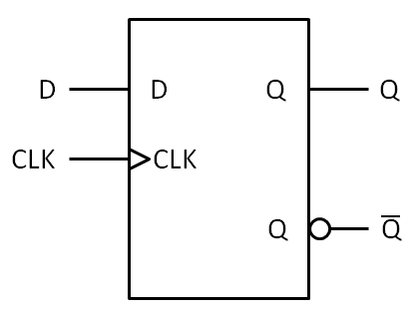
Fig 12.1: (a) logic symbol of D-flip flop (b) logic diagram of D-flip flop
As seen from the Fig 12.1, an inverter is introduced between S and R inputs. With this arrangement, S and R can never become 1 at the same time. Thus the forbidden condition can be avoided. The operation is such that Q will be same as D while CK is high, and Q will remain latched when CK goes low( latched means that Q will remain constant regardless of changes in D).
74LS75 D Latch IC:
The 74LS75 is an example of an integrated circuit D-latch (also called a bi-stable latch). It contains four transparent D latches. Its pin configuration is given in Fig 12.2. Latches 1 and 2 share a common enable (E1-2), and latches 3 and 4 share a common enable (E3-4). The logic function developed by a circuit type latch is the one to transfer the logic value present across the input when the ENABLE signal is high logic value to its output, while the output signal keeps the same if the ENABLE signal is low.
Fig 12.2: 74LS75 Pin Configuration

Lab Examples:
Implementation of D flip flop using 74LS75 IC:
- Carry out the circuits of Fig 12.1 by using IC 74LS75
- Make the circuit on breadboard present on the KL-33001 training kit
- Apply power supply to it
- Connect the input D of circuit to the switch
- Connect the terminal of clock to the input CK of the flip flop
- Connect the outputs Q and $\overline{Q}$ of both circuits to the LEDs
- Analyze the circuit’s behaviour by giving clock signal and 0,1 data through the switch and fill the observation tables

Inputs |  | Outputs
CK | D | Q | $$\overline{Q}$$
1 | 1 | 1 | 0
1 | 0 | 0 | 1
0 | x | x | X
0 | x | X | X
Table 12.1: Observation table of D flip flop
Lab Activities:
Analysis of 74LS75 IC:
- Connect the signals D and EN of one of the two latches shown in BISTABLE LATCH clock the two switches and Q & $\overline{Q}$to two LEDs
- Vary the state of the inputs and observe the circuit operation

Lab Exercises:
Implement D flip-flop in Multisim, attach circuit diagram and observed waveforms.

