

**Department of Information Technology Assignment**

**Date:** 22/04/2025 **Subject:** Web Application Development (2024-25)

|  |  |  |  |
| --- | --- | --- | --- |
| **Q. No.** | **Question** | **Mapping with CO** | **Marks** |
| Q.1) | Illustrate the need Cheerio Package | CO2 | 10 |
| Q.2) | Implement small application which will make use of mentioned package (I/p, O/p) | CO1,CO2 | 10 |
| Q.3) | Illustrate the need for code of ethics | CO1,CO2,CO3 | 5 |

**SOLUTION**

### ****Q1) Illustrate the need for the Cheerio****

### ****Answer:****

**Cheerio is a fast, flexible, and lean implementation of jQuery designed for the server side. It is used for parsing and manipulating HTML and XML in Node.js.**

**Need for Cheerio:**

* **Server-Side DOM Manipulation: Cheerio allows developers to use jQuery-like syntax to manipulate HTML on the server side without a browser.**
* **Web Scraping: It is commonly used for web scraping where you extract information from websites.**
* **Lightweight: Compared to a browser environment, Cheerio is lightweight and doesn't require rendering or loading styles/scripts.**
* **Easy to Use: Simple syntax for traversing and modifying elements using familiar jQuery functions.**

### ****Q2) Implement a small application which will make use of the mentioned package (Input, Output)****

### ****Answer:****

#### ****Application Title:**** Webpage headings extracter

**Input: HTML content from a sample webpage  
Output: Extracted elements such as headings or links**

**CODE :**

**const axios = require('axios');**

**const cheerio = require('cheerio');**

**const url = 'https://kbtcoe.org/';**

**axios(url)**

**.then(response => {**

**const html = response.data;**

**const $ = cheerio.load(html);**

**const menuItems = [];**

**// Corrected selector based on website structure**

**$('#menu-main-menu li a').each((i, el) => {**

**const text = $(el).text().trim();**

**if (text) menuItems.push(text);**

**});**

**console.log("KBTCOE Website Navigation Items:");**

**menuItems.forEach((item, index) => {**

**console.log(`${index + 1}. ${item}`);**

**});**

**})**

**.catch(error => {**

**console.error('Error fetching website:', error);**

**});**

**OUTPUT :**

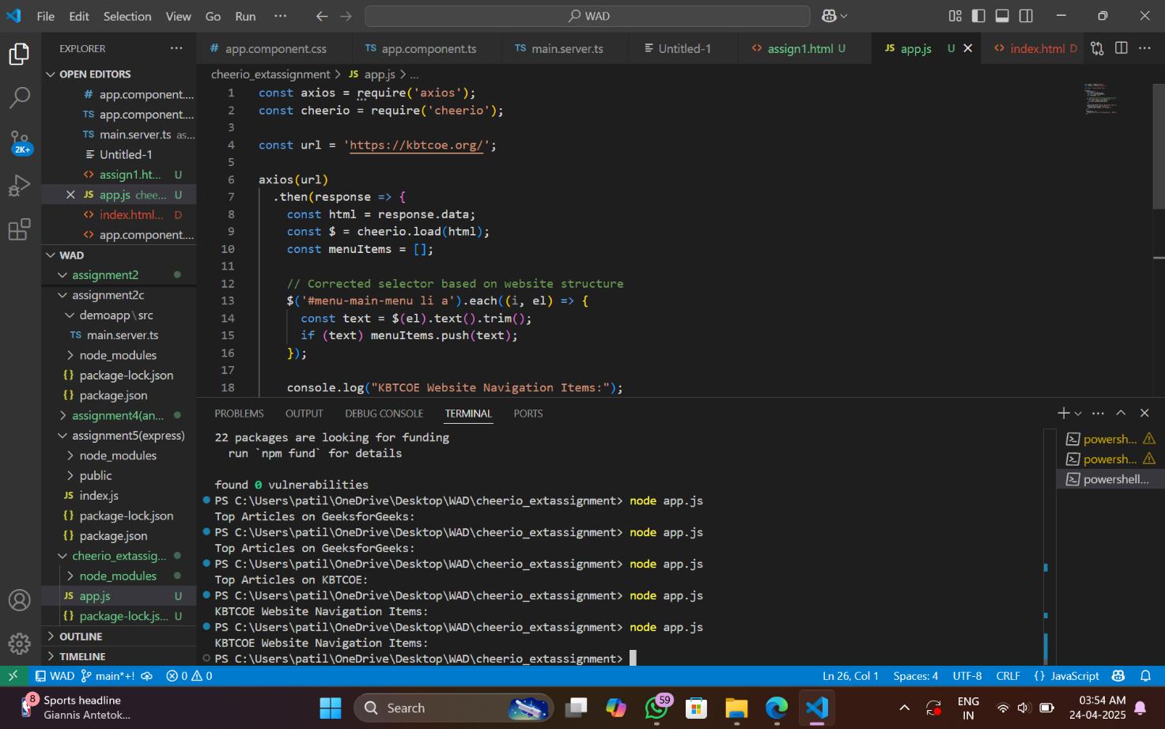

### ****Q3) Illustrate the need for a Code of Ethics****

### ****Answer:****

**Answer: In web development and especially in web scraping (which Cheerio is used for), ethical considerations are critical.**

**Why Code of Ethics is Needed:**

* **Respecting Website Policies: Many websites prohibit scraping; developers must respect terms of service.**
* **User Privacy: Do not scrape or use user data without permission.**
* **Security Practices: Avoid writing code that can harm or exploit web services.**
* **Fair Use: Use data responsibly and avoid overloading servers.**