**Assignment 1**

**Git repository for assignment 1 &2**

[https://github.com/pranjalpg/WebApplication1.git](https://apc01.safelinks.protection.outlook.com/?url=https%3A%2F%2Fgithub.com%2Fpranjalpg%2FWebApplication1.git&data=05%7C01%7Cpranjal.nema%40nagarro.com%7Cf92cdc183a1742e9f84a08daeec96b7d%7Ca45fe71af4804e42ad5eaff33165aa35%7C0%7C0%7C638084846140075162%7CUnknown%7CTWFpbGZsb3d8eyJWIjoiMC4wLjAwMDAiLCJQIjoiV2luMzIiLCJBTiI6Ik1haWwiLCJXVCI6Mn0%3D%7C3000%7C%7C%7C&sdata=ChsT9C04flazLsSH3Gjgly60QhkCeqqZKKeJ8fHGhsQ%3D&reserved=0)

**Git repository for assignment 3**: <https://github.com/pranjalpg/WebApplication3.git>

**Create freestyle Jenkins job to download code from Git**

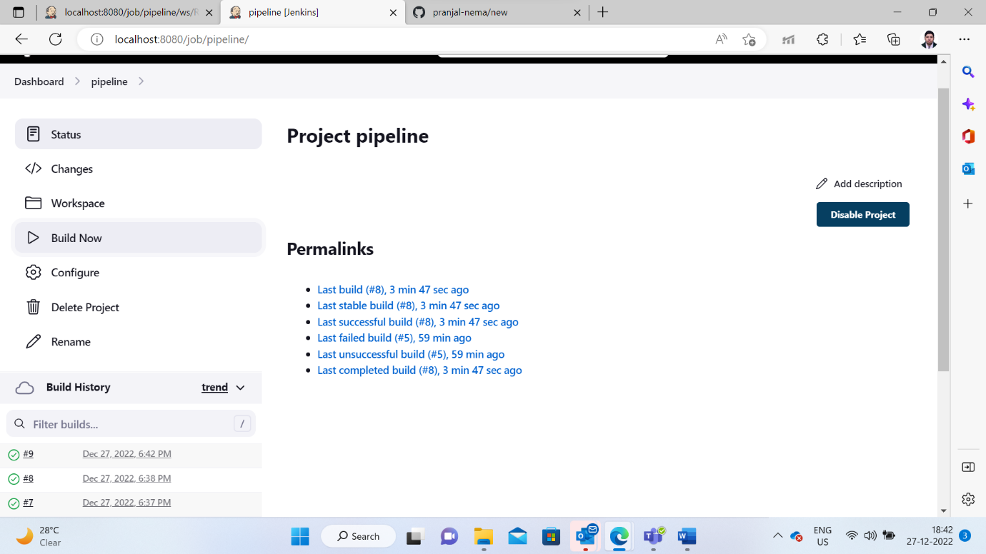

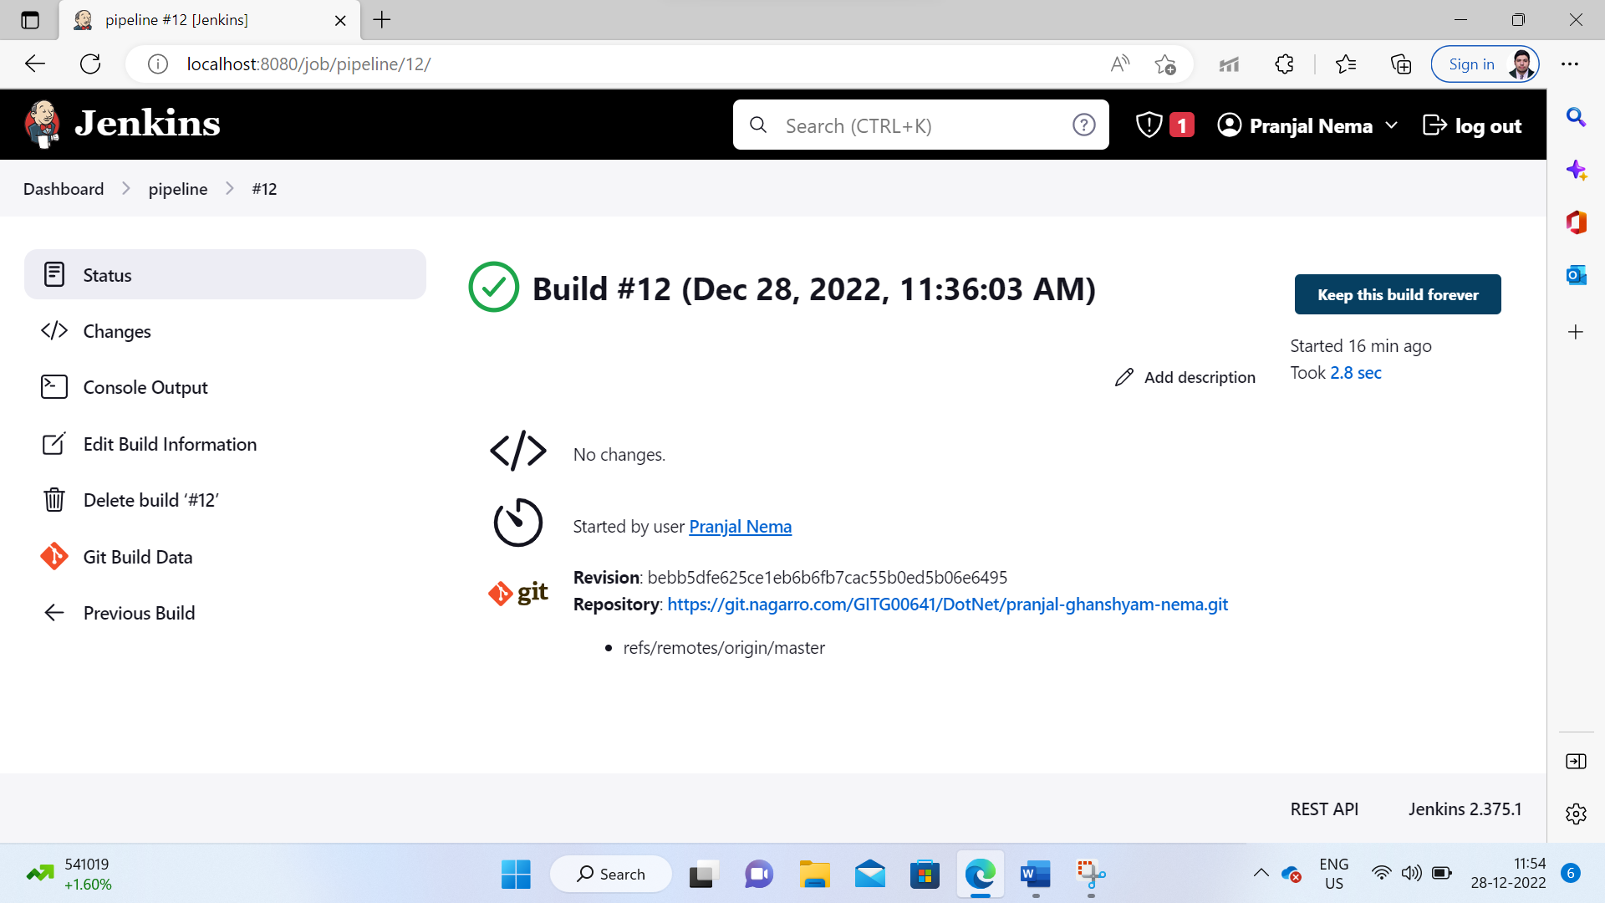

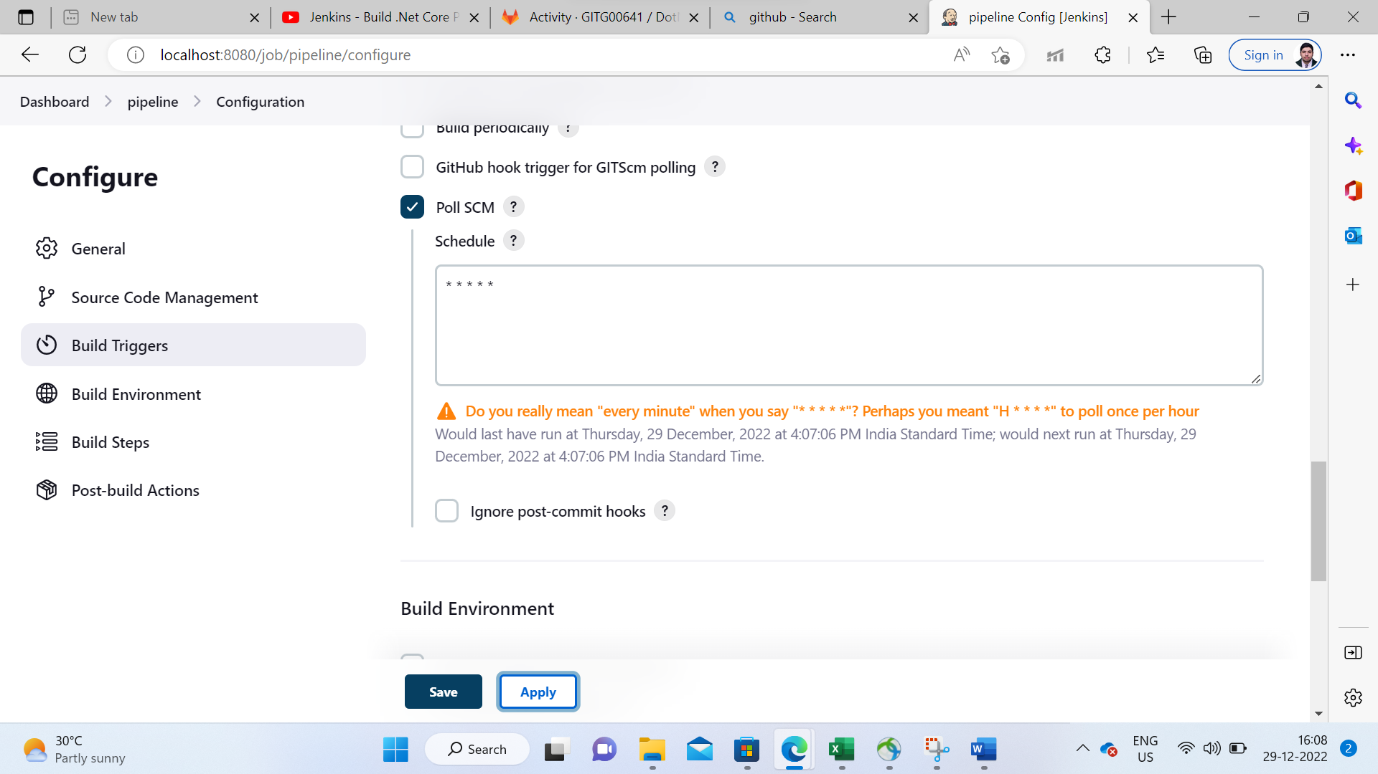

**Assignment 2**

**Git repository:**

[https://github.com/pranjalpg/WebApplication1.git](https://apc01.safelinks.protection.outlook.com/?url=https%3A%2F%2Fgithub.com%2Fpranjalpg%2FWebApplication1.git&data=05%7C01%7Cpranjal.nema%40nagarro.com%7Cf92cdc183a1742e9f84a08daeec96b7d%7Ca45fe71af4804e42ad5eaff33165aa35%7C0%7C0%7C638084846140075162%7CUnknown%7CTWFpbGZsb3d8eyJWIjoiMC4wLjAwMDAiLCJQIjoiV2luMzIiLCJBTiI6Ik1haWwiLCJXVCI6Mn0%3D%7C3000%7C%7C%7C&sdata=ChsT9C04flazLsSH3Gjgly60QhkCeqqZKKeJ8fHGhsQ%3D&reserved=0)

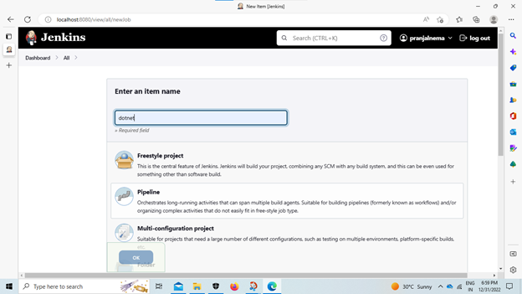

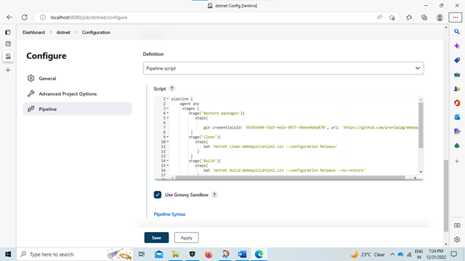

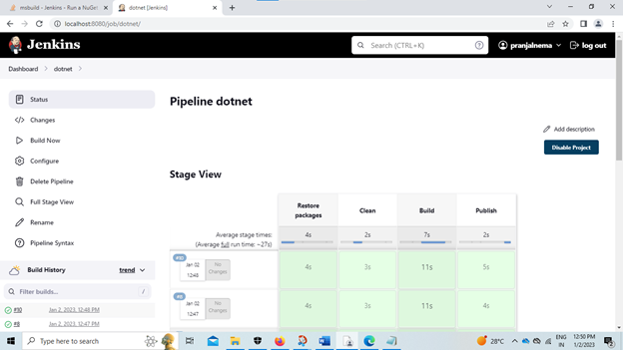

**Assignment 3**

**Git repository:** <https://github.com/pranjalpg/WebApplication3.git>

