# Product name: Vibhavari ceation ,Women Black Printed Straight Kurta

Desc: Black Printed Straight,full sleeves kurta

Cost price: 599

Brand : vibhavari creation

Category : clothing

Size: xl

Colour: black

Material:silk

Product-type: Kurti

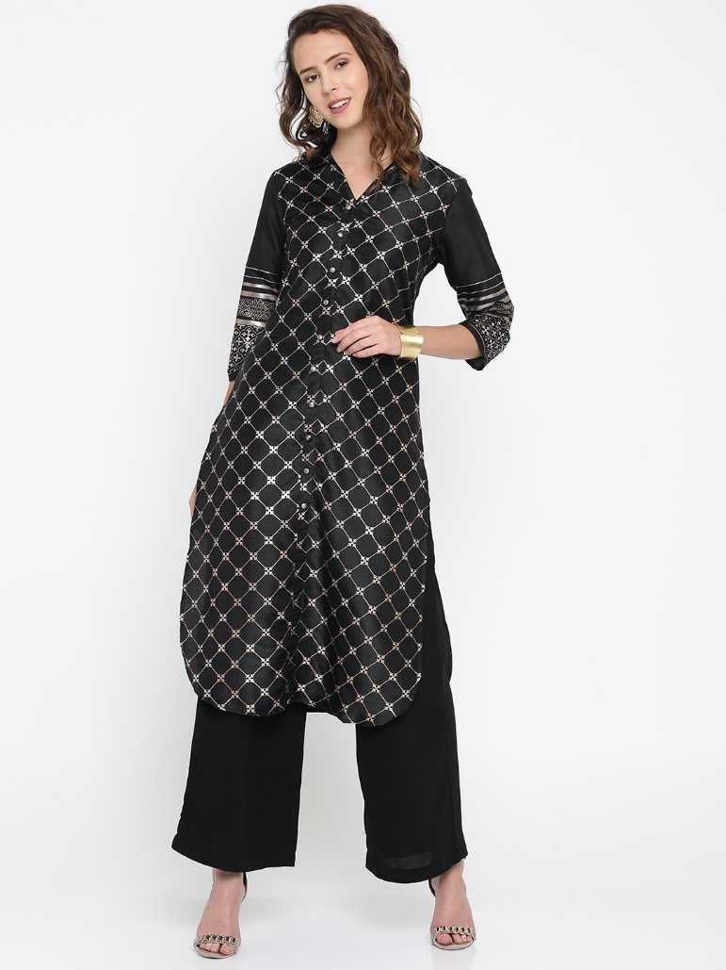

2.

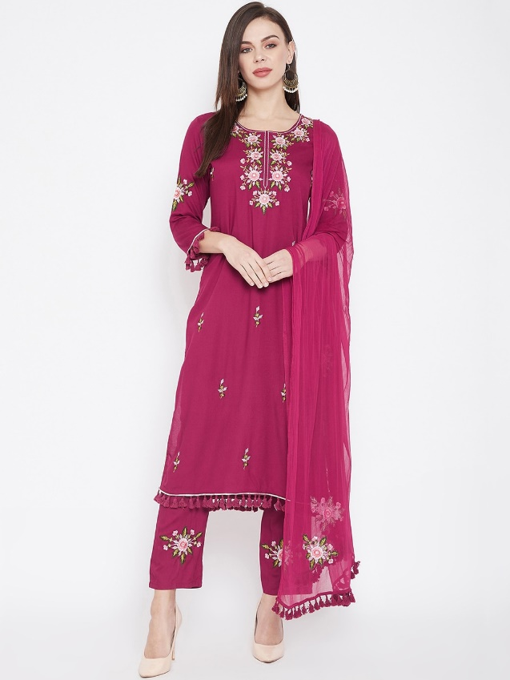

# Product name: Vibhavari ceation , Women Pink Embroidered Kurta with Trousers & Dupatta

# Desc: Women Pink Embroidered Kurta with Trousers & Dupatta

Cost price: 849

Brand : vibhavari creation

Category : clothing

Size: xl

Colour: red

Material:silk

Product-type: Kurti

3.

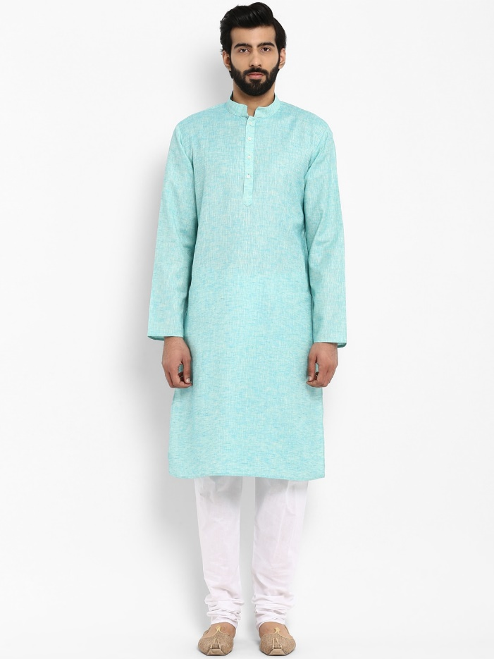

# Product name: Shweta clothing, Men Sea Green & White Solid Kurta

# Desc: Men Sea Green & White Solid Kurta

Cost price: 1592

Brand : **Shweta clothing**

Category : kurti

Size: xl

Colour: sea green

Material: cotton

Product-type:

4

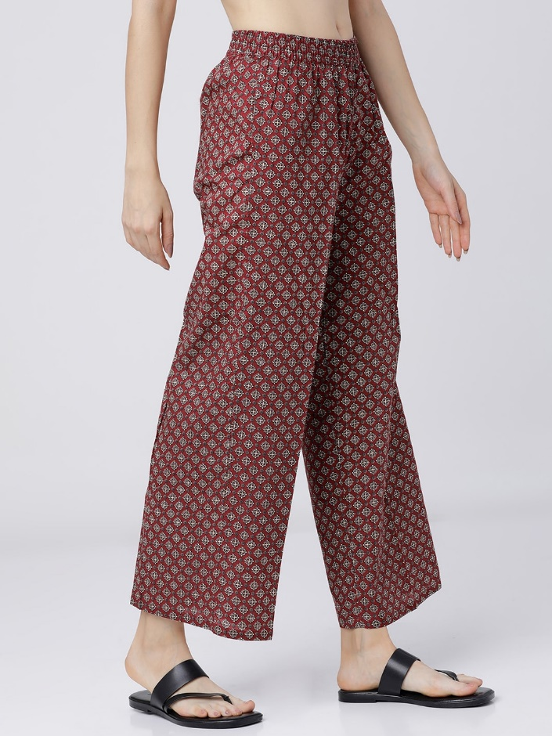

# Product name: kala creation, Women Maroon Printed plazzo

# Desc: Women Maroon Printed

Cost price: 499

Brand : **kala creation**

Category : plazzo

Size: xl

Colour: maroon

Material: cotton

Product-type:

5.

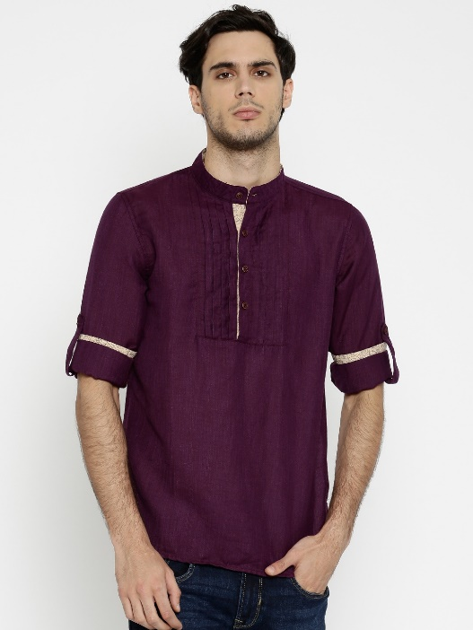

# Product name: shaurya fashion, Men Purple Slim Fit Short Kurta

# 

# Desc: Men Purple Slim Fit Short Kurta

Cost price: 649

Brand : shaurya fashion

Category : kurti

Size: L

Colour: purple

Material: cotton

Product-type:

6.

# Product name: shaurya fashion,

# 

# Desc: Women Grey Printed Pleated A-Line Dress

Cost price: 764.14

Brand : shaurya fashion

Category : kurti

Size: L

Colour: grey

Material: cotton

Product-type:

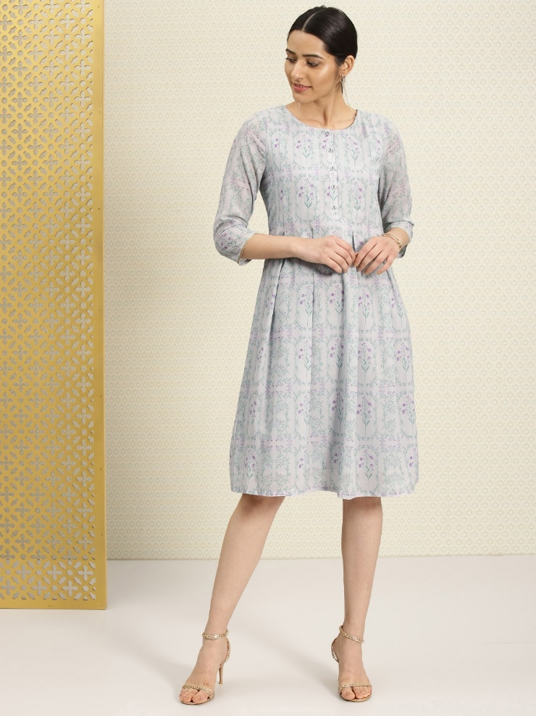

7.

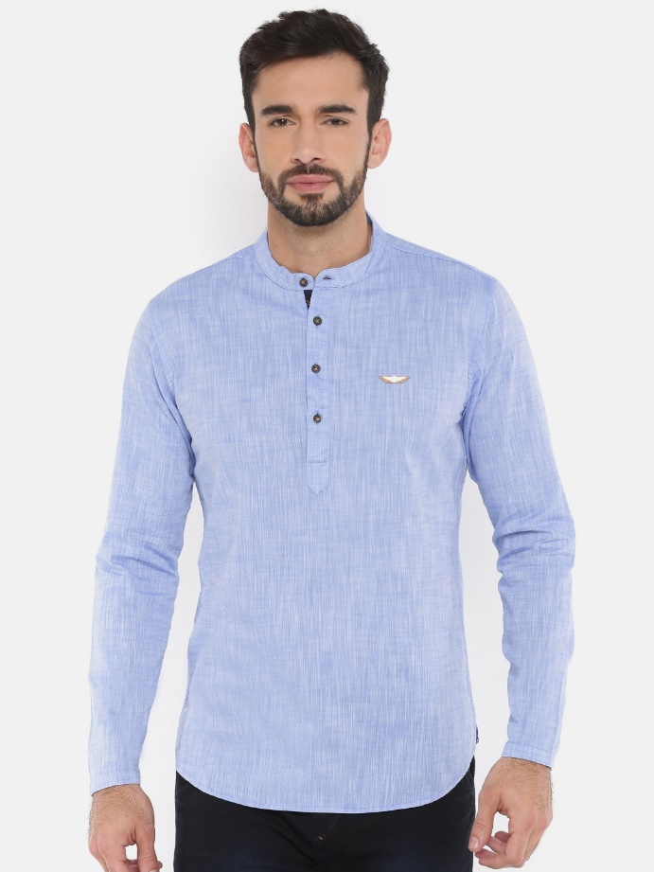

# Product name: Mahavir design ,Men Blue Solid Straight Kurta

# Desc: Men Blue Solid Straight Kurta

Cost price: 754

Brand : Mahavir design

Category : kurti

Size: L

Colour: blue

Material: cotton

Product-type:

8.

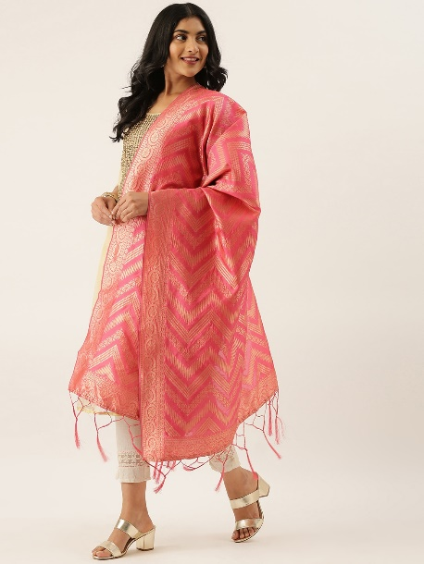

# Product name: rinki shawls,Pink & Gold-Toned Woven Design shawl

# Desc: Pink & Gold-Toned Woven Design shawl

Cost price: 759

Brand : rinki shawls

Category : shawls

Size: L

Colour: pink and gold

Material: cotton

Product-type: