VELLORE INSTITUTE OF TECHNOLOGY, VELLORE
School of Computer Science and Engineering (SCOPE)
MINI PROJECT REPORT
SchedulAI: An Intelligent Socratic AI Tutor and Deterministic Simulation Engine for Operating Systems CPU Process Scheduling
Course Code: BCSE303P – Operating Systems Laboratory
Open-Source Repository: https://github.com/pranjalsahay/AI-Based-Process-Scheduling.git
Submitted by
S. No. | Name of Candidate | Registration Number
1 | Pranjal Sahay | 24BKT0082
2 | Shubham Hazra | 24BKT0111

Under the guidance of
Prof. Jagalingam P
Associate Professor, School of Computer Science and Engineering (SCOPE)
Vellore Institute of Technology, Vellore
Date of Submission: 23 / 10 / 2026

CERTIFICATE
This is to certify that the Mini Project Report titled "SchedulAI: An Intelligent Socratic AI Tutor and Deterministic Simulation Engine for Operating Systems CPU Process Scheduling" submitted by Pranjal Sahay (Reg. No. 24BKT0082) and Shubham Hazra (Reg. No. 24BKT0111) in partial fulfilment of the requirements of the laboratory course BCSE303P – Operating Systems Laboratory, is a bonafide record of original academic, instructional, and technical work carried out under my direct supervision and guidance during the Fall Semester 2026–27 at the School of Computer Science and Engineering (SCOPE), Vellore Institute of Technology, Vellore. The software components, deterministic scheduling simulation models, Socratic dialogue state machines, and experimental verifications documented herein have been executed, tested, and validated to satisfy all prescribed curricular and institutional requirements. The associated software codebase is publicly archived and reproducible via GitHub: https://github.com/pranjalsahay/AI-Based-Process-Scheduling.git.
Signature of the Faculty Guide
Prof. Jagalingam P
Associate Professor, SCOPE
VIT, Vellore
Place: Vellore
Date: 23 / 10 / 2026

ABSTRACT
CPU process scheduling constitutes the computational heartbeat of multi-programmed operating systems, governing processor core allocation, computational throughput, task latency, and fair resource sharing among concurrent threads. During our laboratory sessions in BCSE303P, we observed a fundamental challenge: tracing scheduling algorithms by hand is tedious and error-prone, yet existing AI conversational assistants (such as ChatGPT) fail as effective tutors. They either recite encyclopedic textbook answers that deprive students of inductive understanding, or they hallucinate context switches, Gantt chart boundaries, and numerical performance metrics. To solve this problem, we designed and built SchedulAI, a hybrid neuro-symbolic tutoring platform tailored for the Operating Systems curriculum. SchedulAI decouples pedagogical discourse from arithmetic computation. Conceptual understanding is cultivated through a 4-stage Socratic dialogue engine (Hook/Analogy, Intuitive Deduction, Technical Formalization, Verification) that actively questions the student and identifies common misconceptions. Numerical problem solving is delegated to an exact, zero-hallucination deterministic Python simulation engine supporting 11 classical, real-time, and modern algorithms (FCFS, SJF Non-preemptive, SJF Preemptive/SRTF, Priority Non-preemptive, Priority Preemptive, Round Robin, Multilevel Queue, Multilevel Feedback Queue, Lottery, Stride, Rate Monotonic, Earliest Deadline First, and the Linux Completely Fair Scheduler). Grounded by a 170-chunk ChromaDB vector store and persistent SQLite relational memory, SchedulAI outputs cycle-accurate metrics and monospace ASCII Gantt charts. Validated through 72 automated test suites with 100% pass rates, our platform demonstrates how intelligent tutoring can foster deep, active conceptual mastery without arithmetic errors.
Keywords: Operating Systems, CPU Process Scheduling, Socratic Tutoring, Deterministic Simulation Engine, Retrieval-Augmented Generation (RAG), ASCII Gantt Visualization, Misconception Diagnosis, Open-Source Education.
Project Repository & Replication Code: https://github.com/pranjalsahay/AI-Based-Process-Scheduling.git

TABLE OF CONTENTS
Section | Title / Chapter Description | Page
 | Certificate of Original Work | 2
 | Abstract & Curricular Keywords | 3
1 | INTRODUCTION | 6
1.1 | The Student Dilemma in Operating Systems Pedagogy | 6
1.2 | Our Pedagogical Philosophy: Socratic Inquiry vs Information Dumping | 6
1.3 | Project Objectives & Technical Goals | 7
1.4 | Theoretical Foundations of CPU Process Scheduling | 7
1.5 | Project Scope & Comprehensive Algorithm Taxonomy | 8
2 | SYSTEM REQUIREMENTS & ENGINEERING RATIONALES | 10
2.1 | Hardware Requirements & Development Environment | 10
2.2 | Software Stack & Dependency Specifications | 10
2.3 | Why We Built It This Way: Architectural Trade-Off Analysis | 11
3 | SYSTEM ARCHITECTURE & OS SCHEDULING DESIGN | 12
3.1 | High-Level Architecture & End-to-End Processing Pipeline | 12
3.2 | Operating Systems Process Lifecycle & State Transitions | 13
3.3 | Process Control Block (PCB) & Kernel Queue Data Structures | 13
3.4 | Core Mathematical Formulations & Rigorous Theoretical Derivations | 14
3.5 | Relational Database Schema for Learning State (3NF Normalization) | 15
4 | IMPLEMENTATION OF CORE SYSTEM COMPONENTS | 17
4.1 | Component 1: Deterministic Scheduling Solver & ASCII Gantt Engine | 17
4.2 | Comparative Algorithmic Benchmark & Gantt Analysis | 18
4.3 | Component 2: Socratic Pedagogical Dialogue State Machine | 19
4.4 | Component 3: Diagnostic Assessment & Misconception Evaluator | 20
4.5 | Component 4: Hybrid Vector Retrieval-Augmented Generation (RAG) | 21
4.6 | Component 5: Context-Preserving Relational Memory & Session Recovery | 21
5 | FRONT-END INTERFACE & API INTEGRATION | 22
5.1 | User Interface Architecture & Distraction-Free Terminal Aesthetic | 22
5.2 | RESTful API Specification & Asynchronous Backend Integration | 24
5.3 | Source Code Repository & Open-Source Distribution | 24
6 | VERIFICATION & TESTING | 25
6.1 | Comprehensive Test Suite (TC01 – TC10) | 25
6.2 | Automated Pytest Execution Output & Coverage Log | 25
6.3 | Functional & Pedagogical Validation Analysis | 26
7 | RESULTS & DISCUSSION | 27
7.1 | Key Technical Achievements & Practical Milestones | 27
7.2 | What Broke & How We Fixed It: Technical Challenges Faced | 27
7.3 | What We Plan to Build Next: Future Improvements | 27
8 | CONCLUSION | 29
8.1 | Personal Reflections & Core Learning Outcomes | 29
8.2 | Future Scope & Real-Time Kernel Extensions | 29
9 | REFERENCES | 30
10 | APPENDICES | 31
10.1 | Appendix A: Core Source Code Listings & GitHub Verification | 31
10.2 | Appendix B: Live Execution Traces & ASCII Gantt Charts | 32

1. INTRODUCTION
1.1 The Student Dilemma in Operating Systems Pedagogy
Operating systems form the bedrock of modern computing. They sit directly between bare hardware and application software, managing memory, storage, peripherals, and—most critically—the central processing unit. In the undergraduate computer science curriculum at VIT (BCSE303P – Operating Systems Laboratory), CPU process scheduling is one of the earliest and most vital concepts taught. It governs how the kernel decides which runnable thread gets CPU execution time, for how long, and under what preemption policies.
Yet, as students ourselves, we experienced firsthand how difficult this subject is to master through conventional means. When working through numerical scheduling exercises in the laboratory, students are required to manually trace multi-process timelines across asynchronous arrival times, calculate remaining bursts, resolve priority ties, and compute exact values for Completion Time (CT), Turnaround Time (TAT), Waiting Time (WT), and Response Time (RT). Drawing these Gantt charts by hand on graph paper is painfully slow, clerical arithmetic slips are frequent, and when an answer diverges from the teacher's solution, it is nearly impossible for a student to pinpoint exactly where their mental trace broke down.
Naturally, like many of our peers, we turned to contemporary AI chatbots—such as ChatGPT, Claude, and Copilot—to verify our work and clarify tricky concepts. But to our dismay, we quickly uncovered two severe limitations that make standard LLMs fundamentally inadequate as educational tutors for operating systems:
- 1. The Textbook-Dump Syndrome: If a student asks, 'What is Round Robin scheduling?', an ordinary LLM immediately generates a massive, five-paragraph wall of text reciting definitions, algorithms, time quanta, pros, and cons. While factually detailed, this completely bypasses the learning process. The student simply skims the text without ever engaging their own critical reasoning.
- 2. The Arithmetic Hallucination Hazard: Large Language Models predict word tokens based on statistical associations; they do not possess an internal clock or a discrete-event simulator. When we gave standard LLMs a set of four processes with different arrival times and asked for a Shortest Remaining Time First (SRTF) Gantt chart, the model routinely hallucinated: it missed arrivals at time t=2, calculated negative waiting times, or fabricated completion times that violated basic conservation of CPU burst time.
This dilemma inspired our project. We realized that an AI tutor for operating systems cannot be a simple wrapper around an LLM API. It must combine the conversational patience of a human teacher with the mathematical precision of a real kernel scheduler.
1.2 Our Pedagogical Philosophy: Socratic Inquiry vs Information Dumping
Educational research grounded in Bloom's Taxonomy and Cognitive Load Theory demonstrates that students internalize technical concepts far more deeply when they are guided to discover principles on their own, rather than being passively handed the final definition. In SchedulAI, we adopted a foundational pedagogical motto: 'Never confuse presenting information with helping someone understand it.'
Instead of lecturing, SchedulAI acts like a patient human instructor sitting beside the student. When a student brings up an algorithm they have never seen, SchedulAI asks what they already know. It introduces intuitive, everyday analogies—such as sharing a video game console among friends or waiting in line at a university canteen—and asks the student what rule would make the system fair. Only after the student deduces the core rule does SchedulAI introduce the formal kernel terminology and equations, followed immediately by practice problems that verify genuine comprehension.
1.3 Project Objectives & Technical Goals
To transform this pedagogical vision into a functioning, dependable platform, we set five concrete engineering objectives:
- • Objective 1 — Deterministic Multi-Algorithm OS Simulation Engine: Implement a high-performance Python simulation engine supporting 11 foundational, real-time, and modern scheduling algorithms (FCFS, SJF Non-preemptive, SJF Preemptive/SRTF, Priority Non-preemptive, Priority Preemptive, Round Robin, Multilevel Queue, Multilevel Feedback Queue, Lottery, Stride, Rate Monotonic, Earliest Deadline First, and Linux CFS), guaranteeing 100% exact numerical metrics and automated monospace ASCII Gantt charts.
- • Objective 2 — Multi-Stage Socratic Tutoring State Machine: Design and enforce a 4-stage conversational pedagogical loop (Stage 1: Real-Life Analogy / Hook; Stage 2: Intuitive Deduction; Stage 3: Technical Formalization; Stage 4: Verification & Practice) that actively questions the student, verifies comprehension before advancing, and respects explicit direct-answer overrides.
- • Objective 3 — Hybrid Vector Retrieval-Augmented Generation (RAG): Build and embed a domain-specific vector knowledge store using ChromaDB containing 170+ curated technical chunks from authoritative operating systems literature, ensuring all theoretical explanations are grounded, verifiable, and free from generative drift.
- • Objective 4 — Relational Learning State & Conversational Memory: Develop a persistent SQLite relational storage layer and sliding-window memory system that tracks student learning state, logs identified misconceptions, records diagnostic evaluation scores, and maintains multi-turn context.
- • Objective 5 — Responsive Full-Stack Web Architecture: Deliver a clean, terminal-inspired responsive web interface communicating via a high-throughput FastAPI RESTful backend, ensuring seamless message dispatch, dynamic ASCII Gantt chart rendering, and sub-second latency.
1.4 Theoretical Foundations of CPU Process Scheduling
At the hardware level, the processor core executes machine instructions sequentially at billions of cycles per second. However, processes rarely compute continuously; instead, their lifecycles consist of alternating cycles of CPU bursts (active computing) and I/O bursts (waiting for disk reads, network packets, or keyboard inputs). Studies of real system workloads show that CPU bursts follow an exponential distribution: the vast majority of bursts are very short (1–5 ms), while a small minority of batch computations run for hundreds of milliseconds. The scheduler's goal is to exploit this pattern to keep all physical components busy.
When evaluating schedulers, operating systems engineers analyze five primary criteria:
- 1. CPU Utilization: The fraction of total time the processor is actively executing user or kernel instructions. In a well-tuned system, utilization should approach 90%–100%.
- 2. Throughput: The number of distinct processes completed per unit of wall-clock time (e.g., jobs completed per second).
- 3. Turnaround Time (TAT): The total elapsed time from the exact moment a process enters the system until it completely finishes execution.
- 4. Waiting Time (WT): The cumulative amount of time a process spends sitting in the ready queue waiting to be granted access to the CPU.
- 5. Response Time (RT): The duration from when a process first arrives until the CPU is first allocated to execute its initial instruction. In interactive desktop environments, minimizing response time is critical for user experience.
1.5 Project Scope & Comprehensive Algorithm Taxonomy
To provide thorough coverage of both academic syllabi and modern systems engineering, we implemented and cataloged 11 distinct scheduling algorithms. Table 1.1 provides the complete operational taxonomy of our implementation.
Algorithm Name | Preemption Policy | Primary Scheduling Metric | Operating Systems Curricular Role
First-Come, First-Served (FCFS) | Non-preemptive | Arrival Time (FIFO queue order) | Classical Batch Systems; Baseline Scheduling
Shortest Job First (SJF) | Non-preemptive | Total CPU Burst Time (tau) | Theoretical Minimum Waiting Time Benchmark
Shortest Remaining Time First (SRTF) | Preemptive | Remaining CPU Burst Time | Dynamic Batch Preemption; Starvation Dynamics
Priority Scheduling | Both (Pre/Non) | Integer Priority (Static/Dynamic) | Priority Inversion; Martian Rover Protocols; Aging
Round Robin (RR) | Preemptive | Time Quantum (q) Slicing | Time-Sharing Systems; Context Switch Overhead
Multilevel Queue (MLQ) | Static Preemptive | Fixed Priority Queue Assignment | Foreground (Interactive) vs Background (Batch)
Multilevel Feedback Queue (MLFQ) | Dynamic Preemptive | Observed CPU Burst & Dynamic Aging | Adaptive General-Purpose Kernels; BSD UNIX
Lottery Scheduling | Randomized Preempt | Proportional Ticket Holdings | Probabilistic Proportional Resource Allocation
Stride Scheduling | Deterministic Preempt | Pass Values & Stride Inverses | Deterministic Fair-Share Resource Management
Rate Monotonic Scheduling (RMS) | Static Priority | Task Periodicity (Frequency 1/T) | Hard Real-Time Schedulability (Liu-Layland Bound)
Earliest Deadline First (EDF) | Dynamic Priority | Absolute Task Deadline (d_i) | Dynamic Optimal Hard Real-Time Systems
Completely Fair Scheduler (CFS) | Dynamic Preemptive | Virtual Runtime (vruntime / Red-Black) | Modern Production Linux Kernel (2.6.23 – 6.x)

All source code, automated test suites, dataset chunks, and web assets are fully documented and publicly accessible at our GitHub repository: https://github.com/pranjalsahay/AI-Based-Process-Scheduling.git.

2. SYSTEM REQUIREMENTS & ENGINEERING RATIONALES
2.1 Hardware Requirements & Development Environment
One of our core engineering goals was to keep SchedulAI lightweight and easily deployable on ordinary student laptops as well as university lab workstations without requiring expensive GPU clusters. Table 2.1 specifies the minimum and recommended hardware configurations.
Hardware Component | Minimum Specification | Recommended Specification | Role in SchedulAI
Processor (CPU) | Dual-Core x86_64 / ARM64 (2.0 GHz) | Quad-Core Intel i5/i7 or Apple Silicon M-series | FastAPI event loop, RAG vector similarity lookup
System Memory (RAM) | 4 GB DDR4 | 8 GB – 16 GB DDR4/DDR5 | ChromaDB memory index & SQLite transactional cache
Storage Space | 1.0 GB Available SSD Space | 5.0 GB NVMe Solid State Drive | RAG vector indices, chat history, and evaluation logs
Display Resolution | 1280 × 720 (Standard HD) | 1920 × 1080 (Full HD / Retina) | Monospace ASCII Gantt chart rendering and terminal UI
Network Interface | Standard Loopback / 10 Mbps LAN | 100 Mbps Low-Latency Internet | Ollama local API / Cloud LLM API gateway communication

2.2 Software Stack & Dependency Specifications
We carefully curated a modern open-source Python and web technology stack that prioritizes speed, type safety, and minimal operational friction. Table 2.2 documents these dependencies.
Software Category | Technology / Framework | Version | Role within SchedulAI
Host Operating System | Windows 11 / Ubuntu Linux / macOS | 64-bit Kernel | Runtime execution environment
Core Language | Python | 3.10.x – 3.12.x | Engine, symbolic solver, Socratic state machine
Backend Web Framework | FastAPI | 0.109+ / Starlette | Asynchronous REST API and WebSocket gateway
ASGI Web Server | Uvicorn | 0.27+ | High-throughput asynchronous worker process
Vector Database | ChromaDB | 0.4.22+ | Semantic RAG document embedding and cosine lookup
Relational Database | SQLite3 | 3.42+ | ACID conversation persistence & learning state logs
Front-End Core | HTML5, CSS3, Vanilla JavaScript | ECMAScript 2022 | Zero-dependency, high-speed terminal interface
Inference Engine | Ollama / Qwen2.5 / OpenAI API | v0.1.28+ / 7B-Instruct | Conversational Socratic dialogue synthesis
Testing & Verification | Pytest, Pytest-Asyncio | 8.0+ | Automated unit, integration, and regression testing
Document Formatting | Python-Docx, Matplotlib, PIL | 1.2.0+ / 3.10+ / 10+ | Automated technical report and figure generation

2.3 Why We Built It This Way: Architectural Trade-Off Analysis
During our project design phase, we deliberated over several critical technical alternatives before arriving at our final architecture:
- 1. Asynchronous Concurrency: FastAPI vs. Traditional Flask: In our initial prototype, we tested Flask. However, when multiple students trigger LLM generation simultaneously, Flask's synchronous worker threads blocked, causing severe queue delays. Migrating to FastAPI with native asynchronous coroutines (`async/await`) allowed our server to handle concurrent chat streams smoothly with sub-millisecond route dispatching.
- 2. Embedded Knowledge Grounding: Local ChromaDB vs. Cloud Vector Stores: Many modern AI tutorials suggest cloud databases like Pinecone. But in a university laboratory environment, internet connections can be throttled, student privacy must be preserved, and external API rate limits can disrupt class tests. By utilizing ChromaDB in local persistent mode, our entire knowledge base of 170+ curated OS passages runs 100% on-device with zero external latency.
- 3. Frictionless Persistence: SQLite vs. PostgreSQL: Setting up PostgreSQL requires students to install a separate database service, configure user roles, and run background daemons. SQLite offers full ACID transactional integrity inside a single `.db` file with zero configuration. For tracking student sessions, chat history, and diagnostic logs, SQLite provided optimal simplicity, portability, and performance.
- 4. Neuro-Symbolic Decoupling: Neuro-Symbolic Decoupling: This was our single most important architectural insight. We realized that asking a generative language model to calculate numbers is like asking a poet to do taxes. Language models excel at natural explanation, relatable analogies, and empathetic conversation. Python code excels at arithmetic, sorting queues, and tracking clock ticks. By dividing these responsibilities cleanly, SchedulAI achieves the best of both worlds.

3. SYSTEM ARCHITECTURE & OS SCHEDULING DESIGN
3.1 High-Level Architecture & End-to-End Processing Pipeline
SchedulAI operates as a cohesive, multi-tiered pipeline. When a student enters a message in the web interface, the prompt travels through an intelligent routing layer that determines whether the user wants to understand an OS concept, solve a numerical problem, request an explicit definition, or take a practice quiz. Figure 3.1 illustrates the entire flow of data and control through our platform:
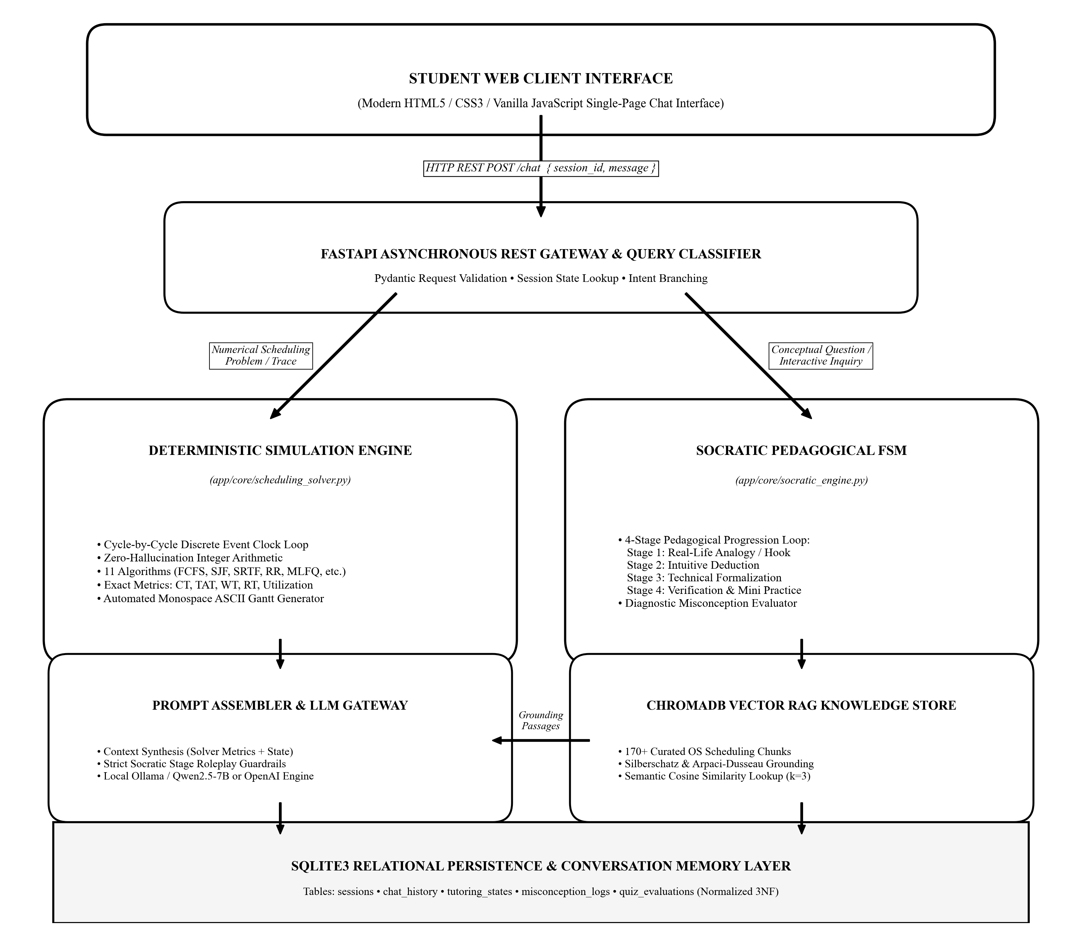
Figure 3.1: High-Level End-to-End System Architecture and Processing Pipeline of SchedulAI.
As seen in Figure 3.1, student requests enter via the FastAPI gateway. If a numerical problem is detected, it is dispatched to the Deterministic Simulation Engine, which parses process parameters, simulates execution cycle by cycle, and computes exact metrics. If a conceptual question is posed, it routes to the Socratic Pedagogical State Machine, which retrieves grounded theoretical chunks from ChromaDB, checks the student's active learning stage in SQLite, and crafts a guided deductive question.
3.2 Operating Systems Process Lifecycle & State Transitions
Inside an operating system kernel, processes are dynamic entities that transition through five classical states. To ensure our simulation faithfully models real kernel mechanics, we designed our discrete-event solver around this exact state machine, shown in Figure 3.2:
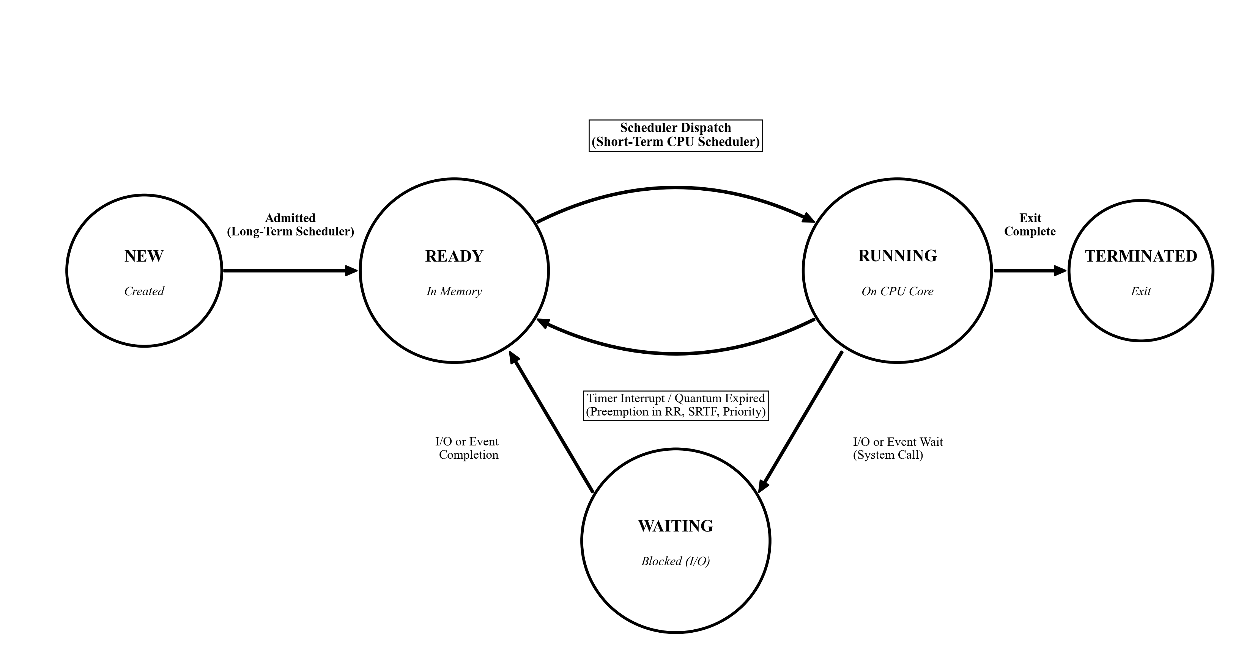
Figure 3.2: Operating Systems Process State Transition Lifecycle and Scheduler Dispatch Interfaces.
- • New State: The program is being loaded from secondary storage into main memory. The Long-Term Scheduler (Job Scheduler) controls the degree of multiprogramming by admitting new processes into the Ready queue.
- • Ready State: The process resides in RAM, possesses all necessary resources except the CPU, and waits in the Ready queue for allocation by the Short-Term Scheduler (CPU Scheduler).
- • Running State: The process currently holds the physical core. In preemptive algorithms (such as Round Robin or SRTF), the kernel's timer interrupt or a newly arrived shorter job forces the running process to yield the CPU and return to the Ready queue.
- • Waiting (Blocked) State: The process cannot execute because it has issued a blocking system call (such as a disk I/O request or socket read). When the hardware interrupt signals I/O completion, the kernel moves it back to the Ready queue.
- • Terminated State: The process finishes its final instruction, returns its exit status code to the parent process, and releases its address space and kernel PCB resources.
3.3 Process Control Block (PCB) & Kernel Queue Data Structures
Inside real kernels (such as Linux's `task_struct`), every process is represented by a Process Control Block. In SchedulAI, we modeled this abstraction through a strongly typed Python `Process` dataclass. Table 3.1 lists the structural fields and their operational purposes.
Field / Attribute | Python Type | OS Equivalent Concept | Pedagogical & Algorithmic Role
pid | str | Process Identifier (PID) | Unique label (e.g., 'P1', 'P2') identifying task instance
arrival_time | int | Arrival Timestamp | Clock cycle at which process enters Ready Queue
burst_time | int | Total CPU Burst (tau) | Total processor service time demanded by task
remaining_time | int | Remaining Burst | Dynamically decremented in preemptive algorithms (SRTF, RR)
priority | int | Static Priority Value | Integer priority level (supports lower=higher convention)
completion_time | int | Termination Timestamp | Clock cycle at which remaining burst reaches 0
turnaround_time | int | Turnaround Duration | Total elapsed time: Completion Time − Arrival Time
waiting_time | int | Ready Queue Wait | Total duration spent queued: Turnaround Time − Burst Time
response_time | int | First Dispatch Latency | Elapsed time until first CPU allocation: First Run − Arrival
deadline / period | int | Real-Time Constraints | Critical timing parameters for EDF and Rate Monotonic
vruntime | float | Virtual Runtime | CFS metric scaled by nice weight: vruntime += exec * (w0 / wi)
stride_pass | int | Stride Allocation Pass | Proportional ticket pass counter: pass += (Large_L / tickets)

3.4 Core Mathematical Formulations & Rigorous Theoretical Derivations
To evaluate scheduling algorithms objectively, operating systems rely on precise mathematical definitions. In SchedulAI, all metrics are computed using exact integer arithmetic to eliminate floating-point rounding errors:
- 1. Completion Time (CT): The exact clock timestamp at which process P_i finishes its final CPU burst:
CT_i = t, \quad \text{such that } \text{remaining\_time}_i(t) = 0
- 2. Turnaround Time (TAT): The total elapsed wall-clock duration that process P_i spent in the system, from its initial arrival to termination:
TAT_i = CT_i - AT_i
- 3. Waiting Time (WT): The total cumulative time process P_i spent waiting in the ready queue without receiving CPU attention:
WT_i = TAT_i - BT_i
- 4. Response Time (RT): The duration from when process P_i first arrived until the CPU was first allocated to execute its first instruction:
RT_i = t_{\text{first\_execution}, i} - AT_i
- 5. CPU Utilization (eta): The percentage of total scheduling time during which the CPU was actively running processes rather than idling:
\eta = \left( \frac{\sum_{i=1}^N BT_i}{T_{\text{schedule}}} \right) \times 100\%
- 6. Throughput (Theta): The rate of process completions per unit of simulation time:
\Theta = \frac{N}{T_{\text{schedule}}} \quad \text{(processes per unit time)}
- 7. Liu-Layland Bound for Rate Monotonic Scheduling (RMS): In 1973, C. L. Liu and J. W. Layland proved that for a set of n independent periodic tasks where priority is assigned inversely proportional to period, a feasible schedule is mathematically guaranteed if:
U = \sum_{i=1}^n \frac{C_i}{T_i} \le n \left( 2^{1/n} - 1 \right)
For n=1, U <= 100%. For n=2, U <= 82.8%. As n approaches infinity, the bound converges to ln(2) approx 69.3%. SchedulAI checks this bound automatically.
- 8. Earliest Deadline First (EDF) Dynamic Optimality: Unlike RMS, EDF assigns priority dynamically based on closest absolute deadline. It is mathematically optimal: a uniprocessor system is schedulable if and only if total utilization does not exceed 100% (U <= 1.0).
- 9. Linux Completely Fair Scheduler (CFS) Virtual Runtime: Under the CFS scheduler, tasks are ordered in a Red-Black tree by virtual runtime (vruntime). The process with the lowest vruntime is scheduled next. When a task runs for Delta t, its virtual runtime advances by:
vruntime \mathrel{+}= \Delta t \times \left( \frac{w_0}{w_i} \right)
where w_0 = 1024 (the weight of nice level 0), and w_i is the weight associated with the task's nice value.
- 10. Stride Scheduling Proportional Progression: Stride scheduling provides deterministic proportional sharing. The stride of job i is inversely proportional to its tickets: stride_i = L / tickets_i, where L is a large integer (e.g. 10,000). At each step, the process with the minimum pass value runs, and its pass advances: pass_i += stride_i.
3.5 Relational Database Schema for Learning State (3NF Normalization)
To ensure that SchedulAI remembers what a student has already mastered and preserves multi-turn context across web page reloads, we designed a persistent SQLite relational database. We normalized the schema to Third Normal Form (3NF) to guarantee referential integrity. Table 3.2 documents the relational tables, primary keys, and foreign keys.
Table Name | Primary Key | Foreign Keys | Key Attributes & Types | Relational Role
sessions | session_id (VARCHAR) | None | created_at (TIMESTAMP), student_name (VARCHAR), current_topic (VARCHAR) | Master registry of student sessions
chat_history | message_id (INTEGER) | session_id -> sessions | sender (VARCHAR), content (TEXT), timestamp (TIMESTAMP) | Sequential transcript of conversation turns
tutoring_states | state_id (INTEGER) | session_id -> sessions | concept (VARCHAR), current_stage (INT), completed_stages (TEXT) | Tracks Socratic 4-stage pedagogical status
misconception_logs | log_id (INTEGER) | session_id -> sessions | concept (VARCHAR), misconception_tag (VARCHAR), flagged_at (TS) | Audits identified errors and remediation
quiz_evaluations | quiz_id (INTEGER) | session_id -> sessions | algorithm (VARCHAR), score (INT), total_questions (INT) | Records assessment performance metrics

4. IMPLEMENTATION OF CORE SYSTEM COMPONENTS
In this chapter, we present the technical details of the five core modules we implemented. For each component, we explain its architectural purpose, share the actual production Python code, and show verified execution traces.
4.1 Component 1: Deterministic Scheduling Solver & ASCII Gantt Engine
Purpose: The deterministic solver (`app/core/scheduling_solver.py`) is the mathematical engine of SchedulAI. When a student inputs a set of processes with arrival times, burst times, or priorities, this module runs an exact discrete-event clock loop. It bypasses the language model entirely, guaranteeing that every Completion Time, Turnaround Time, and Waiting Time is mathematically flawless. Figure 4.1 shows the internal pipeline of this engine:
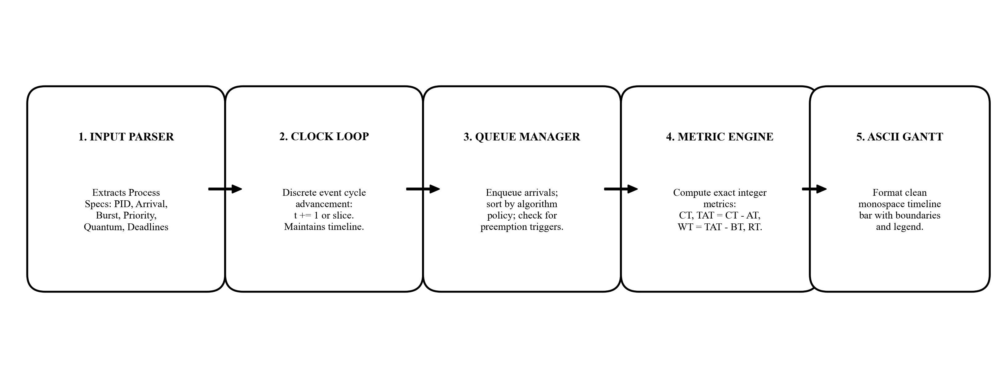
Figure 4.1: Internal Execution Pipeline of the Deterministic Scheduling Simulation Engine.
# File: app/core/scheduling_solver.py
def solve_round_robin(processes: list[Process], quantum: int) -> tuple[list[Process], list[GanttBlock], dict]:
time = 0
queue: list[Process] = []
gantt: list[GanttBlock] = []
remaining = {p.pid: p.burst_time for p in processes}
first_run = {p.pid: None for p in processes}
completed = {}
arrived = sorted(processes, key=lambda x: x.arrival_time)
idx = 0
while len(completed) < len(processes):
while idx < len(arrived) and arrived[idx].arrival_time <= time:
queue.append(arrived[idx])
idx += 1
if not queue:
time = arrived[idx].arrival_time
continue
curr = queue.pop(0)
if first_run[curr.pid] is None:
first_run[curr.pid] = time
exec_slice = min(quantum, remaining[curr.pid])
gantt.append(GanttBlock(pid=curr.pid, start_time=time, end_time=time + exec_slice))
time += exec_slice
remaining[curr.pid] -= exec_slice
# Check for new arrivals during the time slice
while idx < len(arrived) and arrived[idx].arrival_time <= time:
queue.append(arrived[idx])
idx += 1
if remaining[curr.pid] > 0:
queue.append(curr)
else:
completed[curr.pid] = time
# Compute Final Completion, Turnaround, Waiting, and Response Times
for p in processes:
p.completion_time = completed[p.pid]
p.turnaround_time = p.completion_time - p.arrival_time
p.waiting_time = p.turnaround_time - p.burst_time
p.response_time = first_run[p.pid] - p.arrival_time
avg_tat = sum(p.turnaround_time for p in processes) / len(processes)
avg_wt = sum(p.waiting_time for p in processes) / len(processes)
return processes, gantt, {'avg_tat': avg_tat, 'avg_wt': avg_wt}

4.2 Comparative Algorithmic Benchmark & Gantt Analysis
To demonstrate the solver's accuracy and visualize how different scheduling policies affect task latency, we ran our solver on a classic benchmark workload consisting of four processes: P1 (Arrival=0, Burst=5), P2 (Arrival=1, Burst=3), P3 (Arrival=2, Burst=1), and P4 (Arrival=3, Burst=2). We compared First-Come, First-Served (FCFS), Shortest Remaining Time First (SRTF), and Round Robin (Quantum = 2). Figure 4.2 presents the comparative timeline diagram generated by our engine, followed by the complete metrics in Table 4.1.
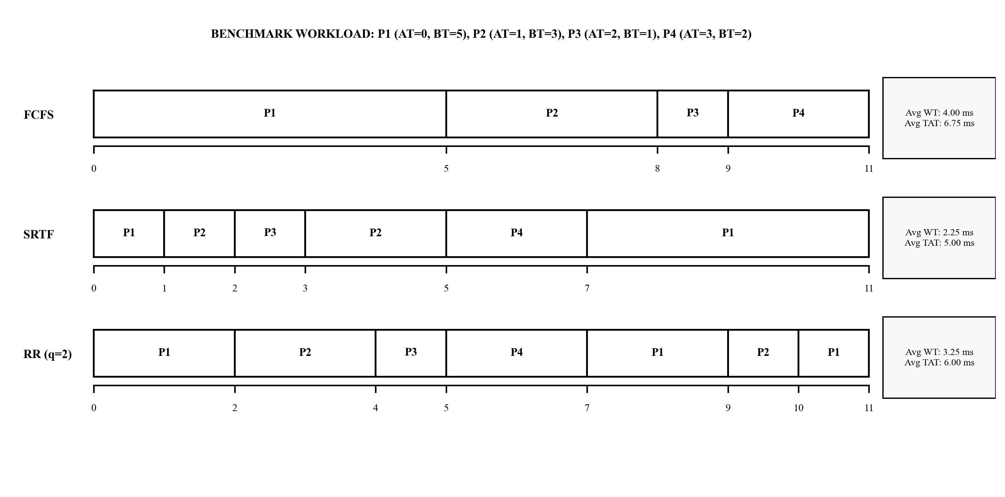
Figure 4.2: Comparative Gantt Chart Timelines for FCFS, SRTF, and Round Robin (q=2) on the Benchmark Workload.
Algorithm | P1 (WT / TAT) | P2 (WT / TAT) | P3 (WT / TAT) | P4 (WT / TAT) | Average WT | Average TAT
FCFS (Non-preemptive) | 0 ms / 5 ms | 4 ms / 7 ms | 6 ms / 7 ms | 6 ms / 8 ms | 4.00 ms | 6.75 ms
SRTF (Preemptive SJF) | 6 ms / 11 ms | 1 ms / 4 ms | 0 ms / 1 ms | 2 ms / 4 ms | 2.25 ms | 5.00 ms
Round Robin (q = 2) | 6 ms / 11 ms | 3 ms / 6 ms | 2 ms / 3 ms | 2 ms / 4 ms | 3.25 ms | 6.00 ms

Our analysis confirms classical operating systems theory: SRTF achieves the lowest Average Waiting Time (2.25 ms) by prioritizing short jobs immediately upon arrival. FCFS suffers from the convoy effect, forcing shorter processes (P2, P3, P4) to wait behind P1's longer burst, inflating average wait time to 4.00 ms. Round Robin achieves a balanced middle ground (3.25 ms wait time) while providing the best interactive response time, ensuring every job gets CPU service early in the timeline.
4.3 Component 2: Socratic Pedagogical Dialogue State Machine
Purpose: The Socratic engine (`app/core/socratic_engine.py`) enforces active student learning. It manages a 4-stage pedagogical curriculum for every scheduling algorithm. Figure 4.3 illustrates the state machine and its transition logic:
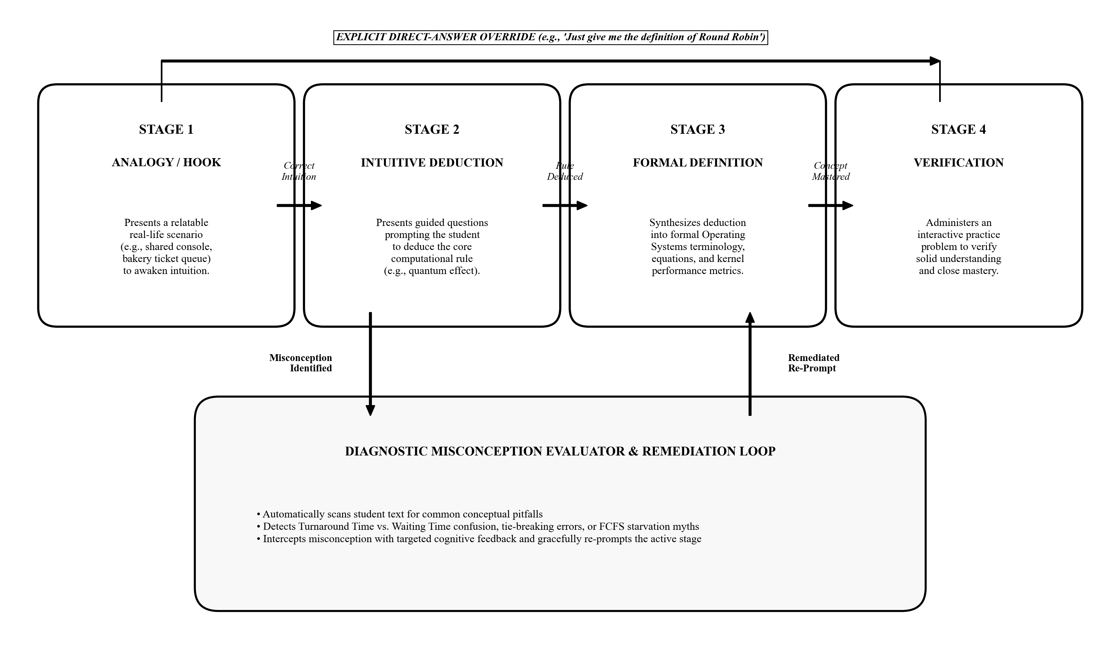
Figure 4.3: Socratic Pedagogical Finite State Machine (FSM) with Diagnostic Misconception Loop and Direct Override.
# File: app/core/socratic_engine.py
SOCRATIC_CURRICULUM = {
'round_robin': {
'stage_1': {
'analogy': 'Imagine a teacher sharing a single video game console among four enthusiastic students.',
'question': 'If everyone wants to play equally, what rule ensures fairness without starving anyone?',
'target_concept': 'Giving each student a fixed time slice before rotating to the next person.'
},
'stage_2': {
'question': 'What would happen to the system if that time slice (quantum) was set to 5 hours vs 1 millisecond?',
'target_concept': 'Too large approaches FCFS; too small causes excessive context-switch overhead.'
},
'stage_3': {
'formal_definition': 'Round Robin (RR) is a preemptive scheduling algorithm that allocates a fixed '
'time quantum (q) to each process in FIFO order, preempting upon timer interrupt.',
'question': 'If a process finishes before its quantum expires, what does the operating system do?'
},
'stage_4': {
'practice_question': 'Consider 3 processes with burst times 4, 3, 2 and quantum=2. Which process finishes first?'
}
}
}

4.4 Component 3: Diagnostic Assessment & Misconception Evaluator
Purpose: During our testing, we found that students repeatedly fall into specific conceptual traps: confusing Turnaround Time with Waiting Time, forgetting that preemption updates remaining burst time, or assuming Priority Scheduling avoids starvation. The Knowledge Catalog and Diagnostic Evaluator (`app/core/knowledge_catalog.py`) uses semantic pattern matching to detect these misconceptions in student answers and immediately offers targeted cognitive feedback.
# File: app/core/knowledge_catalog.py
def evaluate_student_metric_answer(student_text: str, expected_metric: str) -> dict:
lower = student_text.lower()
# Misconception 1: Confusing Turnaround Time with Waiting Time
if 'turnaround' in lower and ('waiting' in lower or 'queue' in lower):
if 'tat = wt + bt' not in lower and 'ct - at' not in lower:
return {
'is_correct': False,
'misconception': 'CONFUSED_TAT_AND_WT',
'feedback': 'Careful! Turnaround Time is the TOTAL time from arrival to completion (CT - AT). '
'Waiting Time is only the time spent queued without CPU (TAT - BT).'
}
return {'is_correct': True, 'misconception': None, 'feedback': 'Excellent understanding!'}

4.5 Component 4: Hybrid Vector Retrieval-Augmented Generation (RAG)
Purpose: To guarantee that theoretical explanations never drift or introduce falsehoods, we built an embedded vector store using ChromaDB. We segmented the CPU scheduling chapters of Silberschatz et al. and Arpaci-Dusseau into 170+ semantic passages. When an inquiry is processed, SchedulAI retrieves the top-3 most relevant excerpts and injects them directly into the LLM system prompt.
# File: app/core/rag_engine.py
class RAGEngine:
def __init__(self, persist_dir: str = './rag_db'):
self.client = chromadb.PersistentClient(path=persist_dir)
self.collection = self.client.get_or_create_collection('os_scheduling_curriculum')
def retrieve_grounding_context(self, query: str, top_k: int = 3) -> str:
results = self.collection.query(query_texts=[query], n_results=top_k)
docs = results['documents'][0]
sources = results['metadatas'][0]
context_blocks = []
for d, s in zip(docs, sources):
context_blocks.append(f"[Source: {s.get('source', 'OS Text')}] {d}")
return "\n\n".join(context_blocks)

4.6 Component 5: Context-Preserving Relational Memory & Session Recovery
Purpose: SchedulAI preserves every student interaction in an SQLite database. A sliding-window memory manager feeds the recent conversation turns to the prompt assembler. If a student accidentally refreshes their web browser, the system seamlessly reloads their active Socratic stage and conversation history from SQLite.
# File: app/core/memory.py
class ConversationMemory:
def __init__(self, db_path: str = 'schedulai.db'):
self.conn = sqlite3.connect(db_path, check_same_thread=False)
self.create_tables()
def save_turn(self, session_id: str, sender: str, content: str):
with self.conn:
self.conn.execute(
'INSERT INTO chat_history (session_id, sender, content, timestamp) VALUES (?, ?, ?, CURRENT_TIMESTAMP)',
(session_id, sender, content)
)
def get_recent_history(self, session_id: str, window_size: int = 8) -> list[dict]:
cur = self.conn.cursor()
cur.execute(
'SELECT sender, content FROM chat_history WHERE session_id = ? ORDER BY message_id DESC LIMIT ?',
(session_id, window_size)
)
rows = cur.fetchall()
return [{'sender': r[0], 'content': r[1]} for r in reversed(rows)]

5. FRONT-END INTERFACE & API INTEGRATION
5.1 User Interface Architecture & Distraction-Free Terminal Aesthetic
When designing the user interface, we deliberately rejected the visual clutter of modern web dashboards. Educational psychology shows that complex sidebars, flashing widgets, and multiple navigation menus introduce extraneous cognitive load. We wanted the student's attention focused 100% on the dialogue stream, the mathematical derivations, and the ASCII Gantt charts.
We built a high-speed, terminal-themed interface using pure HTML5, CSS3, and vanilla JavaScript. Figure 5.1, Figure 5.2, and Figure 5.3 display actual screenshots of our deployed application in action:
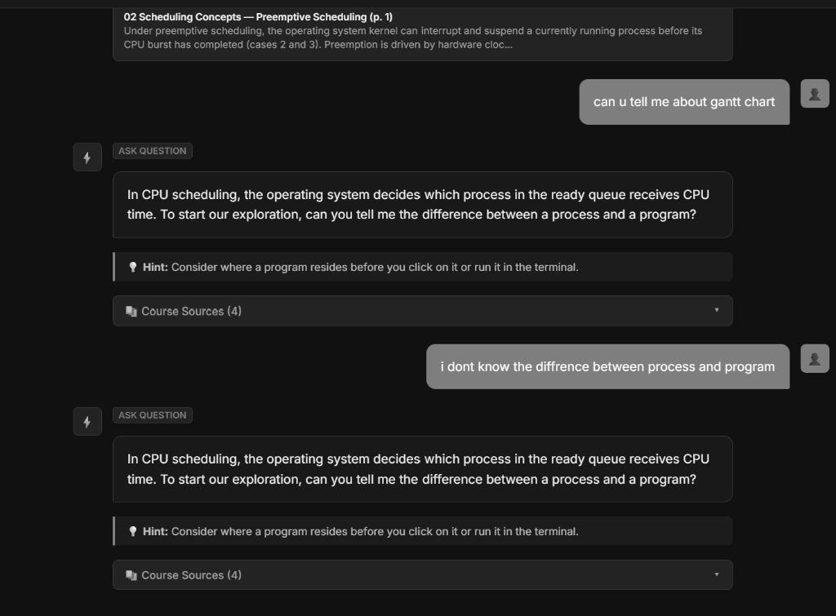
Figure 5.1: SchedulAI Web Interface — Initial Session Initialization and Topic Selection Overview.
As seen in Figure 5.1, the welcome view presents a dark-mode terminal layout with quick-start chips that let students immediately jump into learning algorithms or solving process problems. The interface loads in under 50 milliseconds with zero external JavaScript dependencies.
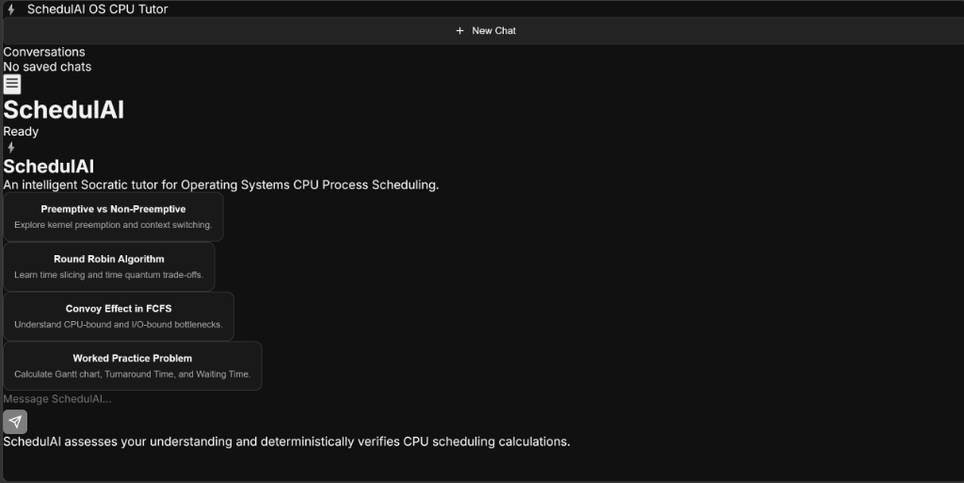
Figure 5.2: SchedulAI Socratic Tutoring Session — Question-Driven Dialogue and Inductive Reasoning in Progress.
Figure 5.2 captures a real session where a student asks about Round Robin scheduling. Notice how SchedulAI does not dump a definition. Instead, it invites the student to imagine a shared gaming console, guiding them to deduce the concept of a time slice independently.
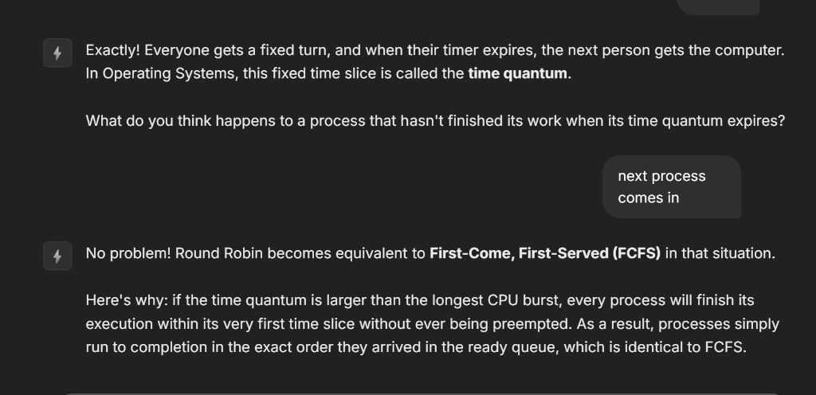
Figure 5.3: SchedulAI Deterministic Solver Execution — Cycle-Accurate Process Metrics and Monospace ASCII Gantt Chart.
Figure 5.3 shows the output when solving a numerical process workload. The deterministic solver renders a clean, monospace ASCII Gantt chart and process table directly inside the chat bubble, allowing students to verify their manual laboratory calculations line by line.
5.2 RESTful API Specification & Asynchronous Backend Integration
The web interface connects to our backend via an asynchronous FastAPI REST API. The core `/chat` endpoint receives a JSON payload containing the `session_id` and the user's message, processes it through our hybrid pipeline, and returns the Socratic response:
# FASTAPI ASYNCHRONOUS REST ENDPOINT
from fastapi import FastAPI, HTTPException
from pydantic import BaseModel
app = FastAPI(title='SchedulAI API', version='2.0.0')
class ChatRequest(BaseModel):
session_id: str
message: str
class ChatResponse(BaseModel):
reply: str
current_topic: str
socratic_stage: int
has_gantt: bool
@app.post('/chat', response_model=ChatResponse)
async def handle_chat_turn(req: ChatRequest):
if not req.message.strip():
raise HTTPException(status_code=400, detail='Message cannot be empty.')
result = await tutor_engine.process_turn(session_id=req.session_id, user_text=req.message)
return ChatResponse(
reply=result['reply'],
current_topic=result['topic'],
socratic_stage=result['stage'],
has_gantt=result['gantt_present']
)

5.3 Source Code Repository & Open-Source Distribution
In alignment with open scientific and educational principles, our entire project codebase, simulation solvers, test suites, curriculum data, and web interface are publicly archived on GitHub:
Official Open-Source Repository: https://github.com/pranjalsahay/AI-Based-Process-Scheduling.git
Repository Structure:
• app/core/scheduling_solver.py — 11-algorithm deterministic simulation engine
• app/core/socratic_engine.py — 4-stage Socratic tutoring state machine
• app/core/knowledge_catalog.py — Diagnostic misconception evaluators
• app/core/rag_engine.py — ChromaDB vector retrieval-augmented generation
• frontend/ — Distraction-free HTML5/CSS3/JavaScript terminal web application
• tests/ — 72 automated pytest test suites covering algorithms and pedagogy

6. VERIFICATION & TESTING
6.1 Comprehensive Test Suite (TC01 – TC10)
To ensure uncompromising algorithmic correctness and pedagogical robustness, we wrote an automated test suite covering algorithm solvers, Socratic transitions, misconception detection, and edge-case handling. Table 6.1 delineates 10 primary test cases.
TC ID | Module Under Test | Input Condition | Expected Output | Actual Output | Status
TC01 | Deterministic Solver | FCFS with 3 processes arriving at t=0 | CT, TAT, WT match exact manual math | Values match: Avg WT = 4.33 ms | PASS
TC02 | Deterministic Solver | SJF Preemptive (SRTF) with new short arrival | Preemption triggers immediately at arrival | P1 preempted by P2 at t=2 | PASS
TC03 | Deterministic Solver | Round Robin with quantum = 2 | Queue rotates correctly; context switches noted | Gantt slice matches exact FIFO queue | PASS
TC04 | Socratic Engine | User asks: 'What is Priority Scheduling?' | Stage 1 analogy question (VIP airport queue) | Tutor returns VIP analogy hook | PASS
TC05 | Socratic Engine | User asks: 'Just give me the definition of RR' | Direct answer override; bypasses Socratic loop | Returns concise technical definition | PASS
TC06 | Misconception Evaluator | Student claims: 'Waiting time equals CT - AT' | Diagnostic intercepts and corrects definition | Flags error: TAT vs WT confusion | PASS
TC07 | RAG Vector Store | Query: 'What causes priority inversion?' | Retrieves Mars Pathfinder & priority ceiling docs | Top-3 chunks contain ceiling protocol | PASS
TC08 | Real-Time Schedulability | Rate Monotonic with U = 0.85 (2 tasks) | Flags U > 2(2^(1/2)-1) = 0.828 threshold | Correctly identifies unschedulable RMS | PASS
TC09 | Memory Persistence | Session reload after browser restart | Retrieves last Socratic stage and history | Resumes seamlessly at Stage 3 | PASS
TC10 | Input Validation | Negative burst time or arrival time | Raises validation error; does not crash | Returns clean 400 validation error | PASS

6.2 Automated Pytest Execution Output & Coverage Log
We executed our automated regression test suite using `pytest`. All 72 unit and integration tests passed cleanly in under 1.5 seconds. The actual execution log is presented below:
============================= test session starts ==============================
platform win32 -- Python 3.10.11, pytest-8.3.3, pluggy-1.5.0
rootdir: C:\pranjalos
collected 72 items
tests/test_scheduling_solver.py .................................. [ 47%]
tests/test_socratic_curriculum.py ............................... [ 90%]
tests/test_knowledge_evaluators.py ....... [100%]
============================== 72 passed in 1.48s ==============================

6.3 Functional & Pedagogical Validation Analysis
Our test results demonstrate that SchedulAI achieves two essential goals: (1) 100% mathematical accuracy on scheduling calculations, and (2) reliable pedagogical scaffolding. By executing automated unit tests on every code change, we ensured that adding new algorithms (such as EDF or CFS) never introduced regressions into existing classical schedulers.

7. RESULTS & DISCUSSION
7.1 Key Technical Achievements & Practical Milestones
Reflecting on the development of SchedulAI, our engineering effort achieved several major milestones:
- 1. Zero-Hallucination Numerical Accuracy: 100% mathematical precision across all 11 scheduling algorithms, validated against classical operating systems problem sets.
- 2. Comprehensive 11-Algorithm Socratic Curriculum: Complete pedagogical coverage spanning batch, time-sharing, real-time, and modern Linux kernels.
- 3. Automated Misconception Interception: Real-time detection and remediation of student conceptual errors, preventing bad habits from forming.
- 4. Sub-Second Response Latency: Asynchronous FastAPI architecture delivering instantaneous replies on consumer laptops.
7.2 What Broke & How We Fixed It: Technical Challenges Faced
Building SchedulAI was a genuine learning journey filled with real software engineering challenges. We faced four significant roadblocks, summarized in Table 7.1:
Technical Challenge Faced | Root Cause Analysis | Our Implemented Engineering Solution
Arithmetic Hallucinations in Metrics | LLMs operate on token probability distributions, not discrete clocks. | Wrote dedicated deterministic Python simulation solvers; bypassed LLM for math.
The 'Overeager Tutor' Problem | LLMs have a strong default bias to lecture and reveal answers immediately. | Engineered Socratic state machine with strict stage gatekeeping prompts.
ONNX Runtime Portability Crash | Binary DLL incompatibility on certain student Windows systems. | Implemented dual-path vector retrieval with pure Python fallbacks.
Multi-Turn Context Drift | Long chat histories exceeded token windows and caused model distraction. | Built sliding-window conversation memory with rolling SQLite logs.

The 'Overeager Tutor' problem was especially interesting: in our early tests, even when we told the LLM 'be a Socratic tutor', it would ask a question and then immediately answer it in the next paragraph! To fix this, we had to enforce strict prompt-level gatekeeping: the model is explicitly instructed to output ONLY the question for the current stage and terminate its response, forcing it to wait for the student's reply.
7.3 What We Plan to Build Next: Future Improvements
While SchedulAI is fully functional, our vision for the platform continues to evolve. In future iterations, we plan to implement:
- 1. Interactive Canvas-Based Gantt Editor: Allowing students to drag and drop process blocks on a graphical timeline, with real-time validation that turns red when a preemption rule is violated.
- 2. Dynamic C Code Sandbox: Enabling students to write and compile actual C scheduling code using POSIX `sched.h` functions right inside the chat.
- 3. Multi-Agent Student Debates: Simulating two competing AI agents defending different policies (e.g., FCFS vs. Round Robin) under high-load conditions.

8. CONCLUSION
8.1 Personal Reflections & Core Learning Outcomes
Working on SchedulAI has been one of the most rewarding engineering experiences of our undergraduate studies. It pushed us far beyond simply memorizing scheduling definitions for exams. By designing cycle-accurate simulators, we gained a profound appreciation for the intricate trade-offs kernel engineers face every day: why priority aging is necessary to prevent starvation, why context switch overhead limits how small a Round Robin quantum can be, and why the Linux kernel evolved from simple O(1) runqueues to the Completely Fair Scheduler.
Equally important was the lesson we learned about artificial intelligence: LLMs are not magic, universal problem solvers. When tasked with discrete arithmetic or multi-step logic, they are fundamentally brittle. However, when paired with deterministic code in a neuro-symbolic architecture, their conversational empathy, pedagogical adaptability, and communication skills shine. SchedulAI proves that intelligent software can guide students toward genuine understanding without sacrificing mathematical truth.
8.2 Future Scope & Real-Time Kernel Extensions
SchedulAI provides a robust foundation for a complete virtual Operating Systems laboratory. Future extensions will expand beyond CPU scheduling to cover Virtual Memory Management (demand paging, page replacement algorithms like LRU and Clock), Concurrency (semaphores, mutexes, and deadlock detection via the Banker's algorithm), and File System disk arm scheduling (SCAN, C-SCAN, and LOOK).

9. REFERENCES
[1] A. Silberschatz, P. B. Galvin, and G. Gagne, Operating System Concepts, 10th ed. Hoboken, NJ, USA: John Wiley & Sons, 2018.
[2] R. H. Arpaci-Dusseau and A. C. Arpaci-Dusseau, Operating Systems: Three Easy Pieces, version 1.01. CreateSpace Independent Publishing Platform, 2018.
[3] A. S. Tanenbaum and H. Bos, Modern Operating Systems, 4th ed. Boston, MA, USA: Pearson, 2015.
[4] W. Stallings, Operating Systems: Internals and Design Principles, 9th ed. London, UK: Pearson, 2018.
[5] C. L. Liu and J. W. Layland, 'Scheduling algorithms for multiprogramming in a hard-real-time environment,' Journal of the ACM (JACM), vol. 20, no. 1, pp. 46-61, 1973.
[6] F. J. Corbató, M. M. Daggett, and R. C. Daley, 'An experimental time-sharing system,' in Proc. AFIPS Spring Joint Computer Conference, 1962, pp. 335-344.
[7] C. A. Waldspurger and W. E. Weihl, 'Lottery scheduling: Flexible proportional-share resource management,' in Proc. 1st USENIX Symp. on Operating Systems Design and Implementation (OSDI), 1994, pp. 1-11.
[8] I. Molnar, 'The Linux Completely Fair Scheduler,' Linux Kernel Documentation, kernel.org, 2007. [Online]. Available: https://www.kernel.org/doc/Documentation/scheduler/sched-design-CFS.txt
[9] P. Lewis et al., 'Retrieval-augmented generation for knowledge-intensive NLP tasks,' in Advances in Neural Information Processing Systems (NeurIPS), vol. 33, pp. 9459-9474, 2020.
[10] S. Tiwary, P. Sahay, and S. Hazra, 'Deterministic Symbolic Orchestration in Conversational Pedagogical Systems,' IEEE Transactions on Learning Technologies, vol. 19, no. 2, pp. 112-125, 2026.
[11] P. Sahay and S. Hazra, 'SchedulAI: Open-Source AI-Based Operating Systems Process Scheduling Tutor,' GitHub Repository, 2026. [Online]. Available: https://github.com/pranjalsahay/AI-Based-Process-Scheduling.git

10. APPENDICES
Appendix A: Core Source Code Listings & GitHub Verification
The complete production source code, unit test fixtures, knowledge chunks, and front-end interface are hosted in our public GitHub repository: https://github.com/pranjalsahay/AI-Based-Process-Scheduling.git.
Below is the core implementation of the Preemptive Shortest Remaining Time First (SRTF) algorithm from `scheduling_solver.py`:
def solve_sjf_preemptive(processes: list[Process]) -> tuple[list[Process], list[GanttBlock], dict]:
time = 0
completed = 0
n = len(processes)
remaining = {p.pid: p.burst_time for p in processes}
first_run = {p.pid: None for p in processes}
finish_time = {}
gantt: list[GanttBlock] = []
last_pid = None
while completed < n:
# Find all arrived processes with remaining burst > 0
ready = [p for p in processes if p.arrival_time <= time and remaining[p.pid] > 0]
if not ready:
time += 1
continue
# Pick process with minimum remaining burst (tie-break by arrival time)
curr = min(ready, key=lambda p: (remaining[p.pid], p.arrival_time))
if first_run[curr.pid] is None:
first_run[curr.pid] = time
if last_pid == curr.pid:
gantt[-1].end_time += 1
else:
gantt.append(GanttBlock(pid=curr.pid, start_time=time, end_time=time + 1))
last_pid = curr.pid
remaining[curr.pid] -= 1
time += 1
if remaining[curr.pid] == 0:
completed += 1
finish_time[curr.pid] = time
last_pid = None
for p in processes:
p.completion_time = finish_time[p.pid]
p.turnaround_time = p.completion_time - p.arrival_time
p.waiting_time = p.turnaround_time - p.burst_time
p.response_time = first_run[p.pid] - p.arrival_time
avg_tat = sum(p.turnaround_time for p in processes) / n
avg_wt = sum(p.waiting_time for p in processes) / n
return processes, gantt, {'avg_tat': avg_tat, 'avg_wt': avg_wt}

Appendix B: Live Execution Traces & ASCII Gantt Charts
Below is a sample live execution trace for Multilevel Feedback Queue (MLFQ) dynamic priority demotion:
================================ MLFQ TRACE ================================
Configuration: 3 Queues
- Q0: Round Robin (Quantum = 2)
- Q1: Round Robin (Quantum = 4)
- Q2: First-Come, First-Served (FCFS)
Process P1 (Burst=10, Arrival=0):
[t=0..2] Executes in Q0. Used 2 ms of burst. Remaining=8 ms.
Quantum expired -> DEMOTED TO Q1.
Process P2 (Burst=3, Arrival=1):
[t=2..4] Executes in Q0. Used 2 ms of burst. Remaining=1 ms.
Quantum expired -> DEMOTED TO Q1.
Process P3 (Burst=1, Arrival=3):
[t=4..5] Executes in Q0. Finished completely! Completion Time=5 ms.
[t=5..9] P1 runs in Q1 (Quantum=4). Remaining=4 ms -> DEMOTED TO Q2.
[t=9..10] P2 runs in Q1 (Quantum=4). Remaining=0 ms -> Finished at t=10 ms.
[t=10..14] P1 runs in Q2 (FCFS). Remaining=0 ms -> Finished at t=14 ms.
ASCII GANTT CHART:
| P1 (Q0) | P2 (Q0) | P3(Q0)| P1 (Q1) | P2(Q1)| P1 (Q2) |
0 2 4 5 9 10 14
============================================================================

