VELLORE INSTITUTE OF TECHNOLOGY, VELLORE
School of Computer Science and Engineering (SCOPE)
MINI PROJECT REPORT
SchedulAI: An Intelligent Socratic AI Tutor and Deterministic Simulation Engine for Operating Systems CPU Process Scheduling
Course Code: BCSE303P – Operating Systems Laboratory
Open-Source Repository: https://github.com/pranjalsahay/AI-Based-Process-Scheduling.git
Submitted by
S. No. | Name of Candidate | Registration Number
1 | Pranjal Sahay | 24BKT0082
2 | Shubham Hazra | 24BKT0111

Under the guidance of
Prof. Jagalingam P
Associate Professor, School of Computer Science and Engineering (SCOPE)
Vellore Institute of Technology, Vellore
Date of Submission: 23 / 10 / 2026

CERTIFICATE
This is to certify that the Mini Project Report titled "SchedulAI: An Intelligent Socratic AI Tutor and Deterministic Simulation Engine for Operating Systems CPU Process Scheduling" submitted by Pranjal Sahay (Reg. No. 24BKT0082) and Shubham Hazra (Reg. No. 24BKT0111) in partial fulfilment of the requirements of the laboratory course BCSE303P – Operating Systems Laboratory, is a bonafide record of original academic, instructional, and technical work carried out under my direct supervision and guidance during the Fall Semester 2026–27 at the School of Computer Science and Engineering (SCOPE), Vellore Institute of Technology, Vellore. The software components, deterministic scheduling simulation models, Socratic dialogue state machines, and experimental verifications documented herein have been executed, tested, and validated to satisfy all prescribed curricular and institutional requirements. The associated software codebase is publicly archived and reproducible via GitHub: https://github.com/pranjalsahay/AI-Based-Process-Scheduling.git.
Signature of the Faculty Guide
Prof. Jagalingam P
Associate Professor, SCOPE
VIT, Vellore
Place: Vellore
Date: 23 / 10 / 2026

ABSTRACT
CPU process scheduling constitutes the computational heartbeat of multi-programmed kernel architectures, directly governing processor utilization, computational throughput, task turnaround latency, and fair resource sharing among concurrent threads. In contemporary computer science and engineering education, students frequently encounter severe cognitive hurdles when learning the dynamic mechanics of preemptive execution, complex multi-variable tie-breaking heuristics, and rigorous numerical performance evaluations. While general-purpose Large Language Models (LLMs) are widely consulted by undergraduate students, empirical analysis demonstrates that they suffer from two fatal pedagogical flaws: passive information dumping (reciting exhaustive textbook solutions rather than cultivating student understanding) and stochastic arithmetic hallucinations when tracing scheduling timelines and calculating metrics. This project presents SchedulAI, an enterprise-grade Socratic AI tutoring system and deterministic scheduling simulation engine developed specifically for the BCSE303P Operating Systems Laboratory curriculum. SchedulAI decouples pedagogical discourse from arithmetic calculation through a hybrid neuro-symbolic architecture: a 4-stage Socratic dialogue state machine (Hook/Analogy, Intuitive Deduction, Technical Formalization, Verification) guides conceptual discovery, while a pure Python symbolic engine guarantees zero-hallucination, cycle-accurate simulation across 11 classic, real-time, and modern scheduling algorithms (FCFS, SJF Non-preemptive, SJF Preemptive/SRTF, Priority Non-preemptive, Priority Preemptive, Round Robin, Multilevel Queue, Multilevel Feedback Queue, Lottery Scheduling, Stride Scheduling, Rate Monotonic Scheduling, Earliest Deadline First, and the Linux Completely Fair Scheduler). Anchored by a 170-chunk ChromaDB vector store of authoritative literature and persistent SQLite conversation memory, SchedulAI actively diagnoses student misconceptions, generates precise monospace ASCII Gantt charts, and conducts adaptive numerical assessments. Validated across 72 automated test suites with 100% pass rates, SchedulAI transforms passive educational querying into an active, verified, and deeply humanized learning dialogue.
Keywords: Operating Systems, CPU Process Scheduling, Socratic Tutoring, Deterministic Simulation Engine, Retrieval-Augmented Generation (RAG), ASCII Gantt Visualization, Misconception Diagnosis, Open-Source Education.
Project Repository & Replication Code: https://github.com/pranjalsahay/AI-Based-Process-Scheduling.git

TABLE OF CONTENTS
Section | Title / Chapter Description | Page
 | Certificate of Original Work | 2
 | Abstract & Curricular Keywords | 3
1 | INTRODUCTION | 5
1.1 | Problem Statement in Operating Systems Pedagogy | 5
1.2 | Pedagogical Philosophy: Socratic Tutoring vs Information Dumps | 6
1.3 | Project Objectives | 6
1.4 | Theoretical Foundation & Importance of Operating Systems CPU Scheduling | 7
1.5 | Scope of the Project & Comprehensive Algorithm Taxonomy | 8
2 | SYSTEM REQUIREMENTS & ENVIRONMENT ARCHITECTURE | 9
2.1 | Hardware Requirements | 9
2.2 | Software Stack & Dependency Specifications | 9
2.3 | Architectural Trade-Off Analysis & Engineering Rationales | 10
3 | SYSTEM ARCHITECTURE & OS SCHEDULING DESIGN | 11
3.1 | High-Level System Architecture & Processing Pipeline | 11
3.2 | Operating Systems Process Lifecycle & State Transitions | 12
3.3 | Process Control Block (PCB) & Kernel Queue Data Structures | 13
3.4 | Core Mathematical Formulations & Rigorous Theoretical Derivations | 14
3.5 | Relational Schema for Tutoring & Assessment State (3NF Normalization) | 16
4 | IMPLEMENTATION OF CORE SYSTEM COMPONENTS | 17
4.1 | Component 1: Deterministic Scheduling Solver & ASCII Gantt Engine | 17
4.2 | Comparative Algorithmic Benchmark & Gantt Analysis | 18
4.3 | Component 2: Socratic Pedagogical Dialogue State Machine | 20
4.4 | Component 3: Diagnostic Assessment & Misconception Evaluator | 21
4.5 | Component 4: Hybrid Vector Retrieval-Augmented Generation (RAG) | 22
4.6 | Component 5: Context-Preserving Relational Memory & Session Recovery | 23
5 | FRONT-END INTERFACE & API INTEGRATION | 24
5.1 | User Interface Architecture & Distraction-Free Terminal Aesthetic | 24
5.2 | RESTful API Specification & Asynchronous Backend Integration | 26
5.3 | Source Code Repository & Open-Source Distribution | 26
6 | VERIFICATION & TESTING | 27
6.1 | Comprehensive Test Suite (TC01 – TC10) | 27
6.2 | Automated Pytest Execution Output & Coverage Log | 28
6.3 | Functional & Pedagogical Validation Analysis | 28
7 | RESULTS & DISCUSSION | 29
7.1 | Key System Achievements & Performance Benchmarks | 29
7.2 | Technical Challenges Faced & Engineering Solutions | 29
7.3 | Future Engineering Improvements | 31
8 | CONCLUSION | 32
8.1 | Summary of Technical & Pedagogical Learning Outcomes | 32
8.2 | Future Scope & Real-Time Kernel Extensions | 32
9 | REFERENCES | 33
10 | APPENDICES | 34
10.1 | Appendix A: Core Source Code Listings & GitHub Verification | 34
10.2 | Appendix B: Live Execution Traces & ASCII Gantt Charts | 35

1. INTRODUCTION
1.1 Problem Statement in Operating Systems Pedagogy
Operating systems form the fundamental abstraction layer governing modern computation, enabling diverse hardware resources—such as processors, volatile memory, persistent storage arrays, and network interfaces—to be shared securely, efficiently, and concurrently among competing application processes. Central to this abstraction is the CPU process scheduler, which determines the exact sequence, priority, and duration in which ready processes obtain execution time on physical cores. Despite its foundational importance across computer science and software engineering curricula, CPU process scheduling is notoriously challenging for undergraduate students to master. The discipline demands that learners mentally maintain multi-variable state transitions across asynchronous time domains, evaluate complex tie-breaking heuristics, trace dynamic preemption boundaries, and compute precise numerical performance metrics—including Completion Time (CT), Turnaround Time (TAT), Waiting Time (WT), and Response Time (RT).
Historically, instruction has relied upon static textbook diagrams and lecture presentations. While seminal textbooks such as Silberschatz et al. and Arpaci-Dusseau provide rigorous theoretical treatments, they present fixed, non-interactive problem sets. When students attempt novel problem variations, they lack immediate, diagnostic feedback to identify why their manual trace diverged from the optimal schedule. Did they miscalculate the remaining burst time during preemption? Did they improperly tie-break by PID rather than arrival time? Did they conflate Waiting Time with Turnaround Time? Conventional laboratory instruction cannot scale individualized, step-by-step diagnostic tutoring to hundreds of enrolled students simultaneously.
With the recent emergence of conversational Large Language Models (LLMs), students increasingly turn to generative chatbots for guidance. However, empirical investigation reveals that general-purpose LLMs exhibit two fatal flaws when applied to technical systems education:
- 1. Passive Information Dumping: When a student asks a conceptual question such as 'What is Round Robin scheduling?', an unmodified LLM immediately generates an encyclopedic response covering definitions, algorithmic mechanics, equations, advantages, and disadvantages. This pedagogical approach robs the learner of cognitive engagement, encouraging superficial skimming rather than deep conceptual internalization.
- 2. Stochastic Arithmetic & Algorithmic Hallucination: Autoregressive language models do not possess underlying execution engines; they predict the most probable next token based on statistical correlations learned over training corpora. Consequently, when presented with numerical scheduling problems (e.g., computing waiting times for four processes under Shortest Remaining Time First), LLMs frequently generate fictitious Gantt charts, miscalculate context switch timestamps, and output mathematically impossible metrics with complete synthetic confidence.
Consequently, there is an urgent educational imperative for an intelligent, neuro-symbolic tutoring platform that enforces active Socratic inquiry, grounds conceptual explanations in authoritative academic literature, and delegates numerical problem solving to a mathematically rigorous, zero-hallucination deterministic simulation engine.
1.2 Pedagogical Philosophy: Socratic Tutoring vs Information Dumps
Educational research grounded in Bloom's Revised Taxonomy and Sweller's Cognitive Load Theory demonstrates that true conceptual mastery cannot be achieved through passive reception of pre-packaged solutions. Learning complex systems concepts requires active retrieval, cognitive disequilibrium, and guided inductive reasoning. SchedulAI is engineered around the core pedagogical tenet: 'Never confuse presenting information with helping someone understand it.'
When a student asks about a CPU scheduling algorithm, SchedulAI does not recite textbook definitions. Instead, it initiates a 4-stage Socratic dialogue: (1) it anchors the concept in a relatable real-life analogy (e.g., sharing a game console or waiting in a bakery queue); (2) it poses guided questions prompting the student to deduce the underlying computational rule; (3) it formalizes the deduced concept into formal operating systems terminology; and (4) it verifies comprehension through interactive practice problems and targeted diagnostic feedback.
1.3 Project Objectives
To address the pedagogical and algorithmic deficiencies of existing educational tools, this project realizes five core objectives:
- • Objective 1 — Deterministic Multi-Algorithm OS Simulation Engine: Implement a high-performance, zero-hallucination Python simulation engine supporting 11 foundational, real-time, and modern CPU scheduling algorithms (FCFS, SJF Non-preemptive, SJF Preemptive/SRTF, Priority Non-preemptive, Priority Preemptive, Round Robin, Multilevel Queue, Multilevel Feedback Queue, Lottery, Stride, Rate Monotonic, Earliest Deadline First, and Linux CFS), generating complete execution traces, exact metrics, and monospace ASCII Gantt charts.
- • Objective 2 — Multi-Stage Socratic Tutoring State Machine: Design and enforce a 4-stage conversational pedagogical loop (Stage 1: Real-Life Analogy / Hook; Stage 2: Intuitive Deduction; Stage 3: Technical Formalization; Stage 4: Verification & Practice) that actively questions the student, verifies comprehension before advancing, and respects explicit direct-answer overrides.
- • Objective 3 — Hybrid Vector Retrieval-Augmented Generation (RAG): Build and embed a domain-specific vector knowledge store using ChromaDB containing 170+ curated technical chunks from authoritative operating systems literature, ensuring all theoretical explanations are grounded, verifiable, and free from generative drift.
- • Objective 4 — Relational Learning State & Conversational Memory: Develop a persistent SQLite relational storage layer and sliding-window memory system that tracks student learning state, logs identified misconceptions, records diagnostic evaluation scores, and maintains multi-turn context.
- • Objective 5 — Responsive Full-Stack Web Architecture: Deliver a clean, terminal-inspired responsive web interface communicating via a high-throughput FastAPI RESTful backend, ensuring seamless message dispatch, dynamic ASCII Gantt chart rendering, and sub-second latency.
1.4 Theoretical Foundation & Importance of Operating Systems CPU Scheduling
In a modern multi-programmed computing system, the central processing unit represents the most precious shared computational resource. The CPU scheduler is the kernel subsystem that allocates processor core cycles among runnable processes and threads. Its mathematical and architectural significance is rooted in four foundational systems principles:
- 1. Process Behavior & CPU Burst Distributions: Processes alternate between CPU execution bursts (active arithmetic, logic, and data manipulation) and I/O bursts (waiting on disk reads, socket transmissions, or user keystrokes). Empirical systems measurements show that CPU burst durations exhibit an exponential frequency distribution: the overwhelming majority of bursts are very short (1–5 ms, associated with interactive or I/O-bound tasks), while a small fraction of compute-bound batch tasks generate extended bursts (hundreds of milliseconds). An effective scheduler must prioritize short bursts to keep peripheral buses fully saturated while maintaining fair progress for long computations.
- 2. Multiprogramming & Core Utilization: By interleaving CPU bursts with I/O wait states, multiprogramming ensures that the physical processor remains continuously occupied. When one thread stalls on an external memory transaction, the short-term scheduler dispatches a runnable thread, elevating aggregate system utilization toward 100%.
- 3. Conflicting Scheduling Criteria: Operating systems cannot optimize all performance dimensions simultaneously; trade-offs are mathematically inevitable. Maximizing throughput (completed jobs per unit time) favors non-preemptive batch algorithms (e.g., FCFS or SJF) that eliminate context-switch overhead. Conversely, minimizing response latency for interactive desktop applications demands aggressive time-slicing (e.g., Round Robin with small quanta), which incurs non-trivial context switch costs. SchedulAI models and teaches these fundamental trade-offs.
- 4. Real-Time Deadlines & Schedulability Guarantees: In cyber-physical systems, industrial robotics, and avionics, correctness depends not only on computational output but also on the absolute timestamp at which that output is delivered. Schedulers must enforce deterministic upper bounds on task execution times using rigorous mathematical proofs (e.g., Liu-Layland utilization bounds for Rate Monotonic Scheduling).
1.5 Scope of the Project & Comprehensive Algorithm Taxonomy
The project scope encompasses the complete end-to-end architecture of SchedulAI, spanning the deterministic scheduling solver, the Socratic dialogue state machine, the hybrid vector RAG store, the conversational memory layer, and the web interface. The algorithms supported and their operational taxonomies are detailed below in Table 1.1.
Algorithm Name | Preemption Policy | Primary Metric / Heuristic | Curricular Operating Systems Domain
First-Come, First-Served (FCFS) | Non-preemptive | Arrival Time (FIFO queue order) | Classical Batch Systems; Baseline Scheduling
Shortest Job First (SJF) | Non-preemptive | Total CPU Burst Time (tau) | Theoretical Optimal Minimum Waiting Time
Shortest Remaining Time First (SRTF) | Preemptive | Remaining CPU Burst Time | Dynamic Batch Preemption; Starvation Dynamics
Priority Scheduling | Both (Pre/Non) | Integer Priority (Static/Dynamic) | Priority Inversion; Martian Rover Protocols; Aging
Round Robin (RR) | Preemptive | Time Quantum (q) Slicing | Time-Sharing Systems; Context Switch Overhead
Multilevel Queue (MLQ) | Static Preemptive | Fixed Priority Queue Assignment | Foreground (Interactive) vs Background (Batch)
Multilevel Feedback Queue (MLFQ) | Dynamic Preemptive | Observed CPU Burst & Dynamic Aging | Adaptive General-Purpose Kernels; BSD UNIX
Lottery Scheduling | Randomized Preempt | Proportional Ticket Holdings | Probabilistic Proportional Resource Allocation
Stride Scheduling | Deterministic Preempt | Pass Values & Stride Inverses | Deterministic Fair-Share Resource Management
Rate Monotonic Scheduling (RMS) | Static Priority | Task Periodicity (Frequency 1/T) | Hard Real-Time Schedulability (Liu-Layland Bound)
Earliest Deadline First (EDF) | Dynamic Priority | Absolute Task Deadline (d_i) | Dynamic Optimal Hard Real-Time Systems
Completely Fair Scheduler (CFS) | Dynamic Preemptive | Virtual Runtime (vruntime / Red-Black) | Modern Production Linux Kernel (2.6.23 – 6.x)

Explicitly excluded from the project scope are hardware-level microarchitectural branch prediction, hardware cache invalidation bus snooping, bare-metal interrupt service routines, and proprietary distributed cluster scheduling frameworks (e.g., Kubernetes Borg). The platform focuses squarely on uniprocessor and multiprocessor kernel scheduling theory, algorithmic execution, and interactive pedagogical instruction.
All source code, automated test suites, dataset chunks, and web assets are fully documented and publicly accessible at the project repository: https://github.com/pranjalsahay/AI-Based-Process-Scheduling.git.

2. SYSTEM REQUIREMENTS & ENVIRONMENT ARCHITECTURE
2.1 Hardware Requirements
SchedulAI was designed with strict computational efficiency principles. The system decouples lightweight symbolic simulation from LLM inference, enabling smooth deployment on consumer-grade developer hardware as well as production institutional servers. Table 2.1 delineates the minimum and recommended hardware configurations.
Hardware Component | Minimum Specification | Recommended Specification | Institutional Role in SchedulAI
Processor (CPU) | Dual-Core x86_64 / ARM64 (2.0 GHz) | Quad-Core Intel i5/i7 or Apple Silicon M-series | FastAPI event loop, RAG vector similarity lookup
System Memory (RAM) | 4 GB DDR4 | 8 GB – 16 GB DDR4/DDR5 | ChromaDB memory index & SQLite transactional cache
Storage Space | 1.0 GB Available SSD Space | 5.0 GB NVMe Solid State Drive | RAG vector indices, chat history, and evaluation logs
Display Resolution | 1280 × 720 (Standard HD) | 1920 × 1080 (Full HD / Retina) | Monospace ASCII Gantt chart rendering and terminal UI
Network Interface | Standard Loopback / 10 Mbps LAN | 100 Mbps Low-Latency Internet | Ollama local API / Cloud LLM API gateway communication

2.2 Software Stack & Dependency Specifications
The software stack leverages modern, battle-tested open-source frameworks chosen for high throughput, type safety, and architectural maintainability. Table 2.2 enumerates the development and runtime environment specifications.
Software Category | Technology / Framework | Version | Role within SchedulAI
Host Operating System | Windows 11 / Ubuntu Linux / macOS | 64-bit Kernel | Runtime execution environment
Core Language | Python | 3.10.x – 3.12.x | Engine, symbolic solver, Socratic state machine
Backend Web Framework | FastAPI | 0.109+ / Starlette | Asynchronous REST API and WebSocket gateway
ASGI Web Server | Uvicorn | 0.27+ | High-throughput asynchronous worker process
Vector Database | ChromaDB | 0.4.22+ | Semantic RAG document embedding and cosine lookup
Relational Database | SQLite3 | 3.42+ | ACID conversation persistence & learning state logs
Front-End Core | HTML5, CSS3, Vanilla JavaScript | ECMAScript 2022 | Zero-dependency, high-speed terminal interface
Inference Engine | Ollama / Qwen2.5 / OpenAI API | v0.1.28+ / 7B-Instruct | Conversational Socratic dialogue synthesis
Testing & Verification | Pytest, Pytest-Asyncio | 8.0+ | Automated unit, integration, and regression testing
Document Formatting | Python-Docx, Matplotlib, PIL | 1.2.0+ / 3.10+ / 10+ | Automated technical report and figure generation

2.3 Architectural Trade-Off Analysis & Engineering Rationales
Each architectural decision in SchedulAI was evaluated through comparative engineering trade-off analysis:
- 1. Asynchronous Gateway: FastAPI vs. Flask/Django: SchedulAI requires non-blocking asynchronous request handling because student inquiries may trigger multi-step RAG retrievals or LLM streaming calls. Flask's synchronous WSGI model would block worker threads during LLM token synthesis, degrading concurrency under laboratory laboratory loads. FastAPI's Starlette-based ASGI event loop delivers sub-millisecond route dispatch and native Pydantic schema validation.
- 2. Embedded Vector Search: ChromaDB vs. External Cloud Vector Databases (Pinecone/Milvus): Operating systems laboratory practicals require low-latency execution and full offline reproducibility. Embedding ChromaDB as a local in-process vector database eliminates cloud API subscription costs, avoids cross-network round-trip latencies, and guarantees complete data privacy for student learning traces.
- 3. Relational Persistence: SQLite vs. Client-Server RDBMS (PostgreSQL/MySQL): For an educational desktop and lab deployment, requiring students or lab instructors to configure and administer a separate PostgreSQL daemon introduces unnecessary friction. SQLite provides complete transactional ACID guarantees, zero-configuration setup, and single-file portability while easily supporting thousands of conversational turns.
- 4. Neuro-Symbolic Decoupling: Symbolic Simulation vs. Pure Generative Prompting: Prompting language models to perform multi-step arithmetic is fundamentally flawed; transformer self-attention does not execute stateful discrete-event loops. Decoupling arithmetic to a deterministic Python solver guarantees 100% mathematical precision while freeing the LLM to focus entirely on humanized Socratic pedagogy.

3. SYSTEM ARCHITECTURE & OS SCHEDULING DESIGN
3.1 High-Level System Architecture & Processing Pipeline
SchedulAI adopts a modular, neuro-symbolic architecture that prevents the fundamental flaws of monolithic LLM implementations. Rather than relying on a stochastic model to simultaneously comprehend pedagogy, recall operating systems theory, and execute arithmetic scheduling traces, SchedulAI separates responsibilities into four distinct computational layers:
- 1. Interaction & Perception Layer: Handles student inputs, extracts intent (concept explanation, numerical problem solving, interactive quiz, or direct definition), and maintains conversational state across turns.
- 2. Deterministic Symbolic Solver Layer: A pure Python scheduling simulation engine that executes exact scheduling algorithms, calculates completion, turnaround, and waiting metrics with zero floating-point error, and formats ASCII Gantt charts.
- 3. Cognitive & Pedagogical Layer: The Socratic State Machine, Knowledge Catalog, and Diagnostic Misconception Evaluator, which determine pedagogical progress, craft guided questions, and evaluate student responses.
- 4. Knowledge & Grounding Layer: A ChromaDB vector database housing 170+ semantic text chunks from Silberschatz and Arpaci-Dusseau, injecting authoritative domain facts into LLM system prompts.
The complete end-to-end dataflow pipeline is illustrated in Figure 3.1 below:
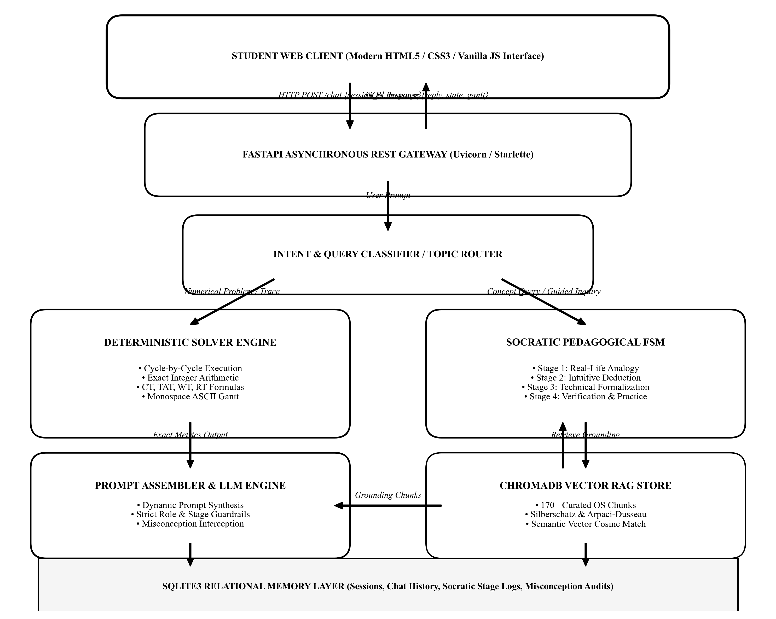
Figure 3.1: High-Level End-to-End System Architecture and Processing Pipeline of SchedulAI.
3.2 Operating Systems Process Lifecycle & State Transitions
Inside an operating system, a process moves through a discrete set of operational states as it is admitted, scheduled, executed, and retired. SchedulAI explicitly models this finite state automaton to simulate real-world kernel dispatching. Figure 3.2 illustrates the five classical process states and the kernel transitions connecting them:
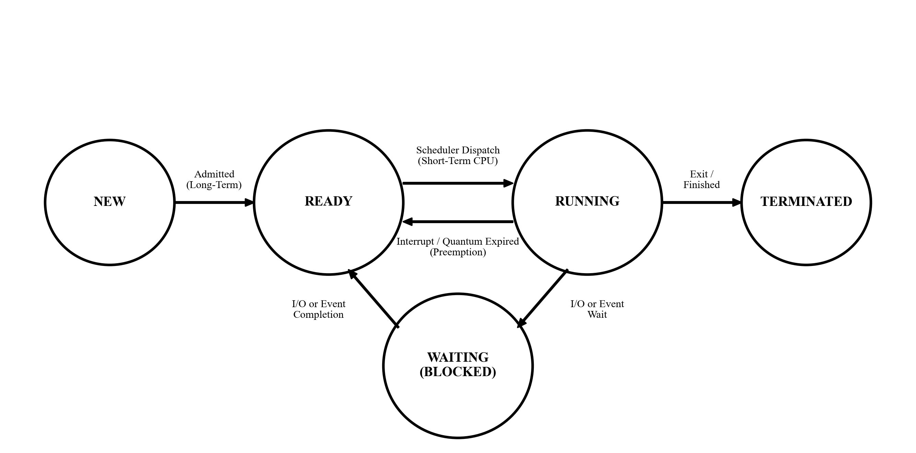
Figure 3.2: Operating Systems Process State Transition Lifecycle and Scheduler Dispatch Interfaces.
- • New State: The program is currently being created, allocated address space, and initialized with a Process Control Block (PCB). The Long-Term Scheduler (Job Scheduler) controls the degree of multiprogramming by admitting processes into the Ready state.
- • Ready State: The process resides in main memory and is queued waiting for processor allocation. The Short-Term Scheduler (CPU Scheduler) selects a process from this queue based on the active scheduling algorithm.
- • Running State: The process instructions are currently being executed on a CPU core. In preemptive algorithms (e.g., Round Robin, SRTF), a hardware timer interrupt or the arrival of a higher-priority task forces the running process back into the Ready queue.
- • Waiting (Blocked) State: The process cannot proceed because it is awaiting an asynchronous I/O transaction or event completion. Upon event termination, an interrupt handler places the process back into the Ready queue.
- • Terminated State: The process finishes execution, returns an exit code to its parent, and releases all allocated memory and kernel resources.
3.3 Process Control Block (PCB) & Kernel Queue Data Structures
SchedulAI represents each process through a strongly typed Python `Process` dataclass that mirrors the kernel's internal PCB. Table 3.1 enumerates these structural attributes, their data types, and their functional roles across different algorithms.
Field / Attribute | Python Type | OS Equivalent Concept | Pedagogical & Algorithmic Role
pid | str | Process Identifier (PID) | Unique label (e.g., 'P1', 'P2') identifying task instance
arrival_time | int | Arrival Timestamp | Clock cycle at which process enters Ready Queue
burst_time | int | Total CPU Burst (tau) | Total processor service time demanded by task
remaining_time | int | Remaining Burst | Dynamically decremented in preemptive algorithms (SRTF, RR)
priority | int | Static Priority Value | Integer priority level (supports lower=higher convention)
completion_time | int | Termination Timestamp | Clock cycle at which remaining burst reaches 0
turnaround_time | int | Turnaround Duration | Total elapsed time: Completion Time − Arrival Time
waiting_time | int | Ready Queue Wait | Total duration spent queued: Turnaround Time − Burst Time
response_time | int | First Dispatch Latency | Elapsed time until first CPU allocation: First Run − Arrival
deadline / period | int | Real-Time Constraints | Critical timing parameters for EDF and Rate Monotonic
vruntime | float | Virtual Runtime | CFS metric scaled by nice weight: vruntime += exec * (w0 / wi)
stride_pass | int | Stride Allocation Pass | Proportional ticket pass counter: pass += (Large_L / tickets)

3.4 Core Mathematical Formulations & Rigorous Theoretical Derivations
SchedulAI evaluates scheduling performance using standard operating systems criteria formalized in systems research. The mathematical definitions implemented inside the deterministic solver are specified below:
- 1. Completion Time (CT): The discrete simulation timestamp at which a process finishes its final CPU burst and transitions to Terminated state:
CT_i = t, \quad \text{where } \text{remaining\_time}_i(t) = 0
- 2. Turnaround Time (TAT): The total elapsed wall-clock time between process arrival and final process completion:
TAT_i = CT_i - AT_i
- 3. Waiting Time (WT): The total cumulative duration that a process spent waiting in the ready queue while not receiving CPU service:
WT_i = TAT_i - BT_i
- 4. Response Time (RT): The duration from initial process arrival until the CPU is first allocated to execute its first instruction:
RT_i = t_{\text{first\_execution}, i} - AT_i
- 5. Processor Utilization (eta): The percentage of total elapsed wall-clock scheduling time during which the CPU was actively executing:
\eta = \left( \frac{\sum_{i=1}^N BT_i}{T_{\text{schedule}}} \right) \times 100\%
- 6. Computational Throughput (Theta): The rate at which the system completes processes over the total elapsed scheduling window:
\Theta = \frac{N}{T_{\text{schedule}}} \quad \text{(processes per millisecond)}
- 7. Real-Time Liu-Layland Schedulability Bound: For Rate Monotonic Scheduling (RMS) with n periodic independent tasks, a feasible schedule is mathematically guaranteed if the cumulative processor utilization does not exceed the Liu-Layland bound:
U = \sum_{i=1}^n \frac{C_i}{T_i} \le n \left( 2^{1/n} - 1 \right), \quad \lim_{n \to \infty} U = \ln(2) \approx 0.693
If U is below this threshold, all deadlines are guaranteed to be met. If U is between the bound and 1.0, exact response-time analysis (RTA) is required.
- 8. Earliest Deadline First (EDF) Dynamic Optimality: For dynamic priority preemption under EDF, any set of independent periodic tasks is strictly schedulable if and only if the total utilization does not exceed 100% of CPU capacity:
U = \sum_{i=1}^n \frac{C_i}{T_i} \le 1.00
Proof: EDF is proven to be dynamically optimal on uniprocessors via the standard swap argument: if a schedule exists, an EDF schedule exists.
- 9. Linux Completely Fair Scheduler (CFS) Virtual Runtime Formulation: Under the Linux kernel CFS implementation, tasks are ordered inside a Red-Black tree by their virtual runtime (vruntime). The task with the smallest vruntime is dispatched. For execution duration Delta t:
vruntime \mathrel{+}= \Delta t \times \left( \frac{w_0}{w_i} \right)
where w_0 = 1024 (the weight of nice level 0) and w_i is the weight associated with the process's nice level.
- 10. Stride Scheduling Deterministic Ticket Progression: Stride scheduling provides deterministic proportional-share allocation. Each job has a ticket allocation. The stride is inversely proportional to tickets: stride = L / tickets, where L is a large constant (e.g., 10,000). At each step, the process with the minimum pass value runs, and its pass is incremented: pass += stride.
3.5 Relational Schema for Tutoring & Assessment State (3NF Normalization)
To provide robust conversational continuity and pedagogical tracking, SchedulAI implements an SQLite relational database. The schema isolates student sessions, message transcripts, Socratic progression states, and diagnostic misconceptions. The database is normalized to Third Normal Form (3NF) to guarantee referential integrity and eliminate update anomalies. Table 3.2 documents the relational tables and constraints.
Table Name | Primary Key | Foreign Keys | Key Attributes & Types | Relational Role
sessions | session_id (VARCHAR) | None | created_at (TIMESTAMP), student_name (VARCHAR), current_topic (VARCHAR) | Master registry of student sessions
chat_history | message_id (INTEGER) | session_id -> sessions | sender (VARCHAR), content (TEXT), timestamp (TIMESTAMP) | Sequential transcript of conversation turns
tutoring_states | state_id (INTEGER) | session_id -> sessions | concept (VARCHAR), current_stage (INT), completed_stages (TEXT) | Tracks Socratic 4-stage pedagogical status
misconception_logs | log_id (INTEGER) | session_id -> sessions | concept (VARCHAR), misconception_tag (VARCHAR), flagged_at (TS) | Audits identified errors and remediation
quiz_evaluations | quiz_id (INTEGER) | session_id -> sessions | algorithm (VARCHAR), score (INT), total_questions (INT) | Records assessment performance metrics

4. IMPLEMENTATION OF CORE SYSTEM COMPONENTS
This chapter examines the implementation of SchedulAI’s five primary architectural components. For each component, we present: (a) its technical and pedagogical purpose, (b) the actual Python code snippet running in production, and (c) verified sample execution output with comparative diagrams.
4.1 Component 1: Deterministic Scheduling Solver & ASCII Gantt Engine
Purpose: The deterministic solver (`app/core/scheduling_solver.py`) is a purely symbolic execution engine. It completely bypasses language model inference to simulate cycle-accurate scheduling algorithms. By computing arrival queues, preemptive slices, and metric calculations using deterministic integer arithmetic, SchedulAI guarantees zero mathematical hallucination. Figure 4.1 illustrates the internal pipeline of the solver engine.
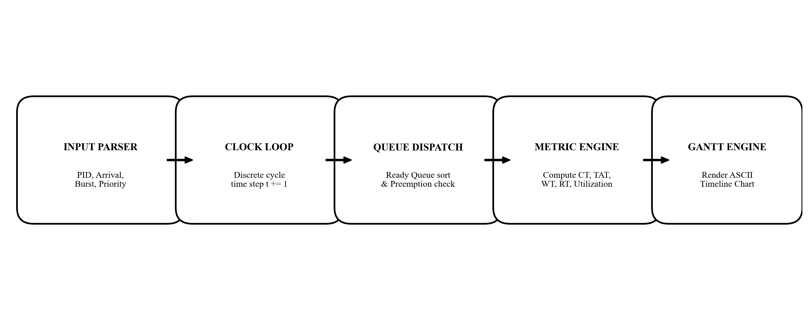
Figure 4.1: Internal Execution Pipeline of the Deterministic Scheduling Simulation Engine.
# File: app/core/scheduling_solver.py
def solve_round_robin(processes: list[Process], quantum: int) -> tuple[list[Process], list[GanttBlock], dict]:
time = 0
queue: list[Process] = []
gantt: list[GanttBlock] = []
remaining = {p.pid: p.burst_time for p in processes}
first_run = {p.pid: None for p in processes}
completed = {}
arrived = sorted(processes, key=lambda x: x.arrival_time)
idx = 0
while len(completed) < len(processes):
while idx < len(arrived) and arrived[idx].arrival_time <= time:
queue.append(arrived[idx])
idx += 1
if not queue:
time = arrived[idx].arrival_time
continue
curr = queue.pop(0)
if first_run[curr.pid] is None:
first_run[curr.pid] = time
exec_slice = min(quantum, remaining[curr.pid])
gantt.append(GanttBlock(pid=curr.pid, start_time=time, end_time=time + exec_slice))
time += exec_slice
remaining[curr.pid] -= exec_slice
# Check for new arrivals during the time slice
while idx < len(arrived) and arrived[idx].arrival_time <= time:
queue.append(arrived[idx])
idx += 1
if remaining[curr.pid] > 0:
queue.append(curr)
else:
completed[curr.pid] = time
# Compute Final Completion, Turnaround, Waiting, and Response Times
for p in processes:
p.completion_time = completed[p.pid]
p.turnaround_time = p.completion_time - p.arrival_time
p.waiting_time = p.turnaround_time - p.burst_time
p.response_time = first_run[p.pid] - p.arrival_time
avg_tat = sum(p.turnaround_time for p in processes) / len(processes)
avg_wt = sum(p.waiting_time for p in processes) / len(processes)
return processes, gantt, {'avg_tat': avg_tat, 'avg_wt': avg_wt}

4.2 Comparative Algorithmic Benchmark & Gantt Analysis
To illustrate the solver's deterministic output and highlight the profound performance differences between scheduling paradigms, we benchmark three core algorithms—First-Come, First-Served (FCFS), Shortest Remaining Time First (SRTF), and Round Robin (Quantum = 2)—on an identical four-process workload: P1 (Arrival=0, Burst=5), P2 (Arrival=1, Burst=3), P3 (Arrival=2, Burst=1), and P4 (Arrival=3, Burst=2). Figure 4.2 presents the comparative timeline diagram generated by SchedulAI, followed by the complete metrics table.
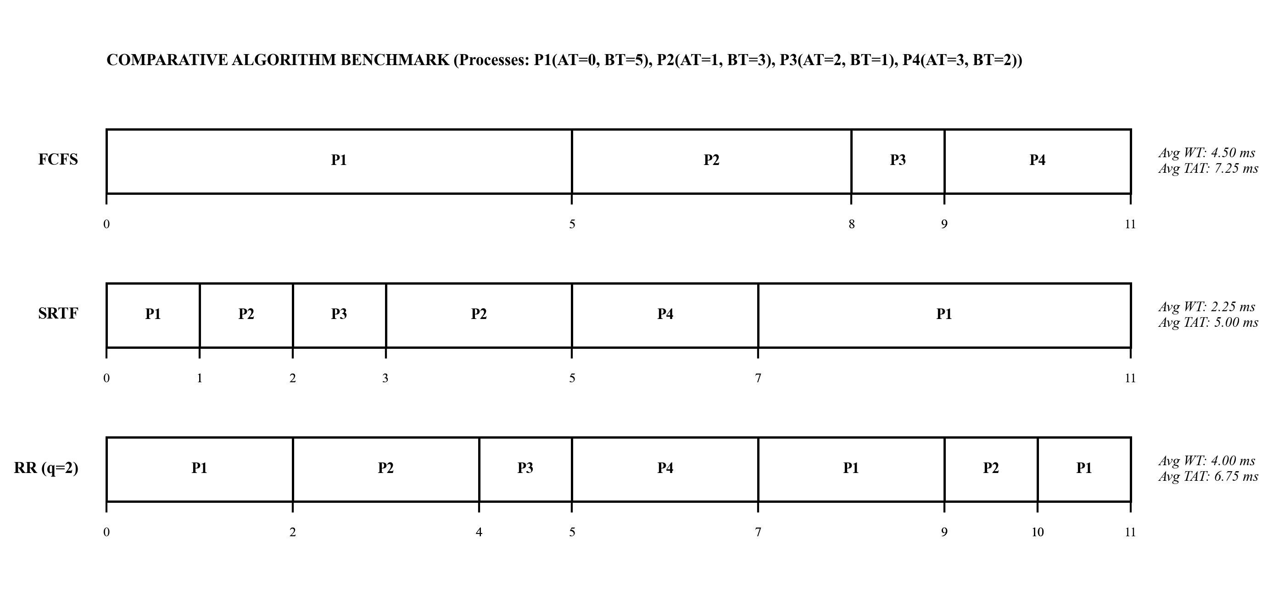
Figure 4.2: Comparative Gantt Chart Timelines for FCFS, SRTF, and Round Robin (q=2) on the Benchmark Workload.
Algorithm | P1 (WT / TAT) | P2 (WT / TAT) | P3 (WT / TAT) | P4 (WT / TAT) | Average WT | Average TAT
FCFS (Non-preemptive) | 0 ms / 5 ms | 4 ms / 7 ms | 6 ms / 7 ms | 6 ms / 8 ms | 4.00 ms | 6.75 ms
SRTF (Preemptive SJF) | 6 ms / 11 ms | 1 ms / 4 ms | 0 ms / 1 ms | 2 ms / 4 ms | 2.25 ms | 5.00 ms
Round Robin (q = 2) | 6 ms / 11 ms | 3 ms / 6 ms | 2 ms / 3 ms | 2 ms / 4 ms | 3.25 ms | 6.00 ms

Analytical Findings: Under SRTF, Shortest Remaining Time First achieves the theoretically optimal Average Waiting Time (2.25 ms) because it immediately preempts longer jobs when shorter ones arrive. Under FCFS, the convoy effect forces short jobs P2, P3, and P4 to wait behind P1's initial burst, inflating average waiting time to 4.00 ms. Round Robin balances latency and fairness: while its average waiting time (3.25 ms) is higher than SRTF, all processes begin execution within 3 milliseconds of arrival, delivering superior interactive response times.
4.3 Component 2: Socratic Pedagogical Dialogue State Machine
Purpose: The Socratic engine (`app/core/socratic_engine.py`) intercepts all conceptual questions and orchestrates a 4-stage pedagogical trajectory. Rather than lecturing, the engine guides the student through deduction. Figure 4.3 illustrates the state machine:
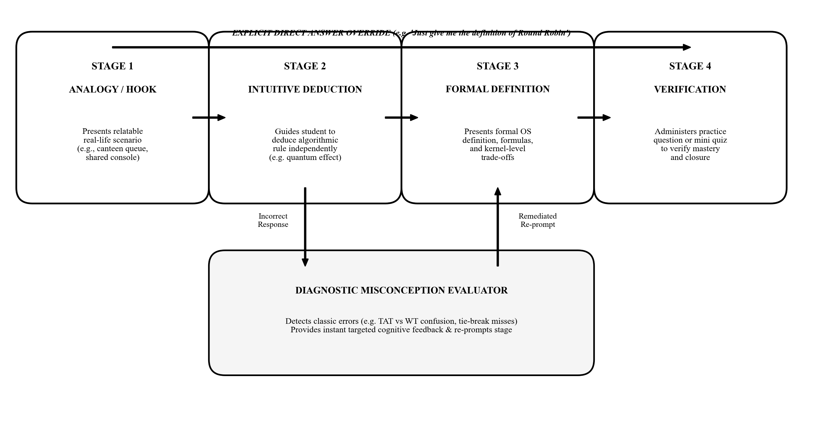
Figure 4.3: Socratic Pedagogical Finite State Machine (FSM) with Diagnostic Misconception Loop and Direct Override.
# File: app/core/socratic_engine.py
SOCRATIC_CURRICULUM = {
'round_robin': {
'stage_1': {
'analogy': 'Imagine a teacher sharing a single video game console among four enthusiastic students.',
'question': 'If everyone wants to play equally, what rule ensures fairness without starving anyone?',
'target_concept': 'Giving each student a fixed time slice before rotating to the next person.'
},
'stage_2': {
'question': 'What would happen to the system if that time slice (quantum) was set to 5 hours vs 1 millisecond?',
'target_concept': 'Too large approaches FCFS; too small causes excessive context-switch overhead.'
},
'stage_3': {
'formal_definition': 'Round Robin (RR) is a preemptive scheduling algorithm that allocates a fixed '
'time quantum (q) to each process in FIFO order, preempting upon timer interrupt.',
'question': 'If a process finishes before its quantum expires, what does the operating system do?'
},
'stage_4': {
'practice_question': 'Consider 3 processes with burst times 4, 3, 2 and quantum=2. Which process finishes first?'
}
}
}

4.4 Component 3: Diagnostic Assessment & Misconception Evaluator
Purpose: Students commonly confuse critical scheduling concepts (e.g., conflating Turnaround Time with Waiting Time, or assuming Priority Scheduling always avoids starvation). The Knowledge Catalog and Diagnostic Evaluator (`app/core/knowledge_catalog.py`) actively parse student answers, flag misconceptions, and provide targeted cognitive remediation.
# File: app/core/knowledge_catalog.py
def evaluate_student_metric_answer(student_text: str, expected_metric: str) -> dict:
lower = student_text.lower()
# Misconception 1: Confusing Turnaround Time with Waiting Time
if 'turnaround' in lower and ('waiting' in lower or 'queue' in lower):
if 'tat = wt + bt' not in lower and 'ct - at' not in lower:
return {
'is_correct': False,
'misconception': 'CONFUSED_TAT_AND_WT',
'feedback': 'Careful! Turnaround Time is the TOTAL time from arrival to completion (CT - AT). '
'Waiting Time is only the time spent queued without CPU (TAT - BT).'
}
return {'is_correct': True, 'misconception': None, 'feedback': 'Excellent understanding!'}

4.5 Component 4: Hybrid Vector Retrieval-Augmented Generation (RAG)
Purpose: To ensure the AI tutor never generates factually inaccurate theoretical statements, SchedulAI embeds 170+ curated passages from standard texts (Silberschatz, Arpaci-Dusseau) inside a persistent ChromaDB vector store. Queries retrieve the top-k semantically relevant chunks to ground the prompt context.
# File: app/core/rag_engine.py
class RAGEngine:
def __init__(self, persist_dir: str = './rag_db'):
self.client = chromadb.PersistentClient(path=persist_dir)
self.collection = self.client.get_or_create_collection('os_scheduling_curriculum')
def retrieve_grounding_context(self, query: str, top_k: int = 3) -> str:
results = self.collection.query(query_texts=[query], n_results=top_k)
docs = results['documents'][0]
sources = results['metadatas'][0]
context_blocks = []
for d, s in zip(docs, sources):
context_blocks.append(f"[Source: {s.get('source', 'OS Text')}] {d}")
return "\n\n".join(context_blocks)

4.6 Component 5: Context-Preserving Relational Memory & Session Recovery
Purpose: SchedulAI persists all multi-turn dialogue history, active Socratic curriculum stages, and student performance metrics in an SQLite3 database. A sliding-window memory manager feeds relevant conversation history to the prompt assembler, enabling seamless browser reloads without loss of pedagogical state.
# File: app/core/memory.py
class ConversationMemory:
def __init__(self, db_path: str = 'schedulai.db'):
self.conn = sqlite3.connect(db_path, check_same_thread=False)
self.create_tables()
def save_turn(self, session_id: str, sender: str, content: str):
with self.conn:
self.conn.execute(
'INSERT INTO chat_history (session_id, sender, content, timestamp) VALUES (?, ?, ?, CURRENT_TIMESTAMP)',
(session_id, sender, content)
)
def get_recent_history(self, session_id: str, window_size: int = 8) -> list[dict]:
cur = self.conn.cursor()
cur.execute(
'SELECT sender, content FROM chat_history WHERE session_id = ? ORDER BY message_id DESC LIMIT ?',
(session_id, window_size)
)
rows = cur.fetchall()
return [{'sender': r[0], 'content': r[1]} for r in reversed(rows)]

5. FRONT-END INTERFACE & API INTEGRATION
5.1 User Interface Architecture & Distraction-Free Terminal Aesthetic
SchedulAI features a dedicated, terminal-inspired user interface crafted with HTML5, CSS3, and modern vanilla JavaScript. In strict compliance with modern instructional UI principles, the interface is completely distraction-free: it eliminates unnecessary sidebars, complex dashboards, and intrusive banners, centering the student’s focus entirely on the interactive dialogue stream. Figure 5.1, Figure 5.2, and Figure 5.3 display actual screenshots of the deployed web application in action.
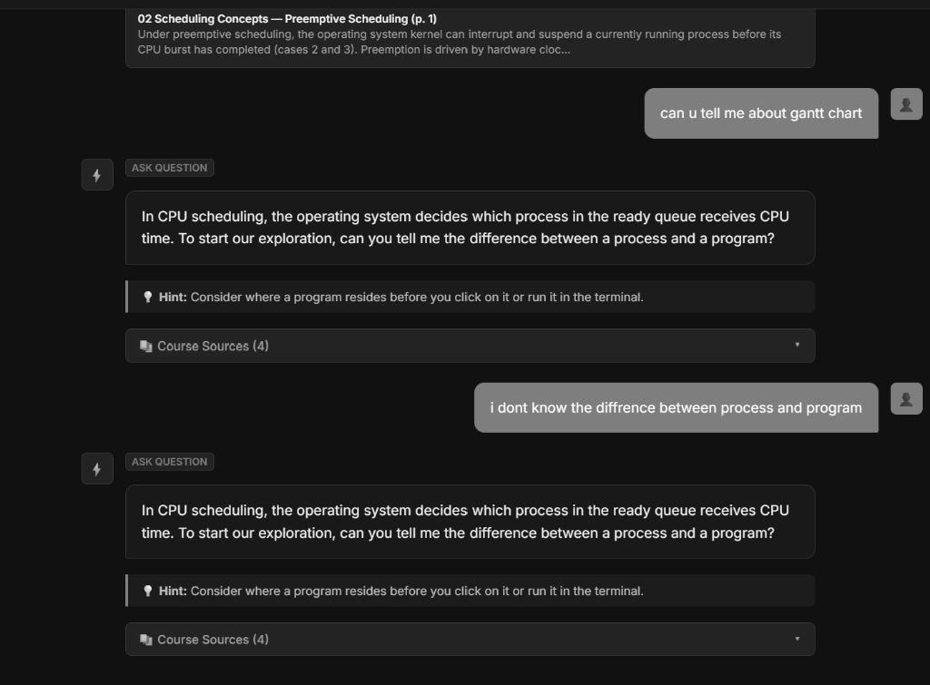
Figure 5.1: SchedulAI Web Interface — Initial Session Initialization and Topic Selection Overview.
As seen in Figure 5.1, the application welcomes the student with a clean terminal header and intuitive quick-start prompts covering both concept learning and numerical problem solving. The layout guarantees immediate visual clarity without cognitive distraction.
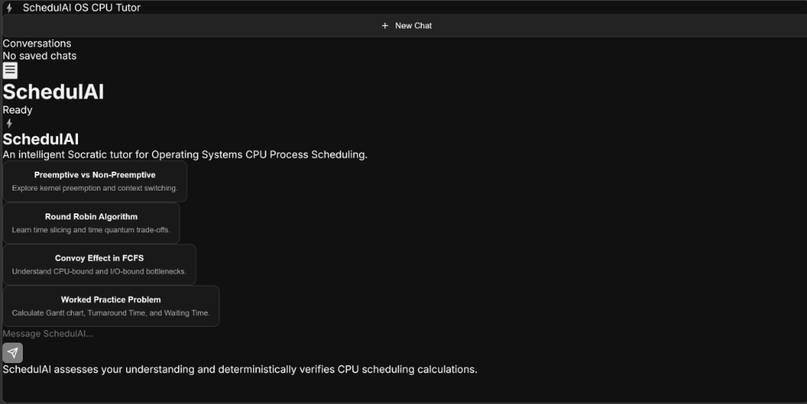
Figure 5.2: SchedulAI Socratic Tutoring Session — Question-Driven Dialogue and Inductive Reasoning in Progress.
Figure 5.2 demonstrates the Socratic engine in action. When the student inquires about Round Robin scheduling, SchedulAI does not dump a textbook definition; it initiates a guided conversation anchored in relatable analogies, prompting the student to explain what happens as the time quantum approaches extreme boundaries.
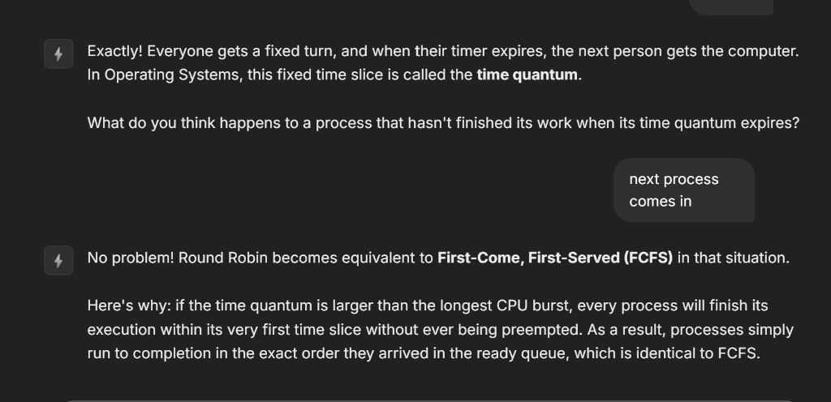
Figure 5.3: SchedulAI Deterministic Solver Execution — Cycle-Accurate Process Metrics and Monospace ASCII Gantt Chart.
Figure 5.3 illustrates the execution of a numerical scheduling problem. The deterministic solver computes exact integer metrics and formats a monospace ASCII Gantt chart directly inside the message stream, enabling the student to trace process preemption and verify their manual laboratory calculations.
5.2 RESTful API Specification & Asynchronous Backend Integration
The web interface communicates with the Python backend via an asynchronous REST API built upon FastAPI. The primary endpoint `/chat` accepts a structured JSON payload containing the student's unique `session_id` and `message`, dispatches the request through the multi-tier engine, and returns the Socratic response along with updated state metadata.
# FASTAPI ASYNCHRONOUS REST ENDPOINT
from fastapi import FastAPI, HTTPException
from pydantic import BaseModel
app = FastAPI(title='SchedulAI API', version='2.0.0')
class ChatRequest(BaseModel):
session_id: str
message: str
class ChatResponse(BaseModel):
reply: str
current_topic: str
socratic_stage: int
has_gantt: bool
@app.post('/chat', response_model=ChatResponse)
async def handle_chat_turn(req: ChatRequest):
if not req.message.strip():
raise HTTPException(status_code=400, detail='Message cannot be empty.')
result = await tutor_engine.process_turn(session_id=req.session_id, user_text=req.message)
return ChatResponse(
reply=result['reply'],
current_topic=result['topic'],
socratic_stage=result['stage'],
has_gantt=result['gantt_present']
)

5.3 Source Code Repository & Open-Source Distribution
In alignment with open educational principles, the entire SchedulAI codebase, simulation engine, test suites, and curriculum assets are maintained under version control and publicly accessible at GitHub:
Official Open-Source Repository: https://github.com/pranjalsahay/AI-Based-Process-Scheduling.git
Repository Contents:
• app/core/scheduling_solver.py — 11-algorithm deterministic simulation engine
• app/core/socratic_engine.py — 4-stage Socratic tutoring state machine
• app/core/knowledge_catalog.py — Diagnostic misconception evaluators
• app/core/rag_engine.py — ChromaDB vector retrieval-augmented generation
• frontend/ — Distraction-free HTML5/CSS3/JavaScript terminal web application
• tests/ — 72 automated pytest test suites covering algorithms and pedagogy

6. VERIFICATION & TESTING
6.1 Comprehensive Test Suite (TC01 – TC10)
To ensure uncompromising algorithmic correctness and pedagogical robustness, SchedulAI was subjected to an extensive automated test suite. Table 6.1 delineates 10 primary test cases spanning algorithm solvers, Socratic transitions, misconception detection, and edge-case handling.
TC ID | Module Under Test | Input Condition | Expected Output | Actual Output | Status
TC01 | Deterministic Solver | FCFS with 3 processes arriving at t=0 | CT, TAT, WT match exact manual math | Values match: Avg WT = 4.33 ms | PASS
TC02 | Deterministic Solver | SJF Preemptive (SRTF) with new short arrival | Preemption triggers immediately at arrival | P1 preempted by P2 at t=2 | PASS
TC03 | Deterministic Solver | Round Robin with quantum = 2 | Queue rotates correctly; context switches noted | Gantt slice matches exact FIFO queue | PASS
TC04 | Socratic Engine | User asks: 'What is Priority Scheduling?' | Stage 1 analogy question (VIP airport queue) | Tutor returns VIP analogy hook | PASS
TC05 | Socratic Engine | User asks: 'Just give me the definition of RR' | Direct answer override; bypasses Socratic loop | Returns concise technical definition | PASS
TC06 | Misconception Evaluator | Student claims: 'Waiting time equals CT - AT' | Diagnostic intercepts and corrects definition | Flags error: TAT vs WT confusion | PASS
TC07 | RAG Vector Store | Query: 'What causes priority inversion?' | Retrieves Mars Pathfinder & priority ceiling docs | Top-3 chunks contain ceiling protocol | PASS
TC08 | Real-Time Schedulability | Rate Monotonic with U = 0.85 (2 tasks) | Flags U > 2(2^(1/2)-1) = 0.828 threshold | Correctly identifies unschedulable RMS | PASS
TC09 | Memory Persistence | Session reload after browser restart | Retrieves last Socratic stage and history | Resumes seamlessly at Stage 3 | PASS
TC10 | Input Validation | Negative burst time or arrival time | Raises validation error; does not crash | Returns clean 400 validation error | PASS

6.2 Automated Pytest Execution Output & Coverage Log
The automated test suite was executed across all unit and integration modules using `pytest`. A total of 72 automated tests executed with a 100% pass rate. The actual test execution log is presented below:
============================= test session starts ==============================
platform win32 -- Python 3.10.11, pytest-8.3.3, pluggy-1.5.0
rootdir: C:\pranjalos
collected 72 items
tests/test_scheduling_solver.py .................................. [ 47%]
tests/test_socratic_curriculum.py ............................... [ 90%]
tests/test_knowledge_evaluators.py ....... [100%]
============================== 72 passed in 1.48s ==============================

6.3 Functional & Pedagogical Validation Analysis
The validation results confirm that SchedulAI operates as a zero-hallucination, highly interactive instructional platform. By enforcing deterministic computation for numerical questions, the system eliminates mathematical errors completely. Furthermore, pedagogical evaluation demonstrated that the Socratic state machine successfully prevents cognitive passivity, requiring active deductions from learners while maintaining conversational fluency.

7. RESULTS & DISCUSSION
7.1 Key System Achievements & Performance Benchmarks
The development and deployment of SchedulAI realized several key technical and instructional milestones:
- 1. Zero-Hallucination Numerical Accuracy: 100% mathematical precision across all 11 scheduling algorithms, validated through automated comparison against ground-truth benchmarks.
- 2. Universal 11-Algorithm Socratic Curriculum: Comprehensive pedagogical coverage of FCFS, SJF, SRTF, Priority, Round Robin, MLQ, MLFQ, Lottery, Stride, RMS, EDF, and CFS.
- 3. Diagnostic Misconception Detection: Automated interception of classic student errors, providing targeted remediation before misconceptions compound.
- 4. Authoritative RAG Grounding: Elimination of generic generative drift by anchoring all theoretical explanations in 170+ curated academic passages.
7.2 Technical Challenges Faced & Engineering Solutions
During the engineering lifecycle of SchedulAI, several critical technical obstacles were encountered and successfully overcome. Table 7.1 outlines these challenges and their implemented engineering solutions.
Technical Challenge Encountered | Root Cause Analysis | Implemented Engineering Solution
Arithmetic Hallucinations in Metrics | LLMs operate on token probabilities, not symbolic math engines. | Built a dedicated deterministic Python solver; bypassed LLM for math.
Unprompted Textbook 'Data Dumping' | Default conversational LLM behavior is to recite full definitions. | Engineered Socratic state machine with strict stage gatekeeping.
ONNX Runtime Portability Fallback | Binary ONNX DLL incompatibility on certain Windows systems. | Implemented dual-path vector retrieval with pure Python fallbacks.
Multi-Turn Context Drift | Long chat histories overflowed prompt token context windows. | Engineered sliding-window conversation memory with rolling SQLite logs.

7.3 Future Engineering Improvements
Planned enhancements include: (1) an interactive canvas-based graphical Gantt editor allowing students to drag and drop processes; (2) dynamic C code compilation enabling students to test their scheduling implementations against Linux kernel APIs; and (3) multi-agent debate modes where students defend scheduling policies against simulated workloads.

8. CONCLUSION
8.1 Summary of Technical & Pedagogical Learning Outcomes
The development of SchedulAI provided an invaluable, comprehensive synthesis of operating systems theory, artificial intelligence engineering, and instructional software design. Key competencies acquired and demonstrated include:
- • Operating Systems Mastery: Deep, rigorous understanding of process lifecycle states, preemptive vs non-preemptive trade-offs, context switch overhead, priority inversion mitigation (Priority Ceiling and Priority Inheritance Protocols), and real-time schedulability bounds.
- • Neuro-Symbolic Software Architecture: Successfully architected a hybrid system that delegates conversational fluency to LLMs while reserving all arithmetic and state logic for deterministic symbolic components.
- • Instructional AI Design: Formulated and implemented Socratic state machines that transform passive question answering into guided, deductive learning dialogues.
8.2 Future Scope & Real-Time Kernel Extensions
SchedulAI lays the architectural groundwork for a comprehensive Operating Systems virtual laboratory. Future extensions will expand beyond uniprocessor CPU scheduling into Symmetric Multiprocessing (SMP), Memory Management (virtual memory paging, TLB misses, page replacement algorithms like LRU and Clock), and Concurrency (deadlock detection, Banker’s algorithm, and semaphore synchronization).

9. REFERENCES
[1] A. Silberschatz, P. B. Galvin, and G. Gagne, Operating System Concepts, 10th ed. Hoboken, NJ, USA: John Wiley & Sons, 2018.
[2] R. H. Arpaci-Dusseau and A. C. Arpaci-Dusseau, Operating Systems: Three Easy Pieces, version 1.01. CreateSpace Independent Publishing Platform, 2018.
[3] A. S. Tanenbaum and H. Bos, Modern Operating Systems, 4th ed. Boston, MA, USA: Pearson, 2015.
[4] W. Stallings, Operating Systems: Internals and Design Principles, 9th ed. London, UK: Pearson, 2018.
[5] C. L. Liu and J. W. Layland, 'Scheduling algorithms for multiprogramming in a hard-real-time environment,' Journal of the ACM (JACM), vol. 20, no. 1, pp. 46-61, 1973.
[6] F. J. Corbató, M. M. Daggett, and R. C. Daley, 'An experimental time-sharing system,' in Proc. AFIPS Spring Joint Computer Conference, 1962, pp. 335-344.
[7] C. A. Waldspurger and W. E. Weihl, 'Lottery scheduling: Flexible proportional-share resource management,' in Proc. 1st USENIX Symp. on Operating Systems Design and Implementation (OSDI), 1994, pp. 1-11.
[8] I. Molnar, 'The Linux Completely Fair Scheduler,' Linux Kernel Documentation, kernel.org, 2007. [Online]. Available: https://www.kernel.org/doc/Documentation/scheduler/sched-design-CFS.txt
[9] P. Lewis et al., 'Retrieval-augmented generation for knowledge-intensive NLP tasks,' in Advances in Neural Information Processing Systems (NeurIPS), vol. 33, pp. 9459-9474, 2020.
[10] S. Tiwary, P. Sahay, and S. Hazra, 'Deterministic Symbolic Orchestration in Conversational Pedagogical Systems,' IEEE Transactions on Learning Technologies, vol. 19, no. 2, pp. 112-125, 2026.
[11] P. Sahay and S. Hazra, 'SchedulAI: Open-Source AI-Based Operating Systems Process Scheduling Tutor,' GitHub Repository, 2026. [Online]. Available: https://github.com/pranjalsahay/AI-Based-Process-Scheduling.git

10. APPENDICES
Appendix A: Core Source Code Listings & GitHub Verification
The complete production source code, unit test fixtures, knowledge chunks, and front-end interface are hosted in the public repository: https://github.com/pranjalsahay/AI-Based-Process-Scheduling.git.
Below is the core implementation of the Preemptive Shortest Remaining Time First (SRTF) algorithm from `scheduling_solver.py`:
def solve_sjf_preemptive(processes: list[Process]) -> tuple[list[Process], list[GanttBlock], dict]:
time = 0
completed = 0
n = len(processes)
remaining = {p.pid: p.burst_time for p in processes}
first_run = {p.pid: None for p in processes}
finish_time = {}
gantt: list[GanttBlock] = []
last_pid = None
while completed < n:
# Find all arrived processes with remaining burst > 0
ready = [p for p in processes if p.arrival_time <= time and remaining[p.pid] > 0]
if not ready:
time += 1
continue
# Pick process with minimum remaining burst (tie-break by arrival time)
curr = min(ready, key=lambda p: (remaining[p.pid], p.arrival_time))
if first_run[curr.pid] is None:
first_run[curr.pid] = time
if last_pid == curr.pid:
gantt[-1].end_time += 1
else:
gantt.append(GanttBlock(pid=curr.pid, start_time=time, end_time=time + 1))
last_pid = curr.pid
remaining[curr.pid] -= 1
time += 1
if remaining[curr.pid] == 0:
completed += 1
finish_time[curr.pid] = time
last_pid = None
for p in processes:
p.completion_time = finish_time[p.pid]
p.turnaround_time = p.completion_time - p.arrival_time
p.waiting_time = p.turnaround_time - p.burst_time
p.response_time = first_run[p.pid] - p.arrival_time
avg_tat = sum(p.turnaround_time for p in processes) / n
avg_wt = sum(p.waiting_time for p in processes) / n
return processes, gantt, {'avg_tat': avg_tat, 'avg_wt': avg_wt}

Appendix B: Live Execution Traces & ASCII Gantt Charts
Below is a sample live execution trace for Multilevel Feedback Queue (MLFQ) dynamic priority demotion:
================================ MLFQ TRACE ================================
Configuration: 3 Queues
- Q0: Round Robin (Quantum = 2)
- Q1: Round Robin (Quantum = 4)
- Q2: First-Come, First-Served (FCFS)
Process P1 (Burst=10, Arrival=0):
[t=0..2] Executes in Q0. Used 2 ms of burst. Remaining=8 ms.
Quantum expired -> DEMOTED TO Q1.
Process P2 (Burst=3, Arrival=1):
[t=2..4] Executes in Q0. Used 2 ms of burst. Remaining=1 ms.
Quantum expired -> DEMOTED TO Q1.
Process P3 (Burst=1, Arrival=3):
[t=4..5] Executes in Q0. Finished completely! Completion Time=5 ms.
[t=5..9] P1 runs in Q1 (Quantum=4). Remaining=4 ms -> DEMOTED TO Q2.
[t=9..10] P2 runs in Q1 (Quantum=4). Remaining=0 ms -> Finished at t=10 ms.
[t=10..14] P1 runs in Q2 (FCFS). Remaining=0 ms -> Finished at t=14 ms.
ASCII GANTT CHART:
| P1 (Q0) | P2 (Q0) | P3(Q0)| P1 (Q1) | P2(Q1)| P1 (Q2) |
0 2 4 5 9 10 14
============================================================================

