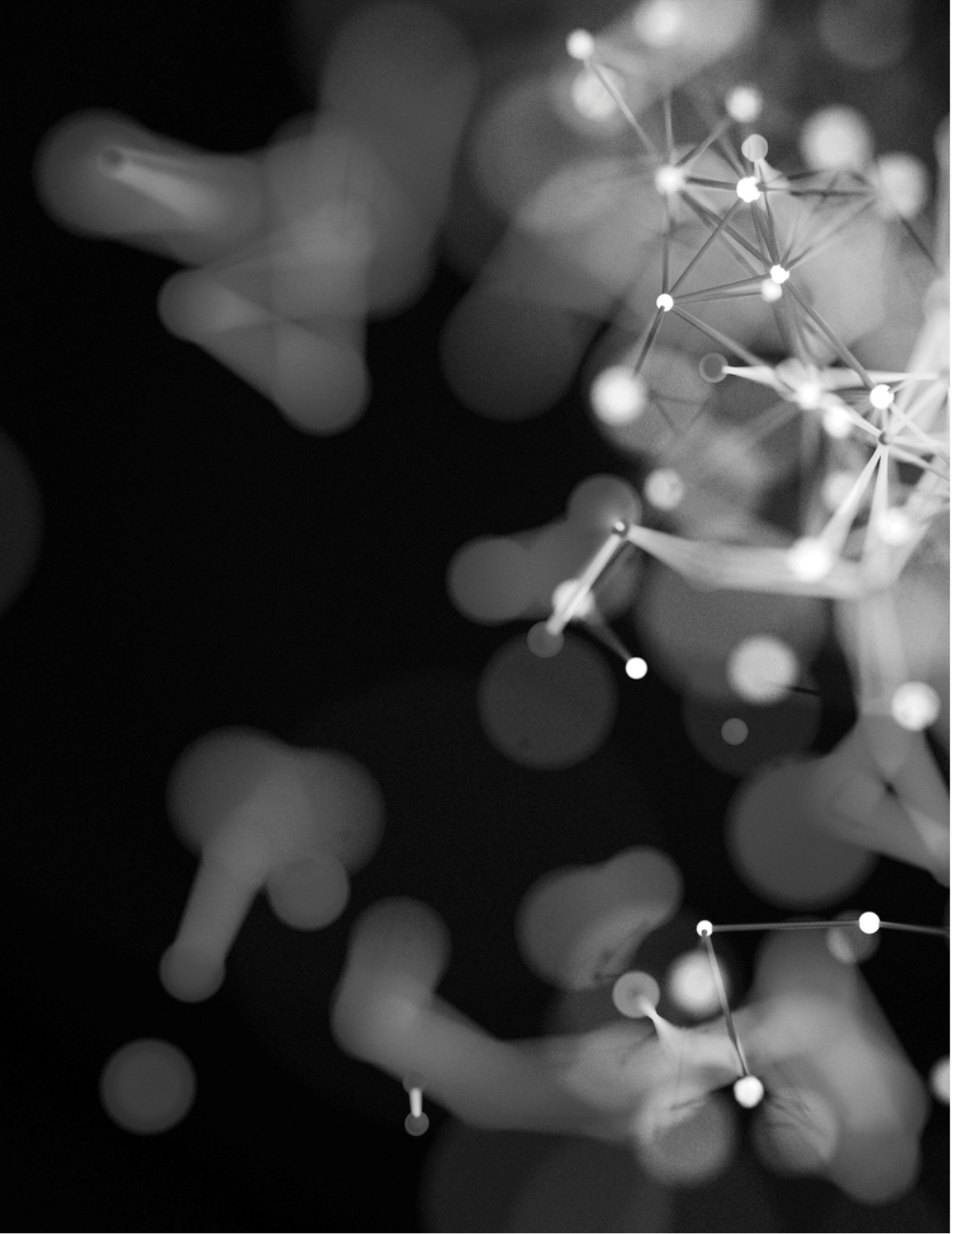

|  |
| --- |
|  |
| Covid-detection using cnn |
| Deep learning assignment report |
| SUBMITTED BY | Pranjal Shandilya(D20021) |

|  |  |  |
| --- | --- | --- |
|  |  | Decorative |
|  |  | APPROACH TAKEN |
| Problem Statement The objective of this project is to identify whether a person is COVID + given his X-ray image (posteroanterior view) available and ready to be feeded to the model. Data Collection For Covid positive x-ray images, I used a standard open dataset from IEEE hosted on github [(Link)](https://github.com/ieee8023/covid-chestxray-dataset) and for the normal x-ray images I used a Kaggle Dataset [(Link)](https://www.kaggle.com/paultimothymooney/chest-xray-pneumonia).   Steps Taken:  * A metadata file is available in the covid positive dataset which gives us a lot of data about the patient, in that dataset I cross-referenced the image using a function and filtered out only the images where RT-PCR test came out as positive after testing and only the posteroanterior view of the images as in Normal X-ray dataset we have only posteroanterior images. * Total number of images Came out to be 220. * Since the count was less, 70:30 ration for train and validation purposes were followed. * Model Building:  1. Model was a traditional CNN with 3 ConV layers, all having pooling layers and ReLU as activation function. A dropout of 0.25 has been added to all the three dense layers in order to remove overfitting. The output layer has a single neuron unit with sigmoid function. 2. The model has been compiled using binary crossentropy with optimization algo as ADAM. 3. The summary of model can be seen below:   Layer (type) Output Shape Param #  =================================================================  conv2d_8 (Conv2D) (None, 222, 222, 32) 896  _________________________________________________________________  conv2d_9 (Conv2D) (None, 220, 220, 64) 18496  _________________________________________________________________  max_pooling2d_6 (MaxPooling2 (None, 110, 110, 64) 0  _________________________________________________________________  dropout_8 (Dropout) (None, 110, 110, 64) 0  _________________________________________________________________  conv2d_10 (Conv2D) (None, 108, 108, 64) 36928  _________________________________________________________________  max_pooling2d_7 (MaxPooling2 (None, 54, 54, 64) 0  _________________________________________________________________  dropout_9 (Dropout) (None, 54, 54, 64) 0  _________________________________________________________________  conv2d_11 (Conv2D) (None, 52, 52, 128) 73856  _________________________________________________________________  max_pooling2d_8 (MaxPooling2 (None, 26, 26, 128) 0  _________________________________________________________________  dropout_10 (Dropout) (None, 26, 26, 128) 0  _________________________________________________________________  flatten_2 (Flatten) (None, 86528) 0  _________________________________________________________________  dense_4 (Dense) (None, 64) 5537856  _________________________________________________________________  dropout_11 (Dropout) (None, 64) 0  _________________________________________________________________  dense_5 (Dense) (None, 1) 65  =================================================================  Total params: 5,668,097  Trainable params: 5,668,097  Non-trainable params: 0   * Image augmentation: Since we have very less count of images in the train and test dataset, we need to do the image augmentation. Horizontal flip and zoom range of 0.2 was used to generate variety and give a model a chance to learn better. * Results:  1. First trial was with 15 epochs where we received the following results:   Epoch 15/15 4/4 [==============================] - 23s 6s/step - loss: 0.1493 - accuracy: 0.9417 - val_loss: 0.1470 - val_accuracy: 0.9667  Which is quite good.   1. Next the model was tested against images with pneumonic symptoms and normal X-ray images where we got result as below:   Training Loss & Accuracy: [0.03196219727396965, 0.9937499761581421]  Validation Loss & Accuracy: [0.07270810753107071, 0.9833333492279053]   * Next the model was saved with h5 format.  |  |  | | --- | --- | | Recall | 1.0 | | Precision | 0.96 |  * A heat-map of confusion matrix was built to visualize the results better: |