**ISOMETRIC DRAWING OF ASSEMBLY**

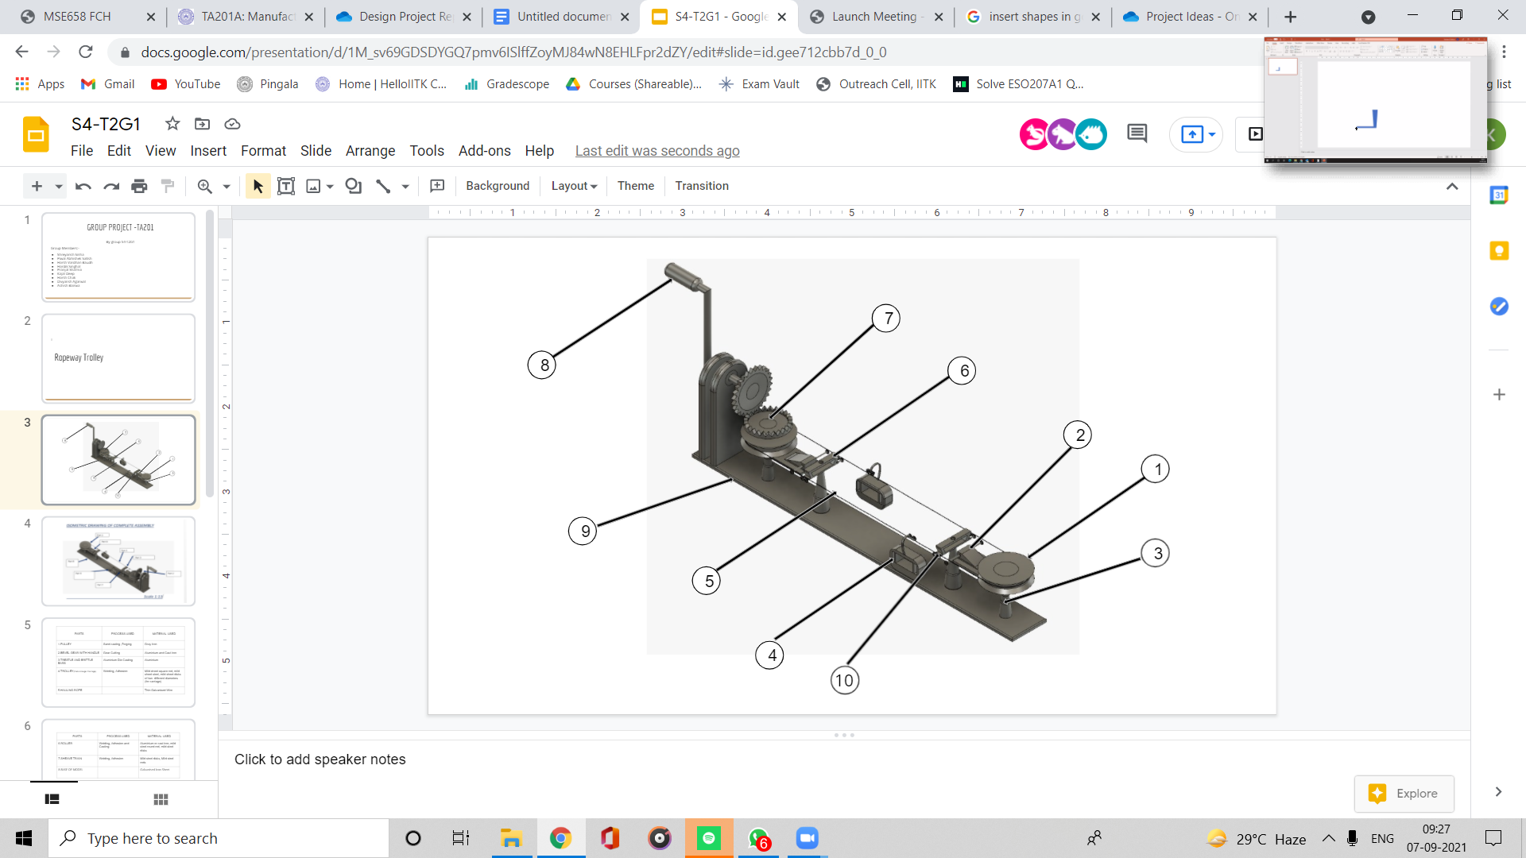

Scale 1:13

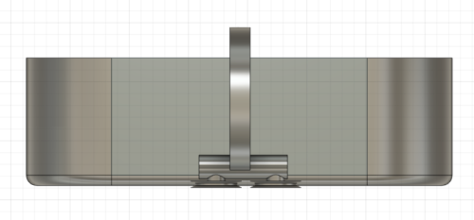 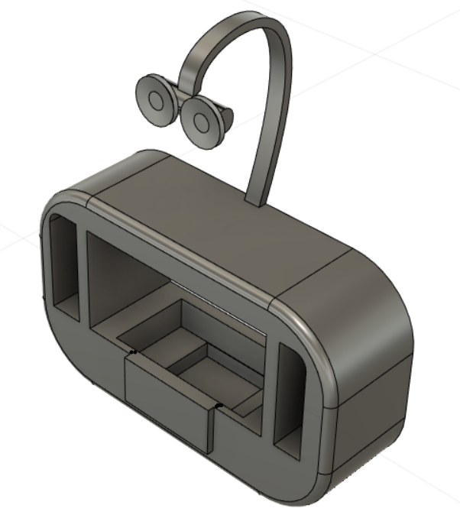

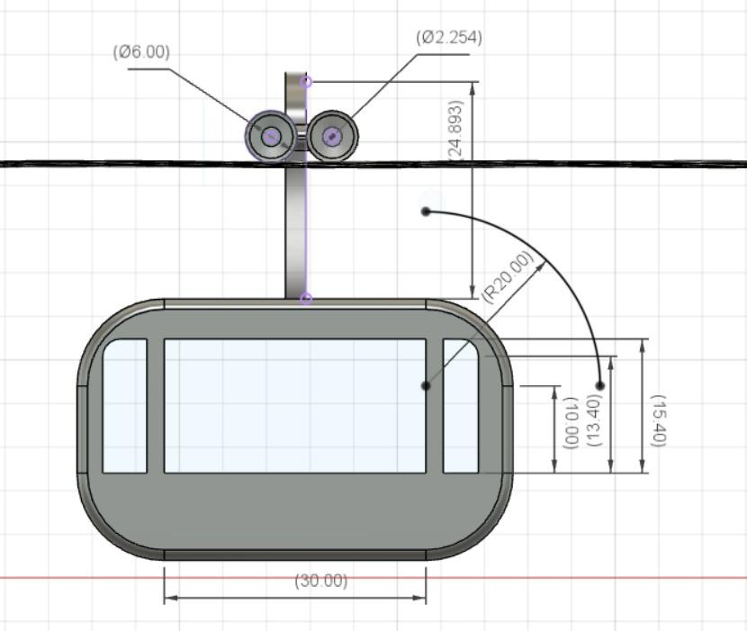 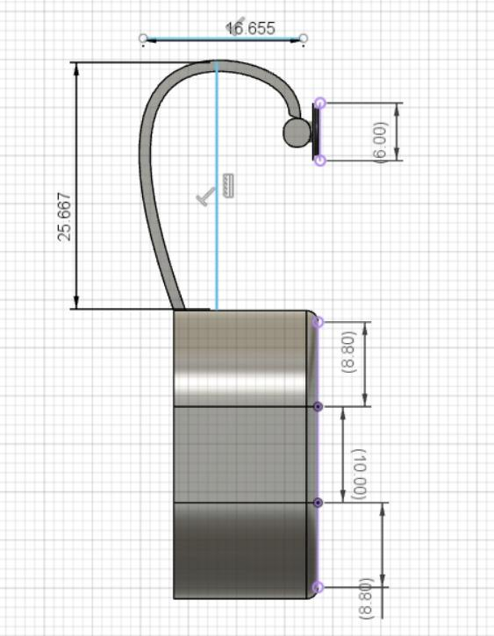

| Part no. - | 4 |
| --- | --- |
| Part Name - | Trolley (Cabin Hanger Carriage) |
| Material used - | Mild steel sheet, mild sheet disks of two different diameters (for carriage) |
| Process - | Welding, Bending. 4 seater cabins shall be semi-closed and made of tubular or rolled steel section in welded construction. Cabin hangers are made of steel are bended to provide the desired structure |
| Quantity - | 2 |
| Cost - | ₹80 (₹40 each, 2 pieces) |

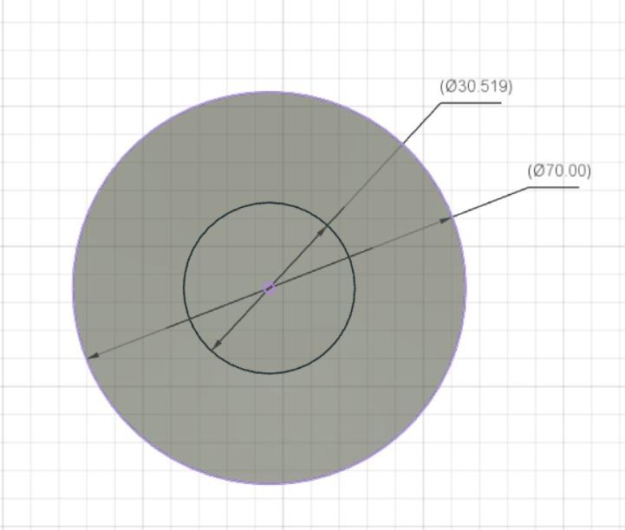 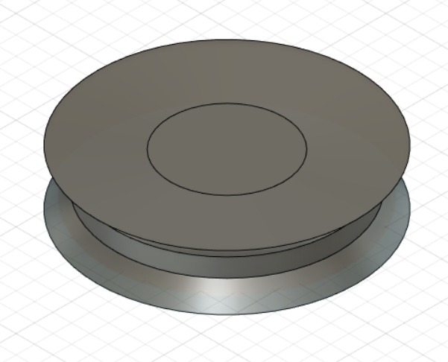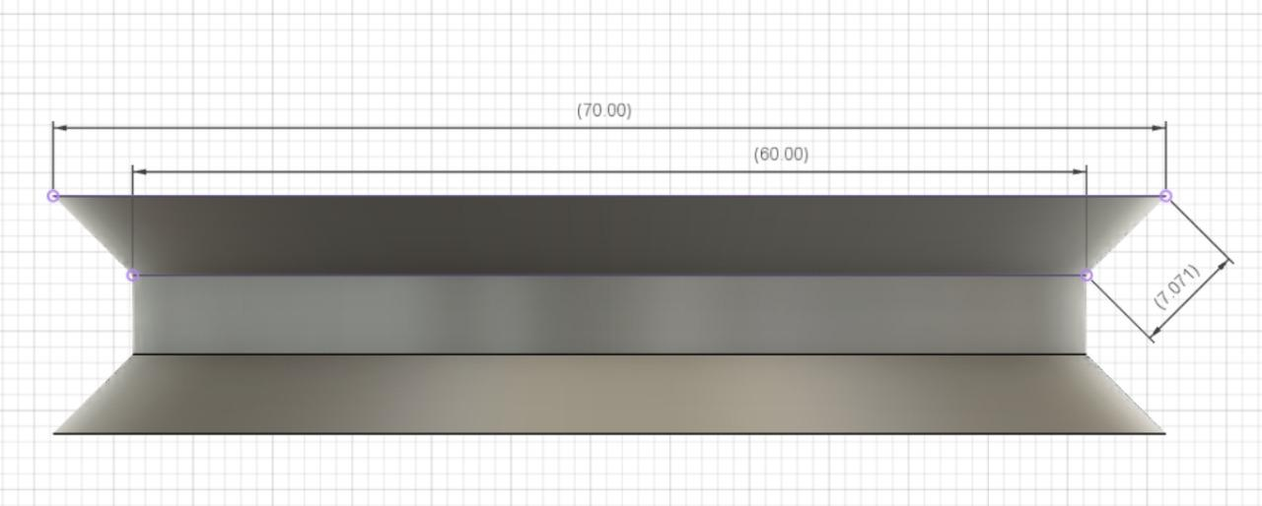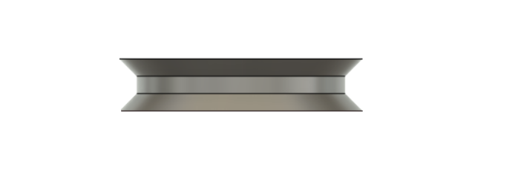

| Part no. - | 1 |
| --- | --- |
| Part Name - | Drive sheave |
| Material used - | Gray Iron |
| Process - | Sand Casting , Forging |
| Quantity - | 2 |
| Cost - | **₹ 150 (₹ 75 each )** |

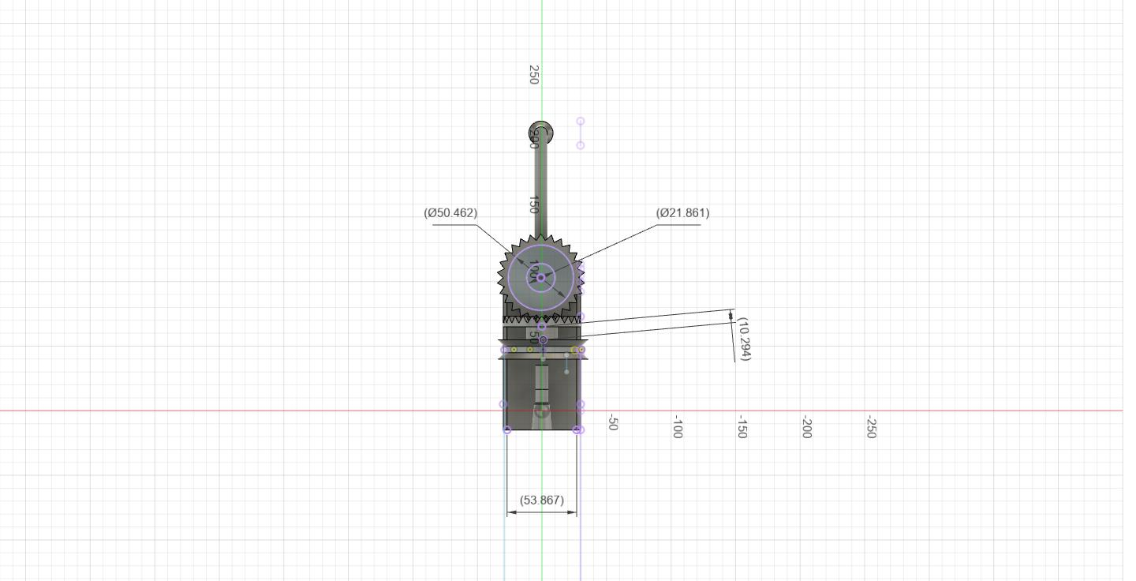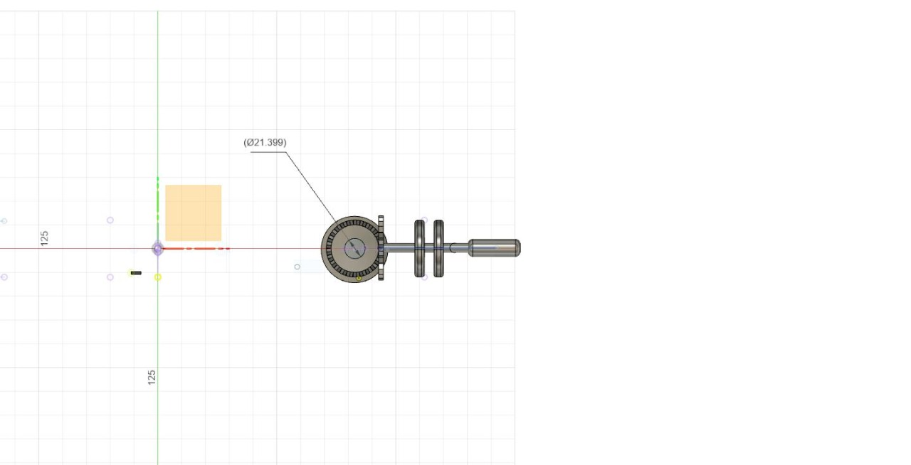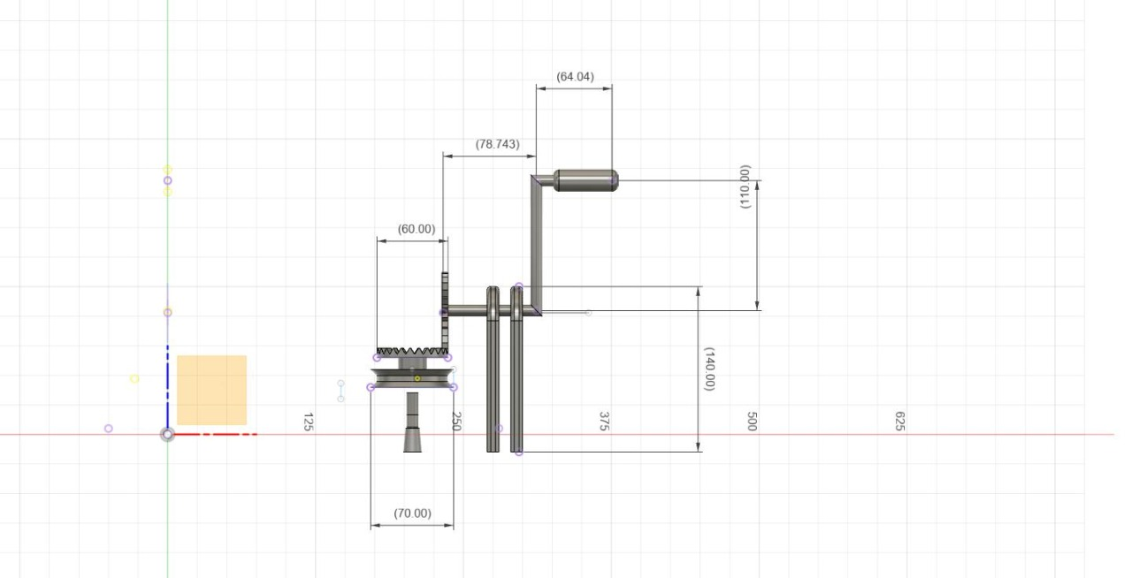

| Part no. - | 2 |
| --- | --- |
| Part Name - | Bevel gear |
| Material used - | Aluminium and Cast Iron |
| Process - | Sawing :The materials are cut to size.  Turning :With a lathe, a cut workpiece is shaped into a gear blank.  Gear Cutting :Gear cutting is done with a Coniflex generator. The cutting usually leaves burrs on the teeth. |
| Quantity - | 2 |
| Cost - | ₹270 (₹90/kg, 3kg required) |

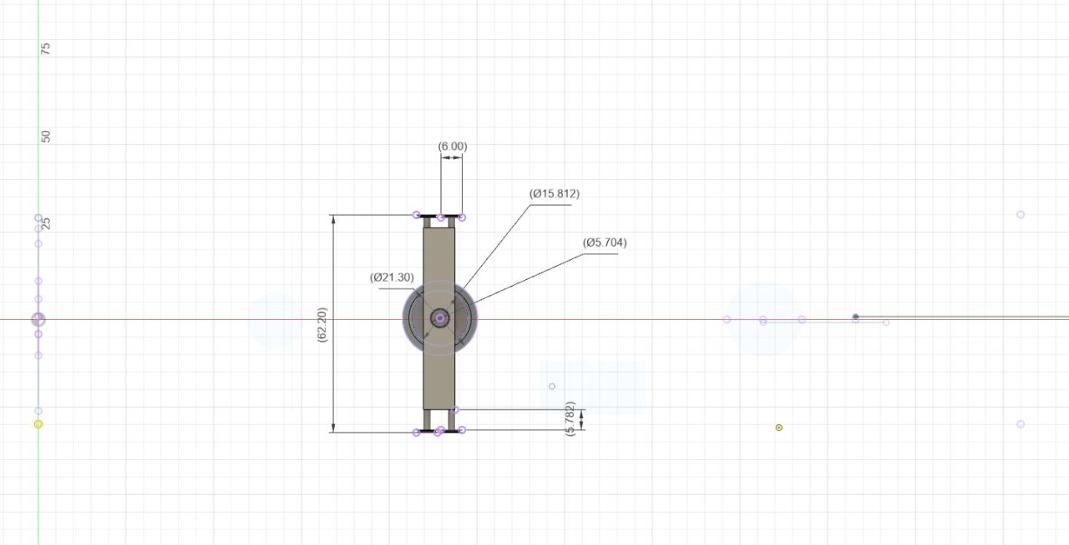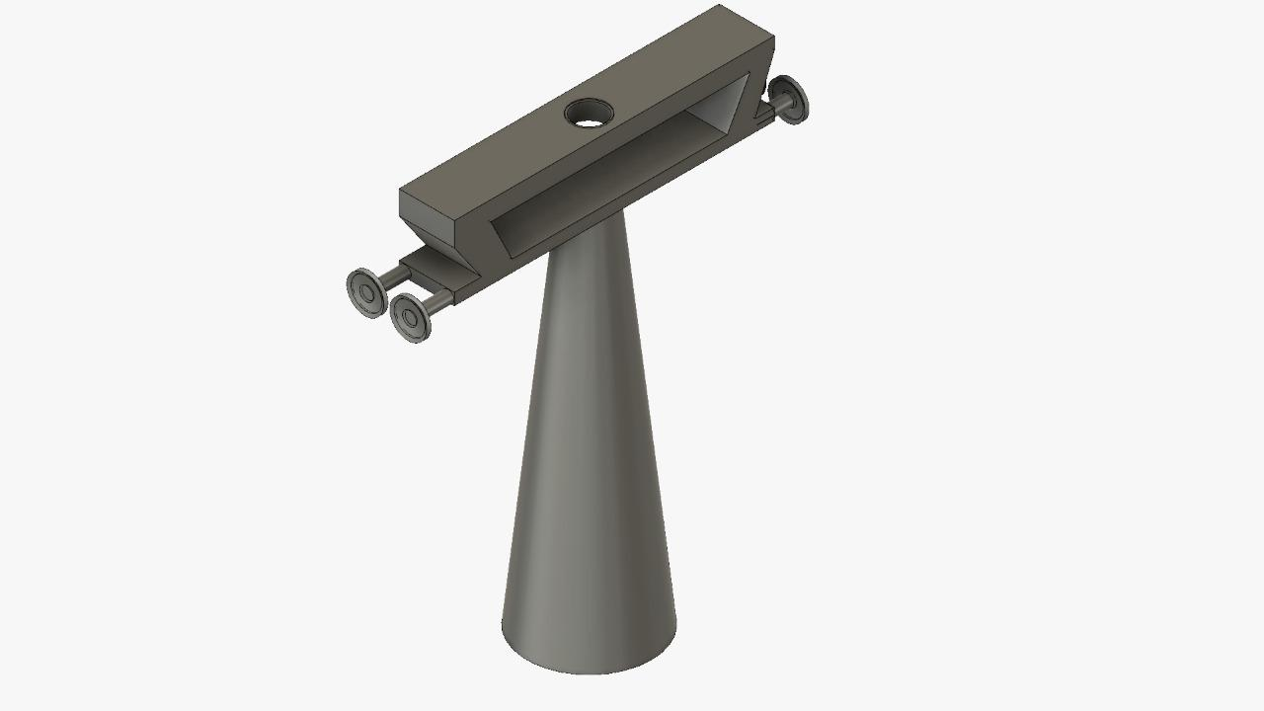

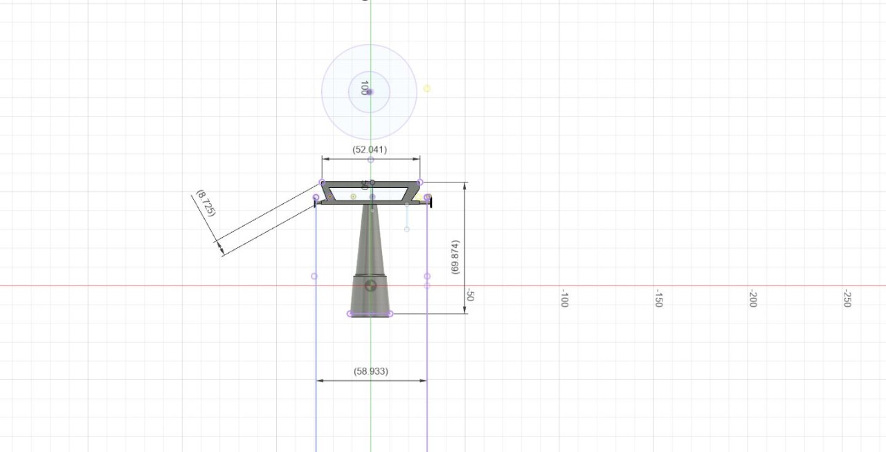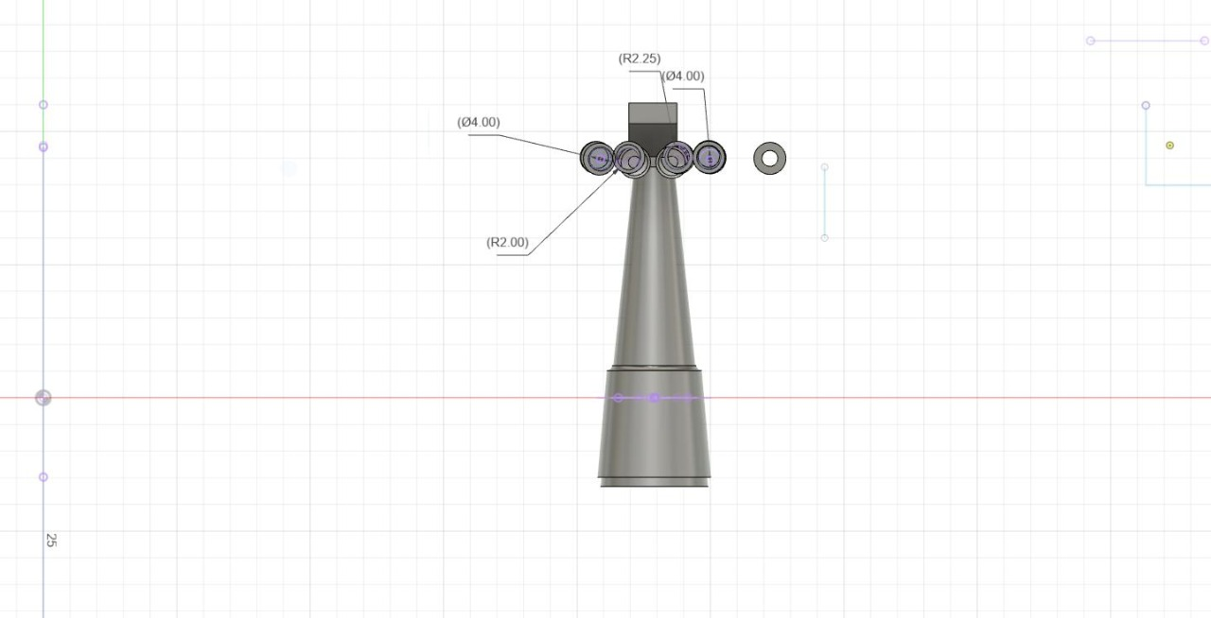

| Part no. - | 3 |
| --- | --- |
| Part Name - | Trestle and Brittle Bars |
| Material used - | Aluminium |
| Process - | Aluminium Dye Casting |
| Quantity - | 2 |
| Cost - | ₹120 (₹60 each, 2 pieces) |

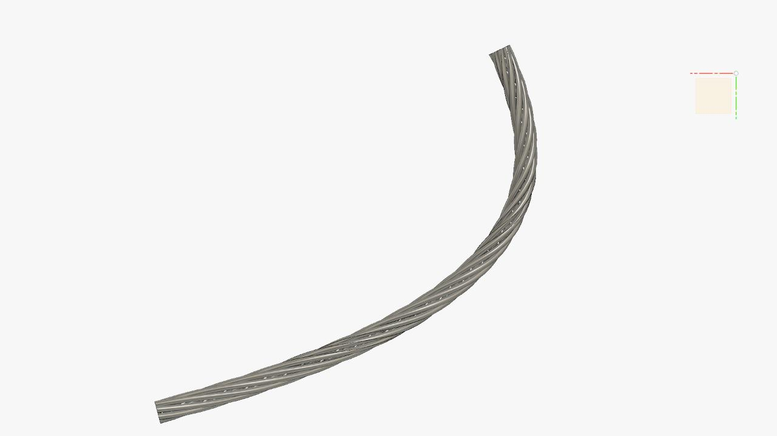

| Part no. - | 5 |
| --- | --- |
| Part Name - | Hauling Rope |
| Material used - | Thin Galvanised Wire |
| Process - | Aluminium Dye Casting |
| Quantity - | 2 |
| Cost - | ₹120 (₹60 each, 2 pieces) |