PROJECT REPORT OF INDUSTRY ORIENTED HANDS-ON EXPERIENCE (IOHE) ON

Smart Expense Tracker
submitted in partial fulfilment of the requirements for the award of degree of

BACHELOR OF ENGINEERING
In
COMPUTER SCIENCE AND ENGINEERING

Submitted By | Roll No. | Supervised By  Dr Rajat Takkar | Organization  Chitkara University
Pranjal | 2210992064
Vishal | 2210992538
Akshit | 2210991236
Vaibhav | 2210992490



DEPARTMENT OF COMPUTER SCIENCE AND ENGINEERING CHITKARA UNIVERSITY INSTITUTE OF ENGINEERING AND TECHNOLOGY
CHITKARA UNIVERSITY, PUNJAB, INDI

ACKNOWLEDGEMENT

I hereby certify that the work which is being presented in the project report entitled “Smart Expense Tracker” in partial fulfilment of requirement for the award of the degree of Bachelor of Engineering (Computer Science and Engineering) submitted in the department of Computer Science and Engineering at Chitkara University Institute of Engineering and Technology, Chitkara University, Punjab, India, is an authentic record of my own work carried out under the supervision of Dr. Rajat Takkar The matter presented in this project report has not been submitted in any other university/institute for the award of any degree.

Place: Rajpura Pranjal
Date: 16-05-2026 2210992064

This is to certify that the above statement made by the candidate is correct to the best of my knowledge and belief.

Dr. Rajat Takkar
Assistant Professor
Department of Computer Science and Engineering
Chitkara University Institute of Engineering and Technology, Chitkara University, Punjab, India

ABSTRACT

The Smart Expense Tracker is a web-based application developed to help users manage and monitor their
daily expenses efficiently. In today’s fast-paced lifestyle, maintaining financial records manually becomes
difficult and time-consuming. This system provides a digital solution for recording income, expenses,
and budget details in an organized manner.

The main objective of the project is to simplify personal financial management by allowing users to track
their spending habits, categorize expenses, and analyze financial data through graphical reports and
summaries. The application enables users to add, edit, and delete expense records while maintaining
secure and accurate data storage.

The system is designed using modern web technologies and may include features such as user
authentication, expense categorization, monthly budget tracking, data visualization, and spending
analysis. Some advanced versions can also integrate machine learning techniques to predict future
expenses and provide smart financial suggestions.

The Smart Expense Tracker improves financial awareness, reduces unnecessary spending, and helps
users make better financial decisions. The project demonstrates the practical implementation
of database management, user interface design, and web application development in solving
real-life financial management problems.

TABLE OF CONTENTS

S.No. | Title | Page No.
1 | Acknowledgement | 2
2 | Abstract | 3
4 | Table of contents | 4
4 | Introduction | 5-8
5 | Methodology | 9-11
6 | System Design and Architecture | 12-14
7 | Implementation | 15-17
8 | Major Findings/Outcomes/Output/Results | 18-24
9 | Conclusion and Future Scope | 25
10 | References | 26-27
11 | Appendices | 28

Introduction

Background and Context
In the modern digital era, managing personal finances has become an important part of daily life Peopleoften spend money on various activities such as shopping, food, transportation, entertainment, education,and online services. Due to busy schedules and increasing financial transactions, many individuals find it difficult to maintain proper records of their income and expenses manually. This lack of financial tracking can lead to overspending, poor budgeting, and difficulty in achieving financial goals.
Traditional methods of expense management, such as maintaining notebooks or spreadsheets,are time-consuming and less efficient. These methods may also result in data loss, calculation errors, and difficulty in analyzing spending patterns. With the rapid growth of technology and the increasing use of smartphones and web applications, digital financial management systems have become more popular and effective.The Smart Expense Tracker is designed to provide a simple, secure, and user-friendly solution for managing daily financial activities. The system allows users to record expenses, categorize transactions, set monthly budgets, and monitor spending habits through graphical reports and summaries. By automating financial tracking, the application helps users save time, maintain accurate records, and make informed financial decisions.This project reflects the growing importance of technology in personal finance management and demonstrates how modern software solutions can improve financial awareness and budgeting practices.

Problem Statement
Managing daily expenses manually is difficult, time-consuming, and prone to errors. Manypeople fail to keep proper financial records, which leads to overspending and poor
budgeting. Traditional methods such as notebooks and spreadsheets are not efficient for tracking and analyzing expenses. Therefore, there is a need for a smart and user-friendly expense tracking system that helps users record, monitor, and manage their financial activities effectively.

Objectives
• To develop a smart and user-friendly expense tracking system.
• To help users record and manage daily income and expenses.
• To categorize expenses for better financial analysis.
• To provide graphical reports and spending summaries.
• To reduce manual calculation errors and save time.
• To improve budgeting and financial decision-making.

Proposed Solution / Overview

The proposed Smart Expense Tracker is a web-based application designed to help users manage their personal finances efficiently and systematically. The system enables users to record daily income and expenses, categorize transactions, and monitor their financial activities in real time. It provides an organized platform where users can maintain accurate financial records without relying on manual methods such as notebooks or spreadsheets.
The application includes features such as user authentication, expense categorization, monthly budget management, graphical analysis, and expense summaries. Users can add, edit, update, and delete transaction records easily through a simple and user-friendly interface. The graphical representation of data helps users understand their spending habits and identify areas where expenses can be controlled.
The system also automates calculations and report generation, reducing human effort and minimizing errors. Secure database storage ensures that financial data remains safe and accessible whenever required. By using this application, users can improve budgeting practices, increase financial awareness, and make better financial decisions.
The Smart Expense Tracker provides a practical and efficient solution for personal expense management by combining modern web technologies with effective financial tracking features.

Expected Outcome
The expected outcome of the Smart Expense Tracker project is the development of an efficient and user-friendly system for managing personal finances. The application will help users record, organize, and monitor their daily income and expenses accurately. It is expected to reduce manual effort, improve budgeting practices, and minimize calculation errors.
The system will provide graphical reports and expense summaries that allow users to analyze their spending habits effectively. Users will be able to maintain better financial control, track savings, and make informed financial decisions. Overall, the project aims to improve financial awareness and provide a reliable digital solution for expense management.

Original Contribution
The Smart Expense Tracker project contributes by providing a modern and efficient solution for managing personal finances digitally. The system is designed to simplify the process of recording, tracking, and analyzing daily expenses through a user-friendly interface and automated functionalities. It reduces the dependency on traditional methods such as notebooks and spreadsheets, which are often time-consuming and prone to errors.
One of the major contributions of this project is the integration of expense categorization, budget management,and graphical analysis within a single platform. The system allows users to monitor their spendinghabits, maintain accurate financial records, and generate expense summaries for better understanding of their financial activities. The graphical representation of data helps users easily identify unnecessary expenditures and improve budgeting practices.
The project also contributes by ensuring secure and organized data storage, which improves the reliability and accessibility of financial information. Automated calculations and report generation minimize manual effort and increase accuracy. In addition, the application promotes financial awareness and supports users in making informed financial decisions.
Overall, the Smart Expense Tracker demonstrates the practical application of web technologies, database management, and financial analysis techniques in solving real-world personal finance management problems.

Feature Area | Existing Tools/Platforms | Traditional Detection Systems | Basic AI Detectors | AetherGuard Forensic (Proposed)
Image Deepfake Detection | Basic | Limited | Good | Excellent
Video Deepfake Analysis | Limited | None | Basic | Excellent
Live Webcam Detection | None | None | None | Real-Time Detection
Biometric Anomaly Detection | None | Basic | Limited | AI-Powered Analysis
Transformer-Based AI Analysis | None | None | Limited | Integrated Ensemble
Investigation History Tracking | None | None | None | Vault Persistence
Unified Multimedia Verification | None | None | Partial | Yes
Modern Enterprise UI | Basic | Traditional | Basic | Cinematic Glassmorphism

2. Methodology
The methodology adopted for the Smart Expense Tracker project focuses on designing, developing, and testing a user-friendly financial management system capable of tracking and analyzing daily expenses efficiently. The system combines modern web technologies, database management, and analytical features to ensure accuracy, security, and ease of use.
I. Requirement Analysis
- Identified the problems associated with manual expense management and financial tracking.
- Defined system objectives such as expense recording, budget management, expense categorization, and report generation.
- Analyzed user requirements for creating a simple and responsive interface.
II. System Design
- Designed the application using a client–server architecture.
- Planned modules such as user authentication, expense management, budget tracking, analytics dashboard, and report generation.
- Created database structures for storing user and transaction details securely.
- Defined the data flow from user input to data processing and report visualization.
III. Development
- Developed the frontend using modern web technologies for an interactive and responsive user interface.
- Implemented backend functionalities for handling user requests and database operations.
- Integrated features for adding, updating, deleting, and categorizing expenses.
- Implemented automated calculations for budget analysis and expense summaries.
IV. Database Management
- Used a secure database system to store financial records and user information.
- Organized data systematically for quick retrieval and accurate processing.
- Ensured data integrity and secure access management.
V. Testing and Validation
- Conducted testing to verify system functionality and performance.
- Checked the accuracy of expense calculations and report generation.
- Performed user interface testing to improve usability and responsiveness.
- Identified and fixed errors to ensure reliable system performance.
VI. Deployment
- Deployed the application on a suitable web platform for user accessibility.
- Ensured smooth integration between frontend, backend, and database systems.
- Monitored system performance and maintained data security during operation.

2.1 Technical Approach
The technical approach of the Smart Expense Tracker project is focused on developing a secure, scalable, and user-friendly financial management system capable of efficiently tracking daily expenses and analyzing spending patterns. The system integrates modern web technologies, database management techniques, and analytical tools to provide accurate and real-time financial monitoring.
I. Application Development
- Developed a responsive and interactive user interface for easy expense management.
- Implemented modules for user authentication, expense tracking, budget management, and report generation.
- Designed the system to support smooth navigation and efficient data handling.
II. System Architecture
- Frontend: Built using modern web technologies to provide a responsive and user-friendly interface.
- Backend: Developed using server-side technologies for handling user requests, calculations, and database communication.
- Database Layer: Stores user details, expense records, budgets, and transaction history securely.
- Analytics Module: Generates graphical reports, expense summaries, and spending analysis.
III. Functional Features
- Expense categorization for better financial organization.
- Automated calculations for total expenses, savings, and monthly budgets.
- Real-time tracking and updating of financial records.
- Graphical visualization using charts and summaries for easy analysis.
IV. Security and Data Management
- Implemented secure login and authentication mechanisms.
- Maintained proper database management for accurate and reliable data storage.
- Ensured data integrity and privacy for user financial information.
V. Testing and Performance
- Performed system testing to ensure accurate calculations and smooth functionality.
- Evaluated the responsiveness and usability of the application.
- Optimized system performance for efficient expense tracking and report generation.
This technical approach ensures that the Smart Expense Tracker functions as a reliable and efficient financial management system, helping users monitor expenses, improve budgeting, and make informed financial decisions.

Identified Research Gap
Current expense management systems are often limited in functionality and do not provide a complete solution for effective personal financial management. Many existing applications mainly focus on basic expense recording and lack advanced features such as intelligent expense categorization, real-time tracking, graphical analysis, budget monitoring, and detailed financial reporting.
Traditional methods like notebooks and spreadsheets are time-consuming, error-prone, and inefficient for maintaining financial records. Even many digital expense tracking tools provide limited analytics, weak user interfaces, and insufficient data visualization, making it difficult for users to understand their spending patterns effectively.
The major research gaps identified include:
- Lack of automated expense categorization and analysis.
- Limited graphical representation of financial data.
- Absence of real-time budget monitoring and spending alerts.
- Poor user experience and complex interfaces in existing systems.
- Inadequate data security and financial record management.
- Limited accessibility and inefficient tracking of daily transactions.
These limitations reduce the efficiency of personal financial management and make it difficult for users to maintain proper budgeting practices. The Smart Expense Tracker addresses these gaps by providing a unified and user-friendly platform that integrates expense tracking, budget management, graphical analytics, secure data storage, and real-time financial monitoring within a single system.

System Design and Architecture (UML Diagrams)
2.1User Flow
The user flow of the Smart Expense Tracker begins with user registration and login authentication. After successful login, the user is redirected to the main dashboard where various financial management features are available.
User Flow Process
- User → Login/Signup → Expense Tracker Dashboard
- From the Dashboard, the user can:
  - Add daily income and expense records
  - Categorize expenses based on type
  - View monthly budget and spending summaries
  - Analyze expenses through charts and graphical reports
  - Update or delete transaction records
  - Track savings and financial activities
  - Maintain secure financial history and records

2.2 Admin Flow
The admin flow is responsible for managing the overall system and maintaining proper functionality of the application.
Admin Flow Process
- Admin → Admin Dashboard
- Admin can manage:
  - User accounts and authentication
  - Expense categories and system settings
  - Database management and financial records
  - Dashboard reports and analytics
  - System monitoring and maintenance
  - Overall platform administration and access control

2.3 System Architectural Flow
The Smart Expense Tracker follows a client–server architecture for smooth communication between frontend, backend, and database systems.
Architectural Flow
- Frontend (Web Interface) → Backend Server
- Backend Server → Database Management System
- Backend → Analytics and Report Generation Module
Components
- Frontend: Provides an interactive and responsive user interface.
- Backend: Handles business logic, calculations, authentication, and data processing.
- Database: Stores user details, expense records, budgets, and transaction history securely.
- Analytics Module: Generates graphical reports and spending analysis.

2.4 External Integrations
The system may integrate external tools and libraries to improve performance and user experience.
External Technologies
- Chart Libraries: Used for graphical expense analysis and reports.
- Database Systems: Used for secure storage and management of financial records.
- Authentication Services: Provide secure login and user verification.
- Web Technologies: Used for responsive interface design and smooth application performance.

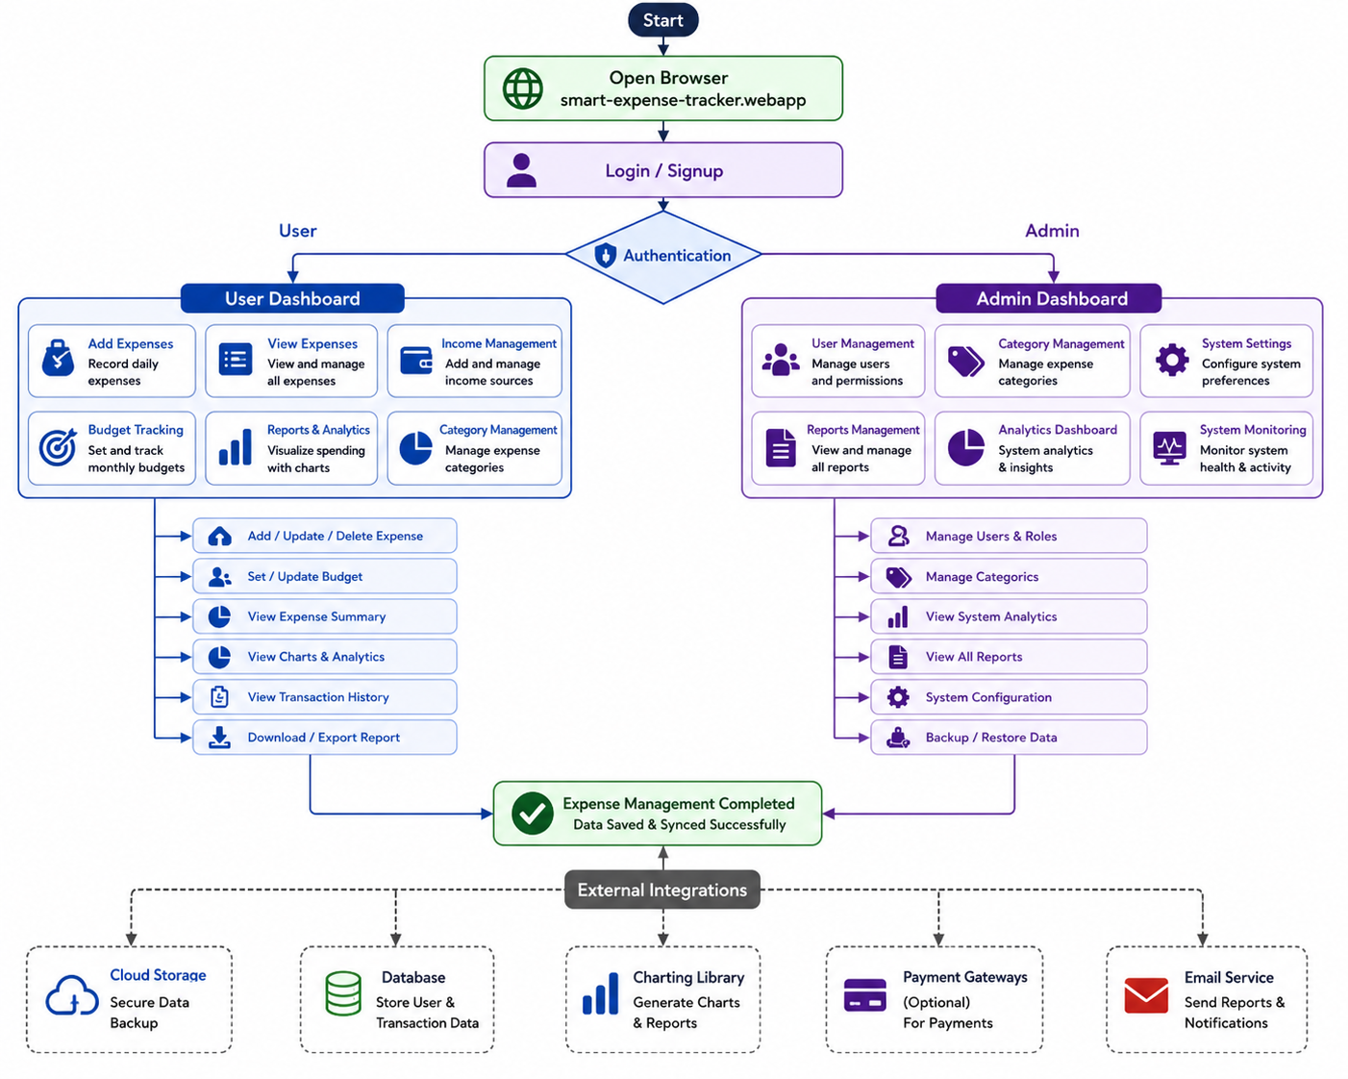

2.5 Module Description
➤ User Module
Handles user registration, login authentication, profile management, and secure access to the expense tracking system. It allows users to manage personal financial records and maintain transaction history securely.
➤ Expense Management Module
Provides functionality for adding, updating, deleting, and managing daily income and expense records. The module helps users organize financial transactions efficiently.
➤ Budget Management Module
Allows users to set monthly or weekly budgets and monitor spending limits. It helps users control unnecessary expenses and improve financial planning.
➤ Expense Categorization Module
Categorizes expenses into different groups such as food, transportation, shopping, bills, and entertainment for better financial analysis and organization.
➤ Reports and Analytics Module
Generates graphical reports, charts, spending summaries, and financial analysis to help users understand spending patterns and manage finances effectively.
➤ Transaction History Module
Maintains a complete history of previous financial transactions, allowing users to review, search, and track past expenses and income records.
➤ Notification and Reminder Module
Provides alerts and reminders for budget limits, bill payments, and important financial activities to improve financial discipline and management.
➤ Database Management Module
Stores user information, budgets, expenses, and transaction records securely in the database while ensuring data integrity and reliability.
➤ Admin Module
Provides administrative control for managing users, monitoring system activities, maintaining database records, handling reports, and controlling overall platform operations.

2.6 Implementation Details
2.6.1 Technology Stack
➤ Frontend: React.js
React.js is used to build a responsive and interactive user interface for the Smart Expense Tracker. It provides smooth navigation, dynamic components, and an improved user experience across different devices.
➤ Backend: Node.js + Express.js
The backend is developed using Node.js and Express.js to handle API requests, user authentication, server-side processing, and communication between the frontend and database.
➤ Database Management: MongoDB
MongoDB is used for storing user information, expense records, budget details, and transaction history securely. It provides flexible and efficient data management.
➤ Data Visualization & Analytics
Chart libraries are integrated to generate graphical reports, pie charts, bar graphs, and expense summaries for better financial analysis and visualization.
➤ Authentication & Security
Authentication mechanisms are implemented for secure login, user verification, and protected access to financial records and application features.
➤ API Communication: Axios
Axios is used for secure and efficient communication between frontend interfaces and backend APIs, enabling smooth data transfer and real-time updates.
➤ Expense & Budget Management
The system includes modules for recording expenses, categorizing transactions, setting budgets, and tracking spending activities automatically.
➤ Cloud Storage & Backup
Cloud-based storage and backup mechanisms can be integrated to maintain secure financial records and prevent data loss.
➤ Version Control
GitHub is used for source code management, version tracking, and collaborative development of the Smart Expense Tracker project.

2.6.2 Frontend Implementation

➤ Frameworks

1.React.js: Used for building a dynamic and interactive user interface.

2.Tailwind CSS: Provides responsive styling and modern UI design.

3.Chart Libraries: Used for displaying expense analytics, reports, and financial summaries through

4.graphs and charts.

➤ Design

1.Responsive and user-friendly dashboards for both users and administrators.

2.Simple navigation system for managing expenses, budgets, and reports efficiently.

3.Modern interface optimized for desktop and mobile devices.

➤ Core Features

1.User Authentication (Login/Signup with secure access).

2.Add, update, and delete income and expense records.

3.Expense categorization and budget management.

4.Display expense summaries, charts, and financial analytics.

5.Generate and download financial reports.

6.Dashboard for monitoring monthly spending and savings.

.➤ Integration

1.REST APIs are integrated for smooth communication between frontend and backend systems.

2.Real-time data updates for expense tracking and financial monitoring.

➤ Deployment

1.Frontend application can be hosted on platforms such as Vercel or Netlify.

2.GitHub is used for version control and continuous project updates.

2.7 Database Implementation
➤ Database
- MongoDB (NoSQL): Used for flexible, scalable, and efficient storage of financial records and user information.
➤ Data Stored
- User credentials and profile information.
- Income and expense transaction records.
- Budget details and expense categories.
- Financial reports, summaries, and transaction history.
➤ File Handling
- Cloud storage integration can be used for secure backup and report storage.
- MongoDB stores references and manages financial data efficiently.
➤ Security
- Encrypted passwords using secure authentication methods.
- Role-based access control for users and administrators.
- Secure database management to protect financial information.
➤ Scalability
- Optimized database queries for faster retrieval of expense records.
- Supports scalable storage and efficient handling of large transaction datasets.

Testing and Debugging
The Smart Expense Tracker application is tested using unit testing, functional testing, and API testing tools such as Postman. Frontend components are tested for responsiveness, usability, and smooth user interaction, while backend APIs are tested for security, performance, and accurate data processing.
➤ Frontend Testing
- Tested user interface responsiveness on multiple devices.
- Verified navigation, forms, charts, and dashboard functionality.
- Ensured proper validation for user inputs and expense records.
➤ Backend Testing
- Tested APIs for secure communication and correct data handling.
- Verified authentication, database operations, and financial calculations.
- Checked system performance and error handling.
➤ Debugging
- Identified and fixed bugs related to expense calculations, database retrieval, and report generation.
- Improved system stability, accuracy, and overall application performance.

2.8Major Findings, Outcomes, and Results

2.1 Major Findings
➤ Unified Expense Management System
The Smart Expense Tracker integrates expense recording, budget management, financial analysis, and report generation into a single platform, providing a complete solution for personal finance management.
➤ Improved Financial Tracking
The system enables users to record and monitor daily income and expenses efficiently, reducing dependency on manual methods.
➤ Real-Time Expense Monitoring
Users can track expenses and budgets in real time, helping them maintain better financial control and avoid overspending.
➤ Graphical Analytics and Reports
Interactive charts and financial summaries help users analyze spending patterns and understand their financial activities more effectively.
➤ Secure Data Management
The application ensures secure storage of financial records and user information through proper authentication and database management.
➤ User-Friendly Interface
The responsive and simple interface improves accessibility and enhances the overall user experience across devices.
➤ Scalable System Architecture
The web-based architecture supports efficient handling of large financial datasets and allows smooth system performance.
➤ Automated Calculations and Reporting
The system automatically calculates expenses, savings, and budget summaries, reducing manual effort and improving accuracy.

2.2 Outcomes
➤ Effective Expense Management
The system successfully manages daily income and expense records in an organized and efficient manner.
➤ Improved Budget Planning
Users can set budgets, monitor spending, and manage finances more effectively through automated tracking features.
➤ Financial Awareness
Graphical reports and expense analytics help users understand spending habits and make informed financial decisions.
➤ Secure Transaction History
The application maintains secure and persistent financial records for future reference and analysis.
➤ Automated Report Generation
Expense summaries and financial reports are generated automatically and can be viewed or downloaded easily.
➤ Better User Experience
The responsive dashboard and simple interface improve usability and accessibility for users.
➤ Scalable and Reliable System
Cloud-based deployment and secure database management support efficient performance and reliable data handling.
➤ Enhanced Financial Decision-Making
The Smart Expense Tracker helps users improve budgeting practices, control unnecessary expenses, and maintain better financial discipline.

Results
The Smart Expense Tracker successfully managed daily income and expense records with high accuracy and efficiency.
1.Real-time expense tracking and budget monitoring helped users maintain better financial control and reduce unnecessary spending.
2.Graphical reports and analytics provided clear visualization of spending patterns, monthly expenses, and savings.
3.Automated calculations generated accurate expense summaries, budget analysis, and financial reports without manual effort.
4.The system securely stored transaction history and financial records, ensuring reliable access and data management.
5.Role-based dashboards improved workflow management, where users managed personal expenses while admins monitored users and system activities.
6.The web-based architecture provided scalable performance and accessibility across multiple devices and platforms.
7.Integration with database systems and cloud services improved data security, backup management, and overall application reliability.

Snapshots
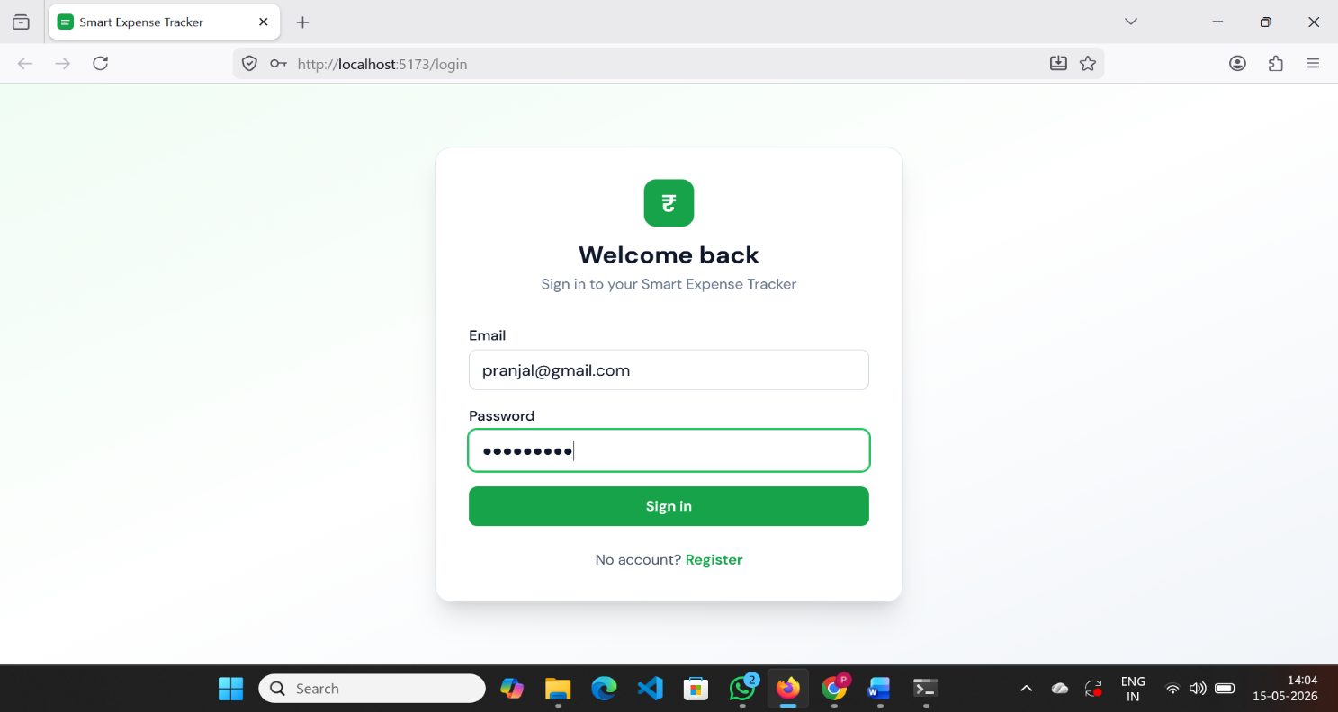

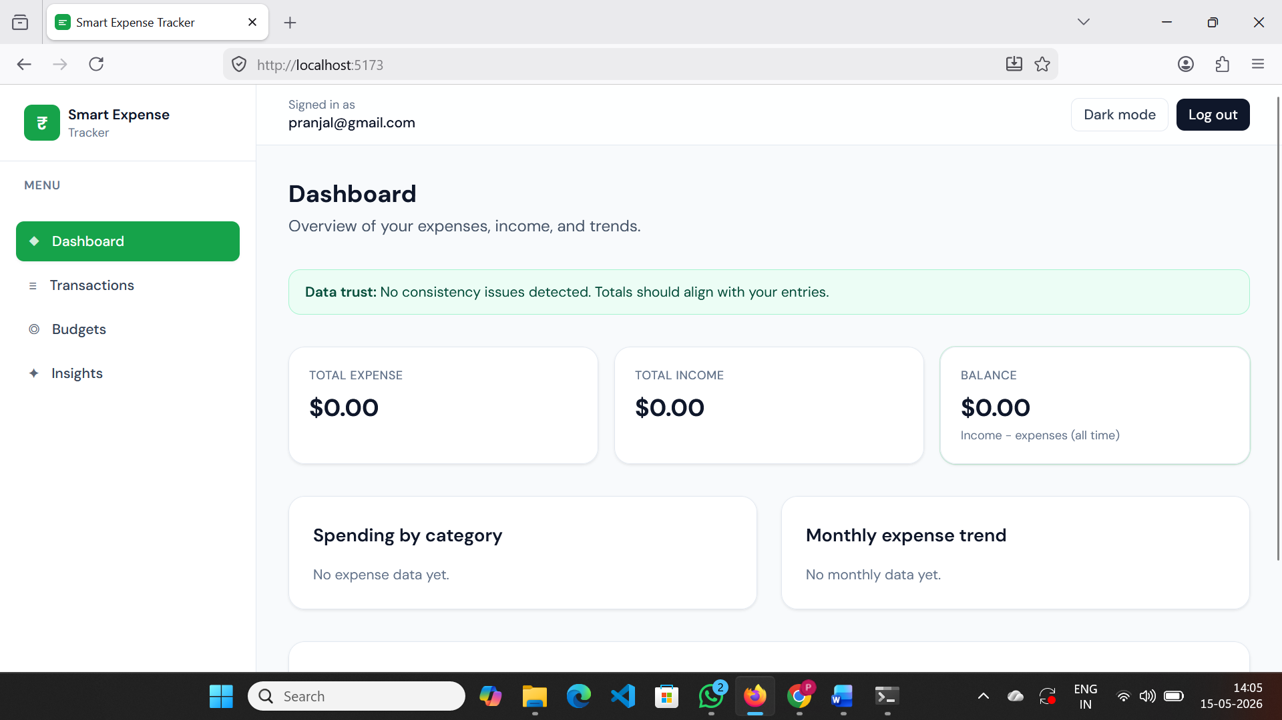

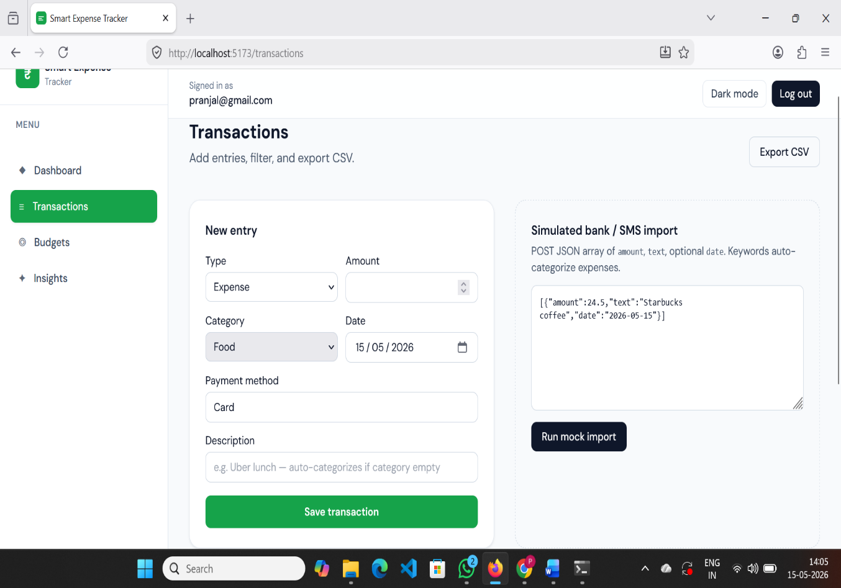

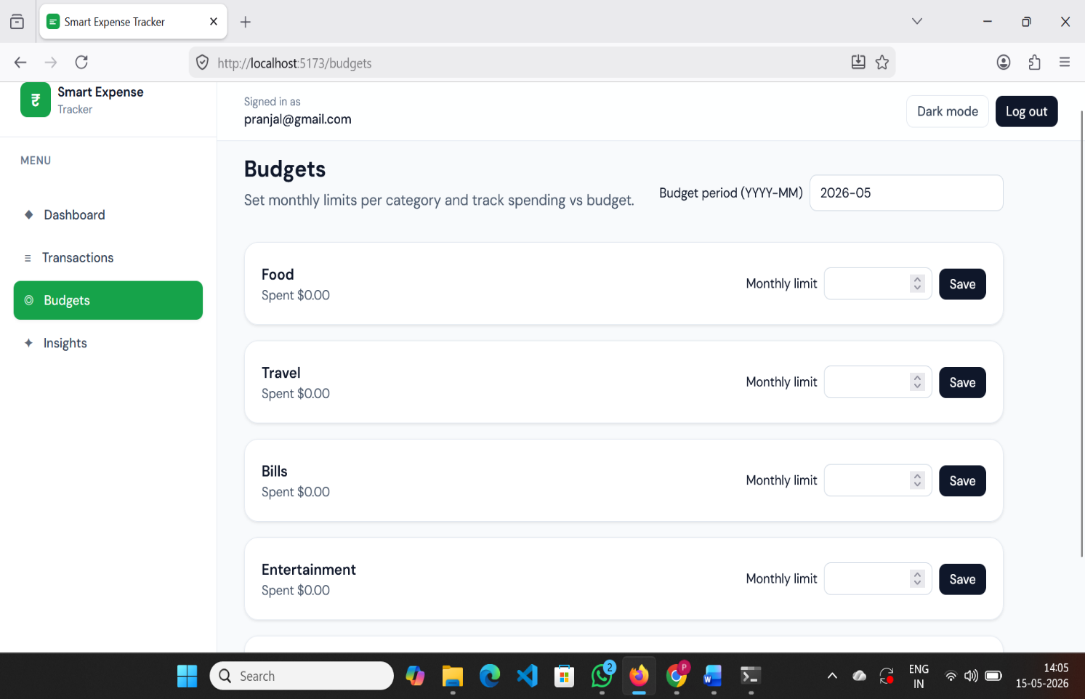

Code Snippets
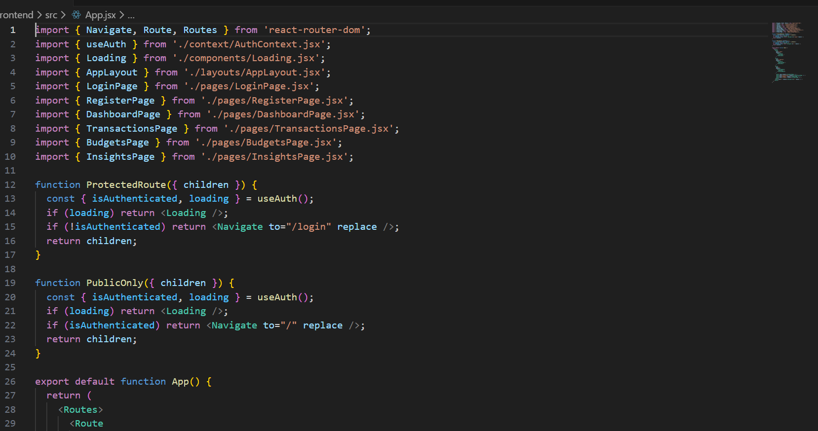

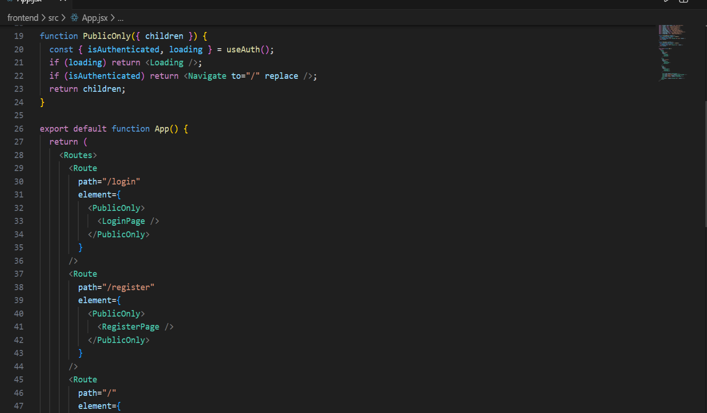

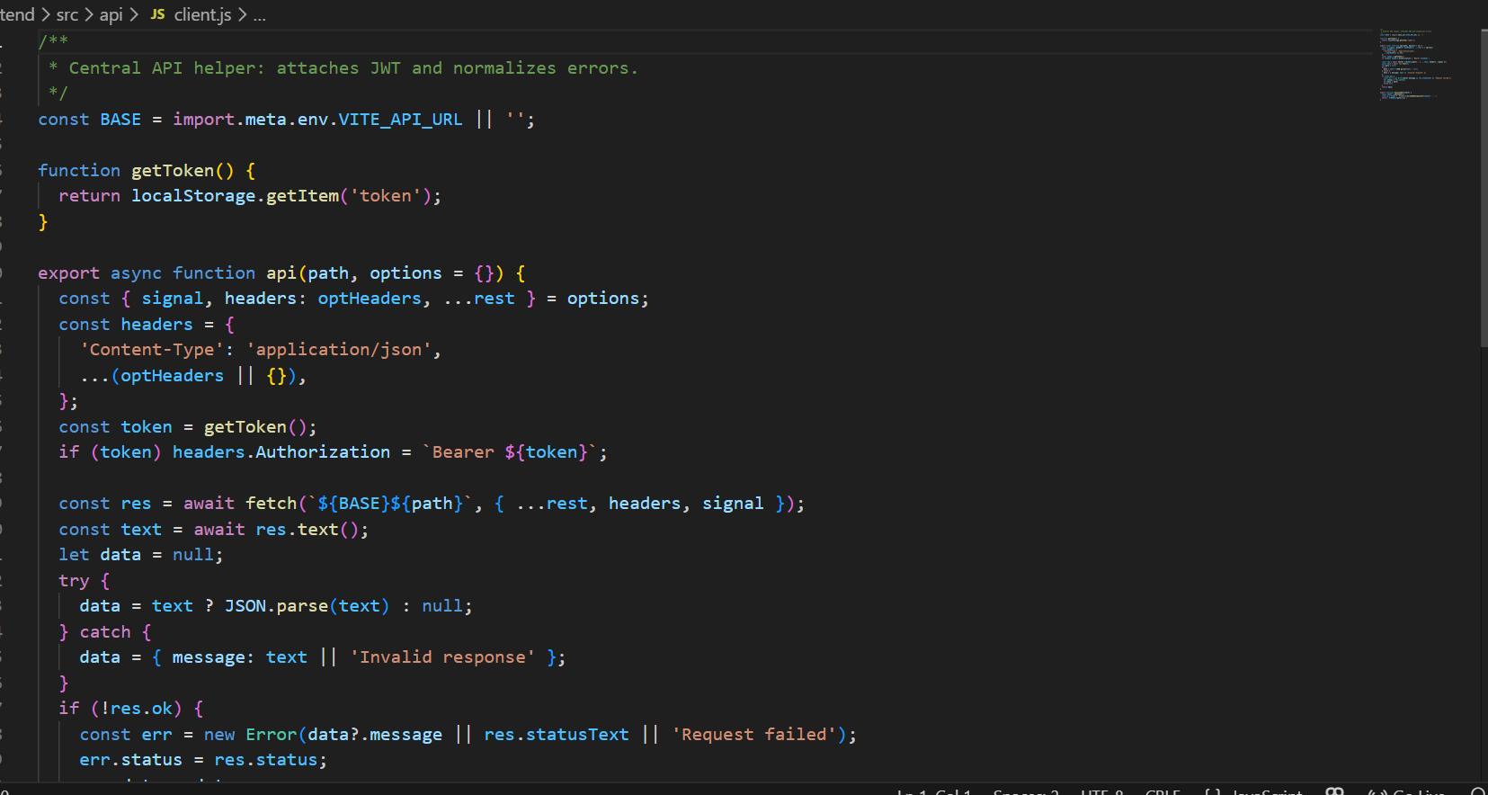

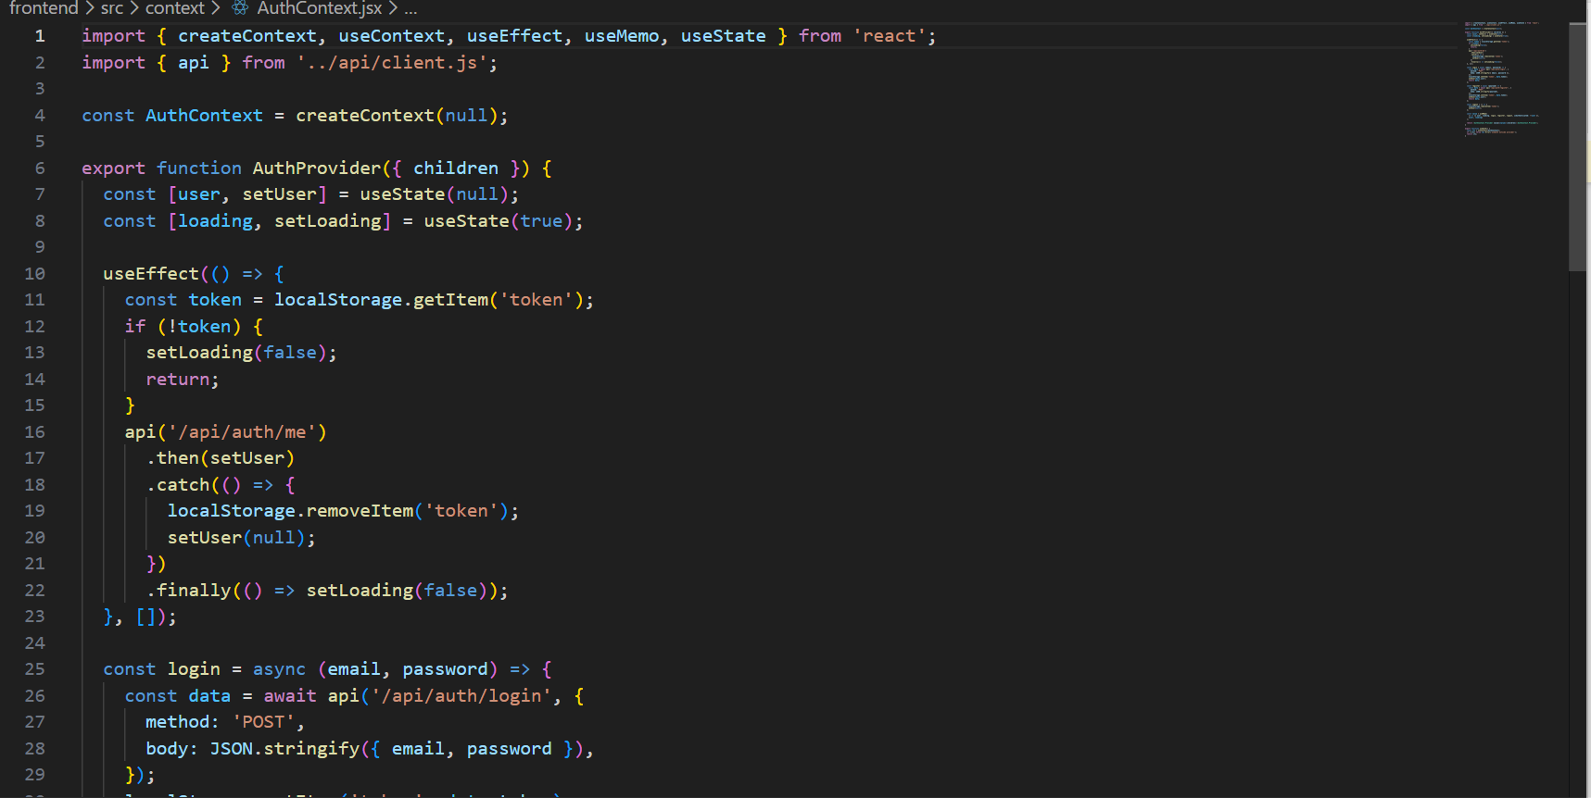

3. Conclusion and Future Scope
3.1 Conclusion
The Smart Expense Tracker project successfully demonstrates a modern and efficient financial
management system capable of tracking daily income and expenses in an organized manner. By
integrating expense recording, budget management, graphical analytics, and secure data storage, the
system addresses many limitations of traditional expense management methods.
The application provides users with real-time expense monitoring, automated calculations, and detailed
financial summaries, helping them improve budgeting practices and financial decision-making. The
responsive user interface, secure database management, and scalable web-based architecture make the
system reliable and easy to use for personal financial management.
Key highlights:
- Real-time expense and budget tracking
- Graphical reports and financial analytics
- Secure transaction history management
- Automated expense calculations and summaries
- User-friendly and responsive dashboard

3.2 Future Scope
1.AI-Based Expense Prediction → Integrate machine learning models to predict future expenses and spending habits.
2.Smart Budget Recommendations → Provide intelligent suggestions for saving money and improving budgeting practices.
3.Mobile Application Development → Develop Android and iOS applications for wider accessibility and convenience.
4.Cloud Synchronization → Enable real-time cloud backup and synchronization across multiple devices.
5.Multi-Currency Support → Add support for different currencies and international financial tracking.
6.Advanced Analytics → Include advanced charts, financial insights, and personalized spending analysis.
7.Notification and Reminder System → Implement automated reminders for bill payments, savings goals, and budget limits.
8.Integration with Banking Services → Connect with online banking systems and digital payment platforms for automatic transaction tracking.

3.2References
[1] P. Sharma and R. Gupta, “Smart Expense Tracker Using Machine Learning Techniques,” International Journal of Research in Computer Applications, vol. 10, no. 3, pp. 45–50, 2022.
[2] A. Kumar and V. Singh, “Design and Development of an Automated Expense Management System,” International Journal of Engineering Research & Technology (IJERT), vol. 9, no. 5, pp. 210–215, 2020.
[3] S. Patel and M. Shah, “Web-Based Personal Finance Management System,” International Journal of Computer Science and Information Technologies, vol. 11, no. 2, pp. 98–103, 2021.
[4] R. Mehta and K. Jain, “Expense Tracking and Budget Analysis Using Modern Web Technologies,” Journal of Emerging Technologies and Innovative Research, vol. 8, no. 6, pp. 1120–1125, 2021.
[5] M. Verma and A. Singh, “Personal Finance Monitoring System Using Data Visualization Techniques,” International Journal of Advanced Research in Computer Science, vol. 12, no. 1, pp. 55–60, 2021.
[6] T. Brown, “Modern Web Application Development with React and Node.js,” Journal of Software Engineering and Applications, vol. 15, no. 4, pp. 180–188, 2022.
[7] D. Miller and J. Wilson, “Cloud-Based Expense Tracking Systems for Personal Finance,” International Journal of Cloud Computing, vol. 6, no. 4, pp. 150–158, 2021.
[8] S. Gupta and R. Arora, “Budget Monitoring and Expense Categorization Using Web Applications,” International Journal of Innovative Technology and Exploring Engineering, vol. 9, no. 8, pp. 320–326, 2020.
[9] A. Roy and P. Das, “Financial Data Visualization Techniques for Expense Management Systems,” Journal of Information Systems and Technology, vol. 14, no. 2, pp. 70–76, 2022.
[10] K. Sharma and V. Bansal, “Secure User Authentication in Web-Based Financial Applications,” International Journal of Cyber Security and Digital Forensics, vol. 5, no. 1, pp. 25–31, 2021.
[11] React Documentation, “React – A JavaScript Library for Building User Interfaces,” Available: https://react.dev/
[12] Node.js Foundation, “Node.js Documentation,” Available: https://nodejs.org/en/docs/
[13] Express.js Documentation, “Fast, Unopinionated, Minimalist Web Framework for Node.js,” Available: https://expressjs.com/
[14] MongoDB Inc., “MongoDB Documentation,” Available: https://www.mongodb.com/docs/
[15] Tailwind CSS Documentation, “Utility-First CSS Framework,” Available: https://tailwindcss.com/docs/
[16] Axios Documentation, “Promise Based HTTP Client for the Browser and Node.js,” Available: https://axios-http.com/docs/intro
[17] Chart.js Documentation, “Simple yet Flexible JavaScript Charting Library,” Available: https://www.chartjs.org/docs/
[18] GitHub Documentation, “Version Control and Collaborative Development Platform,” Available: https://docs.github.com/
[19] Vercel Documentation, “Frontend Cloud Platform for Deployment,” Available: https://vercel.com/docs
[20] Postman Documentation, “API Testing and Development Platform,” Available: https://learning.postman.com/docs/introduction/overview/
4. Appendices
- Project Timeline (Development and Deployment Schedule)
- User Manual for Smart Expense Tracker
- System Architecture Diagrams
- UML Diagrams and Workflow Models
- Expense Report Sample
- Dashboard UI Design Samples
- Expense Analytics and Chart Screenshots
- Budget Management Demonstration
- Admin Dashboard Interface
- Database Design and Schema
- API Testing Reports
- Source Code Snippets
- Transaction History Samples
- Deployment and Hosting Configuration
- Financial Analytics Dashboard Screenshots

