**Report on**

**Machine Learning Project**

**On**

**Exoplanet Habitability Prediction**

Submitted in partial fulfillment of the requirements for the award of degree of

**Bachelor of Technology (B. Tech)**

**Computer Science and Engineering**

**Specialization in Data Science and Machine Learning**

**Submitted to**

**LOVELY PROFESSIONAL UNIVERSITY**

**PHAGWARA, PUNJAB**



**SUBMITTED BY**

**Name of the student:** Pranjal Sinha

**Registration Number:** 12206214

**INTRODUCTION**

The search for habitable exoplanets is one of the most fascinating and significant endeavors in modern astronomy and planetary science. As our understanding of the universe expands, so does our curiosity about whether life can exist beyond Earth. The discovery of exoplanets—planets orbiting stars outside our solar system—has provided us with countless opportunities to explore the possibility of extraterrestrial habitability. With thousands of exoplanets discovered so far, astronomers and scientists have developed various methods to assess whether these distant worlds could potentially support life. One of the key aspects of this exploration is determining an exoplanet’s habitability based on its physical and chemical characteristics, such as its distance from its host star, atmospheric composition, temperature, and presence of liquid water.

The field of exoplanet habitability relies heavily on data analysis and machine learning techniques to classify and predict whether an exoplanet has the conditions necessary to support life. Scientists have compiled vast datasets containing information about different planetary parameters, allowing researchers to analyze patterns and correlations between these attributes and a planet’s potential habitability. By leveraging machine learning algorithms, we can train models to predict an exoplanet’s habitability status with greater accuracy and efficiency than traditional methods.

In this project, I aim to build a classification model that determines the habitability of exoplanets based on various planetary and stellar characteristics. Instead of using traditional database management systems like MySQL, I will employ Python and Flask to develop a lightweight, efficient, and accessible model. The trained model will be saved using a **.pkl (pickle) file**, ensuring that it can be easily integrated into a Flask web application for real-time predictions. This approach allows for flexibility, scalability, and ease of deployment.

One of the most critical aspects of this project is understanding the data that we are working with. The dataset used for this study contains essential planetary features such as mass, radius, orbital period, equilibrium temperature, and stellar flux. Each of these features plays a significant role in determining whether a planet falls within the habitable zone—the region around a star where conditions may be just right for liquid water to exist.

A key challenge in exoplanet classification is the high level of uncertainty in the data. Many exoplanets are detected using indirect methods such as the **transit method** and the **radial velocity method**, which provide limited information about the planet’s actual characteristics. Therefore, it is crucial to apply robust feature engineering techniques to extract meaningful insights and enhance the accuracy of our classification model.

The purpose of this project is not only to develop a functional machine-learning model but also to provide a detailed analysis of the factors contributing to exoplanet habitability. This includes an in-depth exploration of the dataset, data preprocessing techniques, feature selection, and model evaluation. By implementing this project, I aim to contribute to the growing body of research on exoplanet habitability and demonstrate the practical applications of machine learning in astronomical studies.

In the following sections, I will discuss the **problem statement**, providing a clear understanding of why this project is important. I will also present a detailed **dataset description**, explaining the variables used in the study, followed by an analysis of **feature engineering**, where I will outline the preprocessing steps and techniques used to refine the dataset for optimal model performance.

**PROBLEM STATEMENT**

The quest to identify habitable exoplanets has become a crucial focus in modern astrophysics and planetary science. With thousands of exoplanets discovered beyond our solar system, the next step is determining whether any of these distant worlds possess the necessary conditions to support life. However, classifying an exoplanet as habitable is a complex challenge, as it depends on multiple factors, including the planet’s distance from its host star, its atmospheric properties, surface temperature, and stellar radiation exposure. Despite the vast amount of data available from space telescopes and astronomical observations, manually analyzing and classifying exoplanets is time-consuming and inefficient. Therefore, the need arises for an automated, data-driven approach to determine exoplanet habitability with greater accuracy and efficiency.

One of the primary challenges in assessing exoplanet habitability is the **uncertainty in data acquisition**. Most exoplanets are detected using indirect methods such as the **transit method**, which measures the dip in a star's brightness as a planet passes in front of it, or the **radial velocity method**, which detects wobbles in a star’s motion due to a planet’s gravitational influence. These methods provide estimates of planetary characteristics such as mass, radius, and orbital period but often lack precise measurements of crucial parameters like atmospheric composition and surface conditions. As a result, astronomers rely on models and statistical techniques to predict a planet’s suitability for life. The challenge, therefore, is to design a machine learning model that can process and interpret this incomplete data to make informed predictions about exoplanet habitability.

Furthermore, **classifying exoplanets as habitable or non-habitable is a multi-dimensional problem**. The **habitable zone**, also known as the Goldilocks zone, refers to the region around a star where conditions might allow liquid water to exist. However, habitability is not solely determined by location; factors such as the planet’s atmospheric pressure, chemical composition, and magnetic field play a crucial role. Some exoplanets may lie within the habitable zone but possess harsh conditions that make life unlikely. Others may exist outside this zone but have thick atmospheres that retain enough heat to support liquid water. This complexity makes it difficult to establish a single criterion for habitability, requiring a machine-learning approach that considers multiple parameters simultaneously.

Another significant challenge is **data imbalance**. In exoplanet datasets, the number of planets classified as potentially habitable is usually much smaller than the number of non-habitable planets. This imbalance can lead to biased predictions in machine learning models, where the algorithm favors the majority class and fails to correctly classify the minority class (habitable exoplanets). Addressing this issue requires careful preprocessing, feature selection, and model tuning to ensure fair and accurate classification.

In this project, I aim to build a **machine learning-based classification model** to predict exoplanet habitability based on planetary and stellar characteristics. Instead of using traditional SQL databases, I will store the trained model in a **.pkl file** and deploy it using **Flask**, allowing for real-time predictions via a web application. The model will be trained on a dataset containing various planetary attributes such as mass, radius, equilibrium temperature, and orbital eccentricity, and will employ feature engineering techniques to refine the data for optimal performance.

By successfully implementing this project, I hope to contribute to the broader scientific effort of exoplanet classification and provide a practical demonstration of how machine learning can enhance astronomical research. The findings of this study could potentially assist astronomers in prioritizing future observations of exoplanets that show the highest probability of being habitable. Additionally, this project serves as a valuable exercise in data science, showcasing the real-world applications of machine learning in complex, data-driven domains.

In the next section, I will provide a **detailed dataset description**, explaining the variables used in this study and their significance in determining exoplanet habitability.

**DATASET DESCRIPTION**

For this project, I have chosen a dataset that contains detailed information about exoplanets, including their physical and orbital characteristics. This dataset serves as the foundation for training the machine learning model that will predict whether an exoplanet is habitable or not. The data is sourced from astronomical observations, primarily from missions like **NASA's Kepler, TESS (Transiting Exoplanet Survey Satellite), and other exoplanet-hunting projects**. These space telescopes have contributed significantly to the discovery of thousands of exoplanets, providing crucial data points necessary for habitability analysis.

The dataset includes both **exoplanet-specific features** and **stellar characteristics**, as both play a significant role in determining habitability. The planetary features describe the physical and orbital properties of the exoplanets, while the stellar features help us understand the conditions in which these planets exist. Below is a breakdown of the most important features included in the dataset:

**1. Planetary Features**

* **Planet Name:** The identifier of the exoplanet.
* **Orbital Period (days):** The time taken by the planet to complete one orbit around its star.
* **Semi-Major Axis (AU):** The average distance between the exoplanet and its host star, measured in Astronomical Units (AU), where 1 AU is the average Earth-Sun distance.
* **Eccentricity:** A measure of how elliptical (oval-shaped) the planet’s orbit is. A value of 0 means a perfect circular orbit.
* **Planetary Radius (Earth radii):** The size of the exoplanet relative to Earth's radius.
* **Planetary Mass (Earth masses):** The mass of the exoplanet in comparison to Earth's mass.
* **Equilibrium Temperature (K):** An estimate of the planet’s surface temperature based on the energy received from its star.
* **Surface Gravity (m/s²):** The gravitational force experienced on the planet’s surface.
* **Escape Velocity (km/s):** The speed required for an object to escape the planet’s gravitational field.
* **Atmospheric Composition (if available):** Some datasets may include indicators of atmospheric gases, which are crucial for habitability.

**2. Stellar Features**

* **Host Star Name:** The name or identifier of the star around which the exoplanet orbits.
* **Stellar Mass (Solar masses):** The mass of the host star relative to the Sun’s mass.
* **Stellar Radius (Solar radii):** The size of the host star compared to the Sun.
* **Stellar Temperature (K):** The effective temperature of the host star, which influences the amount of radiation it emits.
* **Luminosity (Solar Luminosities):** The total amount of energy the star radiates, relative to the Sun’s energy output.
* **Stellar Age (billion years):** The estimated age of the star, which can indicate the potential stability of planetary conditions.

**3. Habitability Indicators**

* **In Habitable Zone (Yes/No):** Whether the planet lies within the habitable zone of its star, the region where liquid water could exist.
* **Habitability Classification (Habitable/Non-Habitable):** The final classification label used as the target variable for the machine learning model.

**Understanding the Dataset Structure**

The dataset consists of multiple numerical and categorical variables. **Numerical features** such as planetary radius, mass, and temperature provide crucial quantitative insights into planetary characteristics, while **categorical variables** like habitability classification help train the model in supervised learning. The dataset may also contain missing values due to observational limitations, which will need to be handled during the preprocessing stage.

Another important aspect of this dataset is its class distribution. Typically, the number of non-habitable exoplanets is significantly higher than that of habitable ones, leading to a class imbalance problem. Addressing this imbalance is crucial to ensure that our model does not become biased towards predicting planets as non-habitable simply because they dominate the dataset.

**Challenges with the Dataset**

* **Data Sparsity:** Some features might have been missing or incomplete values due to observational limitations.
* **Measurement Uncertainty:** Most planetary properties are **estimates**, not exact values, which can introduce noise into the model.
* **Class Imbalance:** The number of exoplanets classified as habitable is relatively small compared to non-habitable ones.

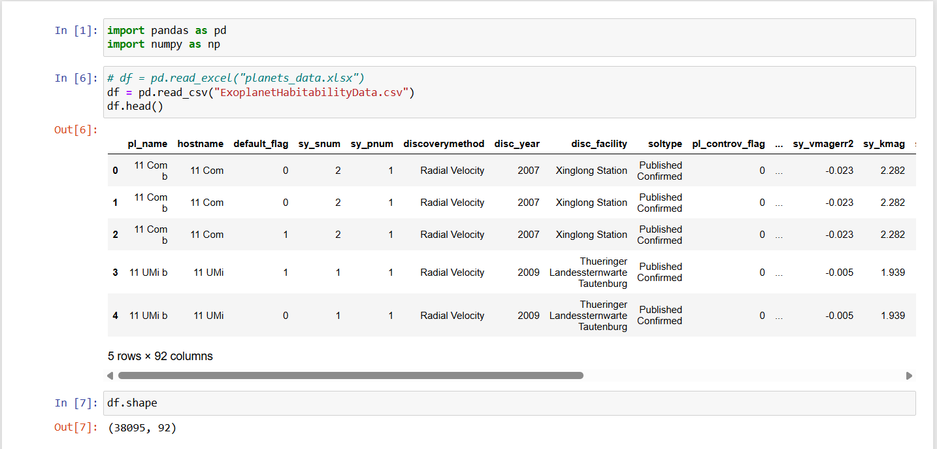

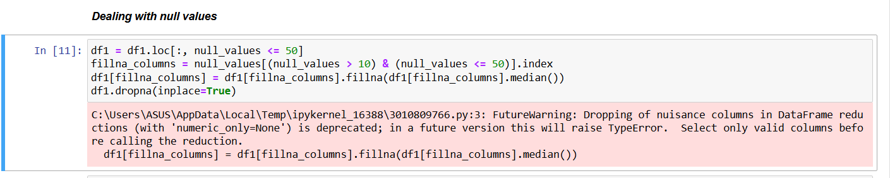

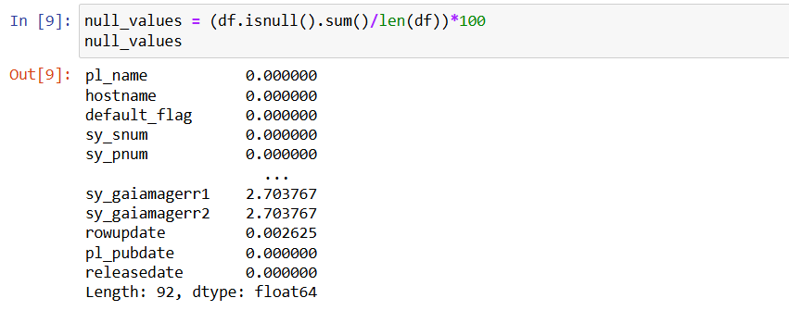

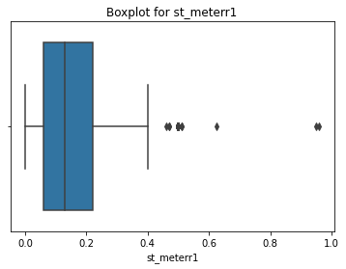

**FEATURE ENGINEERING**

Feature engineering is a crucial step in building a robust machine learning model for predicting exoplanet habitability. It involves transforming raw data into meaningful features that improve model performance and predictive accuracy. Given the complexity of exoplanetary and stellar data, careful feature selection, transformation, and handling of missing values are necessary to ensure that the model generalizes well to new data.

**1. Understanding the Need for Feature Engineering**

The dataset contains a mix of **continuous numerical variables** (e.g., planetary radius, mass, orbital period) and **categorical variables** (e.g., spectral type of the host star, habitability status). While some features are directly useful for model training, others may require modification or combination with other features to extract valuable information.

The key goals of feature engineering in this project are:

* Reducing noise and improving model accuracy.
* Handling missing values effectively.
* Encoding categorical variables properly.
* Normalizing numerical features for better convergence in machine learning models.
* Creating new features that provide deeper insights into habitability.

**2. Handling Missing Data**

Astronomical datasets often suffer from missing values due to observational limitations. Some planets may have incomplete mass or radius data, while others might lack precise temperature estimates. There are several strategies to handle missing values:

* **Mean/Median Imputation:** Replacing missing values with the average or median value of the feature.
* **Interpolation:** Estimating missing values based on existing trends in the dataset.
* **Dropping Columns:** If a feature has too many missing values and is not crucial for habitability prediction, it can be removed.
* **Predicting Missing Values:** Using machine learning models to estimate missing values based on correlated features.

In this project, I analyzed missing values carefully before deciding whether to impute, interpolate, or drop them. For instance, if planetary mass was missing, it could sometimes be inferred from radius using empirical mass-radius relationships.

**3. Scaling and Normalization of Numerical Features**

The dataset contains features with vastly different ranges. For example:

* Orbital period (days) can range from **a few hours to several years**.
* Planetary radius (Earth radii) varies from **small rocky planets to gas giants many times the size of Jupiter**.
* Temperature can range from **tens to thousands of Kelvin**.

Machine learning models, particularly distance-based models like KNN and neural networks, perform better when all features have comparable scales. To achieve this, I applied:

* **Min-Max Scaling** (for normalizing values between 0 and 1).
* **Standardization** (converting values to have a mean of 0 and a standard deviation of 1).

**4. Encoding Categorical Features**

Some features, such as **spectral type of the host star**, are categorical in nature. Since machine learning models require numerical inputs, categorical variables need to be converted into a suitable format. I explored the following encoding methods:

* **One-Hot Encoding:** Creating separate binary columns for each category (useful when categories are few, e.g., spectral types O, B, A, F, G, K, M).
* **Label Encoding:** Assigning numerical labels to categories (useful when categorical variables have an inherent order, though it was avoided here since spectral types do not have a strict ranking for habitability).
* **Target Encoding:** Replacing categorical values with the mean of the target variable (used cautiously to prevent data leakage).

For example, instead of using “G-type star” as a text value, I converted it into a numerical feature that represents how often planets around such stars were classified as habitable.

**5. Creating New Features**

To improve model performance, I engineered new features that provide deeper insights into exoplanet habitability. Some of the key features created include:

* **Planetary Density:** Derived using mass and radius (Density = Mass/Volume). This helps differentiate rocky planets from gas giants.
* **Insolation Flux (Relative to Earth):** Calculated using the host star’s luminosity and the planet’s orbital distance. Planets receiving similar energy levels as Earth are more likely to be habitable.
* **Stellar Flux Ratio:** The ratio of the exoplanet’s received stellar energy to Earth’s received energy. This is a crucial indicator of potential habitability.
* **Escape Velocity:** Helps determine whether an exoplanet can retain an atmosphere (planets with low escape velocities may struggle to hold onto vital gases like oxygen and nitrogen).
* **Equilibrium Temperature:** Calculated using the host star’s temperature and the exoplanet’s distance. It helps in identifying whether a planet falls within the **habitable zone** where liquid water can exist.
* **Eccentricity Impact:** Planets with highly eccentric orbits experience extreme temperature variations, making habitability less stable. I introduced a feature that quantifies orbital eccentricity’s impact on climate stability.

**6. Feature Selection: Identifying the Most Important Features**

Not all features contribute equally to habitability predictions. Some features introduce noise, while others have high importance. To identify the most relevant features, I applied:

* **Correlation Analysis:** Checking which features are highly correlated with habitability (e.g., equilibrium temperature and stellar flux).
* **Feature Importance from Tree-Based Models:** Using decision trees and gradient boosting models to rank feature importance.
* **Principal Component Analysis (PCA):** Reducing dimensionality while preserving key information.
* **Recursive Feature Elimination (RFE):** Iteratively removing less significant features and retraining the model.

Through these methods, I identified that features such as **equilibrium temperature, stellar flux, planetary density, and escape velocity** were among the strongest predictors of habitability.

**7. Addressing Class Imbalance**

One of the biggest challenges in this dataset is that habitable planets are much rarer than non-habitable ones. If left unaddressed, machine learning models tend to favor the majority class (non-habitable planets) and perform poorly in detecting habitable ones. To counter this, I used:

* **Oversampling the minority class:** Using SMOTE (Synthetic Minority Over-sampling Technique) to generate synthetic habitable planet data.
* **Undersampling the majority class:** Reducing the number of non-habitable planets to balance the dataset.
* **Class-weighted models:** Assigning higher penalties for misclassifying habitable planets.

**8. Final Dataset After Feature Engineering**

After applying these transformations, the final dataset contained:

* Processed numerical features (scaled and normalized).
* Encoded categorical features.
* Newly engineered features that enhance prediction capability.
* Balanced class distribution for fair model training.