# Checklist-Report

## Problem Statement

**Prepare a checklist for audit components present in the transformer-Energy-Audit spreadsheet.**

## Approach One

**Initial Visualization of the major mindset. Just a small setup which closely resembles a banking app. Using PHP I have enabled my XAMPP server and I have hosted a small replica of the user-form required for excel form command prompt as well. We will storing the data in PHP-MyAdminLogin-Page. The data base will closely resemble the different sections present in the userform in form of tables only.**

## Approach Two

**Solution with linking data storage to different tables present in the same workbook. Using VBA codes, designing a full form using user-form option in excel and then processing the VBA code using command buttons.**

**Details of Approach-One:**

**Procedure:**

1. Install PHP and run the XAMPP server for this download the “xampp-windows-x64-8.2.12-0-VS16-installer.exe” (for windows - 11) from the link as given below:
   1. **Installation Link:** <https://www.apachefriends.org/faq_windows.html>

**Note:**

This is for just running the server like we can run our Apache web server in Ubuntu Linux environment.

1. While installation kindly the note the directory where XAMPP will be located.
2. Now open the XAMPP directory and relocate your project folders namely “Transformer-Energy-Audit-Web” to HTDOCS folder.
3. **Project : Transformer-Energy-Audit-Web**

The project folder should have only 3 files. The files are index.html, submit.php and export.php. All these php files should be normalized with user schema that can be relatable to 6 different tables. I have their screenshots, SQL Codes, and other images linked to the web page as well .

1. After building the project files move project folder to the XAMPP - HTDOCS directory. Please refer to the below given screenshots for doing the above specified operations.
2. Once you have downloaded the xampp installer it might run in form of a dummy server. Just run Apache Module and MySQL Module just ports of the PID container have to be emptied. You will be able to run your PHP - My admin-LoginPage as well. Below I have pasted a screenshot please refer to it.
3. For this open shell using the xampp server and run the following commands.
4. cd htdoc
5. cd Transformer_Energy_Audit_Web
6. php -S localhost:8000
7. Just open PHP - My admin-LoginPage go to SQL table and then run your SQL commands and then run go.

**Note:**

1. Our project folder should be present in XAMP directly only. And then we will be able to locate HTDOCS folder. This is where our project folder should be located. So that our project runs successfully.
2. We need XAMP folder because of our PHP-MyAdmin-Login-Page Setup.
3. Just build the server. I have carefully recorded the screenshots how my project was building up.

**Check my GitHub repository link for all the code related issues.**

1. **Download Link:**

**<https://github.com/pranjalsinha1965/Checklist-Implementation.git>**

1. **Check picutres:**
2. **GUI : <https://github.com/pranjalsinha1965/Checklist-Implementation/tree/main/GUI>**
3. **Tables: <https://github.com/pranjalsinha1965/Checklist-Implementation/tree/main/Tables>**

# Important Screenshots

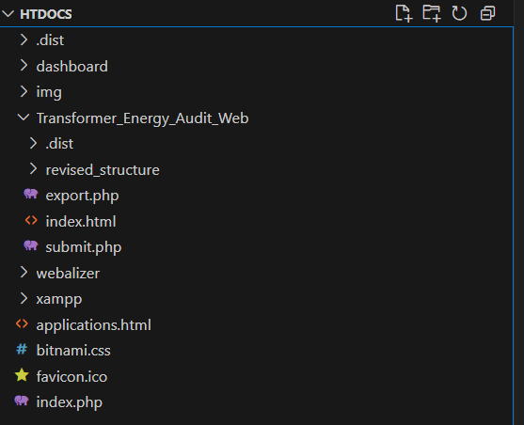

**Kindly build tables with normalized user schema for storing specific details entered from the GUI.**

**Hierarchy of the Transformer-Energy-Audit folder. Files present are Export.php, Index.html, Submit.php**

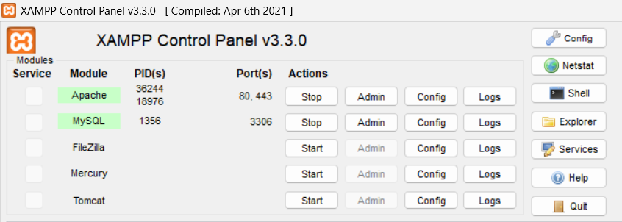

**XAMPP Control Panel for running my PHP-My-Admin-Login Page. You can use netstat, shell and other buttons for running commands. Using shell command you can run the log and ports associated with the containers as well.**

**It will start generating the command logs. And if you enter any sample command which has errors and you can also generate the the detailed logs. Don`t forget to connect with the MySQL database because then you will be able to store the data inform of store data from the forms only.**

**PHP Shell Command Line**

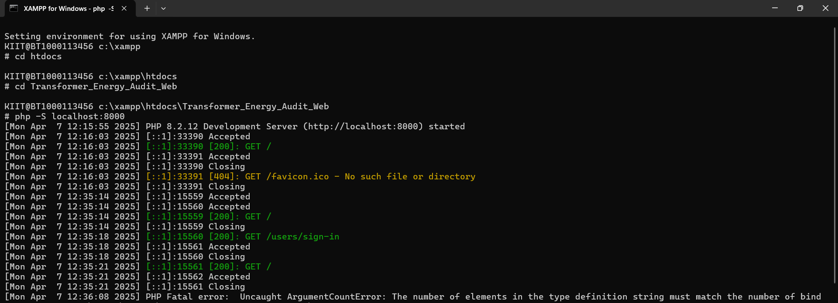

**Database using php-MyAdmin-LoginPage its built using MySQL**

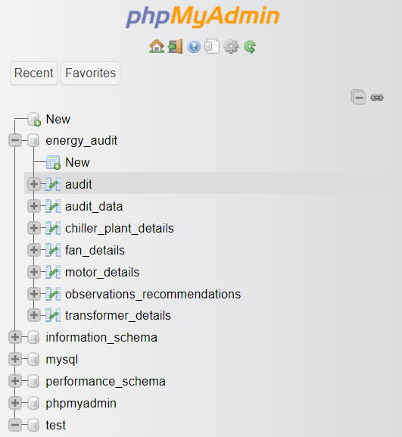

**Details of Approach Two:**

### ****Audit Form Summary****

### Integrated with drop-downs from Transfer-Energy-Audit for standardization. **VBA "Submit" button** triggers data validation and transfer to Audit-data. Fields reset after successful submission to allow new entries.

### ****AuditData Sheet Summary:****

### Acts as the **backend storage** for all submitted audit entries. Data stored row-wise, with columns representing each field. Includes fields for:

### Transformer ID, Capacity, Voltage, etc.

### Motor ID, Ratings, Efficiency

### Chiller plant values

### Fan information

### Observations and Recommendations

### Timestamp auto-inserted via VBA during submission.Sheet is **protected** from direct edits to avoid accidental overwrites.

### ****Master Data Sheet Summary****

### Contains static reference data used across the workbook:

### Building Types

### Voltage Ranges

### Manufacturer List

### Cooling Types

### Linked to Audit Form through **data validation dropdowns**.

### Ensures **consistency** across user entries.

### Easily extendable without modifying VBA code.

### ****Export Sheet Summary****

### Populates data from AuditData for CSV download/export.

### Serves as a **buffer sheet** to format data before saving.

### Connected to a **VBA button**:

### Saves as .csv using a filename format: AuditExport_<date>.csv

### Export operation prompts user for a save location.