CASE-STUDY

Automation
Of
Energy Invoice

Through IoT Integration and OCR – Driven Data Extraction

- Supported with energy conservation uses
- Proper calculations as shown in tables
- API based integration as implemented for cloud storage and data extraction

By Pranjal Sinha

IOT Based Monitoring of Invoices

- Introduction

This documentation outlines an IoT-enabled OCR automation system designed for efficient monitoring and analysis of invoices. The system replaces manual data entry by using IoT devices to capture documents and OCR/AI models to automatically extract key parameters such as Contract Demand, Billing Demand, Maximum Demand, fixed Charges and Consumption details. Extracted data is then processed for energy calculations, ECM evaluation, and payback assessment.

To support automation at scale, the platform includes pre-processing pipelines, structured data storage, API integrations, web-hooks, and an AI-driven interface for validation and analysis. A CI/CD workflow ensures seamless deployment and updates. This documentation summarizes the system workflow, key components, analytical methods, and the observations made during testing in the real audit environment.

With respect to the AWS Well Architect-ed framework it helps us understand pros and cons of building workloads on AWS.It`s intended for those who have scope for technology operations. The sustainable workloads on AWS Cloud are based on the following pillars only this provides us support for business outcomes:

- Operational excellence
- Security
- Reliability
- Performance efficiency
- Cost optimization
- Sustainability

AWS is responsible for optimizing sustainability of the cloud - delivering efficient, shared infrastructure, water stewardship, and source renewable power. Customers are responsible for sustainability in the cloud - optimizing workloads and resource utilization, and minimizing the total resources required to be deployed for your workloads. Cloud providers have a lower carbon footprint and are more energy efficient than typical on-premises alternatives because they invest in efficient power and cooling technology, operate energy efficient server populations, and achieve high server utilization rates. Cloud workloads, reduce impact by taking advantage of shared resources, such as networking, power, cooling, and physical facilities. You can migrate you cloud workloads to more efficient technologies as they become available and use cloud - based services to transform your workloads for better sustainability.

In context with the cloud it`s a continuous effort focused on primarily on energy reduction and efficiency across all components of a workload by achieving benefit from minimizing the total resources required. This effort can range from the initial selection of an efficient programming language, adoption of modern algorithms, use of efficient data storage techniques, deploying to correctly sized and efficient compute infrastructure, and minimizing requirements for high - powered end- user hardware.

Examples of these challenges include reducing carbon emissions, lowering energy consumption, recycling water, or reducing waste in other areas of your business or organization. Sustainability through the cloud is when you use AWS technology to solve a broader sustainability challenge. For example you can use machine learning service to detect abnormal behaviour in industrial machinery. Using this detection data, you can conduct preventative maintenance to reduce the risk of environmental incidents caused by unexpected equipment failures and ensure that the machinery continuous to operate at peak efficiency.

- Design principle for sustainability in the cloud
Apply these design principles when architecting your cloud workloads to maximize sustainability and minimize impact.
Understand your impact: Measure the impact of your cloud workload and model the future impact of your workload. Include all sources of impact, including impacts resulting from customer use of your products, and impacts resulting from their eventual decommissioning and retirement. Compare the productive output with the total impact of your cloud workloads by reviewing the resources and emissions required per unit of work. Use this data to establish key performance indicators (KPIs), evaluate ways to improve productivity while reducing impact, and estimate the impact of proposed changes over time.
Establish sustainability goals: For each cloud workload, establish long-term sustainability goals such as reducing the compute and storage resources required per transaction. Model the return on investment of sustainability improvements for existing workloads, and give owners the resources they need to invest in sustainability goals. Plan for growth, and architect your workloads so that growth results in reduced impact intensity measured against an appropriate unit, such as per user or per transaction. Goals help you support the wider sustainability goals of your business or organization, identify regressions, and prioritize areas of potential improvement.
Maximize utilization: Right-size workloads and implement efficient design to ensure high utilization and maximize the energy efficiency of the underlying hardware. Two hosts running at 30% utilization are less efficient than one host running at 60% due to baseline power consumption per host. At the same time, eliminate or minimize idle resources, processing, and storage to reduce the total energy required to power your workload.
Anticipate and adopt new, more efficient hardware and software offerings: Support the upstream improvements your partners and suppliers make to help you reduce the impact of your cloud workloads. Continually monitor and evaluate new, more efficient hardware and software offerings. Design for flexibility to allow for the rapid adoption of new efficient technologies.
Use managed services: Sharing services across a broad customer base helps maximize resource utilization, which reduces the amount of infrastructure needed to support cloud workloads. For example, customers can share the impact of common data center components like power and networking by migrating workloads to the AWS Cloud and adopting managed services, such as AWS Fargate for serverless containers, where AWS operates at scale and is responsible for their efficient operation. Use managed services that can help minimize your impact, such as automatically moving infrequently accessed data to cold storage with Amazon S3 Lifecycle configurations or Amazon EC2 Auto Scaling to adjust capacity to meet demand.
Reduce the downstream impact of your cloud workloads: Reduce the amount of energy or resources required to use your services. Reduce or eliminate the need for customers to upgrade their devices to use your services. Test using device farms to understand expected impact and test with customers to understand the actual impact from using your services.

- Best practices for sustainability in the cloud

Optimize workload placement, and optimize your architecture for demand, software, data, hardware, and process to increase energy efficiency. Each of these areas represents opportunities to employ best practices to reduce the sustainability impact of your cloud workload by maximizing utilization, and minimizing waste and the total resources deployed and powered to support your workload.

- Region selection
The choice of Region for your workload significantly affects its KPIs, including performance, cost, and carbon footprint. To effectively improve these KPIs, you should choose Regions for your workloads based on both business requirements and sustainability goals.

Best practices
SUS01-BP01 Choose Region based on both business requirements and sustainability goals

- Alignment to demand
The way users and applications consume your workloads and other resources can help you identify improvements to meet sustainability goals. Scale infrastructure to continually match demand and verify that you use only the minimum resources required to support your users. Align service levels to customer needs. Position resources to limit the network required for users and applications to consume them. Remove unused assets. Provide your team members with devices that support their needs and minimize their sustainability impact.

Best practices
Scale workload infrastructure dynamically
Align SLAs with sustainability goals
Stop the creation and maintenance of unused assets
Optimize geographic placement of workloads based on their networking requirements
Optimize team member resources for activities performed
Implement buffering or throttling to flatten the demand curve

- Software and architecture
Implement patterns for performing load smoothing and maintaining consistent high utilization of deployed resources to minimize the resources consumed. Components might become idle from lack of use because of changes in user behavior over time. Revise patterns and architecture to consolidate under-utilized components to increase overall utilization. Retire components that are no longer required. Understand the performance of your workload components, and optimize the components that consume the most resources. Be aware of the devices your customers use to access your services, and implement patterns to minimize the need for device upgrades.

Best practices
Optimize software and architecture for asynchronous and scheduled jobs
Remove or refactor workload components with low or no use
Optimize areas of code that consume the most time or resources
Optimize impact on devices and equipment
Use software patterns and architectures that best support data access and storage patterns

- Data management
Implement data management practices to reduce the provisioned storage required to support your workload, and the resources required to use it. Understand your data, and use storage technologies and configurations that best support the business value of the data and how it’s used. Lifecycle data to more efficient, less performant storage when requirements decrease, and delete data that’s no longer required.

Best practices
Implement a data classification policy
Use technologies that support data access and storage patterns
Use policies to manage the lifecycle of your datasets
Use elasticity and automation to expand block storage or file system
Remove unneeded or redundant data
Use shared file systems or storage to access common data
Minimize data movement across networks
Back up data only when difficult to recreate
- Hardware and services
Look for opportunities to reduce workload sustainability impacts by making changes to your hardware management practices. Minimize the amount of hardware needed to provision and deploy, and select the most efficient hardware and services for your individual workload.

Best practices
Use the minimum amount of hardware to meet your needs
Use instance types with the least impact
Use managed services
Optimize your use of hardware-based compute accelerators

- Process and culture
Look for opportunities to reduce your sustainability impact by making changes to your development, test, and deployment practices.

Best practices
Communicate and cascade your sustainability goals
Adopt methods that can rapidly introduce sustainability improvements
Keep your workload up-to-date
Increase utilization of build environments
Use managed device farms for testing

- Related Work
Existing research invoice automation and energy monitoring highlights the growing use of OCR, IoT and AI driven systems to improve accuracy and efficiency. Traditional OCR engines such Tesseract and modern cloud-based solutions like Mindee, Affinda, and Google Vision are widely used for extracting structured fields from invoices and utility bills. These systems demonstrate strong performance in text recognition, table extraction, and key-value identification, forming the foundation for automated financial and energy data processing.

IoT-based data acquisition is also extensively applied in energy management systems, where smart meters and sensors transit real-time consumption data to centralized servers. This concept aligns with invoice monitoring, where IoT devices can capture billing documents from field locations and provide continuous data flow for analysis.

Further machine-learning based approaches including named – entity recognition, anomaly detection, and document classification have been explored to enhance accuracy and detect missing or inconsistent invoice parameters. Modern platforms also incorporate API-driven integration, web-hooks, and automated pipelines to support end-to-end workflow automation.

Together, these works demonstrate the feasibility and importance of integrating IoT sensing, OCR extraction, and AI analytics to build a robust and scalable invoice monitoring and energy-analysis system.
- Experimental Results

The IoT-based OCR automation system was evaluated using a diverse set of utility invoices collected from different field locations. IoT devices successfully captured invoice images and transmitted them to the OCR engine, were automated pre-processing improved clarity and readability. The OCR and AI models demonstrated high accuracy in extracting essential invoice parameters, including Contract Demand, Billing Demand, Maximum Demand, fixed Charges, and Consumption details.

The system generated structured datasets for further processing, enabling ECM calculations, payback analysis, and comparison of consumption trends across invoices. The AI-enabled interface displayed results in real time and provided alerts for missing or inconsistent data.

During the testing phase, two key shortcomings were identified:
- The system could not store multi pages data effectively, as outputs were constrained to single CSV files and
- Certain invoices lacked complete consumption information, requiring an automated detection mechanism to flag missing parameter

Despite these limitations, the experiments confirmed that the proposed system is feasible, and efficient for automating invoice monitoring and supporting energy audit workflows.

- Energy Based Calculations(ECM)

Energy Conservation Measures (ECMs) were evaluated using the data extracted from the invoices through the OCR automation system. The extracted parameters – such as Contract Demand, Maximum Demand, kWh Consumption, tariff rates, fixed charges, and billing demand – were used to assess energy performance and estimate potential savings.

Baseline energy consumption was first established from historical invoices. Using this baseline, ECM calculations were carried out to determine reductions in demand, improvements in consumption, and corresponding cost savings.

Typical ECM based analyses includes:

- Demand Reduction
- Energy Savings
- Cost Savings
- Payback Period

These calculations enabled comparison of existing conditions against expected improvements after ECM implementation. By using OCR-extracted invoice data, the system automatically produced energy-savings estimates, financial impacts, and priority recommendations. This automated approach ensured faster analysis, reduced errors, and supported auditors in identifying the most impactful ECMs.
- CI/CD Pipeline with web hooks on Linux

The Affinda documentation covers webhooks for document processing workflows. The documentation shows how to set up webhooks to receive notifications when documents are parsed/validated, including Python code examples for webhook receivers. However, this is focused on Affinda's document processing, not general CI/CD pipeline setup.

To set up webhooks with your trial account:

- Create a subscription via POST to /v3/resthook_subscriptions with your target URL, event type (e.g., document.parse.completed), and organization identifier
- Confirm subscription: Affinda sends a POST with X-Hook-Secret header to your URL. Respond with 200 status code
- Activate: Use the X-Hook-Secret to POST to /v3/resthook_subscriptions/activate

Note:
Your webhook is now active and will receive notifications when events occur. The Webhooks documentation has detailed setup instructions with Python code examples.

- Affinda AI`s Description(Cloud)

Affinda has already used Amazon SageMaker to support its ML models and has since expanded its approach with AWS generative AI technologies, using Amazon-Bedrock - based large language models (LLMs) powered by different version of Claude Sonnet. It provided a real boost to give data sovereignty, regional data processing, and seamless integration with our existing AWS environment.

With Amazon Bedrock, there’s very little need for specific model training data. As a result, data accuracy has seen a 90 percent reduction in configuration time for new document extraction. Affinda also simplified model correction through natural-language explanations, cutting engineering overhead. The company reports a 90 percent cost savings for its product delivery team in the effort and resources required to roll out a custom use case. The platform now allows customers to self-serve, configuring new data extraction models themselves in a matter of minutes—a task that previously took Affinda’s internal team weeks or even months. By lowering the barrier to entry, Affinda has made intelligent document processing accessible to organizations across industries and use cases. This approach has reduced time to value and increased return on investment for Affinda’s customers. Meanwhile, customers also benefit from instant learning and adaptation, which improves accuracy and allows for straight-through processing at scale. Affinda is now advancing its AI capabilities by developing agents that act like seasoned data-entry professionals—detecting anomalies, tracing answers through internal systems, asking smart questions of the right people, and delivering resolved outcomes.

The company runs its Kubernetes clusters on Amazon Elastic Kubernetes Service (Amazon EKS) with Amazon Elastic Compute Cloud (Amazon EC2) and trains hundreds of custom models on Amazon SageMaker. Affinda also uses AWS CloudFormation to automate infrastructure management across its technology stack.
Namely the services used are:

1. Amazon EC2
2. Amazon Bedrock
3. Amazon Sage Maker
4. Amazon Elastic Kubernetes Service

Next task is to execute this flask-based application given in free code camp only.

To improve energy efficiency and reduce overall power consumption, we conducted a detailed analysis of fan usage patterns. Based on our findings, we proposed energy-saving measures for different operational scenarios, considering during hostel time and School time utilization rates.

A comprehensive analysis, including estimated energy savings and recommended conservation strategies, is presented in the respective chapter.

complete, production-ready logging, monitoring setup only Bash and basic Linux tools
Assumptions
- All scripts are written assuming your application webhook/log files are located in:
Location: /var/log/webapp/

Application Logging Script
This is a centralized logger your web app can call.

Location: /usr/local/bin/app_logger.sh
#!/bin/bash
# Usage: app_logger.sh "log-message"
LOG_DIR="/var/log/webapp"
LOG_FILE="$LOG_DIR/app.log"
mkdir -p "$LOG_DIR"
TIMESTAMP=$(date +"%Y-%m-%d %H:%M:%S")
echo "$TIMESTAMP | $1" >> "$LOG_FILE"

Make executable:

sudo chmod +x /usr/local/bin/app_logger.sh

Inside your Python/Flask app, you can call it like:

import os

os.system(f'/usr/local/bin/app_logger.sh "Received webhook payload"')

2. Error Logging Wrapper Script
This catches STDERR from any command:

Location: /usr/local/bin/capture_errors.sh
Script
#!/bin/bash
# Usage: capture_errors.sh "<command>"
LOG_DIR="/var/log/webapp"
ERROR_LOG="$LOG_DIR/errors.log"
mkdir -p "$LOG_DIR"
TIMESTAMP=$(date +"%Y-%m-%d %H:%M:%S")
# Execute command and redirect stderr
eval "$1" 2>>"$ERROR_LOG"
# If exit code is not zero, log an alert
if [ $? -ne 0 ]; then
echo "$TIMESTAMP | ERROR running: $1" >> "$ERROR_LOG"
fi
Make it executable:
sudo chmod +x /usr/local/bin
capture_errors.sh

Example Usage:
capture_error.sh “systemctl restart webhook.service”

3. Simple Health Check Script
Checks that your web hook service is running, log file is active, end port is open
Location: /usr/local/bin/health_check.sh
Script
#!/bin/bash
LOG="/var/log/webapp/health.log"
WEBHOOK_SERVICE="webhook.service"
PORT=5000
timestamp() {
date +"%Y-%m-%d %H:%M:%S"}
{echo "---- Health Check $(timestamp) ----"
# 1) Check Systemd service
systemctl is-active --quiet "$WEBHOOK_SERVICE"
if [ $? -eq 0 ]; then
echo "STATUS: Webhook service active"
else
echo "ERROR: Webhook service NOT running"
fi
# 2) Check listening port
ss -ltn | grep ":$PORT " >/dev/null
if [ $? -eq 0 ]; then
echo "STATUS: Port $PORT open"
else
echo "ERROR: Port $PORT NOT open"
fi

# 3) Check if logs are being updated
LOG_FILE="/var/log/webapp/app.log"
if [ -f "$LOG_FILE" ]; then
LAST_UPDATE=$(date -r "$LOG_FILE" +"%Y-%m-%d %H:%M:%S")
echo "LOG UPDATED AT: $LAST_UPDATE"
else
echo "ERROR: app.log missing"
fi
echo "" # spacing
} >> "$LOG"

Make executable:
Sudo chmod +x /usr/local/bin/health_check.sh

4. Monitoring Script (Alerts for errors, anomalies)
Location: /usr/local/bin/monitor_logs.sh
Script
#!/bin/bash
LOG_DIR="/var/log/webapp"
APP_LOG="$LOG_DIR/app.log"
ERROR_LOG="$LOG_DIR/errors.log"
ALERT_LOG="$LOG_DIR/alerts.log"
mkdir -p "$LOG_DIR"
timestamp=$(date +"%Y-%m-%d %H:%M:%S")
# Look for suspicious patterns
patterns="error|failed|unauthorized|forbidden|invalid|denied|timed out"
matches=$(tail -n 300 "$APP_LOG" | grep -Ei "$patterns")
if [ ! -z "$matches" ]; then
echo "$timestamp | ALERT TRIGGERED" >> "$ALERT_LOG"
echo "$matches" >> "$ALERT_LOG"
echo "---" >> "$ALERT_LOG"
fi
# Also check error.log
if [ -s "$ERROR_LOG" ]; then
echo "$timestamp | ERROR LOG CONTENT" >> "$ALERT_LOG"
tail -n 50 "$ERROR_LOG" >> "$ALERT_LOG"
fi

Make executable:
Sudo chmod +x /usr/local/bin/monitor_logs.sh

5. Daily Log Rotation (lightweight version)

Location: /usr/local/bin/rotate_logs.sh

Script
#!/bin/bash

LOG_DIR="/var/log/webapp"
BACKUP_DIR="$LOG_DIR/archive"
mkdir -p "$BACKUP_DIR"

timestamp=$(date +"%Y%m%d-%H%M")

for file in $LOG_DIR/*.log; do
if [ -f "$file" ]; then
mv "$file" "$BACKUP_DIR/$(basename $file)-$timestamp"
touch "$file"
fi
done

gzip $BACKUP_DIR/*.log* 2>/dev/null

Make executable:
Sudo chmod +x /usr/local/bin/rotate_logs.sh

6. Scheduling All Tasks (cron jobs)

1. Run Monitoring every minute:

***** /usr/local/bin/monitor_logs.sh

Daily health checks:

0****/usr/local/bin/health_check.sh

Rotate logs daily:

00***/usr/local/bin/rotate_logs.sh

7. Real-time Log Monitoring Commands

Application Logs:

Tail -F /var/log/webapp/app.log

Error Logs:

Tail -F /var/log/webapp/errors.log

Alert:

Tail -F /var/log/webapp/alerts.log

Check service status:

Journalctl -u webhook.service -f

8. Optional: Attach These Scripts to CI/CD Pipeline
In your CI/CD pipeline YAML you can run:

Script

1. ssh user@server "/usr/local/bin/app_logger.sh 'CI/CD: Deployment started'"
2. ssh user@server "sudo capture_errors.sh 'systemctl restart webhook.service'"
3. ssh user@server "/usr/local/bin/app_logger.sh 'CI/CD: Deployment complete'"

- Experimental Results – ECM Based Calculations
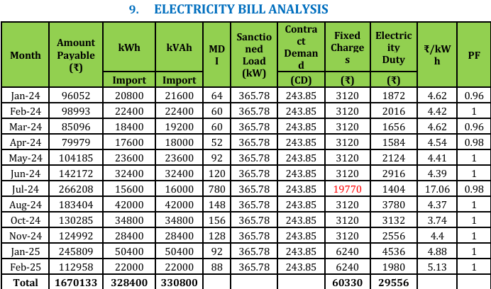
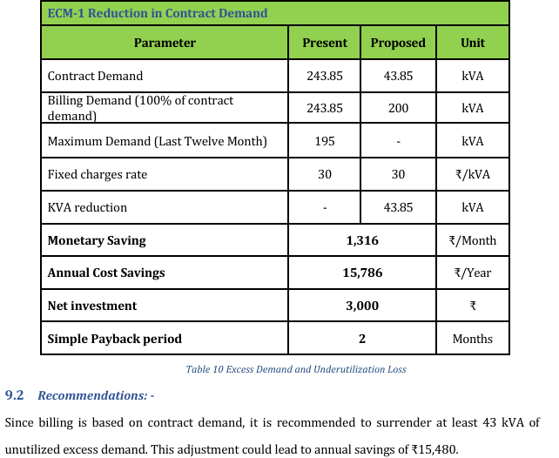

- Refined Recommendations
1. Enhance Indoor Illumination Efficiency
Apply high-reflective paint in classrooms, offices, and auditoriums, and replace existing curtains with thick, light-colored variants. This improves natural lighting, reduces artificial lighting requirements, and enhances overall visual comfort.

2. Improve Light Distribution
Install beam-mounted lighting fixtures to achieve uniform illumination across the room and eliminate dark spots, ensuring optimal learning and working conditions.
3. Deploy Smart Occupancy-Based Controls
Introduce occupancy sensors across laboratories, classrooms, and office spaces. These systems intelligently adjust lighting levels based on real-time presence, significantly cutting unnecessary energy usage.

4. Upgrade to High-Efficiency LED Systems
Replace all conventional fluorescent lamps with high-efficiency LED fixtures. Additionally, swap out older LED units with newer, energy-optimized models.

5. Automate Common Area Lighting
Install timers and motion-sensor systems in corridors, staircases, and other shared spaces to ensure lighting operates only when needed.

6. Deploy Advanced Smart Energy Monitoring
Implement a real-time energy monitoring system to continuously track load patterns, identify inefficiencies, and optimize overall energy performance. Encourage active load management during peak hours (12 PM–2 PM) to minimize demand spikes.

- Graphical Analysis
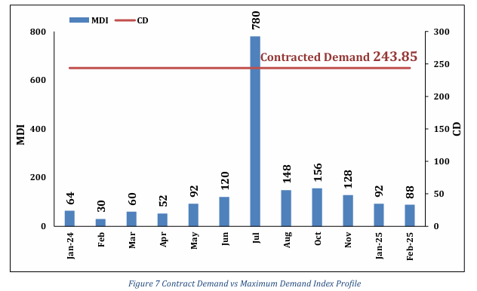
Shows the month-wise variation in electricity consumption and highlights seasonal load patterns.
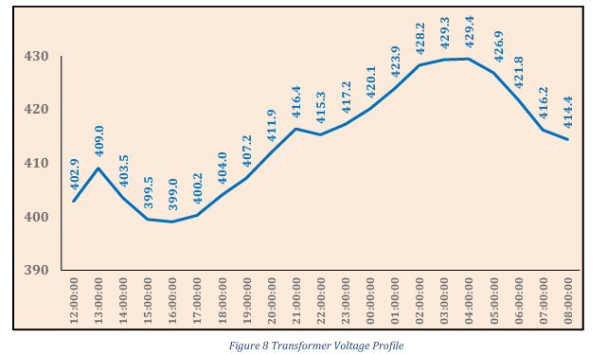
Illustrates the trend in total monthly electricity expenditure based on recorded utility invoices
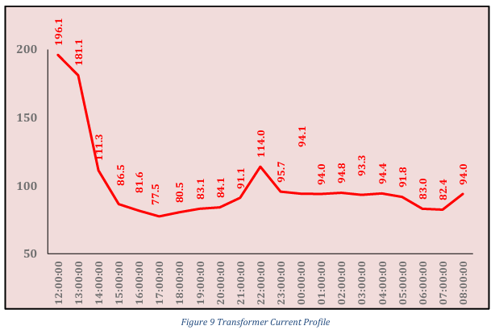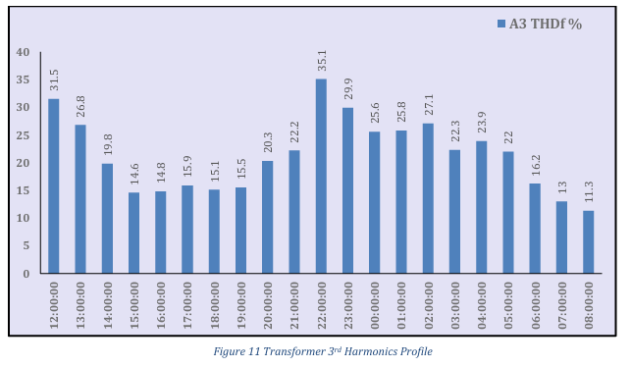
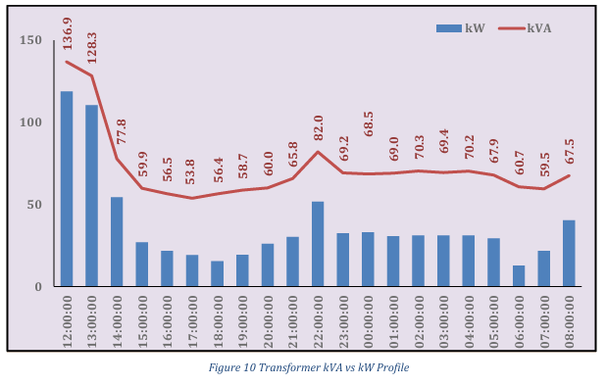
- Indicates the percentage loading on the transformer and assesses operational efficiency
- Demonstrates the current loading pattern on each phase to detect imbalance and overloading.

- Affinda AI`s Description

Affinda is an AI transformation partner to organizations globally. With deep expertise in business process automation and a proprietary intelligent document processing platform, Affinda enables organizations to integrate AI workflows and agents, driving operational efficiency and margin improvements.

AI-driven software is increasingly being used to extract data from documents, and Affinda provides this capability to organizations worldwide. The company recently set out to reduce technical configuration time and achieve high data accuracy levels faster. By transitioning to generative AI on Amazon Web Services (AWS), Affinda revamped its document AI processing solution—cutting setup time for new cases by 90 percent, reducing costs by 90 percent, and improving customer experience.

Opportunity | Accelerating accuracy with generative AI

Organizations that process high volumes of documents are adopting AI-based tools to extract important information quickly and accurately. Affinda meets this need with intelligent document processing software that automates the extraction of information from physical documents. The company initially relied on traditional machine learning (ML) models that required extensive technical setup and data annotation, making the process time-consuming and complex for both Affinda and its customers.

Andrew Bird, head of AI at Affinda, explains, “We used open-source models that we fine-tuned for specific document types and schemas, and it took a lot of engineering effort to do that. Even when we eventually created a self-service model for our customers, they still needed to produce their own training data sets.” To overcome these challenges and achieve faster accuracy, Affinda shifted its focus to generative AI technology.

Solution | Revamping document AI with Amazon Bedrock

Affinda had already used Amazon SageMaker to support its ML models and has since expanded its approach with AWS generative AI technologies, using Amazon Bedrock–based large language models (LLMs) powered by Claude Sonnet 3.5 V2, Claude 3.7 Sonnet, and Claude Sonnet 4. “AWS is our preferred cloud provider, and technologies like Amazon SageMaker and Amazon Bedrock give us confidence in data sovereignty, regional data processing, and seamless integration with our existing AWS environment,” Bird says.

The company runs its Kubernetes clusters on Amazon Elastic Kubernetes Service (Amazon EKS) with Amazon Elastic Compute Cloud (Amazon EC2) and trains hundreds of custom models on Amazon SageMaker. Affinda also uses AWS CloudFormation to automate infrastructure management across its technology stack.

Affinda revamped its AI document processing solution on its new generative AI environment and rolled it out to customers in late 2024. The setup supports asynchronous inferences triggered by customer actions and maintains a hybrid approach that combines traditional and generative AI models. “We initially targeted a specific customer use case where we needed the model to learn more rapidly and dynamically based on user input,” says Bird. “That success convinced us to rebuild the entire application around this new paradigm, moving away from reliance on fine-tuned models.”

Screenshot of Affinda AI: Web Interface

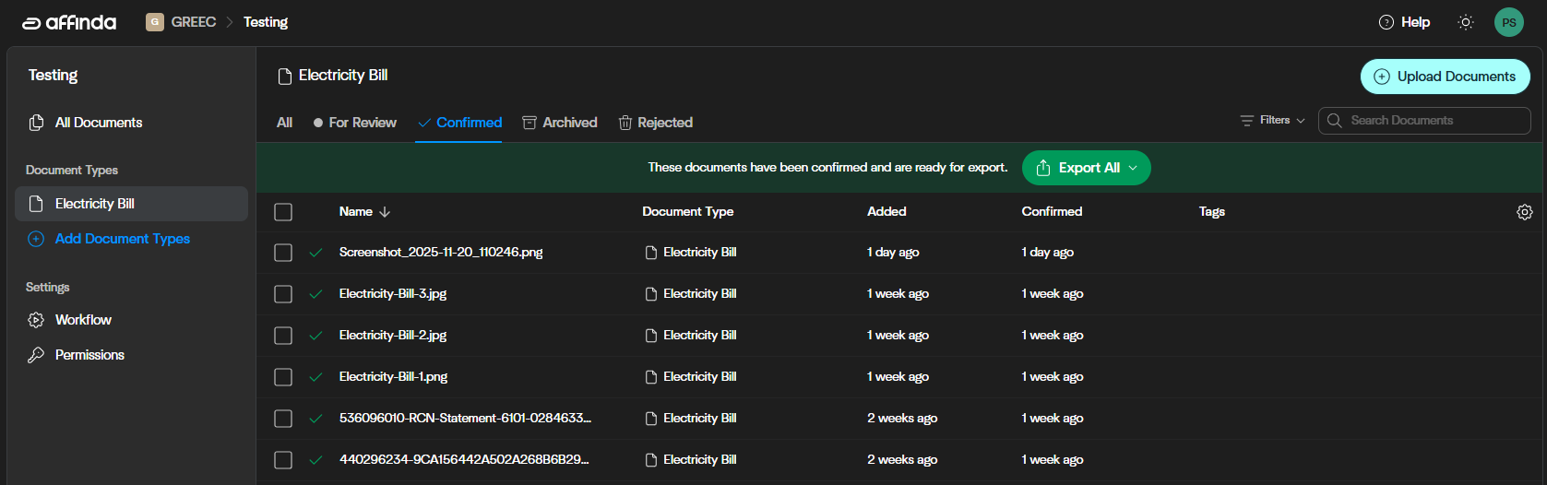
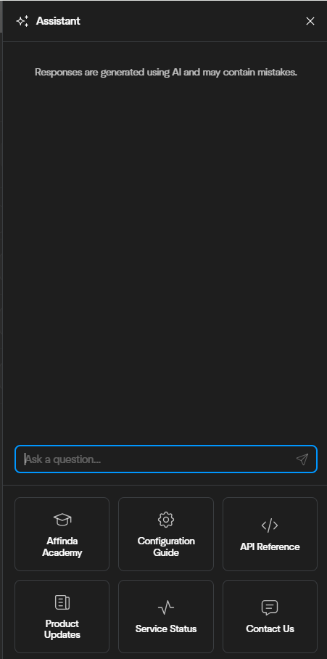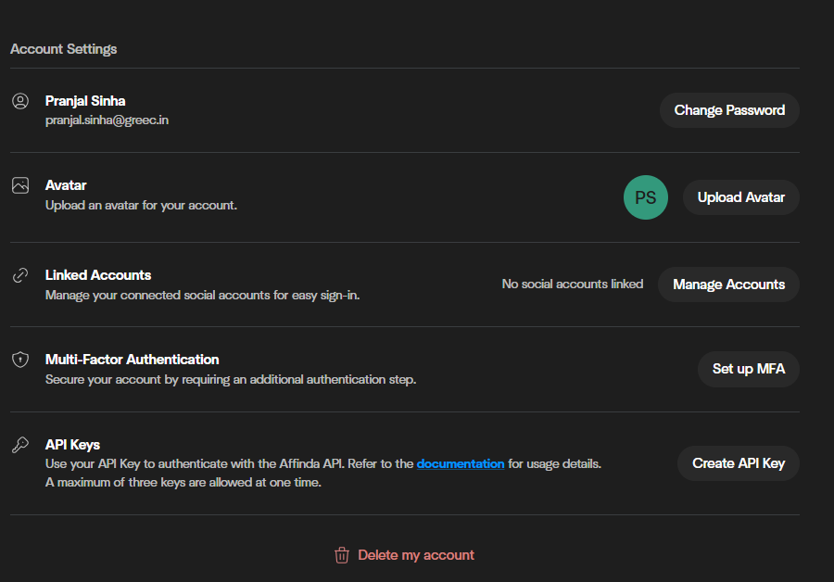
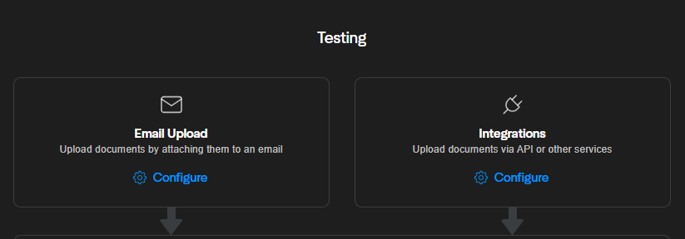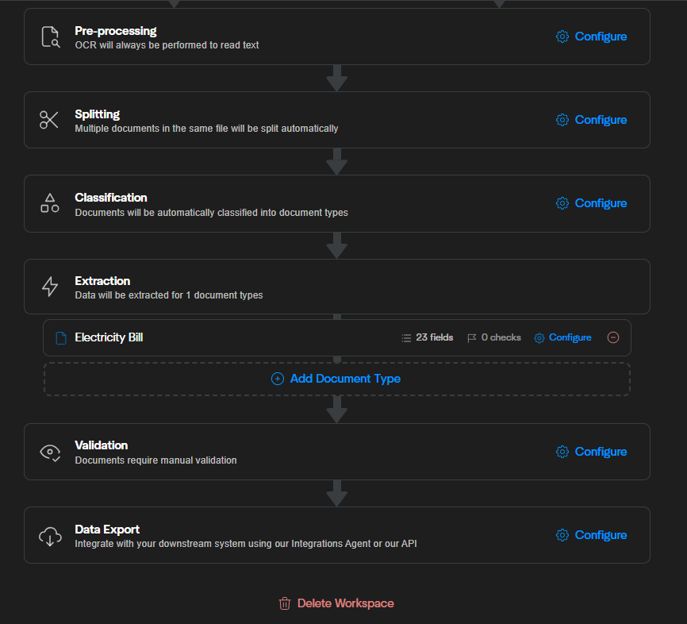

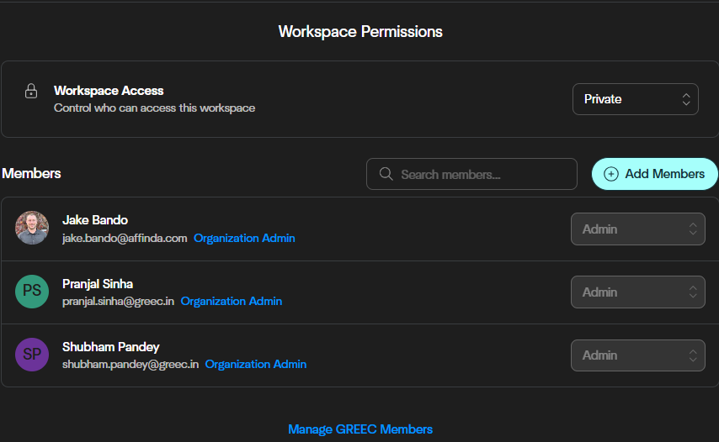

- Conclusion
After observing factors related to invoice processing, energy consumption patterns, demand analysis, and the automation workflow, it is evident that integrating IoT devices with OCR and AI-based extraction significantly for reliable energy efficient system. This system converts them into structured datasets that enable precise ECM calculations and payback assessments.
By using these design principles and best practices supported by AWS services, you can make informed decisions balancing security, cost, performance, reliability, and operational excellence with sustainability outcomes for your AWS Cloud workloads. Every action you take to reduce resource usage and increase efficiency across your workloads contributes to a reduction in environmental impact and contributes to your organizations’ broader sustainability goals.
It provided clear opportunities for improved energy performance. Automated ECM calculations further support decision-making by quantifying savings and identifying priority areas for efficiency improvements. AI also enables interfaces that enhanced data validation, while API integrations and web hooks streamline downstream processes.

Overall there were two shortcomings which are as follows:

- Multi-page invoice data storage, which currently limits full document extraction, and
- Automatic detections of missing or incomplete consumption values, needed for accurate ECM computations

Sr. No. | Reference
1. | https://docs.affinda.com/reference/webhooks
2. | https://docs.affinda.com/reference/pydantic-models
3. | https://aws.amazon.com/solutions/case-studies/affinda-case-study/
4. | https://aws.amazon.com/solutions/guidance/intelligent-document-processing-on-aws/?refid=ft_ec2
5. | https://www.freecodecamp.org/news/create-a-basic-cicd-pipeline-with-webhooks-on-linux/
6. | https://github.com/affinda/self-hosted?tab=readme-ov-file#installation
7. | https://docs.affinda.com/configuration/export-data
8. | https://docs.affinda.com/configuration/workflow
 | https://docs.aws.amazon.com/wellarchitected/latest/sustainability-pillar/conclusion.html
 | https://aws.amazon.com/solutions/guidance/intelligent-document-processing-on-aws/

