SER 421 – Lab 4 EC 2

Pranjal Karankar

ASURITE: pkaranka [1211290961]

Responsive sites change layout based on browser window size (regardless of device), while adaptive sites detect user agent i.e. When you are on a mobile device, it displays different HTML accordingly. That means that if you are looking at an adaptive site on a mobile device (even one with a large screen) you’ll still be served specific mobile content.

<https://phoenix.craigslist.org/>:

**Neither**

When the window was resized, the content on the right side of the screen is simply hidden rather than resized or moved elsewhere. Hence it is not a responsive website.

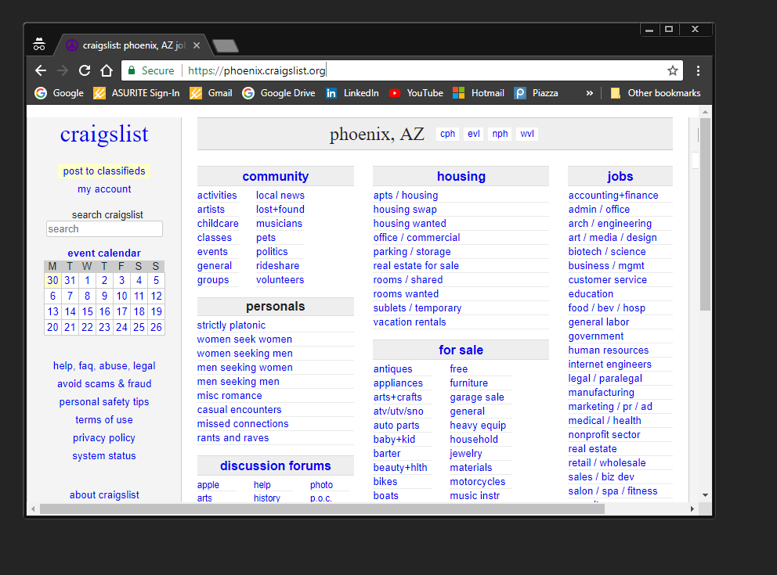

When I changed user agent to -Android device, the website did not render content suitable for mobile device. Hence it is not adaptive.

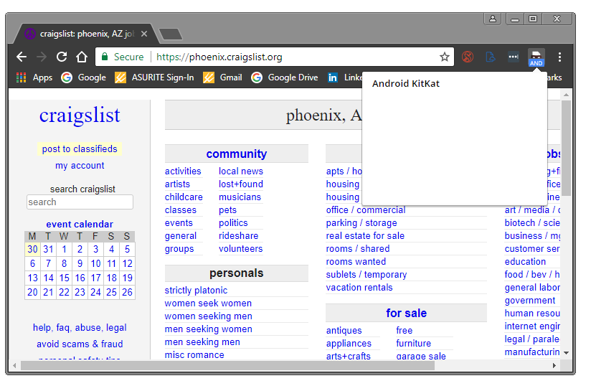

www.public.asu.edu/~kgary

**Responsive**

The layout changes based on your browser window size, even on a desktop. That means this site is responsive.

However, when user agent was changed to mobile device, it did not adapt to provide UI suitable for mobile device.

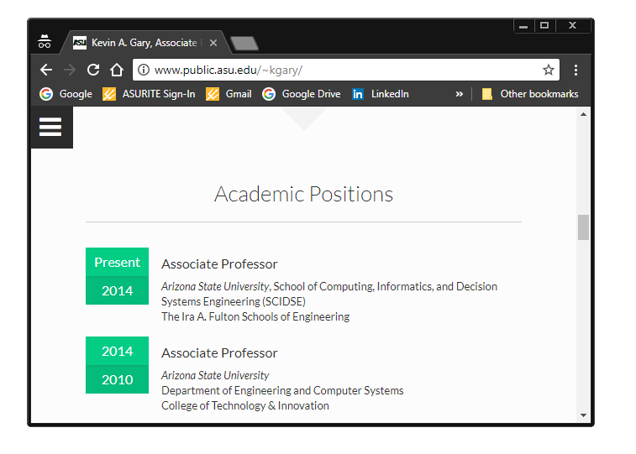

www.mlbtraderumors.com

**Responsive and Adaptive**

The layout changes based on your browser window size, even on a desktop. That means this site is responsive.



Also, when I changed user agent to mobile device -windows phone, it adapted to provide content suitable for mobile device.

