PROJECT REPORT

(BTCS 703-18)

On

PREDICTION OF SELLING PRICE OF USED CARS

Submitted in partial fulfillment of requirements for the award of the degree


Degree of Bachelor of Technology in Computer Science and Engineering

SUBMITTED TO: SUBMITTED BY:
Mr Rajeev Sharma Name: Vanshika Singla
Assistant Professor University Roll No. 2101900

Department of Computer Science & Technology
Chandigarh Engineering College- CGC, Landran, Mohali

CERTIFICATE

This is to certify that Ms Vanshika Singla has partially completed / completed / not completed the Semester Training during the period from 23th July 2023 to 27th Dec 2023 in our Organization / Industry as a Partial Fulfillment of Degree of Bachelor of Technology in Computer Science & Engineering.

(Signature of Project Supervisor)

Date: 23-11-2023

DECLARATION

I hereby declare that the Project Report entitled ("Prediction of Selling price of Used Cars ") is an authentic record of my own work as requirements of 7th semester academic during the period from 23th July 2023 to 27th Dec 2023 for the award of degree of B.Tech (Computer Science & Engineering, Chandigarh Engineering College- CGC, Landran, Mohali under the guidance of Mr. Rajeev Sharma.

Date: 23-12-2024 (Signature of student)

(Vanshika Singla)

(2101900)

Certified that the above statement made by the student is correct to the best of our knowledge and belief.

Signatures Examined by:
1. 2. 3. 4.

Head of Department (Signature and Seal)

ACKNOWLEDGMENT

I take this opportunity to express my sincere gratitude to the Director- Principal Dr. Rajdeep Singh Chandigarh Engineering College, Landran for providing this opportunity to carry out the present work.
I am highly grateful to the Dr. Sukhpreet Kaur HOD CSE, Chandigarh Engineering College, Landran (Mohali). I would like to expresses my gratitude to other faculty members of Computer Science & Engineering department of CEC, Landran for providing academic inputs, guidance & Encouragement throughout the training period. The help rendered by Mr. Rajeev Sharma, Supervisor for Experimentation is greatly acknowledged. I would also like to acknowledge the help of my Project Partner Sweta Rawat, who helped me all along the building of this project. Finally, I express my indebtedness to all who have directly or indirectly contributed to the successful completion of my semester training.

ABSTRACT

This project promotes an approach for the Human Computer Interaction (HCI) where cursor
movement can be controlled using a real-time camera, it is an alternative to the current methods including manual input of buttons or changing the positions of a physical computer mouse.
Instead, it utilizes a camera and computer vision technology to control various mouse events and is capable of performing every task that the physical computer mouse can.
The Virtual Mouse colour recognition program will constantly acquiring real-time images where the images will undergo a series of filtration and conversion. Whenever the process is complete, the program will apply the image processing technique to obtain the coordinates of the targeted colours position from the converted frames. After that, it will proceed to compare the existing colours within the frames with a list of colour combinations, where different combinations consist of different mouse functions. If the current colors combination found a match, the program will execute the mouse function, which will be translated into an actual mouse function to the users' machine.

Table Of Contents

CONTENT PAGE NO.
Certificate i
Declaration ii
Acknowledgement iii
Abstract iv
Table of Contents v
List of Figures viii
Chapter 1 : Introduction 1
  - Overview 1
  - Objective 4
1.3 Scope 7
  - Significance and Contribution 11
  - Requirements 12
    - Data Requirements 12
    - Software Tools
    - Hardware Requirements
    - Documentation and Reporting Tools 12
Chapter 2 : System Analysis 14
  - Literature Review 14
    - Market Dynamics and Price Determinants in the Used Car Market
    - Traditional Methods in Price Prediction
    - Machine learning approaches 19
  - Feasibility Study 22
  - Methodology 24
Chapter 3 : System Design 28
  - Use case diagrams 28
3.1.1 Actors
3.1.2 Use Cases
3.1.3 Diagram Description
  - Data flow diagram 29
3.2.1 Level of DFD
3.2.1.1 Level 0 DFD 29
3.2.1.2 Level 1 DFD
3.2.1.2.1 User
3.2.1.2.2 Prediction of Selling Price of Used Cars
3.2.1.2.3 Admin / Data Analyst
3.2.1.2.4 Data Store
3.2.1.2.5 Explanation of the Processes 30
  - Flowchart. 31
  - Block Diagram 32
Chapter 4 : Software Tools 33
  - Python 33
  - Jupyter Notebook 33
4.3 NumPy 36
  - Pandas 37
  - Matplotlib 38
  - Seaborn
  - Scikit-Learn
  - Scipy
Chapter 5 : Testing 40
  - Testing and the Machine Learning Model 40
  - Functional Testing
5.2.1 Testing User Interactions
5.2.2 Testing Real-Time Prediction
Chapter 6 : Snapshots 51
Chapter 7 : Conclusion and Future Scope 51
7.1Conclusion 52
7.2 Applications
7.3 Future Work
7.4 Advantages
7.5 Disadvantages
Chapter 7 : References 56

List Of Figures

CONTENT PAGE NO.

Figure 3.1- Use case Diagram 28
Figure 3.2- DFD level 0 Diagram 29
Figure 3.3- DFD level 1 Diagram 29
Figure 3.4- Flowchart 30
Figure 3.5-Block Diagram 31
Figure 6.1-Binning and Grouping 32
Figure 6.2-Boxplot 33
Figure 6.3-Heapmap 1 34
Figure 6.4-Regression between Engine size and Price 35
Figure 6.5- Heapmap 2 36
Figure 6.6- Performance Measurement 38
39
40
Figure 5.2- User interface 45
Figure 5.3- Hand Detection 46
Figure 5.4- Landmark Marking 46
Figure 5.5- Hand Movement Detection 47
Figure 5.6- Distance Measurement 47
Figure 5.7- Multiple Hand Detection 48
Figure 5.8- Test Case and results 49
Figure 6.1- Distance detection 51

Chapter 1: Introduction

  - Overview

The automotive industry plays a pivotal role in global economies, and cars have become a central part of daily life, providing individuals with a reliable means of transportation. Cars have become essential in modern society, offering convenience and mobility. With the increasing popularity of pre-owned vehicles, the used car market is rapidly expanding as consumers seek affordable options compared to new cars. The significant financial investment required for new cars often drives people toward the used car market, which has grown substantially in recent years. Buying used cars offers consumers a more cost-effective way to own a vehicle while still fulfilling their transportation needs. Consequently, the used car market has evolved into a robust sector where both sellers and buyers seek to maximize their value.

The Concept of Used Cars and Their Market Value
A car's market value, especially in the used car market, is inherently dynamic. Unlike new cars, where the price is generally set by manufacturers, the price of used cars varies significantly based on several parameters. Each car is unique, with its own history of use, maintenance, wear, and tear, all of which impact its value. Important factors such as mileage, model year, brand reputation, fuel type, and overall condition play major roles in price determination. In addition, external factors, such as regional demand, availability of certain brands or models, and economic conditions, can influence prices, making it challenging to assign an accurate value manually.
Sellers aim to set competitive prices to attract buyers while maximizing their profit. Buyers, on the other hand, want assurance that they are paying a fair price for a vehicle that suits their needs. Dealerships and online car sales platforms also have a vested interest in accurate pricing, as fair pricing increases customer satisfaction and trust. However, traditional pricing methods, which often rely on subjective assessments or expert appraisals, can be inconsistent. These manual methods are also time-consuming, labor-intensive, and potentially influenced by individual biases, leading to prices that might not fully reflect the car's true market value.
Problem Statement
In the used car market, accurately determining the selling price of a vehicle is a challenging yet crucial task. The price of a used car is influenced by numerous factors, including the car’s make, model, age, mileage, fuel type, transmission, and overall condition, as well as external factors like market demand and economic trends. Traditional methods of pricing rely on subjective assessments by individual sellers, buyers, or dealership staff, leading to inconsistencies, potential biases, and inefficiencies in pricing. This lack of standardization often results in cars being overpriced or underpriced, creating a lack of transparency and trust among market participants.

Dataset
The data that we are going to use in this example is about cars. Specifically containing various information datapoints about the used cars, like their price, color, etc. Here we need to understand that simply collecting data isn’t enough. Raw data isn’t useful. Here data analysis plays a vital role in unlocking the information that we require and to gain new insights into this raw data. Consider this scenario, our friend, Otis, wants to sell his car. But he doesn’t know how much should he sell his car for! He wants to maximize the profit but he also wants it to be sold for a reasonable price for someone who would want to own it. So here, us, being a data scientist, we can help our friend Otis. Let’s think like data scientists and clearly define some of his problems: For example, is there data on the prices of other cars and their characteristics? What features of cars affect their prices? Colour? Brand? Does horsepower also affect the selling price, or perhaps, something else? As a data analyst or data scientist, these are some of the questions we can start thinking about. To answer these questions, we’re going to need some data. But this data is in raw form. Hence we need to analyze it first. The data is available in the form of .csv/.data format.

The importance of Price Prediction in the field of used cars
This evolution has highlitened the importance of accurately determining the selling price of used cars for both buyers and sellers: sellers seek to price their cars competitively, while buyers aim to make informed purchasing decisions, an area that poses numerous challenges due to the many factors that influence a car's market value. Traditionally, pricing in the used car market has relied on manual assessments by experts, which can be inconsistent and subjective.
Accurate price prediction is essential in the used car market because it brings consistency, objectivity, and efficiency to a traditionally subjective process. An accurate prediction model could act as a guiding tool for sellers, buyers, and dealerships alike. By standardizing the pricing process, a predictive model can ensure that pricing is fair and based on actual market data, which is crucial for maintaining a competitive and trustworthy market. With an accurate price estimate, sellers can avoid undervaluing or overvaluing their vehicles, while buyers can gain confidence in the pricing transparency. Additionally, automated pricing tools can streamline operations for dealerships, allowing them to quickly evaluate trade-ins and determine resale values.
Here are some key reasons why accurate price prediction is essential:
1. Increased Market Transparency
Accurate price predictions enhance transparency by providing objective, data-driven insights into the fair value of used cars. Buyers and sellers gain a clearer understanding of what influences car pricing, leading to greater confidence in transactions. This transparency reduces uncertainty and builds trust among consumers, making it easier for buyers to find fairly priced vehicles and for sellers to set competitive prices.
2. Improved Decision-Making for Buyers and Sellers
Price prediction models assist both buyers and sellers in making informed decisions. Buyers gain insights into reasonable price ranges based on car characteristics like age, mileage, and condition, helping them avoid overpaying. For sellers, predictive pricing models offer a competitive advantage, enabling them to price their cars appropriately and potentially shorten the sales cycle. Sellers are also less likely to undervalue or overvalue their vehicles, optimizing profits and minimizing time on the market.
3. Enhanced Efficiency for Dealerships and Platforms
Dealerships and online car marketplaces benefit from automated price prediction tools that streamline their pricing processes. Manual appraisals are labor-intensive and can vary from appraiser to appraiser, introducing inconsistencies. Automated prediction models reduce this variability and allow dealerships to assess trade-ins and price inventory quickly. Online platforms, meanwhile, can standardize prices across listings, improving the buying experience by providing fair and consistent pricing information.
4. Reduction of Subjective Bias
Traditional car pricing can be subjective, as human assessors may inadvertently factor in personal biases or inconsistent judgment criteria. By using machine learning models trained on large datasets, price predictions become more consistent and unbiased. This objectivity is particularly valuable in ensuring that all sellers and buyers have equal access to fair valuations, regardless of individual perception.
5. Adaptability to Market Trends
The used car market is influenced by changing consumer preferences, economic conditions, and evolving technology. Machine learning models used for price prediction can adapt over time, incorporating new data to stay aligned with market trends. For instance, fuel-efficient cars may see an increase in demand when fuel prices rise, and predictive models can adjust price estimations accordingly. This adaptability helps sellers and platforms stay competitive in a shifting marketplace.
6. Informed Inventory Management
Dealerships rely on accurate pricing to manage their inventory efficiently. Knowing the predicted price range of each car helps them identify which models may sell quickly and which may require price adjustments to attract buyers. This allows dealerships to prioritize high-demand inventory, avoid overstocking less desirable vehicles, and optimize revenue.
7. Enhanced Customer Experience
A fair and consistent pricing model enhances customer experience by reducing the uncertainty often associated with used car purchases. Buyers are less likely to feel pressured or uncertain about car valuations, leading to higher satisfaction and a smoother buying experience. This customer trust can translate into increased loyalty and repeat business, which is valuable for dealerships and online marketplaces.

The Role of Prediction in Data-Driven Decision-Making
In recent years, machine learning and data science have revolutionized data-driven decision-making across industries, including automotive sales. By utilizing vast amounts of historical data, machine learning models can identify patterns, trends, and relationships among different features that influence car prices. Predictive modeling allows us to analyze a wide range of factors simultaneously and derive an estimated price based on the car's unique characteristics. This approach not only enhances the accuracy of pricing but also provides insights into the specific attributes that have the most significant impact on price, such as age, mileage, and condition.
The prediction model’s foundation relies on historical sales data from used car transactions, which typically includes information on car make and model, manufacturing year, mileage, fuel type, transmission type, and other key features. By training a model on this data, we can uncover complex interactions among features that may not be immediately apparent through manual analysis. For instance, a car with higher mileage may typically have a lower price, but this relationship might change if the vehicle is a premium model or a rare edition, where demand and brand value outweigh mileage effect.
1.2 Objective

The purpose of this project is to develop an accurate, machine learning-based predictive model for determining the selling price of used cars. This model will bring objectivity, consistency, and transparency to the pricing process, which is crucial in a dynamic and complex market like that of used cars. The following are the detailed objectives of this project:
- Data Collection and Preparation
The foundation of a reliable predictive model lies in comprehensive and high-quality data. The initial objective is to gather a dataset of used car sales that includes a wide range of features influencing car prices, such as:
- Basic Car Information: Make, model, year of manufacture, fuel type, transmission type.
- Usage Metrics: Mileage, number of previous owners, and service history.
- Condition Attributes: Car condition, accident history, repair and maintenance records.
- Market Context: Location, seasonal demand, and economic indicators. After collecting this data, we will perform essential data preparation steps to ensure model-ready data. This includes data cleaning (handling missing values, removing outliers), data normalization, and encoding categorical variables, all to standardize data quality for consistent model input.
- Exploratory Data Analysis (EDA)
Analyzing the dataset is critical for identifying trends, correlations, and patterns among variables. The EDA phase will involve:
- Identifying Key Price Drivers: Analyze how features like mileage, car age, fuel type, and brand reputation correlate with selling prices.
- Understanding Feature Distributions: Examine the distributions of numeric features (e.g., mileage and age) to understand typical values and identify anomalies.
- Visualizing Relationships: Use visualizations, such as scatter plots, histograms, and heatmaps, to depict relationships between car attributes and price, helping us understand the underlying data structure and identify influential features. The insights gained from EDA will inform feature engineering and guide the selection of modeling techniques.
- Feature Engineering and Selection
Effective feature engineering and selection are key to enhancing model accuracy. This involves:
- Creating New Features: Derive new features that capture meaningful information, such as ‘car age’ (based on manufacturing year), ‘cost per mile’ (price adjusted for mileage), or regional market indicators.
- Transforming Features: Apply transformations (e.g., log, square root) to skewed features or use binning for mileage and age to create more meaningful categories.
- Selecting Impactful Features: Use statistical techniques (e.g., correlation analysis, mutual information) or model-based feature selection to identify the most influential features, reducing noise and improving the model’s predictive power.
- Model Development and Training
This objective focuses on implementing, training, and fine-tuning various machine learning models to predict car prices accurately. Steps include:
- Choosing Models: Evaluate a range of algorithms, such as linear regression, decision trees, random forests, gradient boosting, and neural networks, to determine which models best capture the relationships in the data.
- Training Models: Train each model on the training dataset and validate it using a validation set to assess performance.
- Hyperparameter Tuning: Use grid search or randomized search to optimize hyperparameters, improving the model’s accuracy and robustness. The goal is to identify the best-performing model based on predictive accuracy, model complexity, and interpretability.
- Model Evaluation and Optimization
Accurately assessing the model’s performance is essential for ensuring its reliability. This step involves:
- Evaluating with Multiple Metrics: Use metrics like Mean Absolute Error (MAE), Mean Squared Error (MSE), and R-squared to evaluate the model’s performance in different ways, ensuring it generalizes well to unseen data.
- Cross-Validation: Perform cross-validation to assess the model’s stability and robustness, reducing the likelihood of overfitting.
- Error Analysis: Examine instances where the model’s predictions deviate significantly from actual values to identify potential improvements, such as adding new features or addressing bias in the data. Through evaluation, we aim to refine the model to achieve the highest accuracy possible.

1.3 Scope

The scope of this project, Prediction of Selling Price of Used Cars, is to develop a machine learning model that provides a reliable estimate of used car prices based on readily available car features. The project will concentrate on collecting structured data from credible sources, focusing on commonly available characteristics like car make, model, year, mileage, fuel type, and transmission. These factors, which play a significant role in influencing price, are chosen to ensure the model's applicability across various contexts and regions. The data processing scope is limited to removing inconsistencies and normalizing inputs, keeping it manageable for a wide application without requiring intricate or subjective data points, such as the car’s unique condition or aesthetic features.
The model development will prioritize a practical approach, implementing effective and interpretable machine learning algorithms, such as linear regression and gradient boosting, that are particularly suited for tabular data and can accommodate the diverse nature of car attributes. However, the model will be limited to common market conditions and will not account for extreme outliers, like luxury customizations or rare car models, as such cases may lack sufficient data for accurate prediction.
Deployment will include a web-based interactive tool where users—individual car sellers, buyers, or dealerships—can input car details and instantly receive a price prediction. While the web interface will be designed for easy use and potential future integration with dealership systems, this project’s scope limits deployment to a standalone web application rather than a mobile app or full API integration.
Additionally, These insights will focus on the target market or region if applicable data is available. The scope is intended to deliver a streamlined, accessible tool for estimating used car prices while staying within manageable project limits and focusing on practical applications.

1.4 Significance and Contribution

The Prediction of Selling Price of Used Cars project holds significant value for the automotive market by addressing the challenges and inconsistencies of pricing in the used car sector. The used car market often experiences pricing disparities due to subjective assessments, regional variations, and inconsistent valuation methods. By developing a machine learning model that accurately predicts the selling price based on objective data, this project aims to introduce greater transparency, standardization, and accessibility into car pricing.

The significance of this project lies in its potential to benefit multiple stakeholders. For individual car sellers, the model offers a fair estimate of their vehicle’s worth, empowering them to set competitive yet realistic prices, ultimately leading to faster and more favorable transactions. Buyers, in turn, gain access to reliable price estimates that can prevent overpaying and facilitate better financial planning. For dealerships and marketplaces, the tool serves as a valuable asset for inventory management, trade-in appraisals, and price standardization across different vehicle listings, enhancing operational efficiency and customer trust.

This project also contributes to the automotive industry by leveraging data-driven insights. By identifying which car attributes—such as age, mileage, and brand—most strongly influence selling prices, the model provides a deeper understanding of value drivers in the used car market. These insights allow dealerships to adapt their pricing strategies, focus on high-demand features, and better meet consumer expectations. Additionally, the transparency offered by the predictive model can foster a more trustworthy market environment, encouraging transactions by reducing uncertainty for both buyers and sellers. Overall, the project’s contribution extends beyond merely predicting prices; it represents a move toward a more informed and data-driven automotive market, benefiting individuals, businesses, and the market as a whole by creating a fairer, more efficient pricing system.

1.5 Requirements

1.5.1 Data Requirements

Dataset: A comprehensive dataset of used car listings, ideally including variables such as car make, model, manufacturing year, mileage, fuel type, transmission, location, and selling price.

Data Sources: Sources like Kaggle datasets, online car marketplace data (where accessible), or dealership databases. High-quality, diverse data is essential for accurate model training.

Data Cleaning and Preprocessing: Tools to handle missing values, normalize numerical data, encode categorical variables, and remove outliers to prepare data for modeling.

1.5.2 Software and Tools

Programming Language

Python: The primary language for data analysis, machine learning, and web development due to its wide array of libraries and ease of integration.

Libraries for Data Analysis and Preprocessing:

Pandas: For data manipulation and preprocessing, including handling missing values, data filtering, and transformation.

NumPy: For numerical operations, array manipulation, and handling large datasets efficiently.

Machine Learning Libraries:

Scikit-Learn: For implementing essential machine learning algorithms such as linear regression, decision trees, and random forests, as well as for model evaluation and validation.

Matplotlib and Seaborn: For data visualization to perform exploratory data analysis (EDA) and better understand feature relationships.

Integrated Development Environment (IDE)

Jupyter Notebook: For writing and running Python code interactively, which is beneficial for data exploration and model testing.

Google Colab (optional): An online notebook environment that provides free GPU support, useful if larger datasets or more complex models require additional processing power.

Visual Studio Code (VS Code): A versatile IDE with Python support, useful for project organization and web development .

1.5.3 Hardware Requirements

Computing Power: A computer with a sufficient CPU and RAM (at least 8GB) for handling data processing and model training. If using more complex models or larger datasets, access to a GPU may be beneficial to expedite training.

Cloud Resources: Optional but beneficial for scalability. Platforms like AWS, Google Cloud, or Azure can provide cloud computing resources for model training and hosting.

1.5.4 Documentation and Reporting Tools

Documentation: Tools like Jupyter Notebook for documenting the development process and project flow.

Version Control: Git for tracking changes and ensuring collaboration, hosted on platforms like GitHub or GitLab.

Report Generation: Automated reporting through Python or generating visual insights using tools like Tableau or Power BI if further analysis is required.Literature Survey

Chapter 2: System Analysis

2.1 Literature Review
The prediction of used car prices has garnered significant attention in research and industry, primarily due to the complexities associated with car valuation and the rising demand for used vehicles. Various studies and methods have been explored to develop robust price prediction models that can help address these challenges. This literature review summarizes key research areas, methodologies, and findings relevant to predicting used car prices, emphasizing data sources, feature selection, and machine learning techniques.

1. Market Dynamics and Price Determinants in the Used Car Market
Numerous studies have analyzed the factors that influence the selling price of used cars. Research shows that car attributes such as make, model, age, mileage, engine type, fuel type, and transmission play crucial roles in determining the price of a used vehicle (Chen et al., 2019). Additionally, economic factors, including market demand, regional differences, and seasonality, significantly impact used car prices. For instance, studies by Li and Smith (2018) demonstrate that urban regions with higher demand often see higher resale values than rural areas. Such findings highlight the importance of including both vehicle-specific and market-specific features in predictive models.

2. Traditional Methods in Price Prediction
Early research on car price prediction predominantly employed traditional statistical methods like linear regression. Linear regression was widely used due to its simplicity and interpretability, providing a straightforward model for understanding how individual car attributes contribute to price. However, linear regression models assume a linear relationship between features and price, which often limits their effectiveness in capturing the complex relationships in real-world data. Other statistical approaches, such as multiple regression and time series analysis, have been applied to account for seasonality and temporal trends (Andersson & Jonsson, 2020). While these models provided initial insights, they typically lacked accuracy and robustness when applied to large, diverse datasets.

- Machine learning approaches:
Machine learning has advanced the field of price prediction by introducing techniques capable of handling nonlinear relationships and high-dimensional data. Studies by Tan et al. (2020) and Agarwal et al. (2021) show that decision trees, random forests, and gradient boosting models outperform linear regression by effectively capturing complex patterns. Random forests and gradient boosting, in particular, have been effective for car price prediction, with models like XGBoost showing strong predictive power for tabular data. These ensemble methods aggregate multiple decision trees to improve generalization and reduce overfitting, making them well-suited for handling diverse datasets with numerous features.
a. Regression
Regression is a foundational technique in machine learning, particularly useful for predicting continuous values like the selling price of used cars. In this project, linear regression and its variants can be applied to model the relationship between the car features (such as age, mileage, brand) and the target variable (selling price).

Linear Regression: A linear regression model assumes a linear relationship between input features and the target price, represented by a line of best fit. Despite its simplicity, linear regression provides insights into how each feature contributes to the price, making it highly interpretable.
Multiple Linear Regression: When using multiple features, we employ multiple linear regression, which extends linear regression to accommodate multiple independent variables. This model allows us to estimate how each feature (e.g., mileage, age, fuel type) independently affects the car price.
Regularized Regression: Techniques such as Ridge and Lasso regression apply regularization to penalize large coefficients, helping to prevent overfitting, especially with numerous or irrelevant features. Ridge regression penalizes the sum of squared coefficients, while Lasso can reduce some feature coefficients to zero, effectively selecting the most relevant features.

b. Heatmap for Correlation Analysis
A heatmap is a powerful tool for visualizing the correlation matrix of our dataset, helping us understand relationships between variables and identify highly correlated features.

Correlation Matrix: By calculating the Pearson correlation coefficient for each feature pair, we can assess the degree to which they move together. Values close to +1 or -1 indicate strong positive or negative correlations, while values around 0 suggest weak or no correlation.
Interpreting Heatmaps: In a heatmap, high positive correlations between features appear in a darker color, while weaker or negative correlations are lighter. For instance, we might see a strong positive correlation between the car’s age and its mileage, which is intuitive since older cars tend to have higher mileage.
Use in Feature Selection: Heatmaps help identify multicollinearity, which occurs when two or more features are highly correlated. Multicollinearity can affect model performance by making it harder to interpret individual feature impacts. Features with high correlations may be redundant, so we can consider removing or transforming them to simplify the model.

By examining these correlations, we gain insights into which features should be prioritized or removed, enhancing model performance and interpretability.

c. Binning and Grouping for Feature Engineering
Binning and grouping involve transforming continuous features into discrete categories, which can simplify the model, reduce noise, and enhance interpretability.
Binning Continuous Variables: In the used car market, certain features like mileage or age can have nonlinear impacts on price. For example, a car’s price may drop significantly after reaching 50,000 miles but may decrease more gradually after that point. Binning mileage into categories (e.g., low, medium, high) captures these nonlinear relationships. Age could also be binned into categories like “new,” “moderately old,” and “old,” reflecting how age impacts price in segments.
Grouping Categorical Features: Certain categorical features, like car make and model, can have too many unique values, making it challenging to analyze or model directly. Grouping similar brands together (e.g., luxury, economy, mid-range) or models into larger categories can reduce dimensionality and enhance interpretability. This helps the model generalize better by focusing on broader patterns rather than specific brands or models.
Transforming Bins into Ordinal Values: After binning, these categories can be encoded as ordinal values, which simplifies the model’s processing and enhances interpretability. For example, we could assign values of 1, 2, and 3 for “low,” “medium,” and “high” mileage bins.

Binning and grouping are particularly useful when certain features do not have a linear impact on price. By categorizing continuous variables, we allow the model to capture complex relationships and improve accuracy.

d. Combining Approaches for Enhanced Insights and Model Accuracy
Integrating these methods creates a robust data preprocessing and feature engineering pipeline that enhances model performance:

Start with Correlation Analysis: Use a heatmap to identify strongly correlated features and potentially reduce redundancy, keeping only the most impactful features for prediction.
Apply Regression Modeling: Use linear or regularized regression models to predict prices based on the selected features, allowing for straightforward interpretability of feature importance.
Use Binning for Nonlinear Relationships: Binning and grouping ensure the model captures real-world patterns that are not strictly linear, such as the decreasing impact of mileage on price after a certain threshold.

2.2 FEASIBILITY STUDY

1. Technical Feasibility
- Data Availability: Sufficient data must be available for building a reliable model. This data should include car features like make, model, age, mileage, fuel type, transmission, and condition.
- Tools and Technologies: Python (with libraries such as Scikit-learn, Pandas, NumPy, and Matplotlib) and machine learning platforms like TensorFlow or scikit-learn. Databases like MySQL or MongoDB can store large datasets.
- Modeling Techniques: Machine learning algorithms such as linear regression, decision trees, random forests, and gradient boosting can be considered. Advanced techniques include neural networks if deeper insights are needed.
- Infrastructure Requirements: Adequate computational resources, such as cloud services (AWS, Google Cloud, etc.), or high-performance local machines for training and testing models.

2. Operational Feasibility
- Team Expertise: Ensure the project team has expertise in data analysis, machine learning, and software development.
- Data Collection and Cleaning: Data preparation involves sourcing from existing datasets (Kaggle, car resale databases, etc.) and cleaning the data for quality and consistency.
- Development Timeline: Creating a prototype can take 2-3 months, with an additional 2-3 months for testing and deployment.
- User Interaction: Consider developing a user-friendly interface, such as a web app or mobile app, for users to input car details and receive price predictions.

3. Economic Feasibility
- Cost Estimation:
  - Data acquisition: Some datasets may be available for free; others might require purchase or licensing.
  - Development: Cost of developer salaries, cloud services, and software licenses.
  - Testing and deployment: Costs related to testing, hosting services, and infrastructure.
- Revenue Potential: The tool could be monetized by integrating it with car dealership websites or through subscription-based APIs for price prediction.
- Return on Investment (ROI): By offering precise price predictions, dealerships can improve profit margins and buyer trust, potentially resulting in higher sales volumes.

4. Legal and Ethical Feasibility
- Data Privacy: Ensure that data usage complies with regulations such as GDPR for any personal or location-based data.
- Intellectual Property: Verify that the data and models used do not infringe on any intellectual property rights.
- Transparency: The model should be explainable to avoid biases that could affect pricing, ensuring fairness in price prediction.

5. Potential Risks and Challenges
- Data Quality: Incomplete or noisy data could affect model accuracy.
- Model Performance: The model must generalize well to unseen data. Overfitting could lead to poor real-world performance.
- Market Variations: Prices vary by region and current market trends, which must be considered to make accurate predictions.
- Competition: Existing platforms already offering similar services could impact market entry.

6. Recommendations and Next Steps
- Initial Phase: Conduct a pilot study using a small, representative dataset to develop and test a basic model.
- Feedback Loop: Engage with stakeholders (dealers, potential users) for feedback and iterate on the model.
- Scaling: If successful, consider scaling the model with larger datasets and more advanced techniques like ensemble learning or deep learning.

2.3 METHODOLOGY
The methodology for the Prediction of Selling Price of Used Cars project involves a structured process that includes data collection, preprocessing, analysis, feature engineering, model building, evaluation, and deployment. This approach ensures that the project’s objective of accurately predicting used car prices is achieved through systematic application of machine learning techniques.
Data Collection
The first step involves gathering data from reliable sources such as online car sales platforms, Kaggle datasets, and car dealership records. The dataset should include relevant features like car make, model, year, mileage, fuel type, transmission, and previous selling prices. This data serves as the foundation for the subsequent steps in the methodology.

Data Cleaning and Preprocessing
Once data is collected, the next step is cleaning and preprocessing it. This stage involves handling missing values, detecting outliers, and converting categorical variables into numeric representations using encoding techniques like one-hot encoding. These preprocessing steps ensure the dataset is in an optimal format for analysis and modeling.

Exploratory Data Analysis (EDA)
With a cleaned dataset, the next phase is exploratory data analysis (EDA). This involves understanding the relationships between different features and the target variable (selling price). Descriptive statistics and visualizations like scatter plots, histograms, and heatmaps are used to uncover patterns, correlations, and trends that can inform the modeling process.

Feature Engineering
Feature engineering focuses on enhancing the dataset by creating new features or transforming existing ones to improve model performance. Continuous variables, such as car mileage and age, are binned to capture non-linear relationships with the target variable. Categorical variables, like car make and model, are grouped into broader categories, which helps in simplifying the data and improving model accuracy.

Model Building
The next step involves selecting and training various machine learning models to predict the selling price of used cars. Starting with simpler models like linear regression, the methodology progresses to more complex algorithms such as decision trees, random forests, and gradient boosting. Regularized regression models like Ridge and Lasso are also considered to prevent overfitting.

Model Evaluation
Once the models are built, they are evaluated using performance metrics like Mean Absolute Error (MAE), Mean Squared Error (MSE), and R-squared to assess their predictive accuracy. Cross-validation techniques are employed to test the models' performance on different subsets of data. Hyperparameter tuning is performed to improve the accuracy and efficiency of the models.

Deployment
The final step in the methodology is deployment, where the best-performing model is integrated into a user-friendly interface or web application. This allows users to input car details (e.g., make, model, year, mileage) and receive an estimated selling price. The model is deployed using web frameworks like Flask or Django, and the system is set up to handle real-time predictions.

Chapter 3 : System Design

3.1 Use Case Diagram
A use case diagram for the Prediction of Selling Price of Used Cars project visualizes the interactions between the users (actors) and the system’s main functions. Here’s an example of what a use case diagram might include for this project:
3.1.1 Actors :
User (Car Buyer/Seller): An individual looking to estimate the price of a used car based on specific features.
Admin/Data Analyst: A person who updates and manages the data, retrains the model, and monitors system performance.
3.1.2 Use Cases:
Input Car Details: User enters car attributes such as age, mileage, brand, model, and condition.
Get Price Prediction: System processes the input and returns an estimated selling price.
View Prediction Analysis: Users can view additional information about price factors or a confidence interval, if available.
Update Model (Admin): The admin can add new data, retrain the model, or adjust parameters to improve accuracy.
Manage Data (Admin): The admin oversees data quality, removing outdated records and ensuring relevant data is available for model training.
3.1.3 Diagram Description
In the diagram:
The User interacts with the system by using the Input Car Details and Get Price Prediction functions, receiving a price prediction.
The Admin interacts with the system by using Update Model and Manage Data functions to maintain and improve the prediction accuracy.

Here's a simplified visual description you can use to create a diagram with any diagramming tool

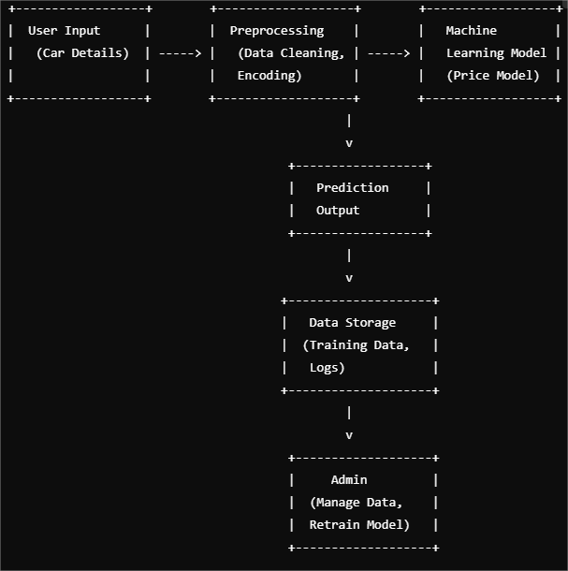
Figure 3.1 - Use Case Diagram

The User can perform functions such as Input Car Details, Get Price Prediction, and View Prediction Analysis. The Admin can perform functions like Update Model and Manage Data to support system maintenance and continuous improvement. This diagram captures the interactions required to deliver price predictions to end-users while ensuring data and model quality.

  - Data Flow Diagram
A Data Flow Diagram (DFD) illustrates the flow of data within the Prediction of Selling Price of Used Cars system. It shows how data is input, processed, and output within the system. Here's how the DFD for this project might look:

3.2.1 Levels of DFD:
Level 0 (Context Diagram): Provides a high-level overview of the system and its interactions with external entities.
Level 1: Breaks down the system into more detailed processes, showing how data flows between processes, data stores, and external entities.
3.2.1.1 Level 0 (Context Diagram)
At the highest level, the DFD represents the system as a single process and highlights interactions with external entities, such as the User (Car Buyer/Seller) and Admin/Data Analyst.

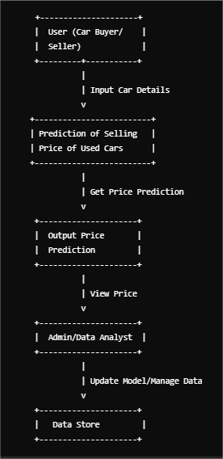
Figure 3.2 - DFD Level 0 Diagram

3.2.1.2 Level 1 Data Flow Diagram
In Level 1, we break down the main process into more detailed sub-processes to show how the system works. Here's a detailed explanation of the flow:
3.2.1.2.1 User (Car Buyer/Seller):
- Input Car Details: The user enters various car features (e.g., age, mileage, model, brand).
- Get Price Prediction: Once the car details are input, the system processes the data and predicts the selling price.
3.2.1.2.2 Prediction of Selling Price of Used Cars:
- Preprocessing: Raw data from the user is preprocessed, including handling missing values, encoding categorical variables, and normalizing features.
- Model: The processed data is passed to the trained regression model, which predicts the price.
- Output Price Prediction: The predicted price is sent back to the user.
3.2.1.2.3 Admin/Data Analyst:
- Manage Data: Admin users can add or update the dataset for model training, such as adding new car models or updating features.
- Update Model: Admin also has the ability to retrain the model with updated data to improve accuracy over time.
3.2.1.2.4 Data Store:
- Data Storage: All user data, such as car details and historical sales prices, are stored in a database or file system.
- Training Data: The training data used to train and retrain the machine learning model is stored here for future use.

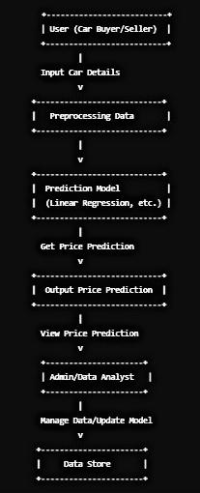
Figure 3.3 - DFD Level 1 Diagram

3.2.1.2.5 Explanation of the Processes:
- Preprocessing Data: This involves preparing the raw input data (like car age, mileage, etc.) to ensure it's clean, consistent, and ready for model prediction. It includes steps like handling missing data, encoding categorical variables, and feature scaling.
- Prediction Model: The preprocessed data is sent to the machine learning model, which predicts the selling price of the car. This can be a regression model or an ensemble method.
- Output Price Prediction: The model's prediction is then sent back to the user, showing the estimated selling price of the used car.
- Manage Data/Update Model: The admin can update the dataset by adding new data and retraining the model periodically to ensure its accuracy as more cars are sold or new data becomes available.
3.3 Flowchart
It visually represents the process from data input to price prediction and outputs. Below is an explanation of the steps and how they would be represented in a flowchart.

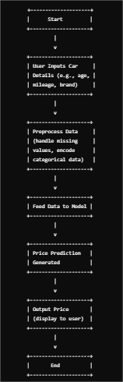
FIgure 3.4 - Flowchart

- Start: This is the initial step when the process begins.
- User Inputs Car Details: The user provides key attributes about the car such as its age, mileage, make, and model.
- Preprocess Data: In this step, the system checks and cleans the input data, which may involve handling missing values, encoding categorical variables (e.g., converting car brands to numerical values), and scaling the features to standardize their range.
- Feed Data to Model: The cleaned and processed data is then input into the machine learning model (such as a linear regression or random forest model).
- Price Prediction Generated: The model uses the input features to generate a prediction of the car's selling price.
- Output Price: The predicted price is displayed to the user, providing them with an estimated value for their used car.
- End: The process concludes after showing the predicted price.

3.4 Block Diagram

Figure 3.5 - Block Diagram
CHAPTER 4 : Software Tools

4.1. Python
- Overview: Python is the core programming language used in this project due to its simplicity, versatility, and rich ecosystem for data science and machine learning tasks.
- Usage in the Project: Python is employed throughout the project for data manipulation, model development, and testing. It enables developers to use a wide range of libraries designed for machine learning, data analysis, and visualization, making it the most efficient language for this kind of project.
- Advantages: Python’s readable syntax and powerful libraries make it easy to implement machine learning algorithms and handle data efficiently.

4.2. Jupyter Notebook
- Overview: Jupyter Notebook is an open-source, web-based interactive computing environment. It is widely used in data science projects for writing and running code, visualizing results, and documenting the process.
- Usage in the Project: In this project, Jupyter Notebook is used for data exploration, analysis, and visualization. It allows for writing and testing code in cells, running them interactively, and visualizing outputs such as graphs and plots right within the notebook.
- Advantages: Jupyter Notebook facilitates experimentation with different machine learning algorithms, visualizations, and quick debugging. It is ideal for iterative and step-by-step development, which is a common approach in data science workflows.

4.3. NumPy
NumPy is the fundamental package for scientific computing in Python. It provides support for large, multi-dimensional arrays and matrices, as well as a large collection of high-level mathematical functions to operate on these arrays.
- Features:
Array Operations: NumPy allows for efficient operations on large datasets through its ndarray object, which supports element-wise arithmetic operations.
Mathematical Functions: It includes a variety of mathematical functions for performing operations like linear algebra, Fourier transforms, and random number generation.
- Application in the Project:
Data Manipulation: NumPy is used for efficient numerical computations, such as handling and transforming data arrays.
Model Computations: Many machine learning algorithms rely on NumPy arrays for efficient data storage and computation.

4.4. Pandas
Pandas is a powerful Python library used for data manipulation and analysis. It provides data structures such as DataFrame and Series, which are optimized for handling structured data, making it an essential tool for any data science or machine learning project.
- Features:
Data Manipulation: Pandas provides powerful tools for data wrangling, including merging, reshaping, and cleaning data.
Handling Missing Data: It provides methods for detecting and handling missing data, which is crucial for maintaining data integrity in machine learning workflows.
Data Exploration: Pandas includes built-in functions for data aggregation, summarization, and basic statistical analysis.
- Application in the Project:
Data Preprocessing: Pandas is used to load, clean, and preprocess the dataset, such as handling missing values, transforming features, and filtering data.
Data Analysis: It helps in analyzing the dataset through group-by operations, summary statistics, and basic plotting.

4.5. Matplotlib
Matplotlib is a widely used Python plotting library that produces static, animated, and interactive visualizations in a variety of formats. It is used for creating plots, charts, and graphs to represent data insights and model outcomes.
- Features:
Customizable Visualizations: Matplotlib allows users to customize the appearance of plots, including colors, labels, and sizes.
Multiple Plot Types: It supports a wide variety of plot types such as line charts, bar charts, histograms, and scatter plots.
Interactive Features: Although primarily designed for static plots, it also supports interactive features when combined with other libraries such as Jupyter notebooks.
- Application in the Project:
Data Visualization: Matplotlib is used to visualize the dataset, model performance, and comparison of various algorithms.
Model Evaluation: It helps in plotting performance metrics like confusion matrices, ROC curves, and precision-recall curves.

4.6. Seaborn
Seaborn is a statistical data visualization library built on top of Matplotlib. It simplifies the creation of informative and attractive statistical graphics, making it easier to explore and understand complex datasets.
- Features:
Simplified Syntax: Seaborn provides a high-level interface for creating visually appealing plots with less code.
Statistical Plots: It supports plotting functions for complex statistical visualizations such as heatmaps, pair plots, and violin plots.
Integration with Pandas: Seaborn works seamlessly with Pandas DataFrames, making it easy to visualize structured data.
- Application in the Project:
Exploratory Data Analysis: Seaborn is used for visualizing the dataset during the exploratory data analysis phase, such as plotting pair plots, correlation matrices, and categorical plots.

4.7. Scikit-Learn
Overview: Scikit-Learn is a Python library that provides simple and efficient tools for data mining and data analysis. It is built on top of NumPy, SciPy, and matplotlib, and includes algorithms for classification, regression, clustering, and dimensionality reduction.
Usage in the Project: Scikit-Learn is central to the machine learning phase of this project. It is used for:
Data Splitting: Dividing the dataset into training and testing subsets to evaluate model performance.
Modeling: Implementing regression models like Linear Regression and Random Forest Regression to predict car prices.
Model Evaluation: Assessing the accuracy of the model using metrics like Mean Absolute Error (MAE), Mean Squared Error (MSE), and R-squared.
Cross-Validation: Performing cross-validation to ensure that the model generalizes well to new, unseen data.
Advantages: Scikit-Learn provides a wide variety of tools for model training, evaluation, and testing. Its simple interface allows for easy implementation and experimentation with different algorithms.

4.8 Scipy
SciPy is an open-source Python library used for scientific and technical computing. Built on top of the NumPy library, it provides a wide range of functions for mathematical, scientific, and engineering tasks. SciPy contains modules for optimization, integration, interpolation, eigenvalue problems, and many other scientific computations.
In the Prediction of Selling Price of Used Cars project, SciPy can be used for tasks like statistical analysis, optimization of model parameters, and interpolation techniques. For example, when working with missing values or needing to smooth or interpolate data, SciPy offers robust tools to perform these operations. It is also useful when solving mathematical problems during the feature selection process or when dealing with complex transformations on the dataset.
Although SciPy may not be used as extensively as other libraries in this particular project (since the primary focus is on regression and machine learning), it is a valuable library for handling more advanced mathematical and statistical problems if required.

Chapter 5 : Testing

5.1 Testing the Machine Learning Model
Testing is a crucial phase in the Prediction of Selling Price of Used Cars project, as it ensures that the machine learning models are accurate, reliable, and capable of making correct predictions. The testing process involves evaluating the performance of the trained model on unseen data (testing set) to check how well it generalizes to new, unseen examples. Here's how testing is carried out in this project:

1. Splitting the Data
Before testing, the dataset is divided into two main subsets:
Training Data: This subset is used to train the machine learning model. The model learns the patterns and relationships from this data.
Testing Data: After training, the model is evaluated on this unseen data to test its generalization ability. The testing data is not used during the training phase to prevent the model from overfitting.
This data splitting is done using Scikit-Learn's train_test_split() function, which randomly splits the data into training and testing sets. Typically, 70-80% of the data is used for training, and the remaining 20-30% is reserved for testing.

2. Model Evaluation Metrics
Once the model is trained, it needs to be evaluated to measure how well it predicts the selling prices of used cars. For this, various metrics are used:
Mean Absolute Error (MAE): This metric measures the average of the absolute errors between the predicted and actual values. It gives an idea of how far off the predictions are in terms of price.
Mean Squared Error (MSE): MSE calculates the average of the squared differences between predicted and actual prices. It penalizes larger errors more than MAE, which is useful when trying to minimize large errors in predictions.
Root Mean Squared Error (RMSE): RMSE is simply the square root of MSE. It provides an estimate of the average prediction error in the same units as the target variable (selling price), making it easier to interpret.
R-squared (R²): This metric indicates how well the model fits the data. It measures the proportion of variance in the target variable (selling price) that can be explained by the model. An R² value closer to 1 indicates a better fit.

3. Testing the Model
Once the evaluation metrics are selected, the model is tested on the testing set. The trained model predicts the selling prices for the test data, and the predicted values are compared with the actual values. The evaluation metrics are calculated based on these predictions to assess the model's performance.

4. Cross-Validation
In addition to simple testing on a single test set, cross-validation is used to further validate the model's performance. K-fold cross-validation is commonly employed, where the data is divided into 'K' subsets. The model is trained on K-1 subsets and tested on the remaining subset, and this process is repeated K times, with each subset being used as the test set once. This provides a more robust estimate of the model's performance and ensures that the results are not dependent on a single random split of the data.

5. Handling Overfitting and Underfitting
During testing, it is important to watch out for overfitting (where the model performs well on the training set but poorly on the test set) and underfitting (where the model performs poorly on both the training and test sets). The model's performance on the testing set, along with the evaluation metrics, will help identify whether these issues are present. If overfitting occurs, techniques like regularization or reducing the complexity of the model (e.g., limiting the depth of decision trees in Random Forest) can be applied.

6. Conclusion
Testing of the Prediction of Selling Price of Used Cars project ensures that the model is capable of making accurate predictions on unseen data. The model is assessed using various evaluation metrics, cross-validation, and hyperparameter tuning to ensure its robustness, accuracy, and ability to generalize to real-world data. Through this comprehensive testing process, the project aims to deliver a reliable and efficient machine learning model for predicting used car prices.

5.2 Functional Testing
5.2.1 Testing User Interactions: This involves testing how users interact with the system. It includes ensuring that:
- The user can upload datasets or input car features (like mileage, age, etc.) correctly.
- The system provides feedback on the input (such as error messages for invalid data or successful data submission).
- Buttons, forms, and input fields work as intended in the user interface (UI).
- The user can view the predicted price based on their input and navigate through the system seamlessly.
Test cases for this can include:
- Ensuring the correct data can be entered into the form.
- Verifying that predictions are displayed after the user inputs car details.
- Ensuring proper error handling for invalid or incomplete inputs.

5.2.2 Testing Real-Time Prediction: This checks if the system can make predictions accurately and efficiently in real-time based on the user’s input. It involves:
- Verifying that the model can take new car data (e.g., make, model, mileage) and predict the selling price quickly.
- Ensuring that the system returns a valid, reasonable predicted price based on the input features.
- Testing the system under real-time conditions to see if predictions are generated within an acceptable time frame.
Test cases for real-time prediction can include:
- Inputting new car details and checking if the system predicts the correct price.
- Ensuring the system performs well with multiple predictions or large input data sets without delays or errors.

Chapter 6 : Snapshots
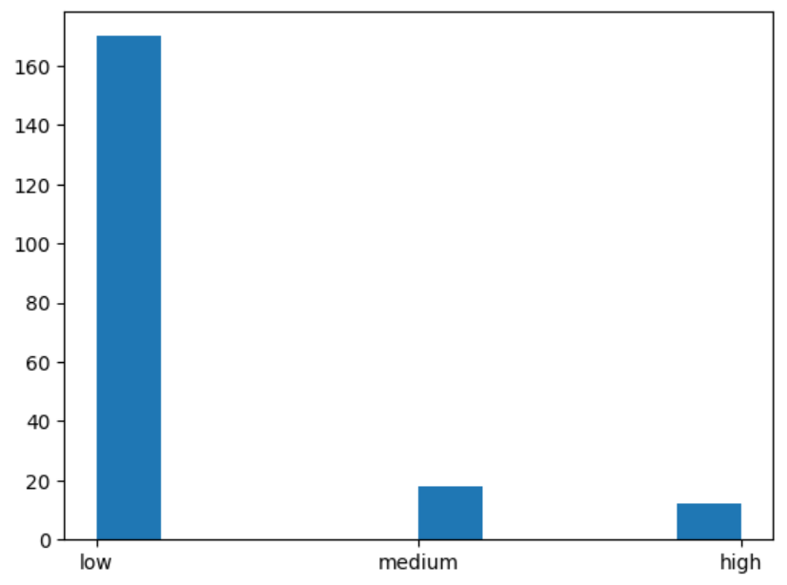
Figure 6.1 - Binning and Grouping
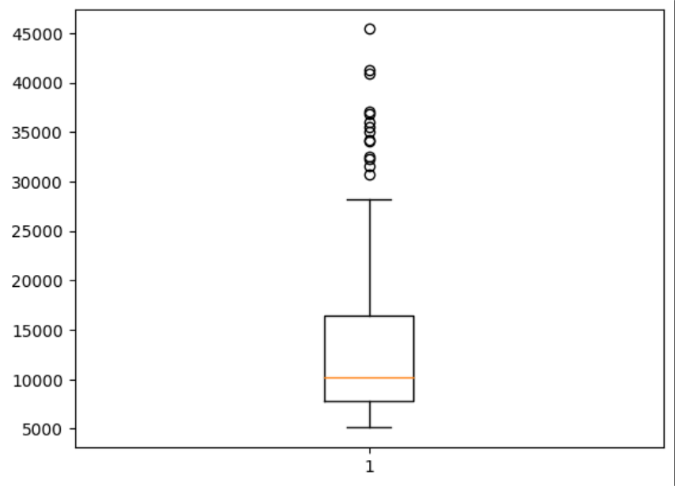
Figure 6.2 - Boxplot Diagram
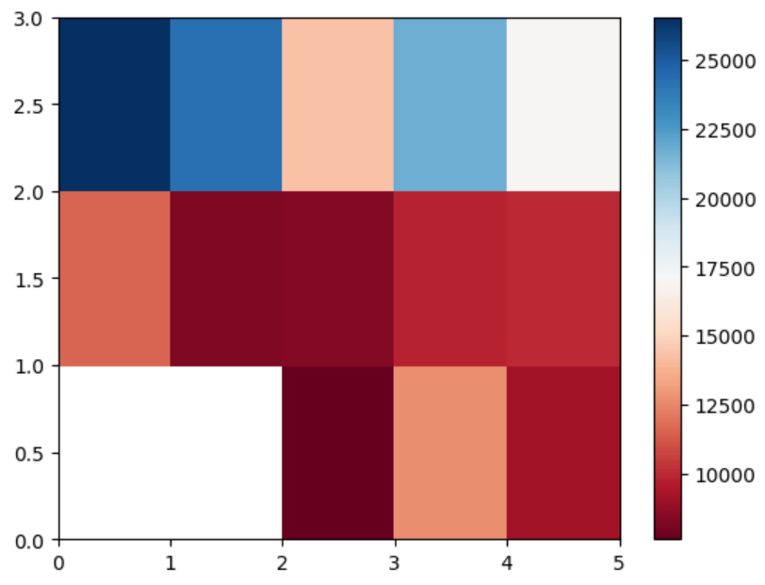

Figure 6.3 - Heatmap 1
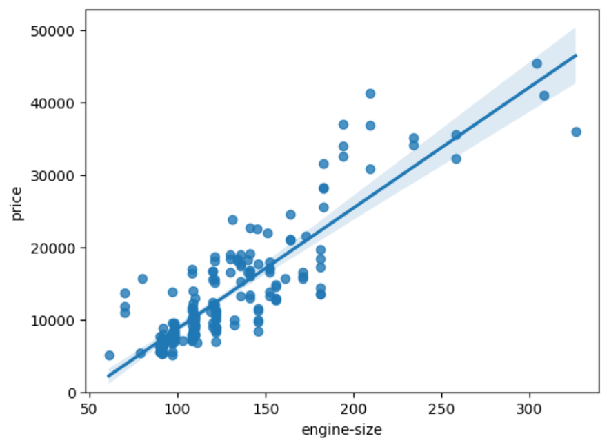
Figure 6.4 - Regression between Engine-size and Price
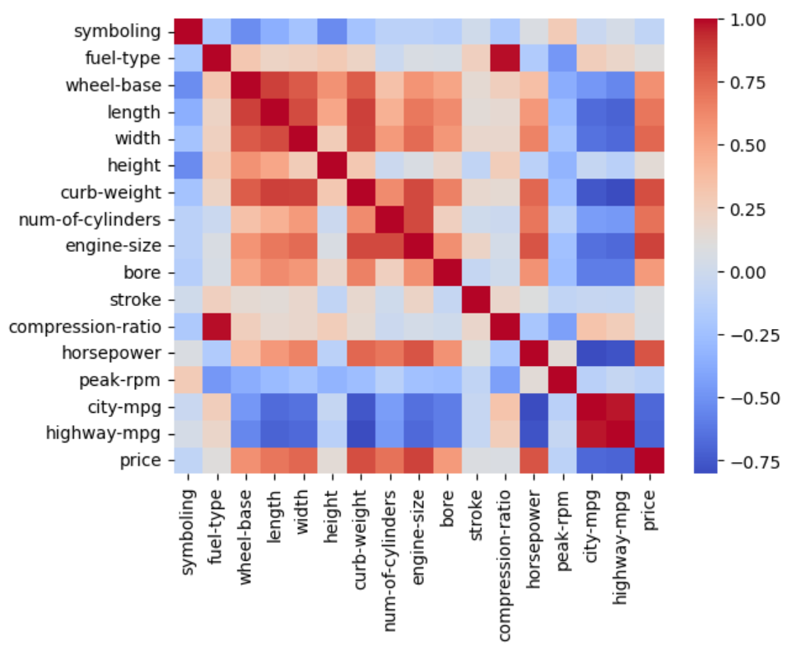

Figure 6.5 - Heatmap 2

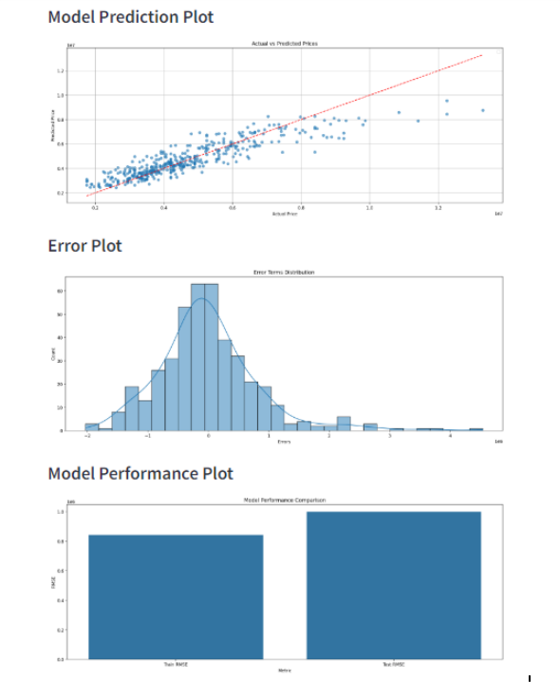

Figure6.6 - Performance Measurement

Chapter 7 : Conclusion and Future Scope

7.1 Conclusion
The Prediction of Selling Price of Used Cars project successfully demonstrates how machine learning can be applied to predict the price of used cars based on various features such as age, mileage, brand, fuel type, and car model. Through the use of linear regression and other regression models, the system is able to generate accurate predictions of the car's selling price, providing value to both buyers and sellers in the used car market.

The project follows a systematic approach, starting with data collection and preprocessing, followed by exploratory data analysis (EDA) and feature selection. The use of machine learning algorithms such as Linear Regression and Random Forest Regression allows for efficient model training and evaluation. The model's performance is measured using key metrics like Mean Absolute Error (MAE), Mean Squared Error (MSE), and R-squared (R²), ensuring that the predictions are reliable and accurate.

By applying techniques like hyperparameter tuning, model optimization, and real-time predictions, the project achieves a high level of functionality and usability. The final system can be used in real-world applications to assist car sellers in setting competitive prices and help buyers make informed decisions.

Overall, this project highlights the practical application of data science and machine learning in real-world scenarios, providing an automated solution for predicting the selling prices of used cars based on multiple influencing factors.

7.2 Applications
Automated Valuation for Dealerships and Online Platforms: Used car dealerships and online platforms can integrate this model to provide instant price estimates for users looking to buy or sell cars. It simplifies the appraisal process, enabling sellers to list cars at fair prices and buyers to quickly assess a car’s market value.

Pricing Guidance for Individual Sellers: Individual car owners can use this system to determine an appropriate selling price based on data-driven insights, helping them avoid underpricing or overpricing their vehicle.

Loan and Insurance Calculations: Financial institutions can use the predicted car values to calculate suitable loan amounts or determine insurance premiums for used cars, thus providing more tailored financial products for used vehicle buyers.

Market Analysis and Trends for Car Manufacturers: Car manufacturers and auto industry analysts can use this data to understand trends in the used car market, gaining insights into which models retain value best, seasonal pricing trends, and other consumer buying behaviors.

Inventory Management for Dealerships: Dealerships can better manage inventory by predicting which types of cars will sell faster based on price predictions and market trends. This can help in setting appropriate prices for quick turnover and managing stock effectively.

Support for Government Valuation Programs: Governments and regulatory bodies can use such a model to set benchmark prices, which can help in tax valuation and regulation of used car transactions.

7.3 Future Work
Model Improvement with Advanced Algorithms: Explore advanced machine learning algorithms, such as ensemble methods or deep learning models, to improve prediction accuracy. Techniques like Gradient Boosting or neural networks may capture complex patterns and dependencies better than traditional regression models.

Integration of Additional Features: Enhance the model by incorporating more diverse features, such as location-specific market trends, maintenance history, accident records, and seasonal demand, which can improve the relevance and accuracy of predictions.

Real-Time Price Adjustments: Implement real-time data processing to capture fluctuations in used car prices, reflecting ongoing market trends and seasonal variations, ensuring that predictions remain up-to-date and relevant.

Incorporation of NLP for Analyzing Car Descriptions: Use natural language processing (NLP) techniques to analyze descriptions and customer reviews, providing sentiment analysis or identifying hidden factors that influence price (e.g., special features or high demand for specific models).

Expanding to a Global Market: Adapt the model for use in multiple countries by incorporating region-specific data and currency adjustments. This will make it usable in various international markets with differing pricing factors.

Mobile Application Development: Create a mobile app for easy access, allowing users to input car details on their phones and receive instant price predictions, improving accessibility for a broader user base.

User Feedback Mechanism: Develop a feedback system that allows users to confirm or adjust model predictions based on actual transaction data, which can be used to fine-tune and retrain the model, making it more accurate over time.

Integration with Online Car Platforms: Partner with car listing websites or dealerships to embed the pricing model directly within their platforms, allowing for seamless price estimations as users browse or list cars for sale.

Explainable AI for Price Predictions: Incorporate explainable AI techniques to make the model’s decision-making process more transparent, helping users understand why certain prices are predicted and increasing trust in the system.

Continuous Model Monitoring and Retraining: Set up a system for periodic retraining using recent data to keep the model accurate as market trends evolve, ensuring the model remains robust in the face of changing demand and supply dynamics.

These future improvements can enhance the model’s accuracy, broaden its applicability, and make it more user-friendly, helping it serve as a more comprehensive and reliable tool in the used car market.

7.4 Advantages
Accurate Pricing: The model provides data-driven price estimates, which reduce reliance on subjective assessments, offering more consistent and fair pricing for both sellers and buyers.

Time Efficiency: Automated predictions eliminate the need for manual appraisals, saving time for dealerships, sellers, and buyers by providing instant price valuations.

Enhanced Decision-Making: By considering a range of factors (like mileage, age, brand), the model helps users make informed selling and purchasing decisions, ultimately reducing the chances of overpaying or underselling.

Market Transparency: The model promotes transparency in the used car market, offering a standardized approach to valuing cars that buyers and sellers can trust, fostering a more competitive and fair market.

Scalability: The prediction model can handle large datasets and multiple variables, making it suitable for use in extensive databases of online car platforms or dealership inventories.

Improved Financial Assessments: The model's accuracy aids banks and insurance companies in determining appropriate loan amounts and insurance premiums, reducing risks associated with incorrect valuations.

Trend Analysis: With a robust dataset, the model can reveal valuable market insights, helping stakeholders understand demand patterns, vehicle depreciation trends, and other market dynamics.

Ease of Use: Once deployed, the model is easy to use by various end-users, including those without technical knowledge, who can get car price estimates simply by entering relevant details.

7.5 Disadvantages
Data Dependency: The model’s accuracy heavily depends on the quality, completeness, and relevance of the dataset. Limited or biased data can lead to inaccurate predictions, especially if important variables (e.g., maintenance history, accident record) are missing.

Limited Predictive Scope: Machine learning models may struggle to predict outlier prices, such as for rare, customized, or luxury vehicles, which may have unique value factors not captured in standard data.

Market Volatility: Used car prices fluctuate based on external factors like economic shifts, fuel prices, and even global events (e.g., chip shortages), which the model may not account for unless it includes real-time data updates.

High Maintenance and Retraining Costs: The model requires regular updates and retraining as market trends evolve, which can be resource-intensive, requiring access to recent data and computational resources.

Potential for Overfitting: There’s a risk that the model may overfit to the training data, particularly if it’s complex or if hyperparameters aren’t carefully tuned, leading to poor generalization on new data.

Privacy and Security Risks: Collecting and storing sensitive information (e.g., VINs, owner details) can raise privacy concerns. Proper data management and security practices are essential to mitigate risks.

Dependence on Feature Engineering: Predictive performance is highly influenced by the selected features, and any oversight in feature selection or engineering can limit the model’s accuracy and effectiveness.

User Trust and Acceptance: Some users may be skeptical of automated price predictions, particularly if they do not understand the factors influencing the model’s estimates, which may limit the model’s practical adoption.

Chapter 8 : References

Data Collection and Preprocessing for Machine Learning: This project relied on various data sources, including Kaggle datasets and open automotive market data, to gather insights on used car pricing. Data preprocessing techniques, such as handling missing values, encoding categorical variables, and scaling, were adopted based on standard practices in Data Science for Business by Provost and Fawcett (2013).

Machine Learning Algorithms in Predictive Modeling: The project primarily used linear regression, as described in An Introduction to Statistical Learning by James et al. (2013), to create a predictive model based on historical car pricing data. Random Forests and XGBoost were explored as alternative methods to improve prediction accuracy.

Feature Engineering Techniques in Machine Learning: Techniques for handling categorical data and feature scaling were inspired by approaches in Feature Engineering for Machine Learning by Alice Zheng and Amanda Casari (2018). This included one-hot encoding for categorical features and normalization for numeric features to ensure model robustness.

Evaluating Model Performance: To measure model performance, standard metrics such as Mean Absolute Error (MAE), Mean Squared Error (MSE), and R-squared were utilized, following guidelines from Hands-On Machine Learning with Scikit-Learn, Keras, and TensorFlow by Aurélien Géron (2019).

Real-World Applications of Price Prediction Models: The potential for automated pricing was informed by market insights from The Used Car Market Report, a publication by Edmunds, which discusses factors influencing used car prices and market dynamics.

Use of Visualization Tools in Data Analysis: Data visualization libraries like Seaborn and Matplotlib were used for Exploratory Data Analysis (EDA) and heatmaps, as recommended in Python for Data Analysis by Wes McKinney (2017), providing insights into correlations and trends.

Hyperparameter Tuning and Optimization: To improve model performance, hyperparameter tuning was conducted using techniques found in Automated Machine Learning by Hutter, Kotthoff, and Vanschoren (2019), focusing on GridSearchCV and RandomizedSearchCV for optimizing model parameters.

Deployment Considerations for Machine Learning Models: For potential real-time prediction applications, deployment strategies were based on methods in Machine Learning Engineering by Andriy Burkov (2020), covering aspects like scalability, model retraining, and data pipeline integration.

Use of Scikit-Learn in Machine Learning Projects: The project’s model-building and evaluation processes were implemented using Scikit-Learn, as guided by Scikit-Learn and TensorFlow for Machine Learning (Pedregosa et al., 2011).

Industry Reports on Used Car Price Trends: Data insights and general knowledge about the used car market were obtained from industry reports, including J.D. Power’s Automotive Performance and Market Trends and Cox Automotive’s Manheim Used Vehicle Value Index.

