**Design Document For UserManagementApp**

**Scope**

The UserManagement App provides the users below mentioned functionality

1. New user can register
2. Login into the app
3. Search for users
4. Resets his password(Session Invalidated after successful reset)
5. Logout Functionality(Manual and Auto)

**Architecture Diagram**

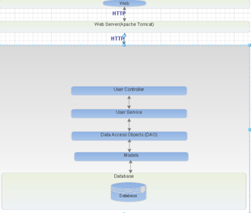

**Database Design**

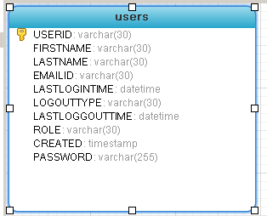

**The database contains Users table which stores all the data related to user operation.**

1)USERID-Will act as primary key

2)FIRSTNAME-Will be used to store the user first name

3)LASTNAME-will store user last name

4)LASTLOGINTIME-will store user last login time

5)LOGOUTTYPE-will store lastloggouttype

6)ROLE-will store the user role

7)CREATED-will store the date when user registered

8)PASSWORD-will store user encrypted password.

This design was considered as we don’t have much attributes for user.

**Technology Stack**

1)Java 1.7

2)Spring 3

3)Hibernate 3

4)Tomcat 1.7

5)MySql5

**URL For application-http://localhost:8080/UserManagementApp/home**

**Class Diagram**

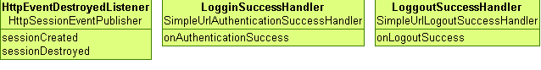

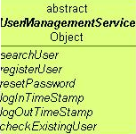

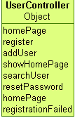 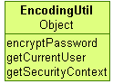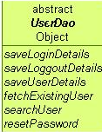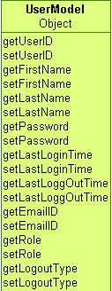

**Design Considerations**

1)Username will be the primary and cannot be duplicate.

2)Password will be encoded with md5 and salt. The salt property will be username.

3)User will be redirected to login page after session expiration.

**Assumptions**

1)User will not dump dummy data

2)Validation FrameWork is not provided

3)User Needs to remember the password after reset as password is auto reset