Report :

Effects of Artificial Light At Night (ALAN)on the feeding behavior, Performance and Defensive Secretion Composition of Phaedon cochleariae

Name:Pranjel

Student ID number

E-mail address

Contents

Abstract……………………………………………………………………………..03

Introduction…………………………………………………………………………04

Materials and Method………………………………………………………………05

Results………………………………………………………………………………06

Discussion………………………………………………………………………..…13

References…………………………………………………………………………..14

Abstract
Artificial light emissions have increased impulsively in recent years all over the world. Various species are exhibit or nearly to exhibit due to these artificial light emissions or disturbed natural Light and Dark cycles. Artificial Light At Night (ALAN) is a situation in which artificial light, its intensities and wavelengths alters and natural light-dark cycles shrinks. ALAN is now accepted as a threat to biodiversity. The results of various studies indicates the negative impact of ALAN on organisms number, their behavior, reproduction ability and biological communication skills. The growing use of artificial light {ALAN} by humans for their development, specifically terrestrial organisms are at high risk. It makes it necessary to evaluate its overall effects on organisms or microorganisms immediately. The present study is focused to determine the impact of ALAN on a group of Larvae and adult Phaedon cochleariae, specifically its effects on feeding behavior, growth rate, defensive secretion composition and survival rates of Larvae and adult of Phaedon cochleariae commonly called mustard beetle or watercress beetle during the experimental duration. The results of the experiment indicated that individuals exposed to ALAN exhibited increased secretion of iridoids(a defensive and volatile substance secreted by these beetles to deter predators) but feeding rates reduced up to 20 percent and survival rates were also reduced slightly. Moreover, those who were exposed to ALAN stopped displaying the natural activities throughout the experiment. Such changes could have serious implications for the long-term sustainability of mustard beetle population and indirect impacts on similar communities in ALAN affected areas.

Introduction

The organisms have evolved over millions of years under a natural cycle of light and dark. The ability of organisms to survive and reproduce depends on both possessing a suitable geographical niche and an ideal temporal one. The increasing use of artificial light by humans has modified the geographical and temporal niche of organisms. These modifications allow humans and organisms to be active at night but there is a dark side of night lighting(Gaston et al,2017). The main objective of artificial light at night (ALAN) was to improve road safety, identify obstructions, and secure hazardous places at night. But with the passage of time, it has been expanded to cover multi facets of human activity, including commercial, industrial, recreational, and tourism. In certain areas of aesthetics (lighting monuments) and advertising (lighting business areas, storefront windows, street signs, and illuminated posters) have taken precedence over actual illumination demands. The artificial light elluminanced ground is equal to full moon (Bennie et al ,2015a, 2016) It is observed that the usage of artificial light at night (ALAN) has increased at an unparalleled rate over the past century, with a current global increasing rate of over 6% annually (Holker et al,2010). Both land and aquatic environments are being significantly impacted by this light. These days, over 80% of people on the earth live beneath a "lit sky" at night (Falchi et al., 2016) in fact, this number is 99% in North America and Europe and is rising in the Middle East and Asia (Tamir et al.,2017, Jiang et al., 2017).
ALAN consequences are multiple and effects not only humans but also all living organisms directly or indirectly. Even basic responses and functions of living organisms are also affected by ALAN. These basic responses and functions are the product of millions of years of their evolution, while ALAN-induced alterations are occurring on a time frame of only a few decades. (Dominoni et al.,2016, Attia et al.,2019). Since the beginning of life on Earth, organisms developed their time-measurement systems - circadian clocks – which enables them to predict and anticipate these natural changes, essential for coordinating physiological activity with the right time (Reiter et ai.,1997). As a result, most of the basic functions of living organisms are controlled by these internal, genetically determined clocks. These clocks depend absolutely on the 24 hour Light and Dark cycle to accurately synchronize their activity with solar time, and in turn they coordinate a wide range of subsequent physiological, biochemical, and behavioral events to ensure that the right procedure takes place at the right time. Thus, change in the natural Light and Dark cycle cannot be without consequences for biological organisms (Attia et al.,2019). Phaedon cochleariae is also an organism which is not far from the effects of ALAN. It is commonly known as mustard beetles or watercress beetles. The adults of Mustard beetle are ovular in form and ranges in length from 3 to 4 mm. Their elytra are a reflective dark blue-green color and are abundantly dotted with dorsal glands in a parallel lined pattern. The paramounted olfactory and visual cues of beetles naturally orient vertically and horizontally striped patterns which helps them accurately differentiate between green and yellow leaves when it comes to feeding behavior(Kuhnle et.ai,2011). Adult’s personality is developed within 5–14 days and stay consistent and stable during the course of Phaedon cochleariae. Although, larvae are often less active and assertive than adults (Muller et.ai,2015). Eating habit of external leaves of horseradish and cabbage plants makes beetle overtly visible to predators. To deter the threat and ensure a higher rate of survival, they have developed the ability to secrete defensive and volatile substances, called irdoids (Burse et.ai,2007), These non-social species flourishes in areas of less competition, availability of more resources and having less population densities.
In the present experiment an effort has been made to provide an overview of the effects of ALAN on the performance, feeding behavior, growth and defensive secretion composition of larvae and adult of Phaedon cochleariae. Specifically the study aims to investigate the feeding behavior and growth of Larvae and Phaedon cchleariae in natural light and artificial light (ALAN) Furthermore, it is to be noticed if there is any defensive secretion composition is present in Larvae and Phaedon cchleariae. It is hypothesized that Artificial Light at Night (ALAN) has negative effect on performance, feeding behavior, growth and survival of larvae and adult of Phaedon cochleariae. The another hypothesis is they have the ability to secrete defensive and volatile irdoids, to deter the threat but Artificial Light at Night (ALAN) would disrupt natural biological processes and alter the chemical composition of larval defensive secretions

Materials and Method :
The experiment was designed to study the effects of continuous light exposure on the feeding and growth patterns of larvae and Phaedon Cochleariae that feeds leaves of Chinese cabbage. Two treatment groups were established: First group is named as Control Group. This group is controlled by the natural light and dark cycle. The second group is named as ALAN Treatment Group which Exposed to continuous artificial light throughout the experimental period. A total of 96 subjects were used. Out of the total sample 24 larvae and 24 adults were selected for the control group and rest 24 larvae and 24 adults for the treatment group. All subjects were placed in petri dishes (24 per group, for both larvae and adults). Approximately uniform in size and circular in shape petri discs were placed with fresh Chinese cabbage leaves for feeding . To maintain humidity and prevent leaf desiccation a moistened filter paper was placed at the base of each petri dish. Every petri dishes were sterilized with ethanol prior to use. On the first day of experiment, all insects (larvae and adults) and leaves were weighed individually and recorded . After weighing each insect was placed in a separate petri dish containing a leaf disc. Petri dishes for the control group were placed in the control light box, while those for the treatment group were placed in the ALAN treatment light box. On every third day petri dishes were opened, and fecal waste was thoroughly cleaned from the leaf discs to prevent it from altering the mass measurements. After thorough cleaning leaf were weighed to determine the amount of feeding (mass reduction of the leaf) and Insects were also weighed to measure their growth. Again a new, moistened filter paper was placed in each petri dish. New cabbage leaf discs were punched and placed in the petri dishes. The insects were then returned to their respective dishes. Petri dishes were cleaned with ethanol and dried before reassembly. This process was repeated four times over a span of 1.5 weeks, ensuring consistent observation intervals. At the end of the experimental period (1.5 weeks), the final weights of the insects and the remaining leaf discs were recorded . The same cleaning, weighing, and replacement procedures were followed to ensure uniformity across all measurements. After the final weighing, all used materials were disposed of appropriately, petri dishes and associated equipment were sterilized with ethanol for future use. Defensive secretions were collected from Phaedon cochleariae larvae to analyse the chemical composition and assess the impact of Artificial Light at Night (ALAN) exposure.
Four treatments were included in the study: two with ALAN exposure of the larvae and two without ALAN exposure of the larvae. An internal standard, citronellal, was added to all four treatments for comparison. Ten larvae per treatment were gently provoked using forceps to induce glandeversion, releasing defensive secretions. The secretions were absorbed onto filter paper strips and subsequently extracted with 150 μL of heptane by vortexing the samples for three minutes. The resulting extracts were transferred into clean vials and stored appropriately. The chemical analysis was performed using a Shimadzu gas chromatography-mass spectrometry (GC-MS) system. The mass spectrometer recorded data across the relevant retention time windows as well as fractionation for compound identification and quantification. An alkane series (C8-C40) was included as a reference to calculate the arithmetic retention index (AI), allowing for more accurate compound identification. This method compensates for retention time biases introduced by differences in individual GC-MS systems, improving crossmachine comparability:
𝐴𝐼(𝑥) = 100 × [𝑧𝑛 + 𝑅𝑇𝑥 − 𝑅𝑇𝑛
𝑅𝑇𝑛−1 − 𝑅𝑇𝑛
x: target peak
n: n-alkane preceding peak x
z: number of C-atoms
A excel sheet was prepared having data of mass of insects at the start and end of each observation period and mass of leaf discs before and after eating, for each group, during each observation interval. In order to get results Log-rank test, Kaplan-Meier curves and boxplots statistical tools and diagram were used to find differences between the biomass gain or loss and feeding amount, survival probability in Phaedon cocheariae and larvae for controlled and Alan groups. For defensive secretions Chromatograms generated from the GC-MS analysis were examined to identify compounds based on retention time, the alkane series and pre-existing literature. Comparisons were conducted between samples collected from control larvae and those exposed to ALAN to determine differences in chemical profiles. These analyses allowed for assessing the potential impact of ALAN on the defensive secretion composition of Phaedon cochleariae larvae.

Result :
During the complete span of experiment data was recorded on a fixed interval three days for Lc means larvae under control .,Lt –Larvae under treatment, Ac- Adult under control and At- Adult under treatment. Here under control represents larvae and adults were examined under light and dark cycle. On the other hand under treatment represents larvae and adults were examined under Artificial light (ALAN). Data was collected for control group and treatment group on a fixed period of time . The collected data was converted into tabular format , analysed and represented by stastistical diagram.

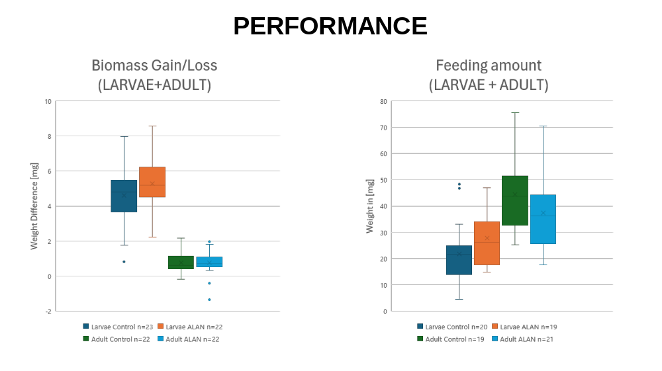
Fig 1
In fig. 1 the boxplots compare weight differences between groups (control and ALAN) for larvae and adults. Larvae under control shows higher biomass gain as compared to ALAN. ALAN group has reduced biomass gain or increased weight loss, indicating a negative effect of ALAN. In adults control and ALAN both groups show less variation, but ALAN again seems to show a marginally lower biomass gain. Larvae of Control group has higher feeding amounts than ALAN. ALAN leads to reduced feeding, suggesting behavioral or physiological effects. Adults: Similar to larvae, feeding in ALAN is lower compared to control. ALAN appears to negatively impact on both biomass gain and feeding, likely due to stress or altered activity.
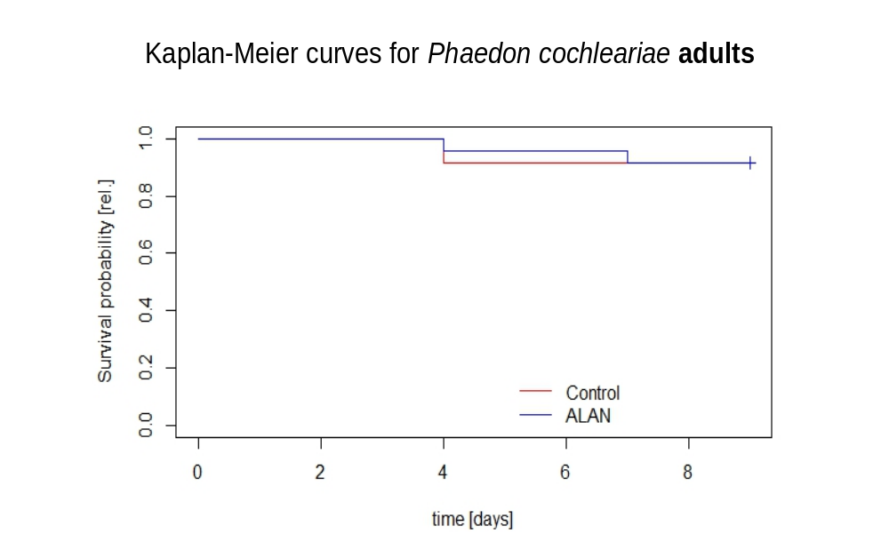
Fig. 2
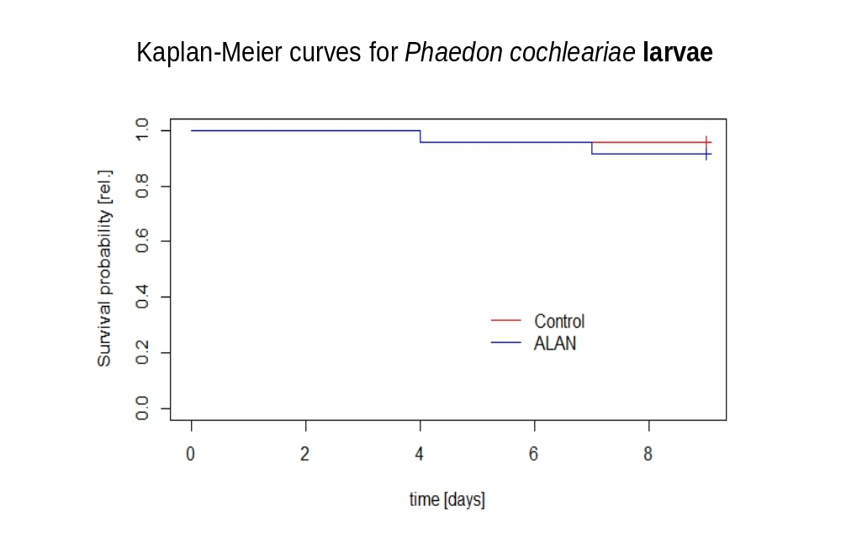
Fig. 3
The survival probability in Phaedon cocheariae and larvae for controlled and Alan group are shown by Kaplan-Meier Curves separately. The survival probability over time is plotted for control and ALAN groups. The curves are nearly identical, showing no significant difference in survival between the adults of two groups. Kaplan-Meier Curves for Larvae is not directly visible in detail, but seems similar to adults with minimal separation between curves, indicating no significant survival difference.

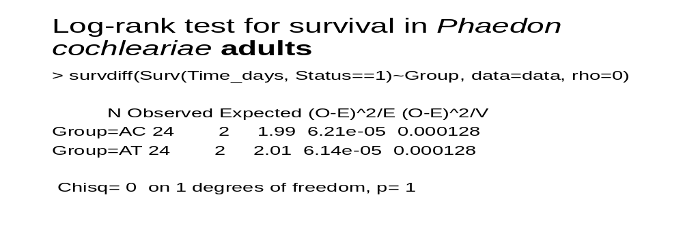
Fig. 4
Log-Rank Test is a statistical test used here to compare survival distributions between control and ALAN groups of adults. In this test the the value of p=1. It means there is no significant difference in survival of adults of control and ALAN groups. The value of Chi-square is 0 with p = 1, confirms that there is no significant difference in survival probabilities. Observed and Expected deaths are nearly identical for both groups (control and ALAN).
GC-MS Analysis of Defensive Secretions
The chromatogram of the internal standard citronellal shows expected peaks around a retention time of 16.355 minutes as was to be expected (Fig. 5).

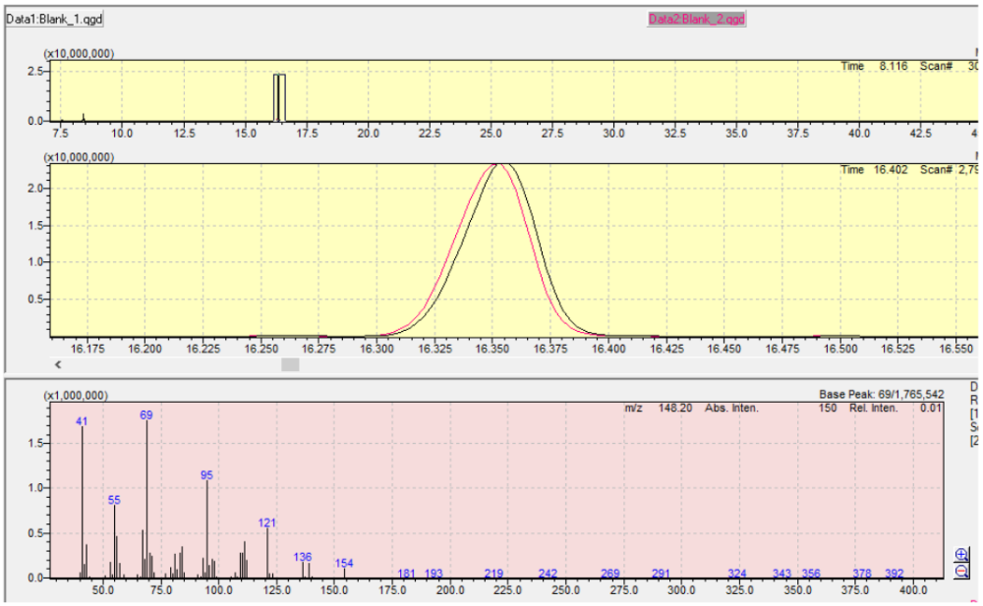
Fig 5

Figure 5: Graphical representation of the results obtained from the gas chromatography-mass spectrometry (GC-MS) analysis of the internal standard citronellal. The upper panel displays the total ion chromatogram (TIC), with a prominent peak corresponding to the internal standard at its retention time. The middle panel presents the extracted ion chromatogram (EIC), which offers a clear illustration of the peak's Gaussian shape and its retention time for accurate identification. The lower panel presents the mass spectrum of the internal standard, highlighting the characteristic fragment ions used for compound verification.

Figure 6, displays four notable Gaussian curves: two originating from the ALAN treatments, shown in red, and two from the non-ALAN treatments, shown in green. These curves are observed around a retention time of approximately 23.68 minutes (Fig. 6). A notable distinction is observes in the height of these peaks, both within each treatment group and especially between the groups (Fig. 6). The green peaks of the non-ALAN treatments are considerably higher.

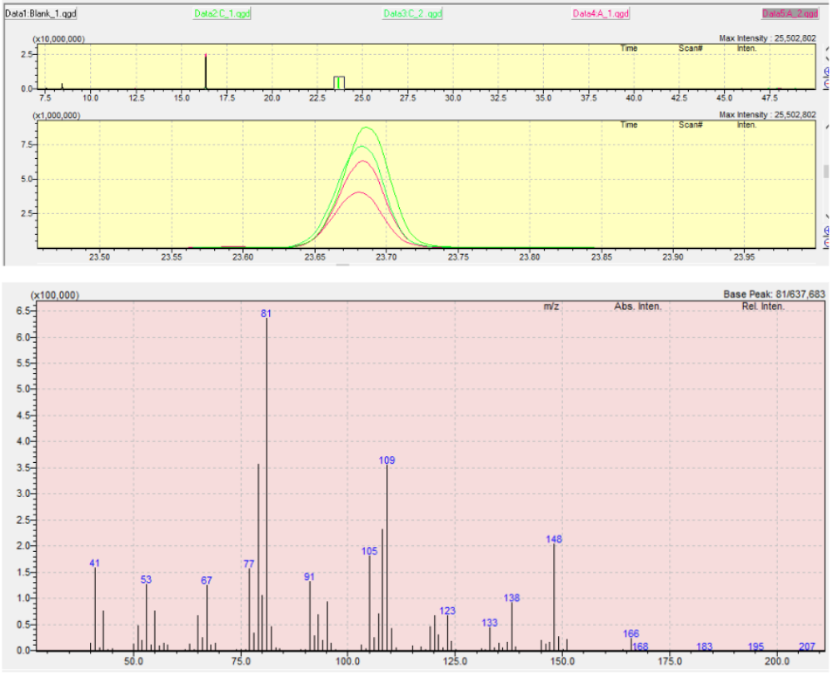
Fig. 6

Figure 6, shows the GC-MS chromatogram with and without ALAN exposure, in addition to the internal standard citronellal. The green peaks represents the treatments devoid of ALAN exposure, while the red peaks represent the treatments that were exposed to ALAN. The upper panel displays the total ion chromatogram (TIC), highlighting the retention time of the internal standard. The middle panel highlights the extracted ion chromatogram (EIC), which utilizes Gaussians to precisely identify the retention times. The lower panel presents the mass spectrum of the fragment ions, which were used for compound verification.

Figure 7 illustrates the positioning of the peaks from Figure 6 within the alkane series,
specifically between the alkanes with 14 and 15 carbon atoms (Fig. 6). The retention times of those alkanes are 23.277 and 25.822 (Fig. 5). The subsequent arithmetic rentention index is therefore:
𝐴𝐼(𝑥) = 100 × [𝑧𝑛 +𝑅𝑇𝑥 − 𝑅𝑇𝑛𝑅𝑇𝑛−1 − 𝑅𝑇𝑛
𝐴𝐼(𝑥) = 100 × [14 +23,680 − 23,277
25,822 − 23,277 = 𝟏𝟒𝟏𝟓, 𝟖𝟑𝟒𝟗𝟕𝟏
Fig.7
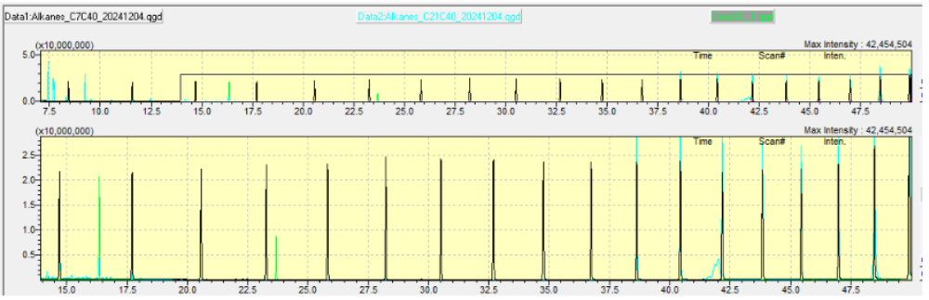
Fig. 8

Figure 8: GC-MS chromatogram of the alkane series, showing retention times of known alkanes (black peaks) alongside the previous green peak. The cyan peaks overlaying the black peaks on the right are additional alkanes.The cyan peak furthest to the left corresponds to an alkane with 21 carbon atoms, serving as a reference to assistin identifying other alkanes and the green peak compound.

Discussion
Performance and survival analysis :
The findings of this experiment support the hypothesis that Artificial Light at Night (ALAN) has negative effect on performance, feeding behavior, growth and survival of larvae and adult of Phaedon cochleariae. Danilo et.al.(2024) and Boyes et.at.(2021) in their experiments found that there are direct and indirect harmful effect of ALAN on feeding behavior and survival of insects in all stages. Figure 1. also support the hypothesis with the findings that ALAN has negative impact on both biomass gain and feeding behavior ie. Performance of larvae and adult of Phaedon cochleariae , likely due to stress or altered activity. The survival probability of ALAN and controlled adult and larvae shows no significant difference). In adults there is no negative impact of ALAN on their survival but ALAN larvae survival probability is less than the control larvae (Fig. 2,3). In the Log-Rank Test the value of p=1. It means there is no significant difference in survival of adults of control and ALAN groups. The value of Chi-square is 0 with p = 1, confirms that there is no significant difference in survival probabilities.
The final conclusion of the experiment is that ALAN negatively affects biomass gain and feeding in both larvae and adults, likely indicating sublethal stress or behavioral changes. ALAN does not significantly impact the survival of adults or larvae within the study duration. This analysis suggests that while ALAN impacts feeding and growth, it does not directly affect mortality under the experimental conditions.
GC-MS Analysis of Defensive Secretions
The results of this experiment support the hypothesis that artificial light at night (ALAN) disrupts not only the natural biological processes but is also responsible for alterations in the chemical composition of larval defensive secretions. Factors like retention times and fragmentation patterns provided by a reference study (Raspotnig et al. 2008), helped to identify the compound observed in the GC-MS analysis as chrysomelidial. The retention time of the green peak in the chromatograms closely matched the reported retention time for chrysomelidial. Furthermore, the mass spectrum exhibited characteristic fragment ions, including m/z 81, 109, and 138, which align with the established literature reference (Fig. 4). These matches confirmed that the primary compound in the larval secretion of Phaedon cochleariae is, in fact, chrysomelidial.
The end results of the gas chromatography-mass spectrometry (GC-MS) analysis revealed that larvae exposed to ALAN produced a lower quantity of chrysomelidial compared to those in non-ALAN conditions. This observation is further supported by the chromatogram (Fig. 4), which demonstrates that the green peaks correspond to the non-ALAN treatments exhibited higher intensity in comparison to the red peaks representing the ALAN treatments. This finding suggests that ALAN exposure results in a lower concentration of chrysomelidial in the larvae. These findings underscore the potential impact of ALAN-induced stress on the larvae's capacity to synthesize or secrete defensive chemicals. This reduction may be attributed to the stress induced by ALAN exposure, which may impact the larvae's ability to synthesize or secrete defensive chemicals. Furthermore, presence of ALAN might have altered the primary chemical compound present in the Brassicaceae plants , which when consumed by the larvae declined the actual potency and biosynthesis of chrysomelidial, further reducing its availability in larval secretions. The overall conclusion is that the ALAN negatively impacts the chemicals required to mediate the chemical communications which directly and indirectly impacts their survival , there is also need to do research that directly addresses the underlying mechanisms by which ALAN exposure leads to the reduction of the grysomelidial levels. This underscores the need for further investigation to deeply study and investigate the mechanisms involved in this phenomenon.
References
- Attia, D., Behar-Cohen, F., Carré, S., Enouf, O., Falcón, J., Gronfier, C., et al. (2019). Effets sur la Santé Humaine et sur L’environnement (faune et flore) des Diodes Électroluminescentes (LED). Available online at: https://www.anses.fr/fr/system/files/AP2014SA0253Ra.pdf
- Bennie, J., Davies, T. W., Cruse, D., Inger, R., and Gaston, K. J. (2015a). Cascading effects of artificial light at night: resource-mediated control of herbivores in a grassland ecosystem. Philos. Trans. R. Soc. B Biol. Sci. 370:20140131. doi: 10.1098/rstb.2014.0131
- Bouchard, P.; Hsiung, C.-C.; Yaylayan, V. A. (1997): Chemical Analysis of Defense Secretions of Sipyloidea sipylus and Their Potential Use as Repellents Against Rats. In: Journal ofchemical ecology 23 (8), S. 2049–2057. DOI: 10.1023 /B:JOEC 0000 006 488.58081.66.
- Boyes,D.H.Eet.al.,(2021)Is light pollution driving moth population declines?A review of casual mechanisms across the life cycle. Insect conservation and diversity.14,1677-187.
- Burse,A.Schmidt,A., Frick,S.,Kuhan,J.(2007) Iridoid biosynthesis in chrysomelina larvae: Fat body produces early terpenoid precursors, Insect Biochemistry and Molecular Biology,37(3):255-265
- Chao,y.,Ryu S.,Kyung,H.(2015) Effects of artificial light at night on human health: A literature review of observational and experimental studies applied to exposure assessment. Chronobiology International, The Journal of Biological and Medical Rhythm Research .
- Chen, Yun-Ru; Wei, Wei-Lun; Tzeng, David T. W.; Owens, Avalon C. S.; Tang, Hsin-Chieh;Wu, Chia-Shong et al. (2021): Effects of artificial light at night (ALAN) on gene expression of Aquatica ficta firefly larvae. In: Environmental pollution (Barking, Essex : 1987) 281, S.116944. DOI: 10.1016/j.envpol.2021.116944.
- Danilo,T.et.al. (2024)Glowing wanders: exploring the diversity and ecological significance of bioluminescent organisms in Brazil, Photochemical and Photobiological Sciences 23(3),1-20
- De Paiva, M. R. S. 1977. Biology and population ecology of the mustard beetle Phaedon cochlearia Fabricius. Doctoral dissertation, University of London.
- Dominoni, D. M., Borniger, J. C., and Nelson, R. J. (2016). Light at night, clocks and health: from humans to wild organisms. Biol. Lett. 12:20160015. doi: 10.1098/rsbl.2016.0015
- Falchi, F., Cinzano, P., Duriscoe, D., Kyba, C. C. M., Elvidge, C. D., Baugh, K., et al. (2016). The new world atlas of artificial night sky brightness. Sci. Adv. 2:e1600377. doi: 10.1126/sciadv.1600377
- Gaston K. J., Davies T. W., Nedelec S. L. and Holt L. A. (2017). Impacts of artificial light at night on biological timings. Annu. Rev. Ecol. Evol. Syst. 48, 49-68. 10.1146/annurev-ecolsys-110316-022745 [DOI] [Google Scholar]
- Geiselhardt, S., Otte, T., Hilker, M. 2009. The Role of Cuticular Hydrocarbons in Male Mating Behavior of the Mustard Leaf Beetle, Phaedon cochleariae (F.). Journal of Chemical Ecology 35, 1162–1171
- Hölker, F., Wolter, C., Perkin, E. K., and Tockner, K. (2010). Light pollution as a biodiversity threat. Trends Ecol. Evol. 25, 681–682. doi: 10.1016/j.tree.2010.09.007
- Kuhnle,Anne,Muller,Carolin (2011) Relevance of visual and olfactory cues for host location in the mustard leaf beetle Phaedon cochleariae, Physiological Entomology,36(1),68-76.
- Lass, Sandra; Spaak, Piet (2003): Chemically induced anti-predator defences in plankton: areview. In: Hydrobiologia 491 (1-3), S. 221–239. DOI: 10.1023/A :102448 7804497.
- Muller T. and Muller.C.(2015)Behavioural phenotypes over the lifetime of a homometabolous insect, Frontiers in Zoology 12(1)58.
- Navara K. J. and Nelson R. J. (2007). The dark side of light at night: physiological, epidemiological, and ecological consequences. J. Pineal Res. 43, 215-224. 10.1111/j.1600-079X.2007.00473.x [DOI] [PubMed] [Google Scholar
- Sharma V. K. (2003). Adaptive significance of circadian clocks. Chronobiol. Int. 20, 901-919. 10.1081/CBI-120026099 [DOI] [PubMed] [Google Scholar]
- Tamir, R., Lerner, A., Haspel, C., Dubinsky, Z., and Iluz, D. (2017). The spectral and spatial distribution of light pollution in the waters of the northern Gulf of Aqaba (Eilat). Sci. Rep. 7:42329. doi: 10.1038/srep42329
- Veith, Martin; Lorenz, Michael; Boland, Wilhelm; Simon, Helmut; Dettner, Konrad (1994):Biosynthesis of iridoid monoterpenes in insects: Defensive secretions from larvae of leaf beetles(coleoptera: chrysomelidae). In: Tetrahedron 50 (23), S. 6859–6874. DOI: 10.1016/S0040- 4020(01)81338-7.

.

