**MongoDB Exercise in mongo shell**

**Insert Documents**

**1.Created database named mongo_practice.**

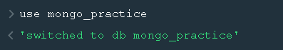

Insert the following documents into a movies collection.

title : Fight Club

writer : Chuck Palahniuko

year : 1999

actors : [ Brad Pitt Edward Norton ]

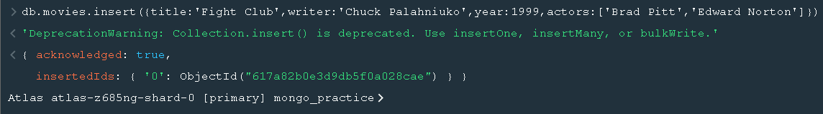

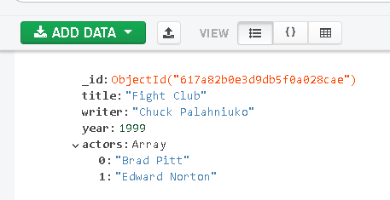

title : Pulp Fiction

writer : Quentin Tarantino

year : 1994 actors : [ John Travolta Uma Thurman ]

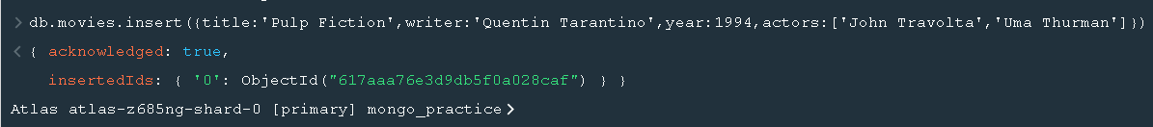

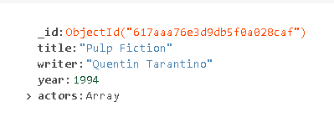

title : Inglorious Basterds

writer : Quentin Tarantino

year : 2009 actors : [ Brad Pitt Diane Kruger Eli Roth ]

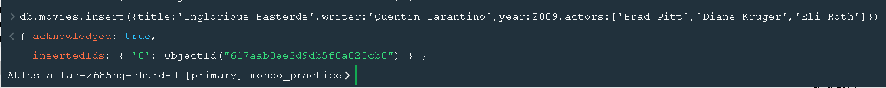

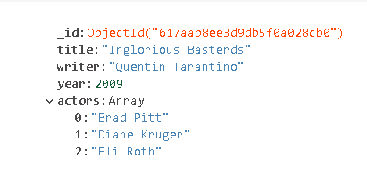

title : The Hobbit: An Unexpected Journey

writer : J.R.R. Tolkein year : 2012

franchise : The Hobbit

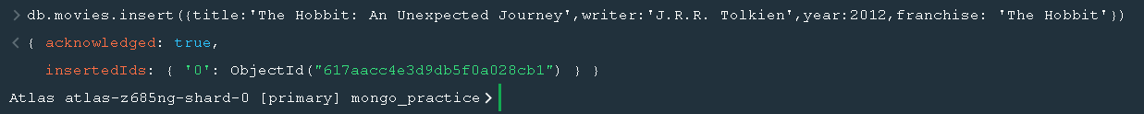

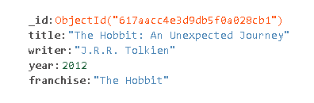

title : The Hobbit: The Desolation of Smaug

writer : J.R.R. Tolkein

year : 2013 franchise : The Hobbit



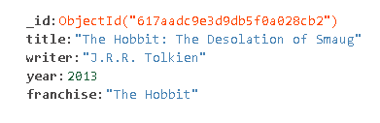

title : The Hobbit: The Battle of the Five Armies

writer : J.R.R. Tolkein

year : 2012 franchise : The Hobbit



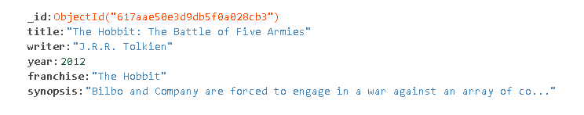

title : Pee Wee Herman's Big Adventure

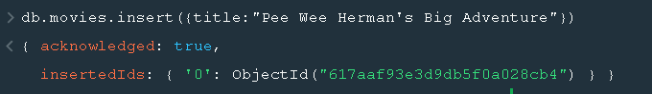

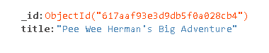

title : Avatar

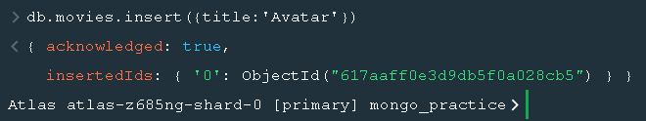

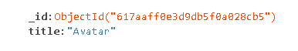

**Query / Find Documents**

query the movies collection to

1. get all documents

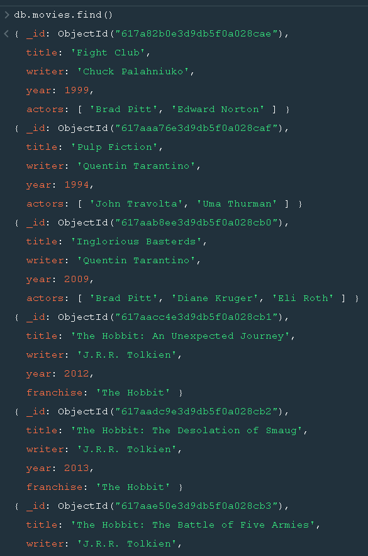

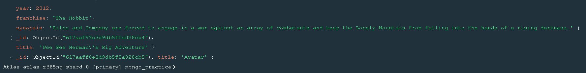

2. get all documents with writer set to "Quentin Tarantino"

3. get all documents where actors include "Brad Pitt"

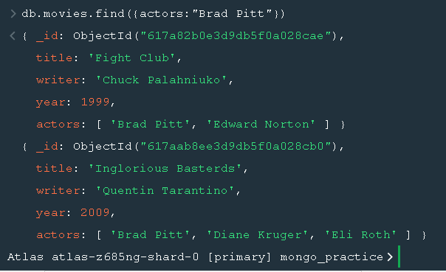

4. get all documents with franchise set to "The Hobbit"

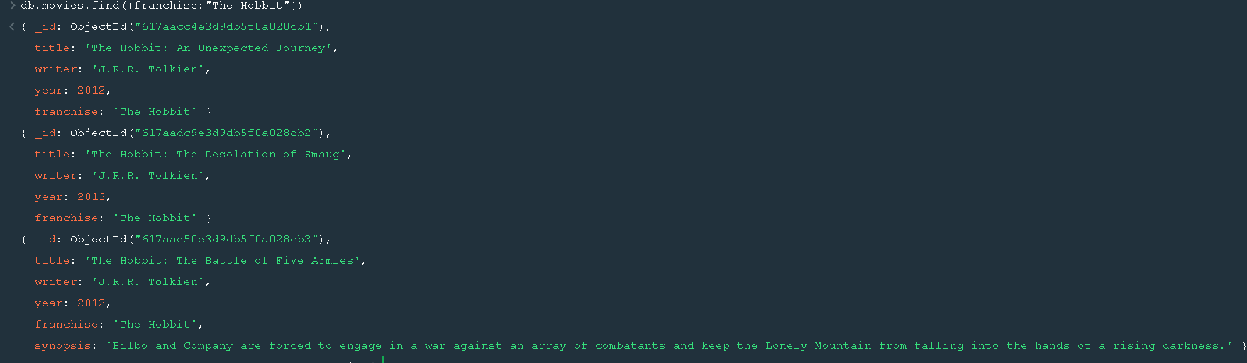

5. get all movies released in the 90s

6. get all movies released before the year 2000 or after 2010.

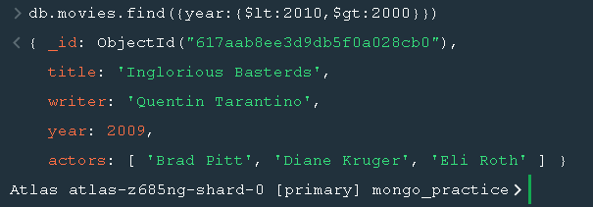

**Update Documents**

**1. add a synopsis to "The Hobbit: An Unexpected Journey" : "A reluctant hobbit, Bilbo Baggins, sets out to the Lonely Mountain with a spirited group of dwarves to reclaim their mountain home - and the gold within it - from the dragon Smaug."**

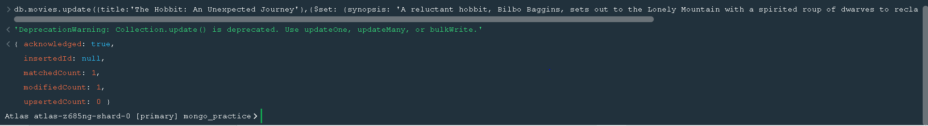

**2. add a synopsis to "The Hobbit: The Desolation of Smaug" : "The dwarves, along with Bilbo Baggins and Gandalf the Grey, continue their quest to reclaim Erebor, their homeland, from Smaug. Bilbo Baggins is in possession of a mysterious and magical ring."**

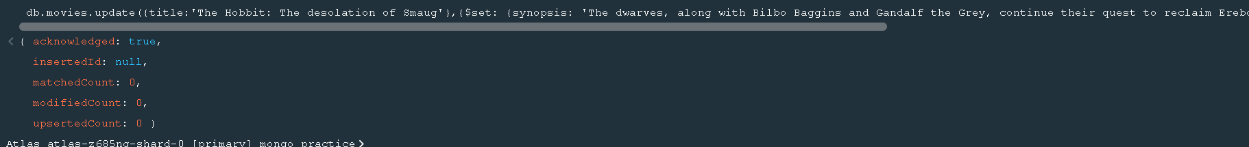

**3. add an actor named "Samuel L. Jackson" to the movie "Pulp Fiction"**

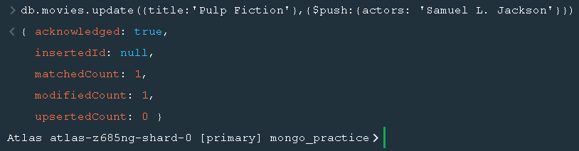

**Text Search**

1. find all movies that have a synopsis that contains the word "Bilbo"

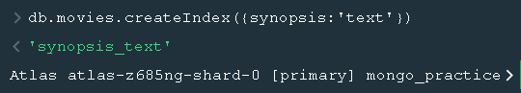

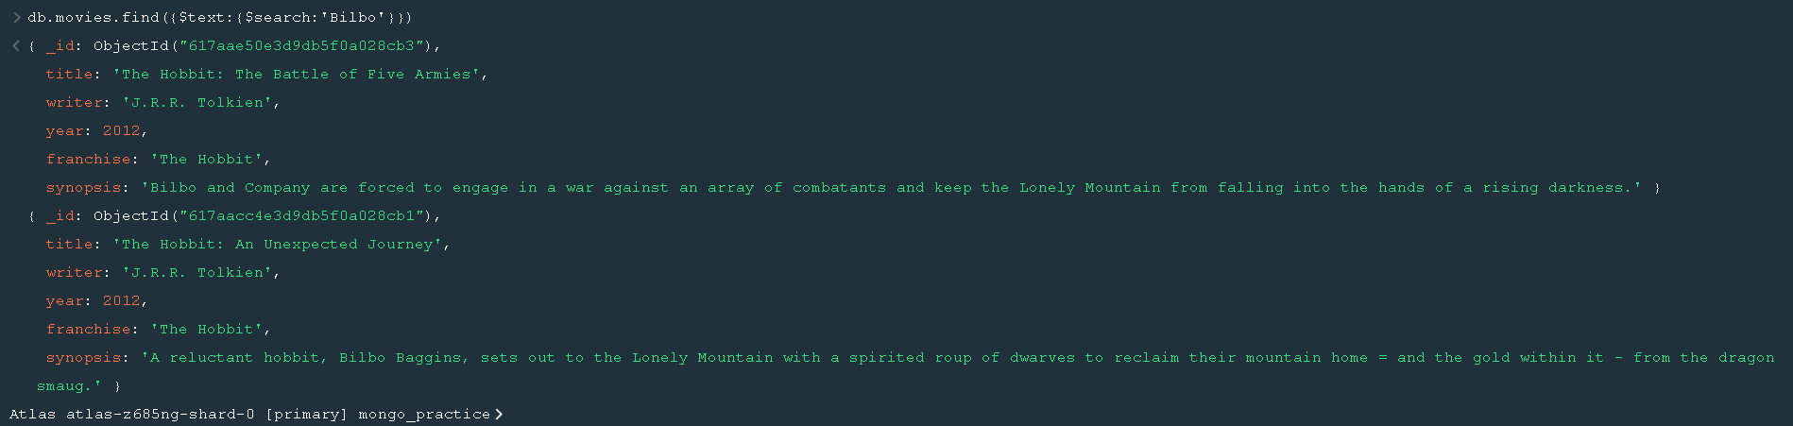

2. find all movies that have a synopsis that contains the word "Gandalf"

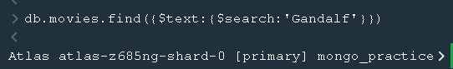

3. find all movies that have a synopsis that contains the word "Bilbo" and not the word "Gandalf"

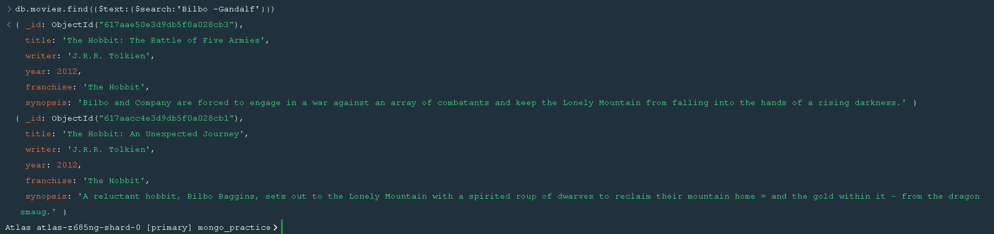

4. find all movies that have a synopsis that contains the word "dwarves" or "hobbit"

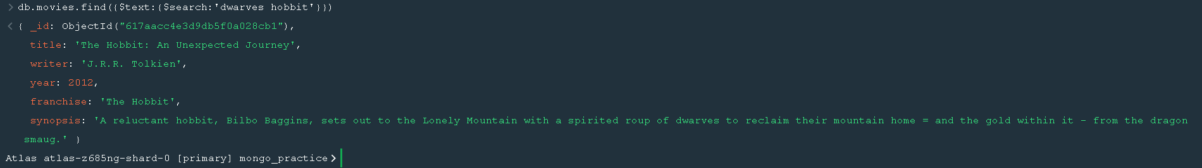

5. find all movies that have a synopsis that contains the word "gold" and "dragon"

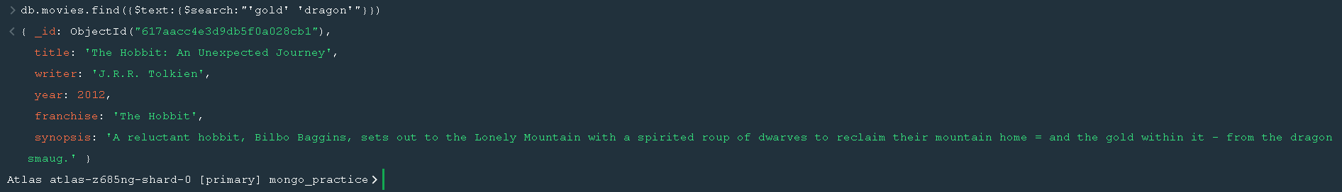

**Delete Documents**

**1. delete the movie "Pee Wee Herman's Big Adventure"**

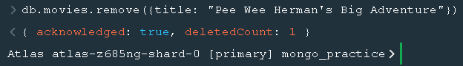

**2. delete the movie "Pee Wee Herman's Big Adventure"**

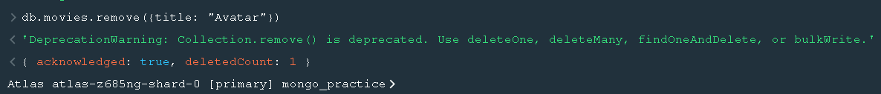

**Relationships**

**Insert the following documents into a users collection**

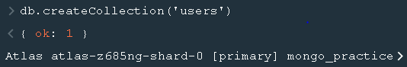

username : GoodGuyGreg

first_name : "Good Guy"

last_name : "Greg"

username : ScumbagSteve

full_name :

first : "Scumbag"

last : "Steve"

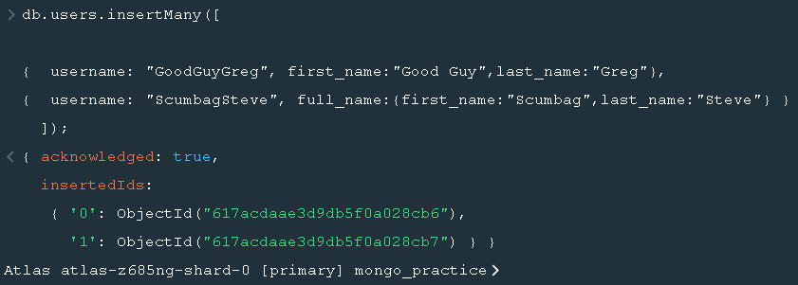

Insert the following documents into a posts collection username : GoodGuyGreg title : Passes out at party body : Wakes up early and cleans house

username : GoodGuyGreg

title : Steals your identity

body : Raises your credit score

username : GoodGuyGreg

title : Reports a bug in your code

body : Sends you a Pull Request

username : ScumbagSteve

title : Borrows something

body : Sells it

username : ScumbagSteve

title : Borrows everything

body : The end username : ScumbagSteve

title : Forks your repo on github

body : Sets to private

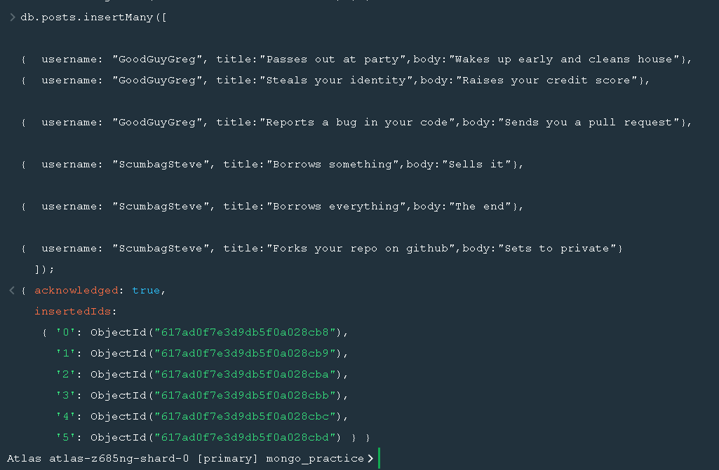

**Insert the following documents into a comments collection.**

username : GoodGuyGreg

comment : Hope you got a good deal!

post : [post_obj_id]

where [post_obj_id] is the ObjectId of the posts document: "Borrows something"

username : GoodGuyGreg

comment : What's mine is yours!

post : [post_obj_id]

where [post_obj_id] is the ObjectId of the posts document: "Borrows everything"

username : GoodGuyGreg

comment : Don't violate the licensing agreement!

post : [post_obj_id]

where [post_obj_id] is the ObjectId of the posts document: "Forks your repo on github

username : ScumbagSteve

comment : It still isn't clean

post : [post_obj_id]

where [post_obj_id] is the ObjectId of the posts document: "Passes out at party"

username : ScumbagSteve

comment : Denied your PR cause I found a hack

post : [post_obj_id]

where [post_obj_id] is the ObjectId of the posts document: "Reports a bug in your code"

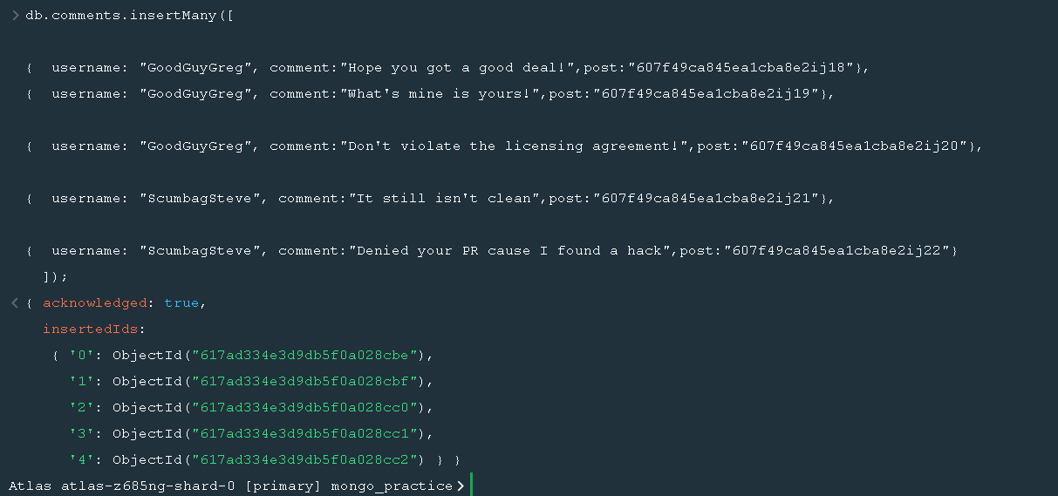

**Querying related collections**

1. find all users

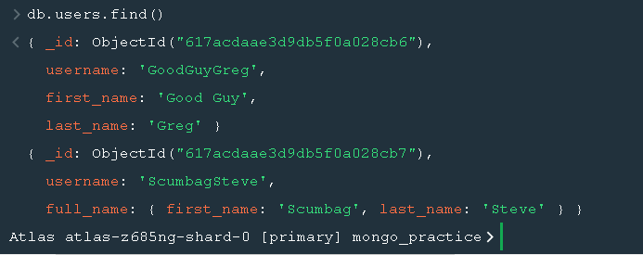

2. find all posts

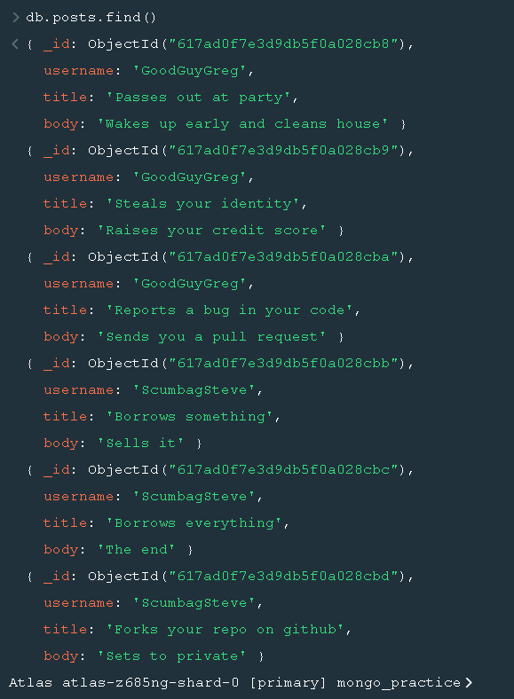

3. find all posts that was authored by "GoodGuyGreg"

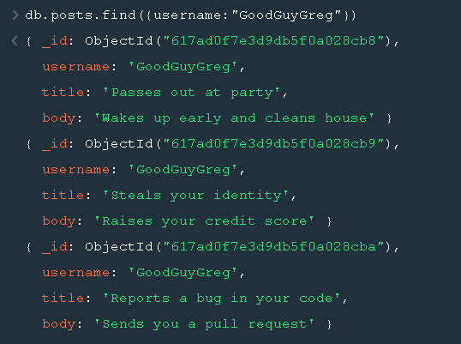

4. find all posts that was authored by "ScumbagSteve"

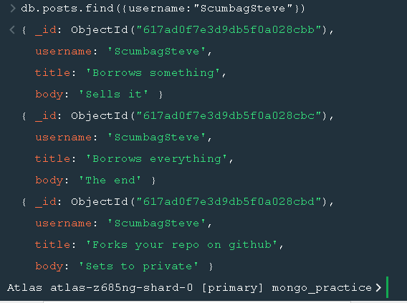

5. find all comments

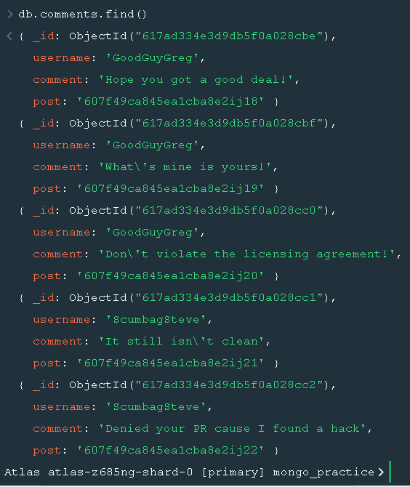

6. find all comments that was authored by "GoodGuyGreg"

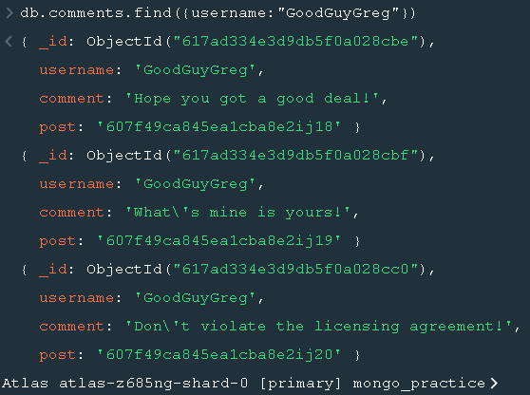

7. find all comments that was authored by "ScumbagSteve" 8. find all comments belonging to the post "Reports a bug in your code"

