**MongoDB -Aggregation Exercises**

**Created database population**



**Atlanta Population**

**1. use db.zipcodes.find() to filter results to only the results where city is ATLANTA and state is GA.**

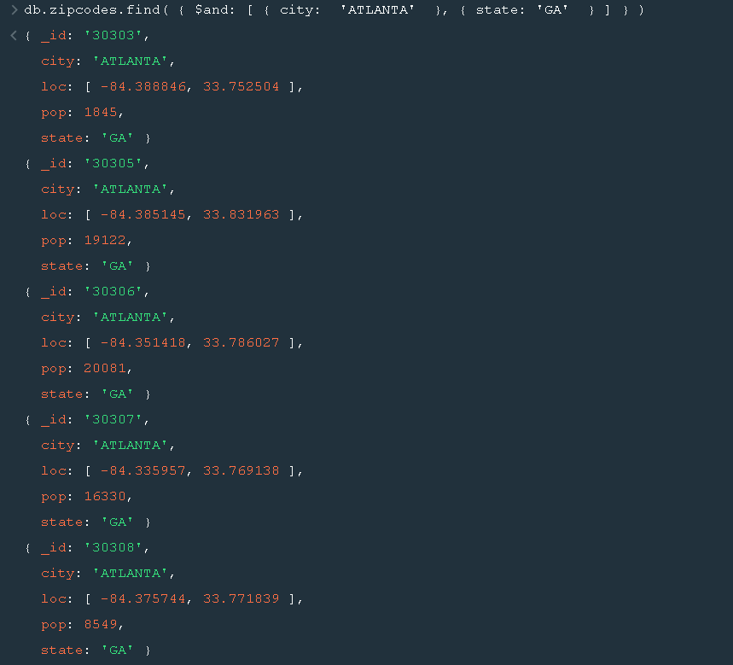

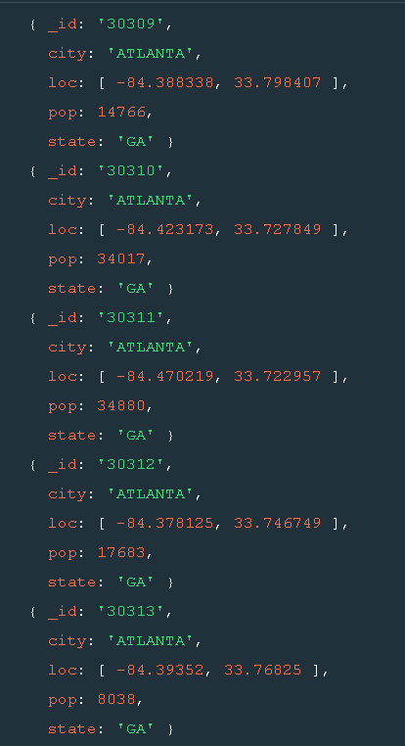

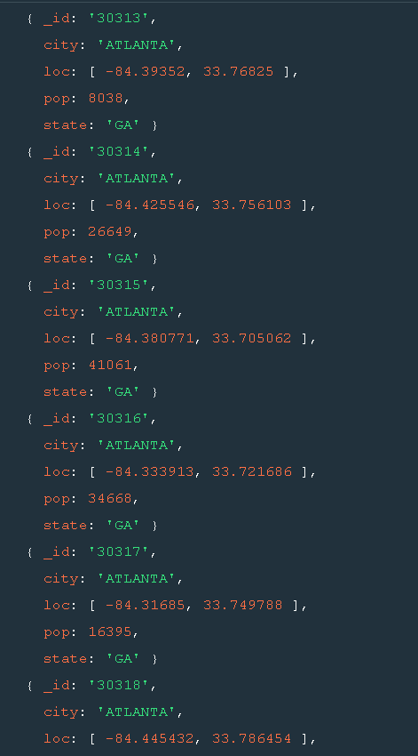

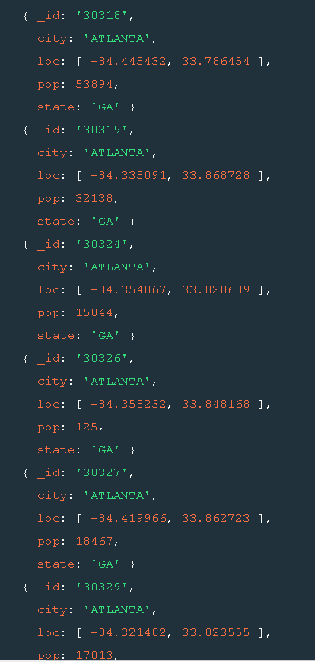

**2. use db.zipcodes.aggregate with $match to do the same as above.**

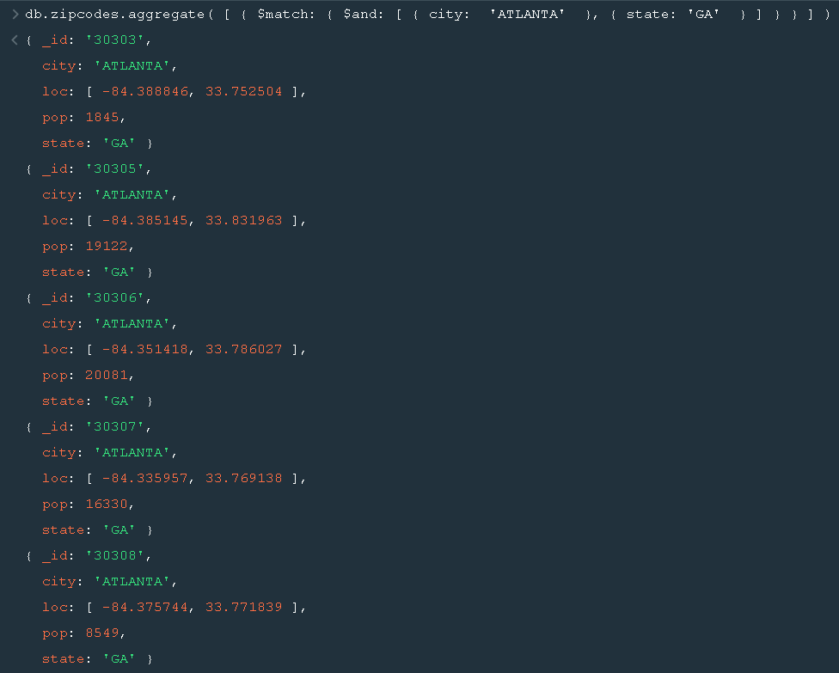

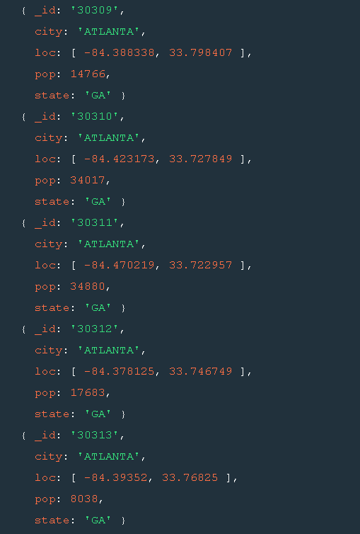

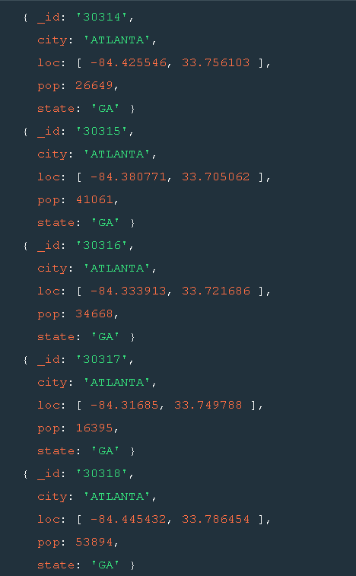

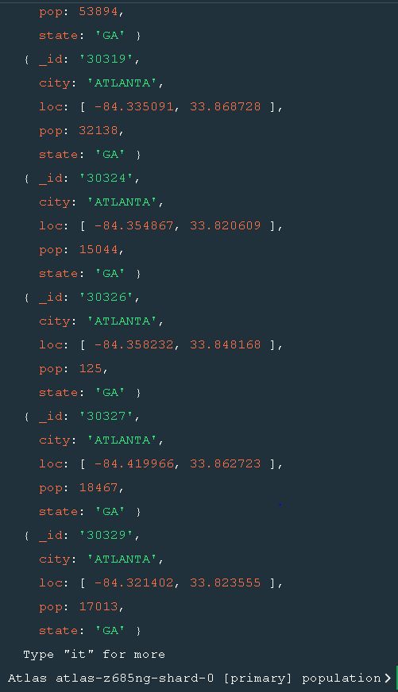

**3. use $group to count the number of zip codes in Atlanta.**

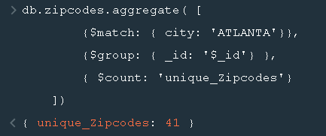

**4. use $group to find the total population in Atlanta.**

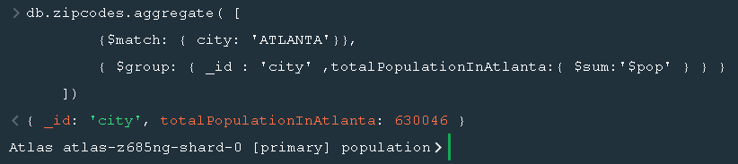

**Populations By State**

**1. use aggregate to calculate the total population for each state**

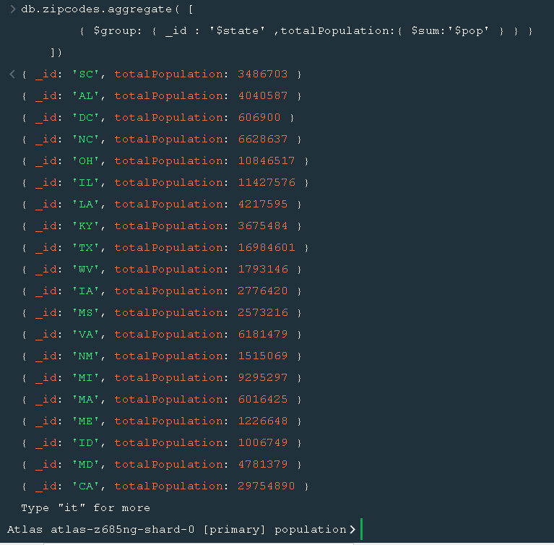

**2. sort the results by population, highest first**

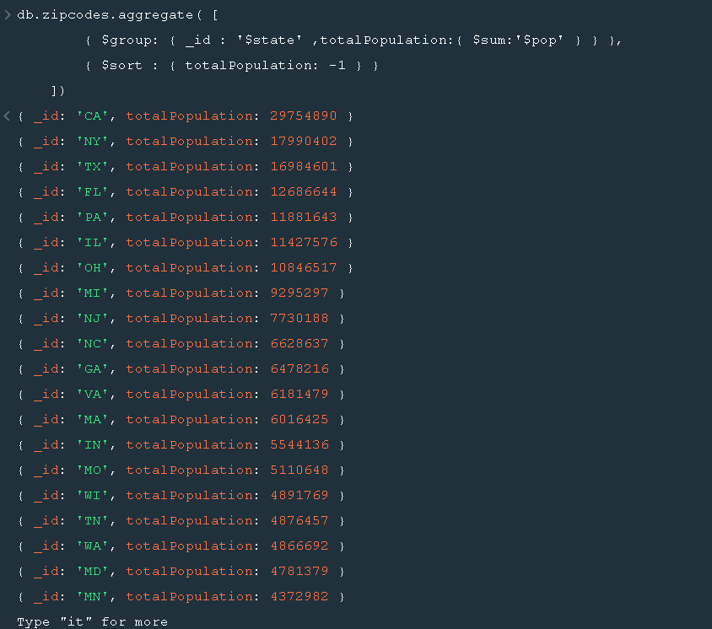

**3. limit the results to just the first 3 results. What are the top 3 states in population**

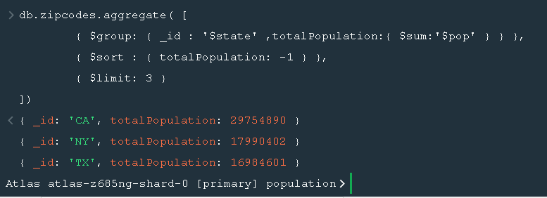

**Populations by City**

**1. use aggregate to calculate the total population for each city (you have to use city/state combination). You can use a combination for the _id of the $group: { city: '$city', state: '$state' }**

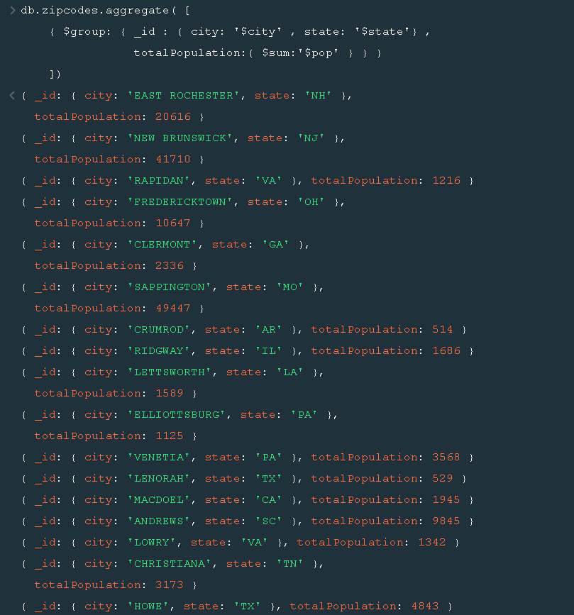

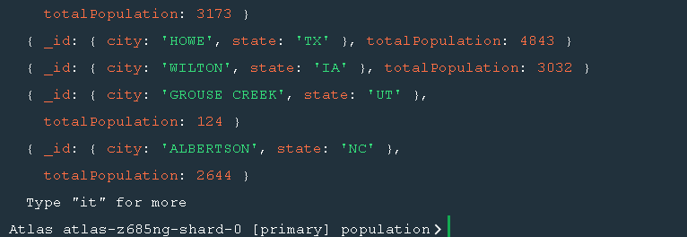

**2. sort the results by population, highest first**

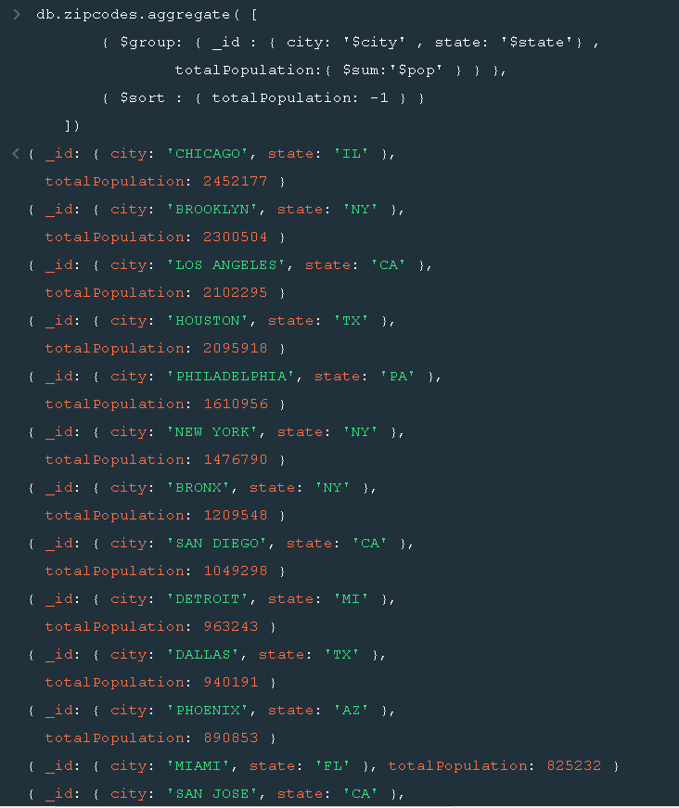

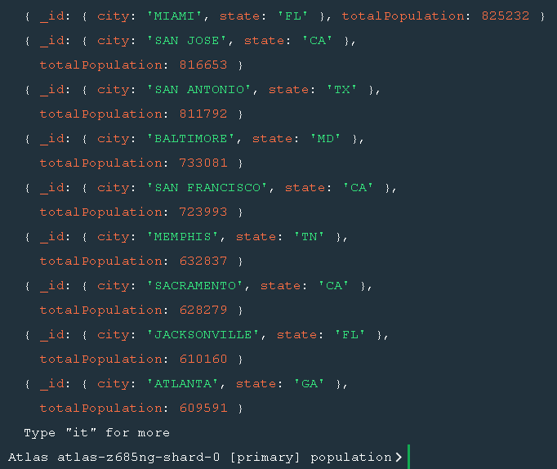

**3. limit the results to just the first 3 results. What are the top 3 cities in population?**

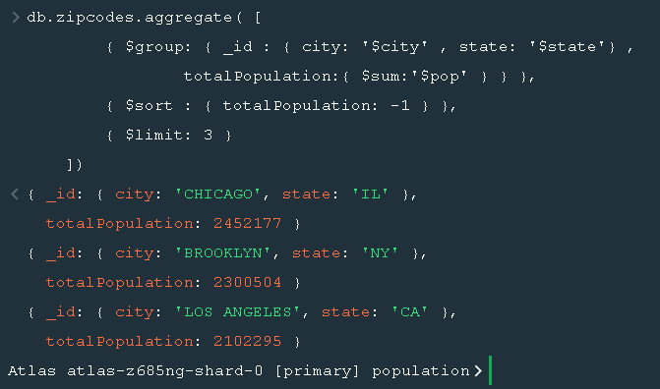

**4. What are the top 3 cities in population in Texas?**

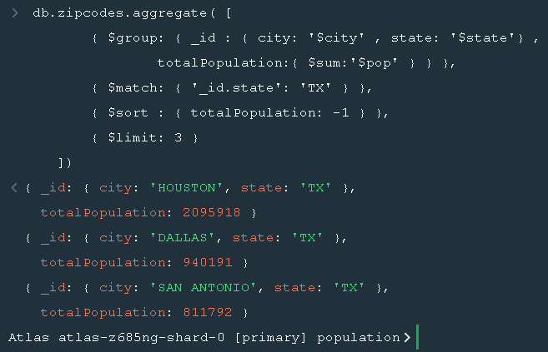

**Bonus**

**1. Write a query to get the average city population for each state.**

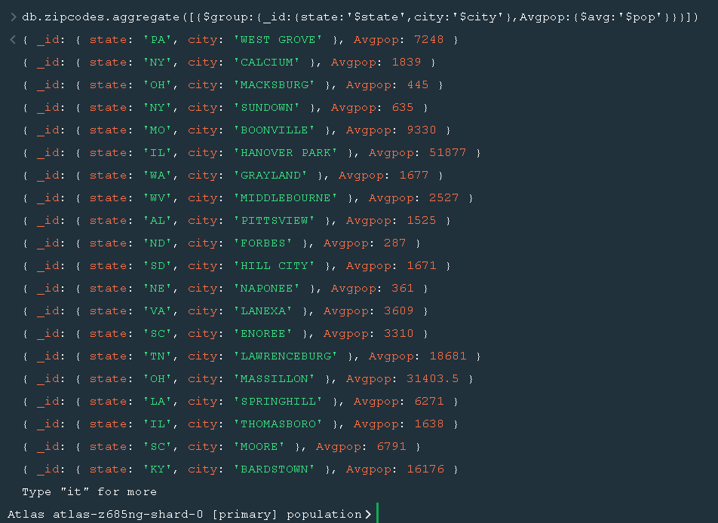

**2. What are the top 3 states in terms of average city population?**

