Real Time Weather Prediction Embedded System using IOT and Machine Learning

Pranjul Mittal

B.Tech. Scholar, Department of Electronics & Communication,

Jaypee Institute of Information Technology, A-10, Sector-62, Noida (U.P.)-India

pranjulmittal97@gmail.com

Vijay Khare

Assistant Professor, Department of Electronics & Communication,

Jaypee Institute of Information Technology, A-10, Sector-62, Noida (U.P.)-India

vijay.khare@jiit.ac.in

Gaurav Verma

Assistant Professor, Department of Electronics &

Communication,

Jaypee Institute of Information Technology, A-10, Sector-62,

Noida (U.P.)-India

gaurav.iitkg@gmail.com

**Abstract:** Now a days, focus has shifted more towards intelligent technologies like IoT and Machine Learning. ESP8266 is a Wi-Fi module and one of the leading platforms for Internet ofThings implementation. It can transfer data to IoT cloud.

Using Internet of Things (IoT), any electronic equipment can be controlled in homes and industries. Moreover, data can be read from any sensor and analysed graphically seated anywhere in the world. Here, temperature and humidity data is read using a DHT11 sensor and light intensity using LDR.This data is uploaded to a ThingSpeak cloud server using NodeMCU and ESP8266-01 module. The data can be displayed on a HTML webpage.

On being placed in a room, this standalone device measures all the abovesaid parameters. The main part of this paper depends on machine learning and serial communication. NodeMCU records the data from sensors (temperature, humidity, light intensity) and then the values are transferred to the jupyter notebook (python). The data is used to train. Once the training is complete, prediction is done for a particular value by blinking the led connecting to NodeMCU.

**Keywords:** NodeMCU, Jupyter Notebook, DHT11, ThingSpeak,

LDR.

# **Introduction**

Will it rain and the match get dismissed or will it be bright and sunny? How can it be determined that whether the conditions are suitable for conducting a cricket match or not?

IoT is a concept that connects all the devices to the internet and allows them to communicate with each other over the internet. IoT is a giant network of connected devices – all of

which gather and share data about how they are used and the environments in which they are operated.

NodeMCU is an open source IoT platform. It includes firmware which runs on the ESP8266 Wi-Fi SoC from Espressif Systems, and hardware which is based on the ESP-12 module. The term "NodeMCU" by default refers to the firmware rather than the development kits.

Machine learning is the study of algorithms and mathematical models that systems use to progressively improve their performance on a specific task.

Using Internet of Things (IOT), we can control any electronic equipment in homes and industries. Moreover, data can be read from any sensor and analyzed graphically seated anywhere in the world. Temperature and humidity data can read from DHT11 sensor and light density using LDR module. This data is uploaded to a ThingSpeak cloud server using NodeMCU and ESP8266-01 module.

ESP8266 is a WiFi module, it is one of the leading platform for Internet of Things implementation. It can transfer data to IoT cloud..

**LITERATURE REVIEW**

Jitcha Shivang et al. developed a simulated system to predict weather condition of Indian subcontinent using Machine Learning. Data for training was collected from data.gov.in, ncdc.noaa.gov and UCI machine learning data repository.

The system utilizes a linear regression algorithm for data training [1].

Zaheer Ullah Khan et al. used various data mining techniques for prediction of weather forecasting including different classifications like K-Nearest Neighbour, Decision Trees.Among the classification Algorithms decision tree has achieved promising results compared to other algorithms.In this paper they achieved an accuracy of 82% [2].

Siddharth S. et al. In this paper they have used data mining technique and Decision tree algorithm to classify weather parameters like minimum temperature and maximum temperature in terms of day, month and year [3].

Radhika et al. presented a paper on the application of Support Vector Machines for weather prediction. Time series data of daily maximum temperature at a location was analyzed to predict the maximum temperature of the next day at that location based on the daily maximum temperatures for a span of previous n days referred to as order of the input.. Non linear regression method was used to train the SVM for this application.[4]

Divya Chauhan et al. used data mining, a tool that predicts behaviours and future trends, allowing businesses to make proactive decisions. This paper presents the review of Data Mining Techniques for Weather Prediction and studies the benefit of using it. The paper can be used to predict meteorological data that is weather prediction.. The paper provides a survey of available literatures of some algorithms employed by different researchers to utilize various data mining techniques, for Weather Prediction[5].

After studying all the papers it was found that all are using data from some or the other website. But in this paper, all the data is measured in different conditions using a set of sensors. In this paper, two sensors viz. LDR and DHT11 have been used for better prediction which measures temperature, humidity and light density. The model is based on logistic regression.

# **Components And Softwares Required**

**ESP12/NODE MCU (CP2102)**

NodeMCU is an updated version of Arduino with inbuilt wifi chip as shown in figure 1 . It is cheaper than other modules performing the same function.



**Figure 1. NodeMCU**

**DHT sensor**

It is a module used for measuring temperature and humidity as shown in figure 2. It uses a capacitive humidity sensor and a thermistor to measure the surrounding air’s humidity and temperature.



**Figure 2. DHT11**

**LDR Sensor**

It is a device used for measuring the light density.

It works on principle of photoconductivity. When LDR kepts in dark its value increases and when kept in light its value decreases as shown in figure 3.



**Figure 3 LDR**

**Breadboard**

It is typically a hand wired circuit using a pegboard with press in terminals. Wire wraps or hand soldered wires connect discrete components together.

**Connecting Wires/Jumpers**

Theyis used to connect NodeMCU to the LDR and DHTt11.

**Softwares Used**

The Arduino IDE (Integrated Development Environment) is the environment where code can be written, compiled and uploaded to the Arduino or Arduino compatible board.

ThingSpeak is an Internet of Things  platform that lets the user collect and store sensor data in the cloud

An HTML web page is a plaintext document with a .html or .htm file name extension. Typically it also contains multimedia contents (words, pictures, other media) and code written in HTML, CSS, and JavaScript to control the look and behavior of that content.

Jupyter notebook is a very popular and flexible tool which helps put the code, output of the code and any kind of visualization or plot etc. in the same document.

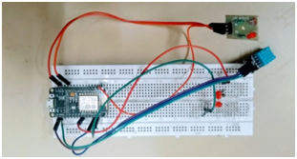

**Figure 4 Circuit Diagram**

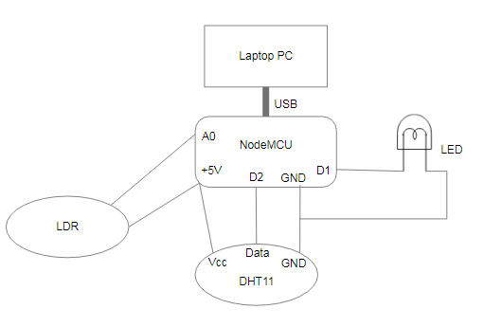

**Figure 5 Schematic Circuit Diagram**

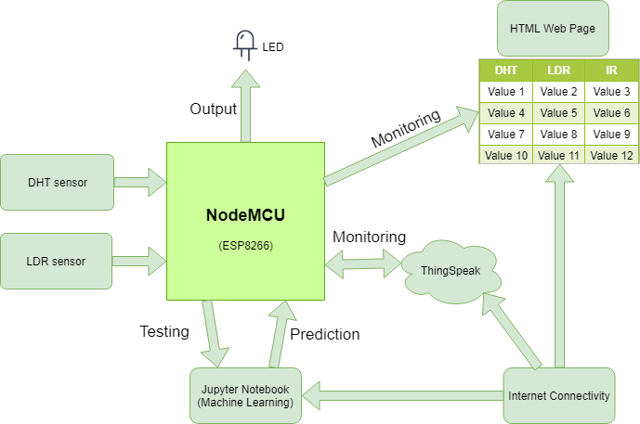

**Figure 6 Block Diagram**

**WORKING**

Connect 2 different sensors with NodeMCU ESP8266 which measure temperature, humidity and light density as shown in figure 4 and figure 5. LDR is connected to analog I/O pins and the remaining sensors are connected to digital I/O pins. Using NodeMCU data is sent to the ThingSpeak cloud server (database) as shown in figure 8. then Thingspeak sends data to the NodeMCU in form of a JSON file so that data can now be displayed on a HTML Web Page which is showing measured readings of different sensors as shown in figure 7.

Now separately with the help of Google spreadsheets, different values of temperature, humidity and light intensity can be recorded in a csv file format[6]. This data can be used to train using Machine Learning, taking all the possible values in which a match may be possible. All the connection are shown in block diagram (figure 6.)

After doing the above mentioned steps certain concepts of Machine Learning are used. A model based on Logistic Regression[8] in Jupyter Notebook(Python IDE) is used and trained on the values which had been taken by the Google spreadsheet. NodeMCU records the current values of temperature, humidity and light intensity of a particular

location.Accuracy of tis model is approx 82% as shown in figure 9. These values are sent to the Jupyter Notebook using serial communication between NodeMCU and Jupyter Notebook. With the help of the model an attempt to predict the feasibility of a match is made. After that, one of ‘0’ or ‘1’ are are sent by the Jupyter Notebook to the NodeMCU as a result[7]. If led blinks then match will be possible otherwise not.

**Results**

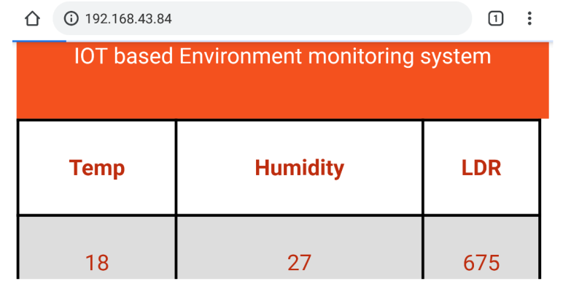

**Figure 7 HTML Webpage**

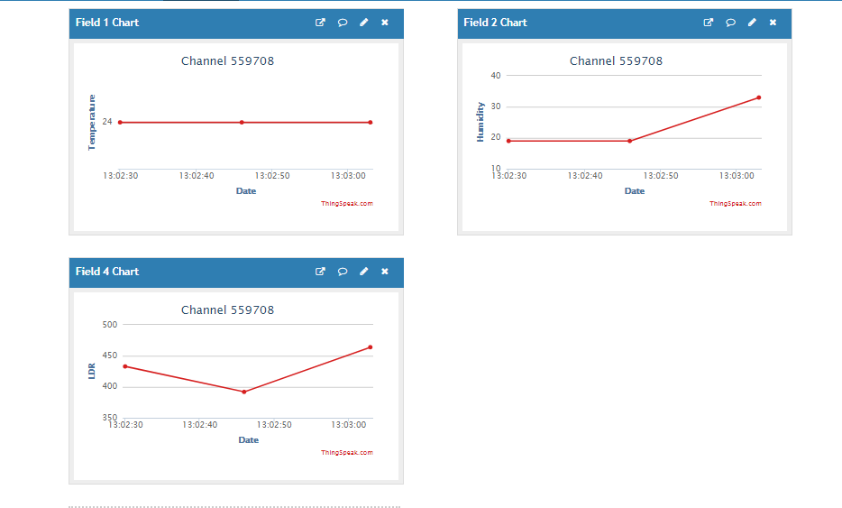

**Figure 8 Thingspeak Database**

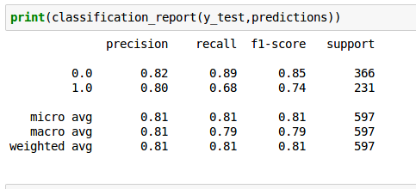

**Figure 9 Model Parameters**

**Conclusion**

The future of IoT is virtually unlimited due to the advances in technology and consumers’ desire to integrate devices such as smart phones with household machines. Wi-Fi has made it possible to connect people and machines on land, in the air and in sea. Logistic regression is used to predict the weather parameters. Forecasting weather parameters for a longer duration with more parameters involves the use of artificial neural networks. The help of this setup, a match can be predicted on the basis of temperature, humidity and light intensity on that particular location.

**References**

[1] Jitcha Shivang, S.S Sridhar, “Weather prediction for indian location using Machine learning,” International Journal of Pure and Applied Mathematics, vol 118, no. 22 pp. 1945-1949, 2018.

[2] Zaheer Ullah Khan and Maqsood Hayat, “Hourly based climate prediction using data mining techniques by comprising entity demean algorithm” Middle-East Journal of Scientific Research 21, vol. 8, pp. 1295-1300, 2014.

[3] Siddharth S. Bhatkande1 ,Roopa G. Hubballi2, “Weather Prediction Based on Decision Tree Algorithm Using Data Mining Techniques.” Belgaum India: International Journal of Advanced Research in Computer and Communication Engineering, vol. 5, no.5, pp. 483-48, 2016.

[4] Radhika, Y., and M. Shashi., “Atmospheric temperature prediction using support vector machines.”International Journal of Computer Theory and Engineering1.1, vol. 1, no. 1, pp.1793-8201, 2009.

[5] Divya Chauhan, Jawahar Thakur, “ Data mining techniques for Weather Prediction:” International Journal of Computer Science Trends and Technology (IJCST), vol. 6, issue 3, pp.249-254, 2018.

[6] Badhiye S.S , Wakode B. V , Chatur P. N. , “Analysis Of Temperature And Humidity Data For Future Value Prediction” International Journal Of Computer Science And Information Technologies , vol.3,no.1 pp.3012-3014, 2012.

[7] Folorunsho Olaiya, Adesesan Barnabas Adeyemo, “Application of Data Mining Techniques in Weather Prediction and Climate Change Studies”, IJCSNS International Journal of Computer Science and Network Security, vol.17 no.6,pp 22-25, 2017 .

[8] Gaurav J. Sawale, Dr. Sunil R. Gupta, “Use of Artificial Neural Network in Data Mining For Weather Forecasting”, International Journal Of Computer Science And Applications vol. 6, no.2, pp383-387, 2013.