SUMMER TRAINING REPORT

**On**

“Virtual Machine: Installation and Configuration”

**Submitted by**

**Pranjul Singhal**

**171510040**

Department of Computer Engineering & Applications

**Institute of Engineering & Technology**



**GLA University**

**Mathura- 281406, INDIA**

**2019**



**Department of computer Engineering and Applications**

**GLA University, Mathura**

**17 km. Stone NH#2, Mathura-Delhi Road, P.O. – Chaumuhan,**

**Mathura – 281406**

**Declaration**

I hereby declare that the work which is being presented in the Summer Training “**Virtual Machine: Installation and configuration”,** in partial fulfillment of the requirements for Summer Training viva voce, is an authentic record of my own work carried under the supervision of “VMware”.

Signature of Candidate:

Name of Candidate: Pranjul Singhal

Roll. No. : 171510040

Course: B.tech (CCV)

Year: 3rd

Semester: V

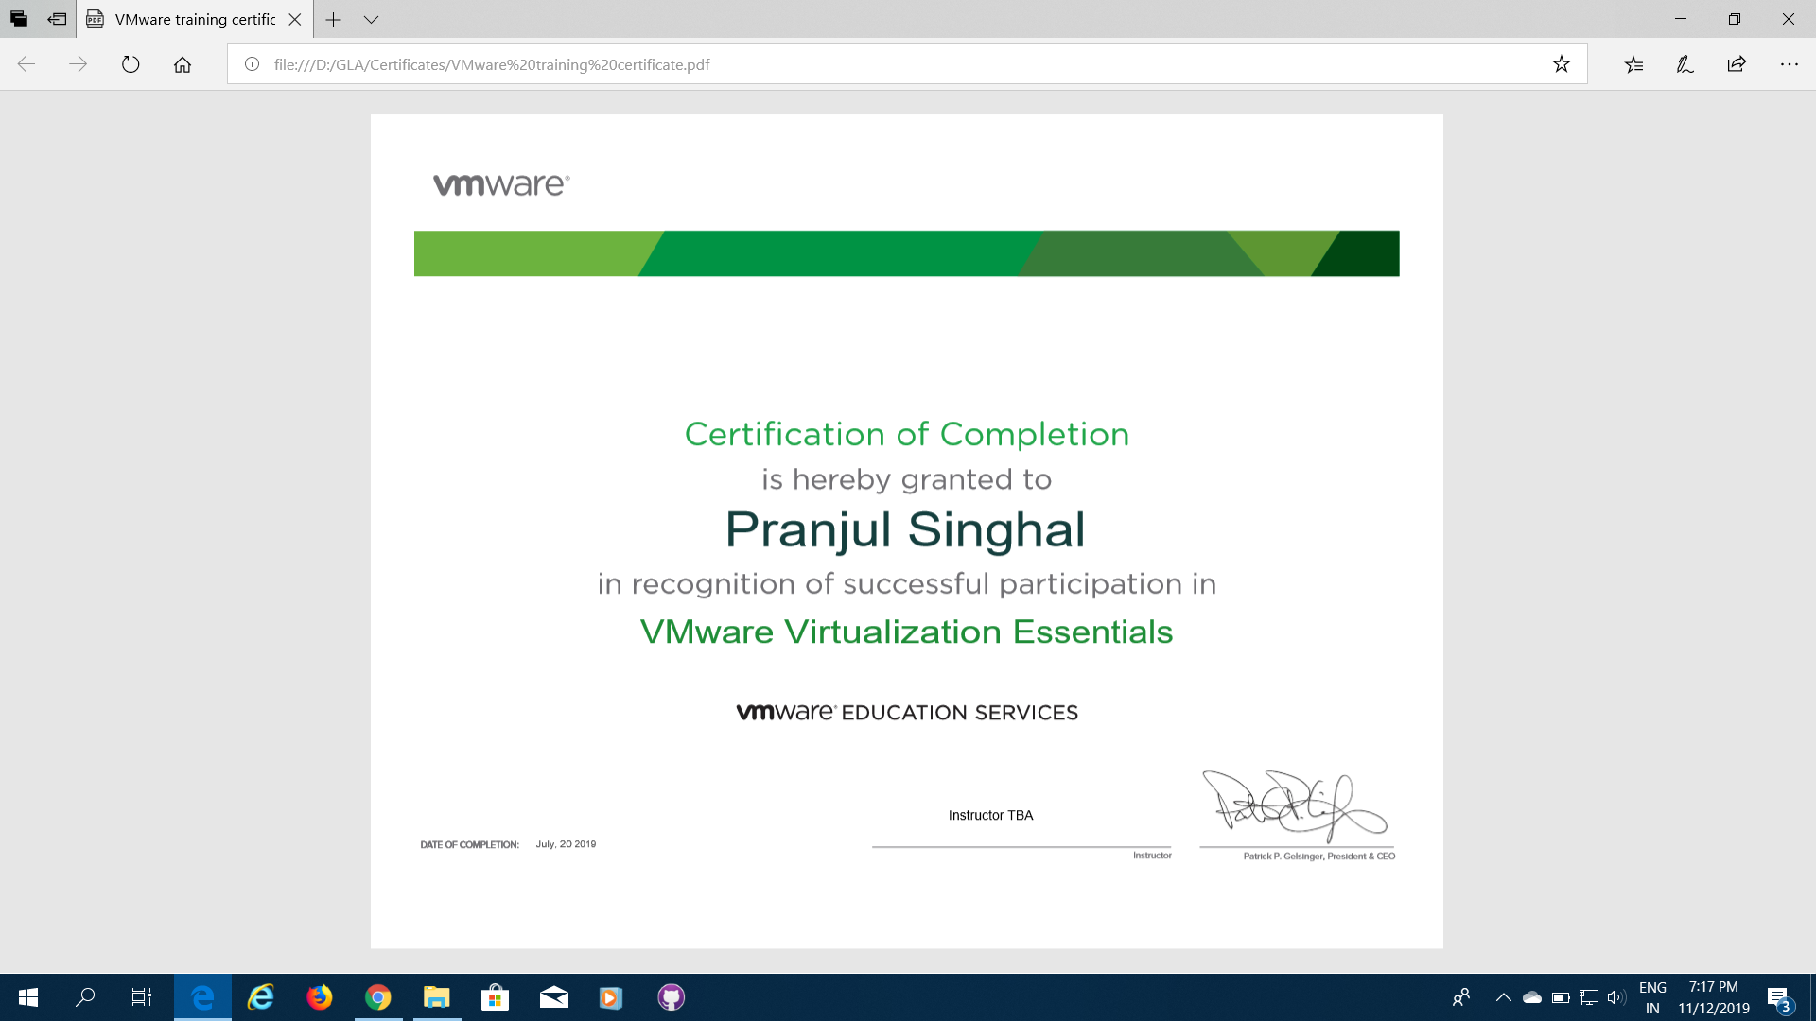

**ACKNOWLEDGEMENT**

The success and final outcome of this project required a lot of guidance and assistance from many people and I am extremely privileged to have got this all along the completion of my project. All that I have done is only due to such supervision and assistance and I would not forget to thank them.

I respect and thank **Mr. Binayak Prasad Gupta**, for providing me an opportunity to do the project work in **VMware** and giving us all support and guidance, which made me complete the project duly. I am extremely thankful to him for providing such a nice support and guidance, although he had busy schedule managing the corporate affairs.

I owe my deep gratitude to my team members, who took keen interest on our project work, till the completion of this project work by providing all the necessary information for developing a good system.

I am thankful to and fortunate enough to get constant encouragement, support and guidance from all Teaching staffs of which helped us in successfully completing our project work.

**ABOUT THE ORGANIZATION**

**VMware**

Vmware, incorporated on February 10, 1998, is an information technology (IT) company. The Company is engaged in development and application of virtualization technologies with x86 server-based computing, separating application software from the underlying hardware. The Company offers various products, which allow organizations to manage IT resources across private clouds and multi-cloud, multi-device environments by leveraging synergies across three product categories: Software-Defined Data Center (SDDC), Hybrid Cloud Computing and End-User Computing (EUC).

Software-Defined Data Center

The SDDC architecture consists of four main product categories: compute, storage and availability, network and security, and management and automation. vSphere, the Company's data center platform, provides the fundamental compute layer for VMware environments. A hypervisor is a layer of software that resides between the operating system and system hardware to enable compute virtualization. Users deploy the vSphere hypervisor when they purchase vSphere, Cloud Foundation or suite versions that include vSphere, such as VMware vCloud Suites and vSphere with Operations Management (vSOM).

Storage and Availability

The Company's storage and availability products serve as hyper-converged infrastructure solutions designed to enable customers to deploy a range of hardware solutions. Hyper-converged infrastructure solutions in this area include vSAN, provides clusters server disks to create shared storage designed for virtual machines.

Network and Security

The Company's Network and Security products provide Network virtualization, which abstracts physical networks. The Network and Security products manage the provisioning and consumption of networking resources.

**OVERVIEW**

**INSTALLING AND CONFIGURING WINDOW SERVER 2008**

**Install windows server 2008 R2**

**Manage service**

**Troubleshoot related issues**

**CONFIGURING ADDRESSING AND SERVICES**

**IP address concept**

**APIPA**

**Configure dynamic host configuring protocol (DHCP)**

**Troubleshooting the DHCP issues**

**IP config Netsh**

**Tools Used**

VMware Workstation

Microsoft Windows Server 2008

Vmware vSphere client

Vmware viclient

**What is VMware ESXI.**

VMware ESXi is an operating system-independent hypervisor based on the Vkernel operating system that interfaces with agents that run on top of it. ESXi stands for Elastic Sky X Integrated.

ESXi is a type-1 hypervisor, meaning it runs directly on system hardware without the need for an operating system. Type-1 hypervisors are also referred to as bare-metal hypervisors because they run directly on hardware.

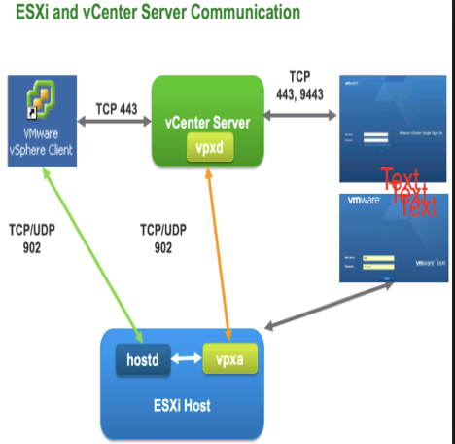

**VMware Workstation**

it is a hosted HYPERVISOR that runs on X64 versions of Windows and Linux operating systems

it enables users to set up virtual MACHINES (VMs) on a single physical machine

supports bridging sharing physical disk DRIVES AND USB DEVICES

includes the ability to group multiple virtual machines in an inventory folder.

**Hypervisor**

A hypervisor is a hardware virtualization technique that allows multiple guest operating systems (OS) to run on a single host system at the same time. The guest OS shares the hardware of the host computer, such that each OS appears to have its own processor, memory and other hardware resources.

A hypervisor is also known as a virtual machine manager (VMM).

TYPES OF HYPERVISOR:

Type 1 hypervisor: hypervisors run directly on the system hardware – A “bare metal” embedded hypervisor

Type 2 hypervisor: hypervisors run on a host operating system that provides virtualization services, such as I/O device support and memory management.

**VMware ESX and ESXi**

* These hypervisors offer advanced features and scalability but require licensing, so the costs are higher.

* There are some lower-cost bundles that VMware offers and they can make hypervisor technology more affordable for small infrastructures.

* VMware is the leader in the Type-1 hypervisors. Their vSphere/ESXI product is available in a free edition and 5 commercial editions.

**Installing and Configuring Windows Server 2008**

Create a new virtual machine.

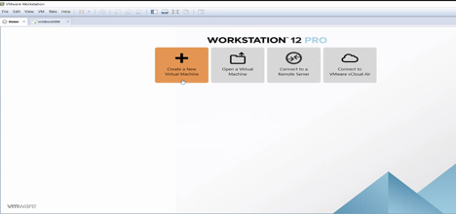

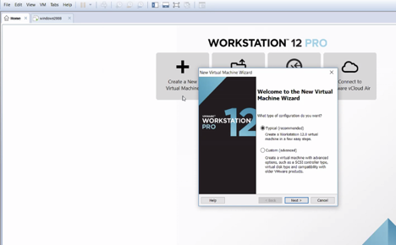

**Name the Virtual Machine.**

**After the installer runs, the Install Windows screen appears.**

**Enter language and other preferences. Click Next.**

**Click Install now. The setup begins.**

**The installer prompts to select an operating system.**

**Enter product key and select Windows server2008.**

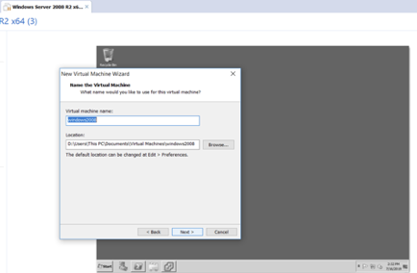

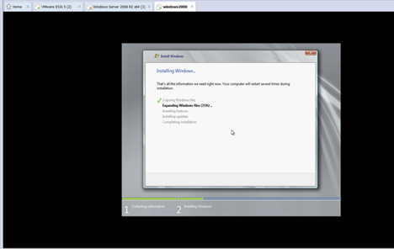

Windows Server2008 is installed in virtual machine

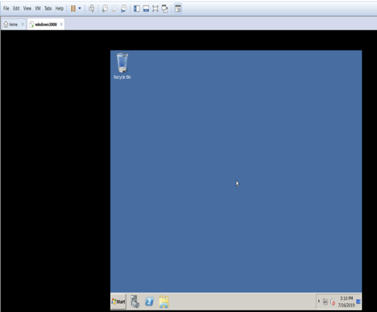

**Manage services**

The File Server Resource Manager (FSRM) is a part of the File Services Role in Windows Server that gives you greater control over the data stored on your file servers.

**You can use FSRM to perform the following tasks**

Limit the size of a folder to 2GB and log an event when the Quota limit is reached.

E-mail an administrator whenever a specific folder reaches 85% of its specified Quota.

Create a File Screen to prevent users from saving of video/audio files to a share and send notifications when users attempt to do that.

Schedule and publish a periodic storage reports that shows how much space is being used by each user.

Generate an instant storage reports to list the largest files on a share.

Automatically execute a script when a folder size exceeds 500 MB to clean up stale data in the folder.

To install FSRM, open the “Server Manager” tool on your file server, right-click the File Server node on the tree and select “Add Role Services”. The “Add Role Services” wizard will start, as shown below:

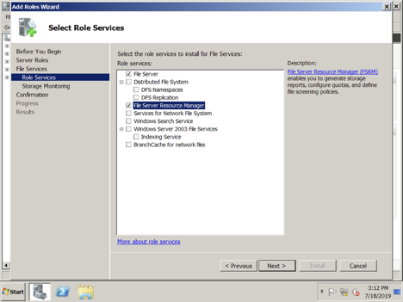

Check the “File Server Resource Manager” box and click “Next”. You will then select the NTFS volumes you want to monitor:

Click on “Options” to see additional options for reports

The screen above shows the standard configuration for a volume, along with the reports that are generated when that threshold is reached.

Select the reports you want, click “OK” to close that window, then click “Next” to continue. This last window before the confirmation lets you specify the folder where the reports are saved and also the e- mail reporting details:

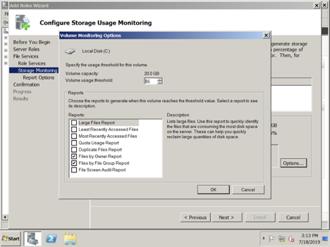

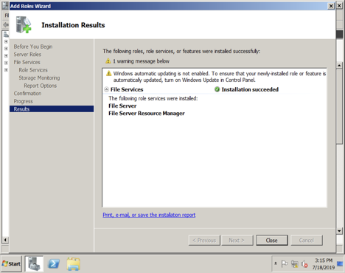

File Service resource manager installed

**File Server Resource Manager MMC**

Click on “Administrative Tools” and select “File Server Resource Manager to launch the FSRM MMC (Microsoft Management Console).

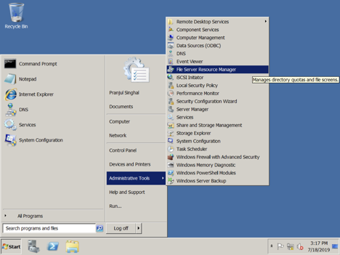

Quotas help you restrict and/or monitor how much space a folder can use.

FSRM can implement both hard Quotas (that actually prevent the users from adding more files, as if the disk were full) and soft Quotas (which only generate events and warnings).

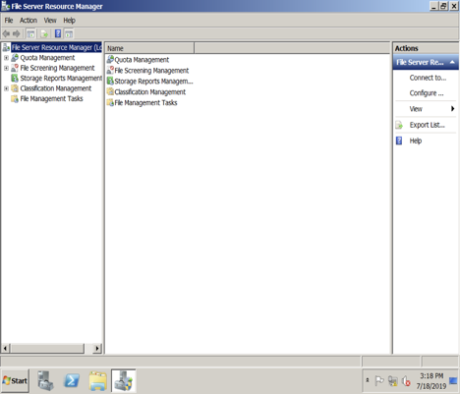

To add more Quota restrictions, click on the “Create Quota…”

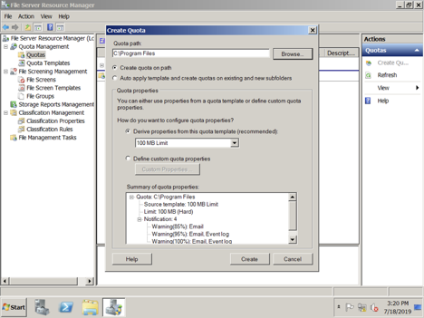

Quotas are always placed on a folder. You have the choice of basing your Quota on a template or defining a custom one.

In addition to specifying the space limit (hard or soft), you can also create different thresholds, with different actions. The sample above sends e-mail alerts at 85%/95%/100% and logs events at 95%/100%. If you click on the “Add…” button, you can see the configuration options for each threshold.

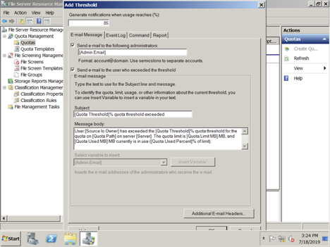

Instead of specifying custom Quotas folder by folder, you can use standard FSRM Quota templates or define your own templates.

**File Screening Management**

File Screening helps you restrict and/or monitor which file extensions can be used on your file server. FSRM can provide both active screening (block file with certain extensions) or passive screening (monitor file extensions without blocking).

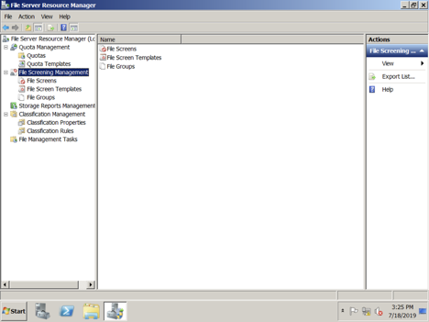

To add a File Screen, click on the “Create File Screen…” action

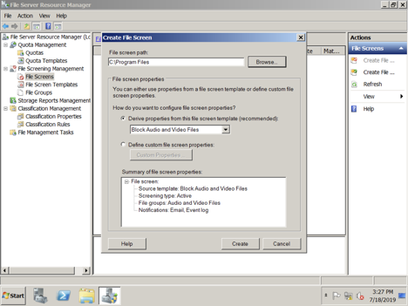

As with Quotas, FSRM supplies some predefined File Screen Templates. You can also opt to define your own File Screening properties

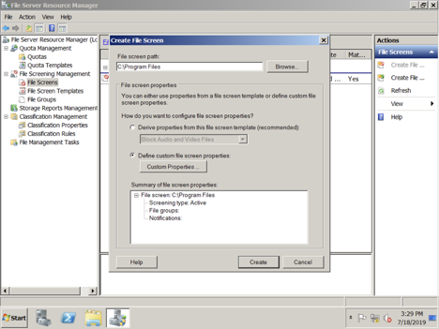

Once you click on “Custom Properties”, you will see the window below

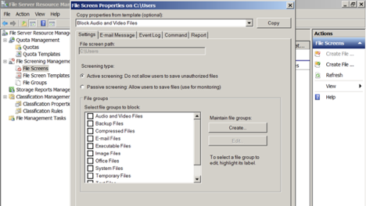

The basic properties include the path to monitor, the type of monitoring (active or passive), the file groups to block/monitor and the specific actions to take You can also create your own File Screening Templates, just like with Quota Templates.

FSRM includes a list of pre-defined File Groups

You can use those, modify them or create your own File Groups

One important feature of FSRM is the ability to provide many reports associated with File Server Management to make your life simpler when managing your file server. Those reports include Files by Group, Files by Owner, Large Files, Most Recently Accessed Files and Duplicate Files, just to mention a few.

Reports can be generated manually, on a scheduled or triggered by a Quota or File Screen. They can also be generated in different formats (see options on the screen below) and are delivered to a folder defined when you installed the role service.

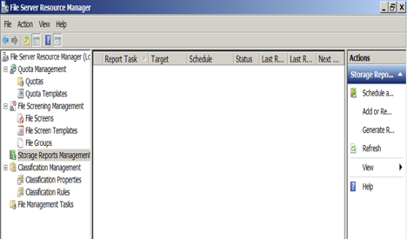

**DHCP Client services**

DHCP Client Service gives Access Denied error. DHCP Client is available as a service and passes configuration information like IP address, Mac address, domain name, etc. to the computer. If this service stops or the OS is not able to access it, the computer will not receive dynamic IP addresses and DNS updates.

DNS

DNS, which is responsible for resolving domain names to IP addresses, isn’t just the name resolution system that underpins the global Internet—it’s also a critical component in Windows Active Directory (AD) for locating network resources.

**Configuring Addressing and Services**

Assigning IP Addresses:

1. Go to 'Control Panel'

Click 'Start -> Control Panel'

*2. Go to 'Network and Internet'*

Click 'View Network status and tasks'

3. Go to 'Setting Adapter'

Click 'Change Adapter settings'

4. Go to Adapter Properties settings

Right click on 'Local Area Connection' and click on 'Properties'

5. Go to TCP/IP settings

Click on 'Internet Protocol Version 4 (TCP/IPv4)' to highlight and select this item and then click on 'Properties'.

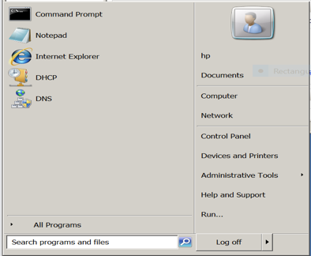

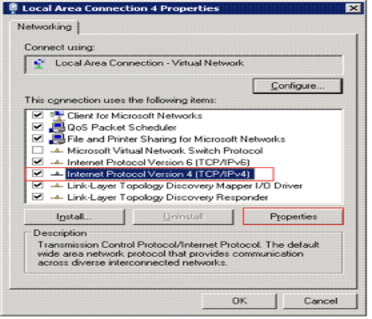

6. Enter correct IP information and click ok

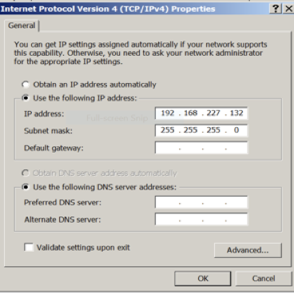

**APIPA:**

When a Windows computer failed to get a valid IP address from DHCP server, OS will automatically assign a Windows generated Automatic Private IP address called APIPA to it. This automatic Private IP address is in the range 169.254.0.1 to 169.254.255.254. In a nutshell, we can say any IP address in the range (169.254.X.X) is APIPA and it shows your computer is not connected to any network.

1.Release and Renew IP Address

When you notice APIPA on your computer, first tries to release and renew the IP address from command prompt. It will prompt your computer to contact the DHCP server and renew the current IP address.

* + ipconfig/release
  + ipconfig/renew

2.Restart your computer

3.Assign Static IP Address

If your laptop does not change 169.254.x.x addressing, assign static IP to it according to the network address of DHCP server. For example, if the address of DHCP server is 192.168.1.1, you can assign a static IP address in between 192.168.1.2 to 192.168.1.254. You must make sure don't assign a number which is used by other devices connected to the DHCP server.

4. Ping the default gateway.

**Configure Dynamic Host Configuration Protocol (DHCP):**

DHCP or Dynamic Host Configuration Protocol is a service that provides IP, DNS and other information to clients or devices. I guess every network now has a DHCP server, since administrators don’t have to go any more to clients and open the network adapter properties to configure the IP, gateway and DNS settings. With DHCP all this is handled automatically, plus you don’t have those IP address conflicts any more. Installing and configuring DHCP on a Windows 2008 R2 server is easy and straight forward. DHCP can run without problems on a Domain Controller in small environments, but for this guide I will use a separate server joined to a domain.

To start, open Server Manager, right-click Roles and choose Add Roles.

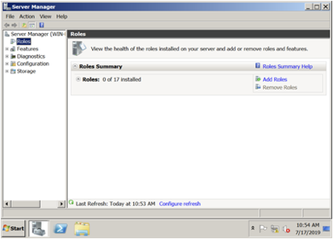

On the Select Server Roles page check the box next to DHCP Server then click Next.

On the Network Connection Bindings page select the adapter that DHCP will use to listen for clients’ request. In this case I have only one network adapter so I’ll just continue the wizard.

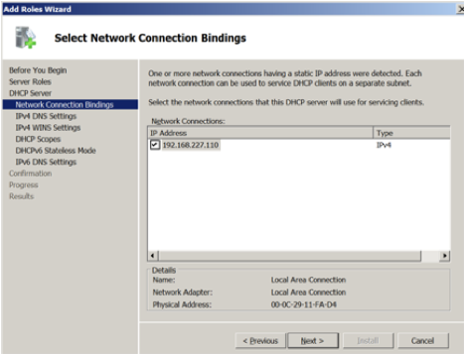

Type the name of your domain in the Parent Domain box, then complete the preferred and alternate DNS boxes with your own DNS servers IP addresses.

Click the Add button to create our first scope. A scope is a range of IP addresses and gateway configuration that DHCP will provide to clients. Give the scope a name, provide the IP rage addresses and gateway information, then click OK. If you leave (and I recommend) the Activate this scope option enabled, DHCP will automatically activate with Active Directory. A Windows DHCP server to function needs to be authorized with AD, or will not provide IP addresses to clients.

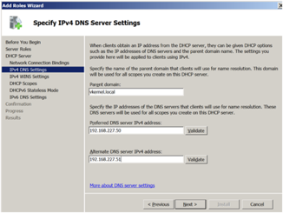

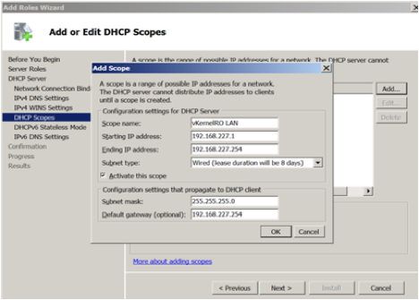

**Troubleshooting the DHCP issues:**

Now you can either user the DHCP snap-in from Server Manager or open the DHCP standalone console from Administrative Tools.

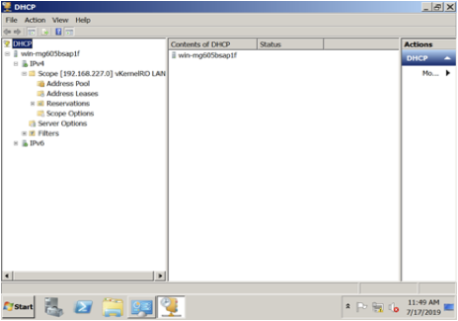

If you click on the Address Pool object you can see the IP address range we configured during the wizard. Sometimes you want to exclude some IP addresses, so the DHCP server will not issue them to clients. For that just right-click the Address Pool object and choose New Exclusion Range. I will exclude my gateway and DNS servers.

If you click the Address Leases object you can see what IP addresses were leased to clients, and the clients details.

On the Reservations object you can add or see the reserved IP addresses. These addresses will never expire, and clients will always have the same IP address.

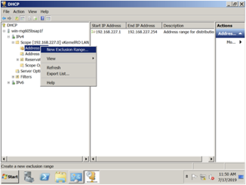

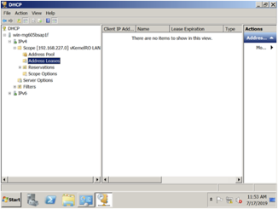

In the Scope Option you can see and change other settings like DNS servers, gateway etc.

**Ip Config:**

Now if I go at my client and do an ipconfig /all I will see all this setting that are configured on this scope.

Netsh:

Microsoft Windows netsh is a command line scripting utility. With Netsh, you can view or change the network configuration of your local computer or a remote computer. You can manually run Netsh commands or you can create batch files or scripts to automate the process. Not only can you run these commands on your local computer but also on remote computers, over the network.

If you run **netsh** you will see that you can supply the remote machine name & IP address and credentials for the remote machine you will run netsh against.

With netsh, exporting and importing your IP address configuration is easy – unlike in the GUI interface. To export your configuration, just do:

*netsh –c interface dump > test*

**Conclusion**

This project introduced the Dynamic Host Configuration Protocol (DHCP), **DHCP** is a protocol which assigns IP to the hosts in a network be it statically or dynamically.

Now that we've completed this project, we should be able to:

1. In this project we installed windows server2008 in virtual machine using VMware Workstation
2. We managed different services in windows server2008
3. Troubleshoot Services Related issues.
4. Install and configure DHCP
5. Troubleshooting the DHCP issues
6. IP Configuration