*SOFTWARE ENGINEERING CONCEPTS – LAB MANUAL*

***Prannov Shabari N***

***220701197***

Overview of the Project 2

Business Architecture Diagram 3

Requirements as User Stories 4

Architecture Diagram depicting the 5

Test Strategy 6

Deployment Architecture of the application 7

Overview of the project:

**Problem Statement:**

The project aims to bridge the communication gap between individuals who use sign language or gestures as their primary means of communication and those who do not understand these languages. It targets the challenge of inclusivity and accessibility for individuals with hearing or speech impairments by providing a real-time translation of gestures into spoken or written language.

**Data Perspective**:

The system relies on two main types of data: gesture data and language data. Gesture data includes video recordings or motion capture data of individuals performing sign language or other gestures. This data is used to train machine learning models to recognize and interpret different gestures accurately. Language data consists of spoken and written language samples corresponding to the translations of various gestures. This data is used to train models for translating gestures into spoken language or text.

**Benefits to Users:**

1. Improved Communication Accessibility: By translating gestures into spoken or written language in real-time, the system enables individuals who use sign language or gestures to communicate effectively with people who do not understand these languages, thus promoting inclusivity and accessibility in various settings.

2. Enhanced Social Interaction: The system facilitates smoother and more natural interactions between individuals with hearing or speech impairments and those without, fostering better understanding and communication in social, educational, and professional environments.

3. Empowerment: For users who rely on sign language or gestures, the system provides a tool for expressing themselves more freely and independently, reducing dependency on interpreters or intermediaries for communication.

4. Efficiency: By automating the translation process, the system reduces the time and effort required for communication between individuals who speak different languages or use different communication modalities, leading to more efficient and productive interactions.

5. Customization and Personalization: The system can be tailored to support different sign languages and gestures, as well as multiple spoken or written languages, allowing for personalized communication experiences based on the users' preferences and needs.

6. Educational Resource: The system can serve as an educational tool for learning sign language or gestures, providing real-time feedback and translations to help users improve their communication skills and understanding of different languages and cultures.

In conclusion, the implementation of this Gesture Language Translator project addresses the communication barriers faced by individuals who use sign language or gestures, promoting inclusivity, accessibility, and empowerment through real-time translation and interpretation of gestures into spoken or written language.

Business architecture diagram:

**Business Need**:

The business need for the Gesture Language Translator project arises from the necessity to facilitate communication between individuals who use sign language or gestures and those who do not understand these languages. By providing a real-time translation of gestures into spoken or written language, the system aims to bridge the communication gap and promote inclusivity and accessibility in various social, educational, and professional settings.

**Current Process**:

Currently, communication between individuals who use sign language or gestures and those who do not typically relies on manual interpretation by human translators or intermediaries. This process involves the following steps:

1. Manual Interpretation: Individuals who use sign language or gestures communicate their messages to interpreters proficient in sign language.

2. Translation: Interpreters translate the gestures into spoken language or text for the benefit of those who do not understand sign language.

3. Communication: The translated message is conveyed to the intended recipient verbally or in written form.

**Business Problems**:

1. Dependency on Interpreters: The current process relies heavily on human interpreters, leading to delays and potential misinterpretations due to human error.

2. Limited Accessibility: Individuals who use sign language or gestures may face barriers to communication in environments where interpreters are not readily available or accessible.

3. Inefficiency: Manual interpretation and translation processes can be time-consuming and inefficient, especially in scenarios with multiple communication participants or in time-sensitive situations.

4. Cost: Hiring interpreters for communication assistance incurs significant costs, especially for businesses or organizations with frequent communication needs.

5. Dependency on Specific Languages: The availability of interpreters proficient in specific sign languages or gestures may be limited, further hindering effective communication.

6. Inclusivity: The current process may not fully address the communication needs of individuals with hearing or speech impairments, leading to social exclusion and limited participation in various activities.

**Different Personas and Their Current Processes:**

1. Individuals who use sign language or gestures: They rely on manual communication methods such as sign language or gestures to convey their messages. They often face challenges in communicating with individuals who do not understand these languages.

2. Interpreters: They act as mediators between individuals who use sign language or gestures and those who do not, translating gestures into spoken language or text. They play a crucial role in facilitating communication but are subject to limitations such as availability and proficiency in specific sign languages.

3. Recipients of communication: They rely on interpreters or intermediaries to understand messages conveyed through sign language or gestures. They may experience delays or misunderstandings in communication due to the reliance on human interpretation.

Requirements as user stories:

### **User Stories:**

**1. As a user, I want to register an account so that I can access the gesture language translator.**

* + **Estimate:** 5 points

**2. As a user, I want to upload videos of gestures so that the system can translate them into text.**

* + **Estimate:** 8 points

**3. As a user, I want to view a history of my translated gestures so that I can review past translations.**

* + **Estimate:** 5 points

**4. As a user, I want to edit the translated text so that I can correct any mistakes made by the translator.**

* + **Estimate:** 5 points

**5. As a user, I want to share the translated text via email or social media so that I can communicate with others easily.**

* + **Estimate:** 3 points

**6. As a user, I want the system to provide suggestions for correcting translation errors so that I can improve accuracy.**

* + **Estimate:** 8 points

**7. As a user, I want to receive real-time translations while performing gestures so that I can communicate instantly.**

* + **Estimate:** 13 points

**8. As a user, I want to customize the language and dialect preferences so that the translations are more accurate for my region.**

* + **Estimate:** 5 points

**9. As a user, I want to access a tutorial or help section so that I can learn how to use the gesture language translator effectively.**

* + **Estimate:** 3 points

**10. As an administrator, I want to manage user accounts and permissions so that I can ensure the system is used appropriately.**

* + **Estimate:** 8 points

### **Non-Functional Requirements (NFRs):**

1. **Performance:** The system must process and translate gestures in real-time with a maximum latency of 2 seconds to ensure smooth and effective communication.
2. **Scalability:** The system should be able to handle up to 10,000 concurrent users without a degradation in performance, ensuring accessibility during peak times.
3. **Security:** User data, including videos and translations, must be encrypted both in transit and at rest, and the system must comply with GDPR for data protection and privacy.

### **Explanation of Estimates:**

* **3 points:** Simple functionalities that require basic implementation and integration.
* **5 points:** Moderate functionalities that involve some complexity and multiple steps.
* **8 points:** Complex functionalities that require significant development effort and integration.
* **13 points:** Highly complex functionalities that may involve advanced algorithms, real-time processing, and integration of multiple systems.

Top of Form

# Architecture Diagram depicting the sign language translator

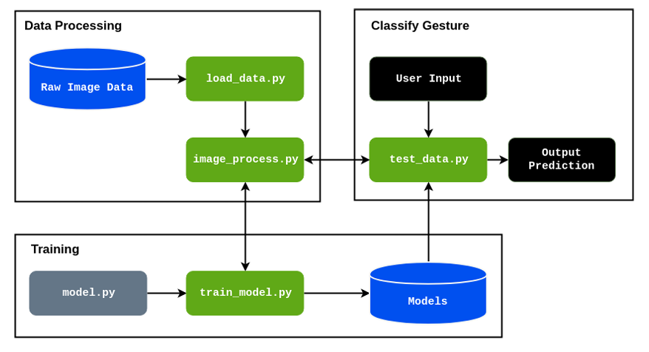

# Class diagrams

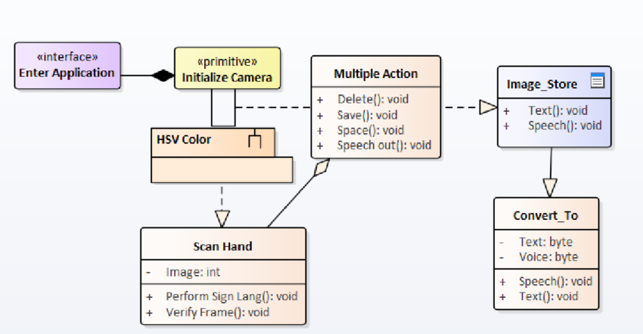

# Sequence diagram

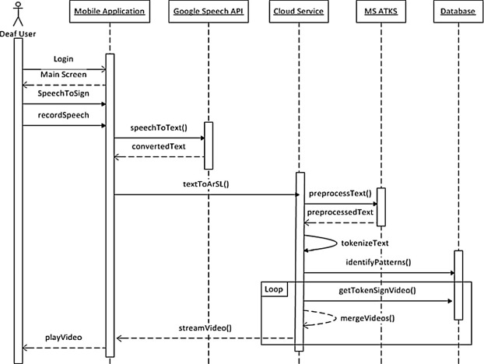

# Test Strategy

test strategy for a sign language translator involves several key steps to ensure its effectiveness and accuracy. Here's a structured approach to developing such a strategy:

1. **Requirement Analysis**:
   * Understand the functional requirements of the sign language translator. Identify its core features, such as real-time translation, accuracy, support for different sign languages, and user interface requirements.
2. **Test Planning**:
   * Define the scope of testing, including the types of testing to be conducted (functional, non-functional, usability, etc.).
   * Identify the testing tools required, such as sign language recognition software, testing frameworks, and devices (e.g., cameras, microphones).
   * Establish test environments for different scenarios, considering factors like lighting conditions, background noise, and distance between the user and the device.
3. **Test Case Design**:
   * Develop test cases covering all functional and non-functional requirements.
   * Include test cases for various scenarios, such as different sign languages, complex hand gestures, speed of signing, and variations in hand positions.
   * Design test cases to validate the accuracy of translations, especially for ambiguous signs or phrases with multiple interpretations.
4. **Test Execution**:
   * Execute test cases in different environments to simulate real-world usage scenarios.
   * Monitor the translator's performance in real-time, focusing on its ability to accurately interpret and translate sign language gestures.
   * Record and analyze test results, noting any discrepancies or areas for improvement.
5. **Usability Testing**:
   * Conduct usability testing with target users, including individuals proficient in sign language.
   * Gather feedback on the translator's user interface, ease of use, and overall user experience.
   * Incorporate user feedback to refine the translator's design and functionality.
6. **Performance Testing**:
   * Evaluate the translator's performance under varying workloads, such as simultaneous translation for multiple users or continuous usage over extended periods.
   * Measure response times and resource utilization to ensure optimal performance.
7. **Security and Privacy Testing**:
   * Assess the translator's security measures to protect user data and ensure secure communication channels.
   * Verify compliance with relevant privacy regulations, such as GDPR or HIPAA, especially if the translator handles sensitive information.
8. **Localization Testing**:
   * Test the translator with users from different cultural backgrounds and linguistic regions.
   * Ensure compatibility with regional sign languages and cultural nuances in signing gestures.
9. **Regression Testing**:
   * Perform regression testing after each update or modification to ensure that new changes do not introduce defects or affect existing functionality.
10. **Documentation**:
    * Document the test strategy, including test plans, test cases, and test results.
    * Provide clear instructions for users and developers on how to use the translator effectively and troubleshoot common issues.

By following these steps, you can develop a comprehensive test strategy for a sign language translator that ensures its reliability, accuracy, and usability across various scenarios and user groups.

# Deployment Architecture of the application

# Overview of the proposed system.