Whenever you open a terminal session (after the project is set up), make sure to always run the command:

source venv/bin/activate

Before you run python from the terminal. If you don’t run the above line, the project will fail to run.

If the terminal closes, you will need to re-run the above command.

If venv has activated successfully, the terminal should have the text (venv) in brackets before the username as visible in the image below:

If the text is present, you should be able to run the project using python3:
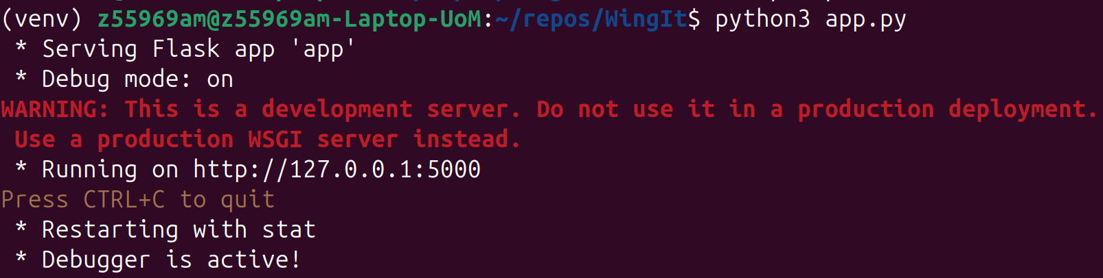
If the ‘(venv)’ text isn’t present, venv has failed to open. This is likely due to some sort data corruption, or you may be in the wrong directory – you must be in the project root directory!
If this fails and you’re in the right location then:
Firstly, close the terminal to clear any inner variables. After this, remove the broken venv directory. You can do this by deleting it via a linux files application. You can also run the command in the terminal:
rm -rf venv
WARNING: Make sure you are in the correct directory of the WingIt project repository, as it will permanently delete the file or directory named ‘venv’ in the current location.

After this is deleted, recreate the virtual environment folder:
python3 -m venv venv

Then activate the virtual environment, using the steps at the beginning of this document to verify that this has worked:
source venv/bin/activate

Then use pip to install all required modules in the virtual environment:
pip install -r requirements.txt

You should then be able to run the project correctly using the line:
python3 app.py

