**MongoDB-Aggregation Exercise**

**Atlanta Population**

1)

first.png

2)

second.png

3)

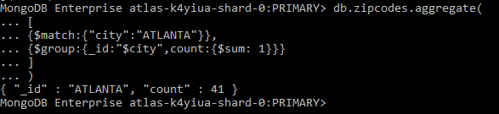

4)

4th.PNG

**Population By State**

1)

5TH.PNG

2)

6th.PNG

3)

7th.PNG

**Population By City**

1)

8th.PNG

2)

9th.PNG

3)

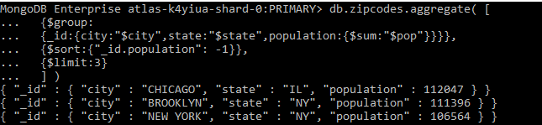

4)



**Bonus**

1)

12th.PNG

2)

last.PNG