**E-commerce Summary**

**Introduction:**

Target Sales Company manages a vast dataset containing detailed information on Sales, orders, customers, products, regions and delivery analysis. The project focuses on extracting meaningful insights from this data to support strategic decision making. Using advanced SQL queries for extraction and visualization tools like Power BI, key business questions were addressed, trends were identified, and actionable insights were presented effectively to enhance decision making processes.

**Sales Performance Analysis:**

**How much total money has the platform made so far, and how has it changed over time?**

**Query to find highest Sale in City**

**Which product categories are the most popular, and how do their sales numbers compare?**

**What is the average amount spent per order, and how does it change depending on the product category or payment method?**

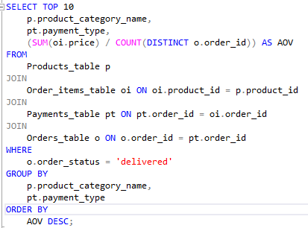

**Identify customers with the highest average order value (AOV). = ((sum)Total revenue/(count)Total no of orders)**

**How many active sellers are there on the platform, and does this number go up or down over time?**

**What do seller ratings look like overall, and do higher ratings lead to better sales?**

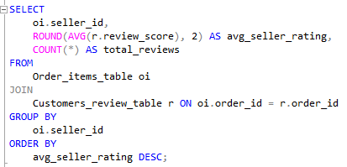

**checking relation with higher ratings and sales**

**Which products sell the most, and how have their sales changed over time?**

**Find the most loyal customers by calculating their purchase frequency (Total no of orders/ distinct (total no of customers) and total spend.**



**Analyse delivery performance by calculating the average delivery time by region**.

**Identify regions or products with the highest delivered rates. = (No. of Orders delivered/ Total no of orders places) * 100**

**Analyse the seasonality of sales to identify peak months.**

**Project Overview**

The analysis utilized **MS SQL** for data extraction and manipulation, combined with **Power BI** for data visualization and dynamic reporting. The aim was to extract actionable insights to support e-commerce decision-making.

**Key DAX Queries:**

* **Revenue Metrics:**
  + Total_Revenue = CALCULATE(SUM(order_items[price]), FILTER(orders, orders[order_status] = "delivered" && NOT(ISBLANK(orders[order_delivered_customer_date]))))
* **AOV:**
  + AOV = DIVIDE([Total_Revenue], CALCULATE(COUNTA(orders[order_id]), orders[order_status] = "delivered" && NOT(ISBLANK(orders[order_delivered_customer_date]))))
* **Delivery Metrics:**
* Average_Delivery_Time = CALCULATE(AVERAGE(orders[Delivery_Time_in_days]), orders[Delivery_Time_in_days] <> BLANK())
* **Loyalty Factor:**
* Loyalty_Factor = [Purchase_Freq] * [Spend_Per_Customer]
* Purchase_freq =

IF(ISBLANK(CALCULATE(COUNT(Order_items_table[order_id]), ALLEXCEPT(Customers_table,Customers_table[customer_id]))),0, CALCULATE(COUNT(Order_items_table[order_id]), ALLEXCEPT(Customers_table,Customers_table[customer_id])))

* Spend_per_Customer = IF(ISBLANK(CALCULATE(SUM(Order_items_table[price]), ALLEXCEPT(Customers_table,Customers_table[customer_id]))),0, CALCULATE(SUM(Order_items_table[price]), ALLEXCEPT(Customers_table,Customers_table[customer_id])))
* **Delivery_Time_in_Days:**
* IF(AND(Orders_table[order_status]="delivered",Orders_table[order_delivered_customer_date] <> BLANK()),

DATEDIFF(Orders_table[order_purchase_timestamp],Orders_table[order_delivered_customer_date],DAY),BLANK())

**Findings and Insights**

1. **Revenue Trends:**
   * Total revenue: **$13.22M**, consistent growth in revenue over time.
   * With an Average Order Value (AOV) of **$137.04**, AOV reflects healthy spending behaviour.
   * **Beauty and Health** is the top product category, contributing **($1.23M)** with AOV of **$12.78** the most to revenue.
2. **Customer Insights:**
   * Loyal customers show high purchase frequency and contribute significantly to revenue.
   * Top 10 customers were identified using the Loyalty Factor, combining purchase frequency and spending metrics.
   * Targeted campaigns can boost retention and engagement.
3. **Product Delivery Efficiency:**
   * Average delivery time: **12.50 days**, with delays in some regions.
   * High delivery success rates in certain regions correlate with customer satisfaction.
   * Peak sales months patterns identified for targeted planning.
4. **Order Insights:**
   * Total products ordered: **113K**, with **542** cancellations, highlighting areas for improvement in order handling.
   * Strategic seasonal marketing campaigns during peak months to maximize sales.
5. **Reviews and Rating**

* Average review score is **4.09**
* Products with **both high ratings and a high number of reviews** show significantly better sales performance.
* **High ratings alone** do not guarantee strong sales if the **review count is low**.
* This suggests that **review volume builds trust** and acts as a key factor in influencing purchase decisions

**Conclusion:**

* Revenue is strong and consistent growth in revenue over time.
* Customer loyalty and product reviews are key drivers of performance.
* Run targeted campaigns for top customers, also focus on one time buyer we can offer them some discount and coupons so that they can buy frequently, easily convert them into loyal customers.
* Peak months to maximize sales is in between March to November.
* Improving delivery in underperforming regions.
* High priced product categories should be strategically optimized through pricing adjustment, promotions, or value communication to enhance accessibility for customer and drive increased sales performance.