Division of Electronics and Communication Engineering 2026-2027 (ODD SEM)
III IA EVALUATION REPORT
for
COMPUTER NETWORKS – PROJECT BASED COURSE
Title of the project: “Design and Implementation of a Simple File Transfer Application Using TCP Socket Programming”
A report submitted by
Name of the Student | SHIVABALAN K.B  PRANOV RAGHAVENDHRA.MD
Register Number | URK23EC1055  UTK23EC1001
Subject Name | COMPUTER NETWORKS
Subject Code | 18EC2017
Date of Report submission | 30/10/2026
Project Rubrics for Evaluation
First Review: Project title selection – PPT should have four slides (Title page, Introduction, Circuit/Block Diagram, and Description of Project).
Second Review: PPT should have three slides (Description of Concept, implementation, outputs, results and discussion).
Total marks: / 40
Marks Signature of Faculty with date:

TABLE OF CONTENTS
CHAPTER | TITLE | PAGE NO.
1. | ABSTRACT | 3
2. | INTRODUCTION | 4
3. | DESCRIPTION OF THE PROJECT | 6
4. | CONCEPT INVOLVED | 8
5. | SYSTEM PARAMETERS AND PROTOCOL DATA | 10
6. | TOOLS USED | 12
7. | IMPLEMENTATION | 13
8. | RESULTS WITH DISCUSSIONS | 16
9. | INFERENCES | 18
10. | CONCLUSION | 19
11. | REFERENCES | 20

CHAPTER 1
ABSTRACT
This project presents the design and implementation of a simple peer-to-peer file transfer application that uses Python TCP socket programming to move files between two computers on the same local network. The application is accessed through a browser-based interface served by a lightweight FastAPI web server, so the user does not need any specialised client software.
The transfer is carried out with an application-level protocol built on top of TCP. The sender first transmits file metadata (file name, file size and a SHA-256 checksum), the receiver validates it and replies with an acknowledgement, the file is then streamed in fixed 4096-byte chunks, and finally the receiver confirms success or failure after verifying the size and the checksum.
Important networking concepts are demonstrated in a working system: the TCP three-way handshake, connection-oriented communication, length-prefix message framing, handling of partial reads, acknowledgements and integrity verification. The receiver also protects itself against unsafe file names and never overwrites an existing file.
The application was tested on localhost with text files and binary files of 1 KB, 500 KB and 5 MB, and with error cases such as a receiver that is not running and duplicate file names. All tests passed and the received files matched the originals bit for bit.
CHAPTER 2
INTRODUCTION
Computer networks allow independent machines to exchange data. When two users on the same Wi-Fi network want to share a file, the common solutions are cloud storage, e-mail or removable drives. Cloud services need internet access and a third-party server, e-mail limits the attachment size, and a pen drive needs physical contact. A direct transfer over the local network avoids all of these problems.
The Transmission Control Protocol (TCP) works at the transport layer of the OSI model and provides reliable, ordered and error-checked delivery of a byte stream. These properties make TCP the natural choice for file transfer, because even one missing or corrupted byte can make a file unusable.
A socket is the programming interface through which an application uses TCP. A socket is identified by an IP address and a port number. In this project the Python standard library module socket is used to create a listening server on the receiving computer and a client on the sending computer.
Since a web browser cannot open raw TCP sockets, a FastAPI backend is placed between the browser and the network. The browser talks to the local backend over HTTP, and the backend talks to the remote receiver over TCP. This gives the user a simple graphical interface while the core data transfer still uses real socket programming.
2.1 Background
Data communication between computers is organised into layers. The application layer holds programs such as web browsers and file transfer tools, the transport layer (TCP or UDP) provides end-to-end delivery between processes, the network layer (IP) moves packets between networks, and the lower layers send bits over the physical medium. A file transfer program normally sits at the application layer and relies on the transport layer for delivery.
Layer | Protocol / Item | Role in this project
Application | Custom file transfer protocol | Metadata, ACK, chunks, SUCCESS / FAILURE
Transport | TCP | Reliable, ordered byte stream
Network | IP (IPv4 address) | Addresses the receiving computer
Link / Physical | Wi-Fi or Ethernet | Carries frames on the local network
Table 2.1 Layers involved in the file transfer
2.2 Motivation
Students, teams and small offices often need to move large files between two machines on the same network. Cloud storage consumes internet bandwidth and uploads private data to a third party, e-mail rejects large attachments, and removable drives need physical access. A direct transfer over the local network is faster, private and independent of the internet.
Building such a tool is also an effective way to understand how real networked software works. Writing the sender and receiver from the socket level forces the designer to deal with the practical issues that textbooks describe: connection set-up, message boundaries, partial reads, timeouts, error recovery and data verification.
2.3 Why TCP and Not UDP
Feature | TCP | UDP
Connection | Connection-oriented | Connectionless
Delivery | Guaranteed, retransmitted | Not guaranteed
Ordering | Preserved | Not preserved
Speed | Slightly slower | Faster
Suitable for | File transfer, web, e-mail | Streaming, games, DNS
Table 2.2 Comparison of TCP and UDP
A file is useful only if every byte is correct. With UDP a lost datagram would silently damage the file and the application would have to build its own retransmission and ordering. TCP already provides these services, so it is the correct choice for this project.
2.4 Scope of the Project
The project covers transfer of a single file at a time between two computers on the same local area network. It includes the sender, the receiver, the application protocol, the browser interface and the test procedure. Encryption, authentication and transfer across the internet through routers and firewalls are outside the scope and are listed as future work.
CHAPTER 3
DESCRIPTION OF THE PROJECT
3.1 Problem Statement
To transfer a file directly from one computer to another on the same local network, without using cloud services, and to confirm that the file arrived completely and correctly.
3.2 Objectives
- To implement TCP socket based file transfer using the Python standard socket library.
- To design a simple application-level protocol with metadata, acknowledgements and checksums.
- To provide a browser-based interface for sending and receiving files.
- To handle errors such as connection failure, corrupted data and duplicate file names.
- To verify file integrity using SHA-256.
3.3 Features
- Send a file by choosing it in the browser and entering the receiver’s IP address and port.
- Receive files by starting a TCP listener with a chosen destination folder.
- Real-time progress bar on both the sending and the receiving side.
- SHA-256 integrity check for every received file.
- Duplicate protection: an existing file is never overwritten; a numbered suffix is added.
- Persistent transfer history with file name, size, direction, time and status.
3.4 System Architecture
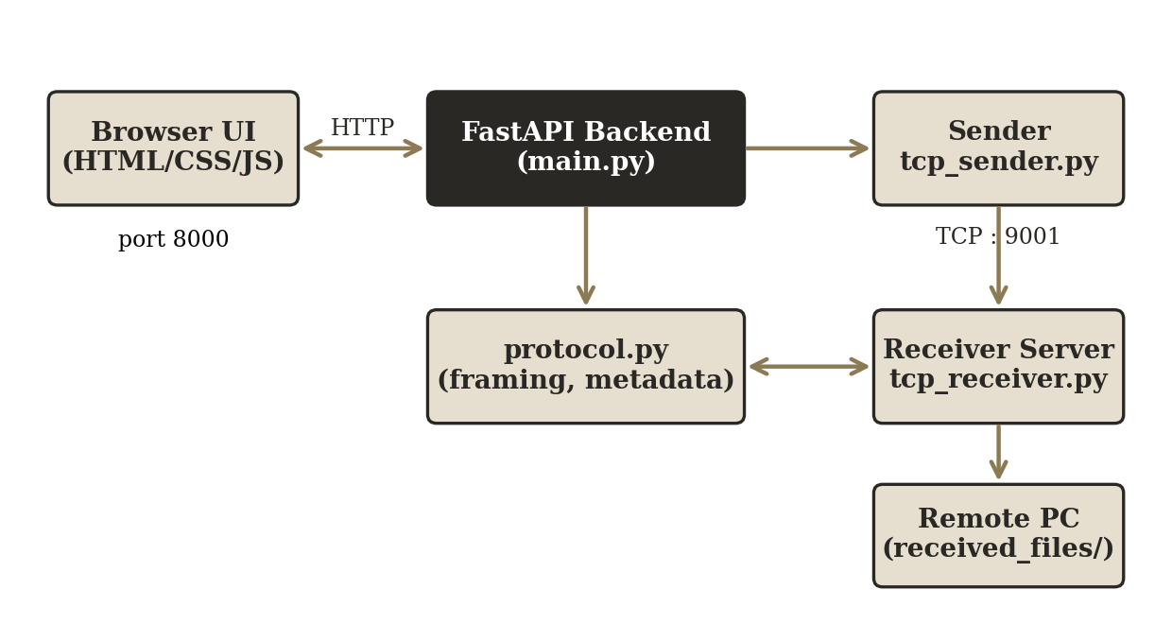
Fig. 3.1 System architecture of the file transfer application
The browser sends the selected file to the FastAPI backend over HTTP (port 8000). The backend calls the TCP sender, which connects to the receiver’s TCP server (default port 9001). On the other computer, the receiver server runs in a background thread, saves the file and reports events that the browser reads by polling.
3.5 Requirements
The functional and non-functional requirements of the application are summarised below.
Type | Requirement
Functional | Select a file, enter the receiver IP address and port, and send it
Functional | Start and stop a receiver on a chosen port and folder
Functional | Show progress and a final success or failure message
Functional | Keep a history of sent and received files
Non-functional | Reliability: the received file must be identical to the original
Non-functional | Safety: unsafe file names rejected, no overwriting
Non-functional | Usability: operated entirely from a web browser
Non-functional | Robustness: timeouts and clear error messages
Table 3.1 Requirements
3.6 Working Procedure
The complete operation can be understood as two cooperating procedures, one on each computer.
Receiver side: The user opens the web page, selects a destination folder and a listening port (default 9001) and clicks Start Receiving. The backend creates a TCP server socket, binds it to all interfaces, and starts a background thread that waits for connections. The page shows that the receiver is listening.
Sender side: The user opens the web page on the other computer, chooses a file, types the receiver’s IP address and port and clicks Send File. The browser uploads the file to the local backend, which computes the SHA-256 checksum, connects to the receiver, and runs the transfer protocol described in Chapter 5 and Chapter 7.
Completion: When the receiver has verified the size and checksum it sends SUCCESS. Both computers show a success message and record the transfer in the history table. If anything goes wrong, a failure message with the reason is shown and the partial file is removed.
3.7 User Interface
The interface is a single web page with three areas. The Receive a File area holds the destination folder, the port number and the Start Receiving and Stop buttons together with a status indicator. The Send a File area holds the file picker, the receiver IP address, the port and the Send File button with a progress bar. The Transfer History table lists every transfer with its direction, file name, size, time and status. A separate How It Works page explains the protocol for learners.
CHAPTER 4
CONCEPT INVOLVED
4.1 Transmission Control Protocol
TCP is a connection-oriented transport protocol. Its main properties are listed below.
Property | Meaning
Reliable delivery | Lost packets are retransmitted automatically
Ordered delivery | Data arrives in the same order in which it was sent
Error detection | Checksums detect corrupted segments
Flow control | A fast sender cannot overwhelm a slow receiver
Congestion control | Sending rate is reduced when the network is congested
Table 4.1 Properties of TCP
4.2 Three-Way Handshake
Before any data is sent, TCP establishes a connection using three messages: the client sends SYN, the server replies with SYN-ACK, and the client answers with ACK. In this project the operating system performs the handshake when the sender calls connect().
4.3 Socket Programming
The receiver creates a socket, binds it to an address and port, listens and accepts connections. The sender creates a socket and connects to the receiver’s address. Data is sent with sendall() and read with recv().
4.4 Partial Reads and Message Framing
TCP is a byte stream and has no message boundaries. A single recv() call may return fewer bytes than requested. To solve this, the project uses a helper function recv_exact() that keeps reading until exactly the required number of bytes has arrived, and length-prefix framing in which every control message is preceded by a 4-byte big-endian length field.
4.5 SHA-256 Integrity Check
SHA-256 produces a 256-bit (64 hexadecimal character) digest of the data. Any change in the input, even a single bit, gives a completely different digest. The sender computes the digest before sending and the receiver recomputes it after receiving; if the two values differ, the file is reported as corrupted.
4.6 Client–Server Model
The two programs play different roles. The receiver is the server: it opens a socket, waits for a connection and serves each incoming transfer. The sender is the client: it initiates the connection to a known address and port. Since the same application is installed on both computers, any computer can act as sender or receiver, which gives the project its peer-to-peer character.
4.7 IP Address and Port Number
An IP address identifies a computer on the network, for example 192.168.1.5, and a port number identifies one application on that computer. The pair (IP address, port) forms a socket address. The receiver in this project listens on port 9001 and the web interface uses port 8000. Port numbers from 1024 to 65535 are normally free for user programs. On Windows the IP address of the receiver can be found with the command ipconfig.
4.8 Why the File is Sent in Chunks
Reading a complete file into memory before sending it would fail for large files. The sender therefore reads the file in blocks of 4096 bytes and sends each block in turn. The receiver reads the same amount, writes it to disk and updates the running hash. In this way memory use stays small and constant, whatever the size of the file, and progress can be reported after every block.
4.9 Multithreading
A server that handled a transfer inside its accept loop could not respond to anything else during that time. The receiver therefore runs the accept loop in a background thread and creates a new thread for each connection. The web server stays responsive, so the browser can keep polling the progress while the data is arriving.
4.10 Timeouts and Error Recovery
Network operations can block forever if the other side disappears. Socket timeouts are used so that a stalled connection is detected and reported. If the connection ends before all the bytes of the file have arrived, the receiver removes the incomplete file and sends FAILURE, so an unusable half file is never left on the disk.
CHAPTER 5
SYSTEM PARAMETERS AND PROTOCOL DATA
5.1 Configuration Parameters
Parameter | Value | Purpose
Chunk size | 4096 bytes | Size of each file block
Frame header | 4 bytes | Big-endian length prefix
Transfer port (default) | 9001 | TCP file transfer
Web server port | 8000 | HTTP for the browser
Timeouts | 30 s / 60 s | Control messages / file data
Hash function | SHA-256 | Integrity verification
Table 5.1 System parameters
5.2 Control Messages
Message | Sent by | Meaning
Metadata (JSON) | Sender | File name, file size and checksum
ACK | Receiver | Metadata is valid, send the file
REJECT | Receiver | Metadata or file name is invalid
SUCCESS | Receiver | Size and checksum matched
FAILURE | Receiver | Size or checksum mismatch
Table 5.2 Control messages of the protocol
5.3 Frame Format
Every control message is sent as a 4-byte unsigned integer in big-endian order that gives the payload length N, followed by N bytes of payload (JSON or an ASCII token). File data is not framed; it is streamed directly, and the receiver stops after the number of bytes declared in the metadata.
5.4 Metadata Message
The first message from the sender is a JSON object that describes the file. An example is shown below.
{
"filename": "report.pdf",
"filesize": 524288,
"checksum": "eed9f1037af064e3...a8b9fb4d"
}

The receiver reads these three fields, validates the file name, and decides whether to accept the transfer. The file size tells it how many bytes of file data will follow, and the checksum is kept for the final comparison.
5.5 Receiver Decisions and Responses
Condition | Reply | Action on receiver
Metadata unreadable or incomplete | REJECT | Report error, close
File name unsafe | REJECT | Report error, close
File name already exists | ACK | Save under a new numbered name
Connection lost during data | FAILURE | Delete partial file
Size does not match | FAILURE | Delete file
Checksum does not match | FAILURE | Delete file
Everything matches | SUCCESS | Keep file, log event
Table 5.3 Receiver decisions
5.6 File Name Rules
A received file name is first reduced to its base name, which removes any directory part, and is then compared with a pattern that allows only letters, digits, hyphens, dots, spaces and underscores. A name such as ../../secret.txt is therefore refused. If the name is acceptable but a file with that name already exists in the destination folder, the receiver tries name_1.ext, name_2.ext and so on until it finds a free name.
CHAPTER 6
TOOLS USED
Layer | Technology
Backend | Python 3, socket (standard library), FastAPI, Uvicorn
Frontend | HTML5, CSS3, Vanilla JavaScript
File integrity | hashlib (SHA-256)
File upload to backend | python-multipart
Browser | Google Chrome
Table 6.1 Tools and technologies
Python was chosen because its socket module gives direct access to TCP with very little code. FastAPI provides a fast and simple way to expose the sender and receiver functions as HTTP endpoints, and Uvicorn is used as the server.
6.1 Project Structure
File | Role
backend/main.py | FastAPI application and HTTP endpoints
backend/tcp_sender.py | TCP file sender logic
backend/tcp_receiver.py | TCP receiver server and per-connection handler
backend/protocol.py | Framing, metadata encoding and decoding
frontend/index.html, script.js, style.css | Browser interface and logic
frontend/how-it-works.html | Explanation page for the protocol
Table 6.2 Files of the project
6.2 Software Used
Tool | Purpose
Python 3.10 or newer | Programming language for the backend and the protocol
socket module | Creating TCP client and server sockets
hashlib module | Computing SHA-256 digests
struct and json modules | Frame headers and metadata encoding
threading module | Background receiver and per-connection threads
FastAPI | HTTP endpoints for the browser
Uvicorn | Server that runs the FastAPI application
Google Chrome | Browser used for the interface and demonstration
Table 6.3 Software tools
CHAPTER 7
IMPLEMENTATION
7.1 Transfer Sequence
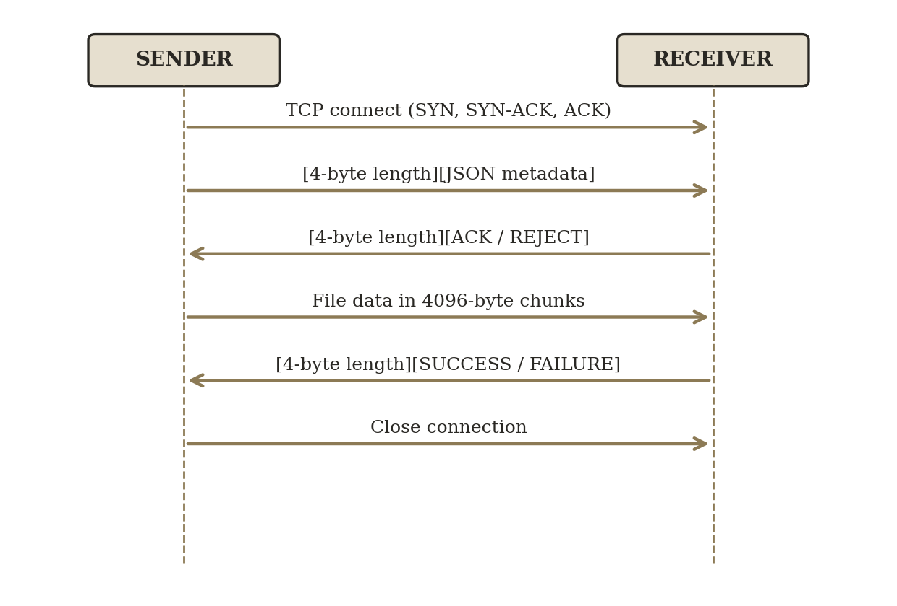
Fig. 7.1 File transfer sequence between sender and receiver
7.2 Reliable Reading (protocol.py)
def recv_exact(sock, n):
buf = b""
while len(buf) < n:
chunk = sock.recv(n - len(buf))
if not chunk:
raise ConnectionError("Connection closed")
buf += chunk
return buf

The function loops until exactly n bytes are collected and raises an error if the connection closes early, so the partial read problem is handled.
7.3 Sender (tcp_sender.py)
The function send_file() computes the SHA-256 checksum, connects to the receiver, sends the framed metadata and waits for ACK or REJECT. After an ACK it reads the file in 4096-byte chunks and sends each chunk with sendall(), reporting progress through a callback. Finally it waits for SUCCESS or FAILURE and returns a result dictionary to the backend.
7.4 Receiver (tcp_receiver.py)
The ReceiverServer class runs a listening socket in a background thread and starts a new thread for each connection. For every connection the handler reads the metadata, sanitises the file name using os.path.basename() and a regular expression, chooses a unique file name, sends ACK, writes the incoming chunks to disk while updating the hash, compares the size and checksum, and sends SUCCESS or FAILURE. If the connection drops, the incomplete file is deleted.
7.5 Backend Endpoints (main.py)
Endpoint | Method | Function
/send | POST | Receive the file from the browser and call send_file()
/receiver/start | POST | Start the receiver server on a port
/receiver/stop | POST | Stop the receiver server
/receiver/status | GET | Return pending events, polled every 800 ms
/history | GET | Return the transfer history
Table 7.1 HTTP endpoints
7.6 Procedure to Run
Install the packages with pip install -r requirements.txt, then start the server with python -m uvicorn backend.main:app --host 0.0.0.0 --port 8000 and open http://localhost:8000 in Chrome. On the receiving computer click Start Receiving; on the sending computer choose a file, enter the receiver’s IP address and port, and click Send File.
7.7 Message Framing Functions (protocol.py)
def send_framed(sock, payload: bytes) -> None:
header = struct.pack(">I", len(payload))
sock.sendall(header + payload)

def recv_framed(sock) -> bytes:
header = recv_exact(sock, 4)
payload_len = struct.unpack(">I", header)[0]
return recv_exact(sock, payload_len)

send_framed() prepends the 4-byte length and sends the message in one call. recv_framed() first reads the 4-byte header, decodes the length and then reads exactly that many bytes, so message boundaries are always preserved.
7.8 Sending the File in Chunks (tcp_sender.py)
sock.connect((receiver_ip, receiver_port))
send_framed(sock, build_metadata(filename, filesize, checksum))
response = recv_framed(sock) # ACK or REJECT
...
with open(filepath, "rb") as f:
while True:
chunk = f.read(CHUNK_SIZE)
if not chunk:
break
sock.sendall(chunk)
bytes_sent += len(chunk)
final = recv_framed(sock) # SUCCESS or FAILURE

After the receiver accepts the metadata, the file is read block by block and each block is sent with sendall(), which keeps sending until the whole block has been handed to TCP. The final reply decides whether the transfer is reported as successful.
7.9 Filename Safety (tcp_receiver.py)
SAFE_FILENAME_RE = re.compile(r'^[\w\-. ]+$')

def _sanitize_filename(name):
base = os.path.basename(name).strip()
if not base or not SAFE_FILENAME_RE.match(base):
return None
return base

7.10 Receiving and Verifying the File
h = hashlib.sha256()
with open(save_path, "wb") as f:
while bytes_received < filesize:
to_read = min(CHUNK_SIZE, filesize - bytes_received)
chunk = recv_exact(conn, to_read)
f.write(chunk)
h.update(chunk)
bytes_received += len(chunk)

if h.hexdigest() != checksum:
send_framed(conn, FAILURE)
os.remove(save_path)
else:
send_framed(conn, SUCCESS)

7.11 Starting the Receiver Server
sock = socket.socket(socket.AF_INET, socket.SOCK_STREAM)
sock.setsockopt(socket.SOL_SOCKET, socket.SO_REUSEADDR, 1)
sock.bind(("0.0.0.0", port))
sock.listen(5)
sock.settimeout(1.0) # re-check the stop flag every second

while not stop_event.is_set():
try:
conn, addr = sock.accept()
except socket.timeout:
continue
threading.Thread(target=_handle_connection,
args=(conn, addr, dest, on_event)).start()

Binding to 0.0.0.0 accepts connections on every interface; the one-second timeout lets the thread stop cleanly.
CHAPTER 8
RESULTS WITH DISCUSSIONS
The application was tested on a Windows machine using localhost. The results are given below.
No. | Test | Observation | Result
1 | Small text file (1 KB) | Received correctly | PASS
2 | Binary file (500 KB) with SHA-256 | Checksums matched | PASS
3 | Receiver not running | Clear connection error shown | PASS
4 | Duplicate file name | file.txt saved as file_1.txt | PASS
5 | Large file (5 MB) with SHA-256 | Checksums matched | PASS
Table 8.1 Test results
8.1 Discussion
- Integrity: for the binary and large files the checksum computed by the sender was identical to the one computed by the receiver, which shows that no data was lost or altered.
- Error handling: when no receiver was listening, the sender returned a readable ‘Cannot connect’ message instead of failing silently.
- Safety: existing files were never overwritten, because a numbered suffix is added to a duplicate name.
- Feedback: the progress bar and the transfer history table update during and after each transfer.
8.2 Limitations
- No encryption: data is sent in plain text, so the application is suitable only for a trusted LAN.
- No authentication: any machine on the network can connect to an open receiver.
- Only one active transfer at a time per application instance.
- The browser-to-backend step uses HTTP, because a browser cannot open raw TCP sockets.
8.3 Test Procedure
Each test was carried out by starting the receiver on port 9001, sending a file to 127.0.0.1, and then comparing the file in the received_files folder with the original. For the binary and large files the SHA-256 value of the original and of the received copy were compared. The transfer history was also checked after every test to confirm that the entry had been recorded with the correct status.
No. | Test case | Expected behaviour | Verification
1 | 1 KB text file | File saved unchanged | Content compared
2 | 500 KB binary file | File saved, hashes equal | SHA-256 compared
3 | Receiver stopped | Connection error shown | Message on screen
4 | Same file sent twice | Second copy renamed with _1 | Folder listing
5 | 5 MB file | File saved, hashes equal | SHA-256 compared
Table 8.2 Test cases and verification
8.4 Analysis of the Results
The first, second and fifth tests confirm the normal path of the protocol: connection, metadata, ACK, chunked transfer, verification and SUCCESS. The 5 MB file requires over a thousand chunks, and the matching hash shows that chunking and reassembly work correctly for files much larger than one block.
The third test shows the behaviour when the connection cannot be made. Because connect() fails immediately, the sender returns a clear message that names the address and port, so the user can see that the receiver has to be started or that the address is wrong.
The fourth test confirms the protection against overwriting. The first file kept its name and the second was saved as dup_test_file_1.txt, which is also visible in the received_files folder of the project.
CHAPTER 9
INFERENCES
- TCP gives reliable and ordered delivery, so a simple file transfer needs no retransmission logic in the application.
- Because TCP is a byte stream, an application protocol with length-prefix framing is needed to separate control messages.
- A recv() call can return less data than requested, so reading must always be done in a loop (recv_exact).
- A checksum gives an end-to-end check of the file that is independent of TCP’s own error detection.
- Validating the file name and avoiding overwrites are essential for the safety of a receiving server.
9.1 Observations from the Implementation
While building and testing the application the following points were observed. They are the practical lessons of the project and show how theory in computer networks appears in real software.
- The protocol worked without any application-level retransmission, which shows how much work TCP does for the programmer.
- Control messages and file data use different methods in the same connection: control messages are framed with a length, while the file data is delimited by the size announced in the metadata.
- Timeouts are necessary, because without them a stalled connection would block the sender or receiver indefinitely.
- Running the receiver in its own thread keeps the interface responsive during long transfers.
- The application is limited by the speed of the local network and the disk, not by the protocol design.
9.2 Advantages
- Direct transfer without cloud storage, e-mail or external drives.
- No internet connection is required; only a shared local network.
- Integrity of every file is proved by SHA-256.
- Simple browser interface with progress and history.
- Small code base that uses only standard Python modules for the networking part.
9.3 Applications
- Sharing project files between computers in a laboratory or hostel network.
- Moving large files inside a small office without using cloud services.
- Teaching aid for socket programming and protocol design in a computer networks course.
CHAPTER 10
CONCLUSION
A working file transfer application was designed and implemented using Python TCP sockets, a custom application-level protocol and a FastAPI browser interface. The system transfers files between two computers on the same network, reports progress, verifies integrity with SHA-256, and handles connection failures and duplicate file names correctly. All planned tests were successful.
The project demonstrates, in a practical form, how connection-oriented communication, message framing and checksums work together to provide dependable data transfer.
Future Work
- TLS encryption using Python’s ssl module.
- Password protection for the receiver.
- Multiple simultaneous transfers.
- Pause and resume support.
- Folder transfer by compressing it before sending.
Summary of Work Done
- Studied TCP, the three-way handshake, sockets, message framing and checksums.
- Designed an application-level protocol with metadata, ACK or REJECT, chunked data and SUCCESS or FAILURE.
- Implemented the sender, receiver and protocol modules in Python.
- Built a FastAPI backend and a browser interface with progress and history.
- Tested the system with text, binary and large files and with error situations.
The objectives set at the start of the project were therefore achieved. The work also shows that reliable network applications need careful treatment of details such as message boundaries, partial reads, timeouts and verification, even when a reliable transport protocol is available.
CHAPTER 11
REFERENCES
[1] Python Software Foundation, “socket – Low-level networking interface,” Python 3 Documentation, https://docs.python.org/3/library/socket.html.
[2] Python Software Foundation, “hashlib – Secure hashes and message digests,” Python 3 Documentation, https://docs.python.org/3/library/hashlib.html.
[3] FastAPI Documentation, https://fastapi.tiangolo.com.
[4] J. Postel, “Transmission Control Protocol,” RFC 793, IETF, 1981.
[5] A. S. Tanenbaum and D. J. Wetherall, Computer Networks, 5th ed., Pearson, 2011.
[6] J. F. Kurose and K. W. Ross, Computer Networking: A Top-Down Approach, 8th ed., Pearson, 2020.
[7] National Institute of Standards and Technology, “Secure Hash Standard (SHS),” FIPS PUB 180-4, 2015.

