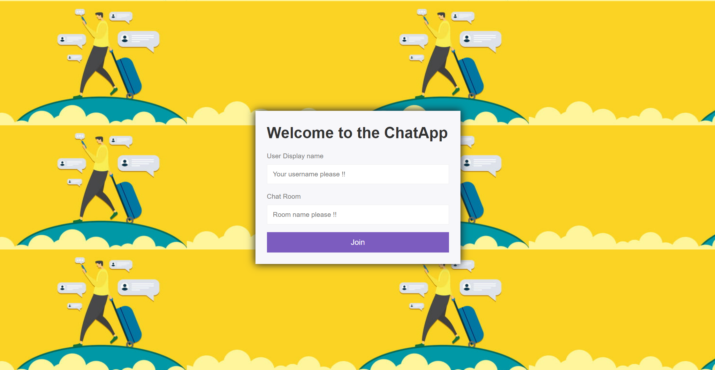  
A user can either create a new chat room with a unique name or join an existing room (by just specifying an already existing name)….using this UI  
  
**Creating a new chat room as an initial user:**

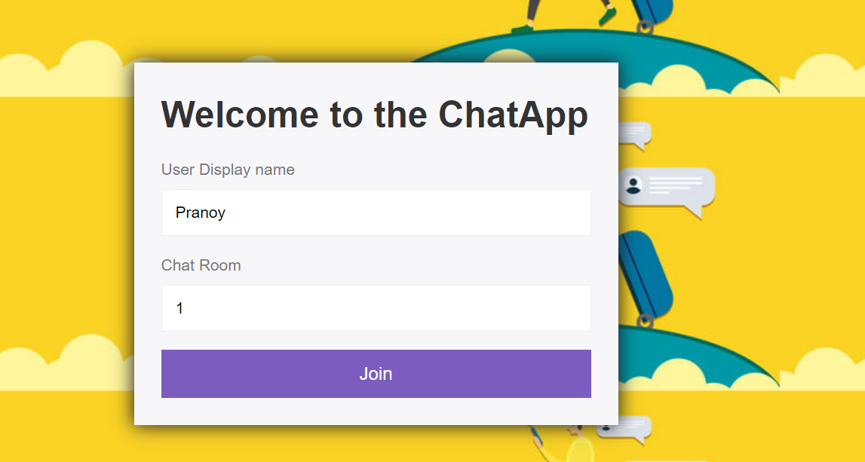

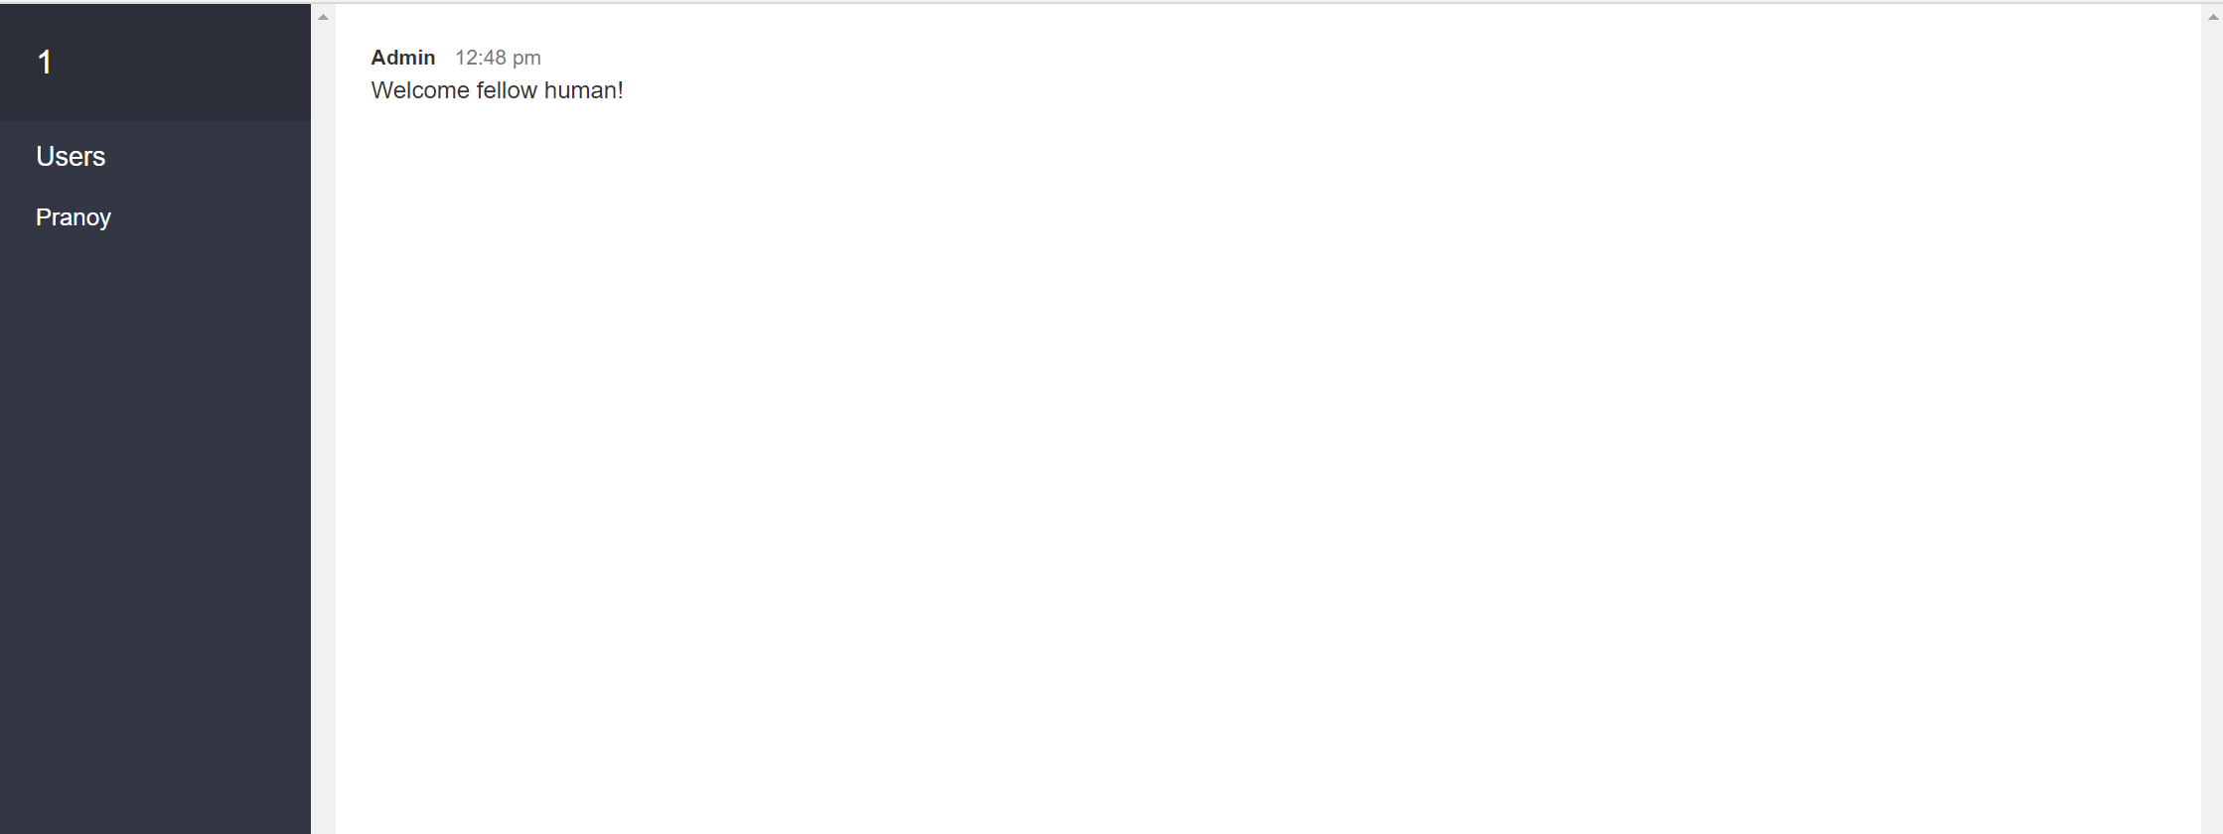

**Now, another user wants to join this room:**

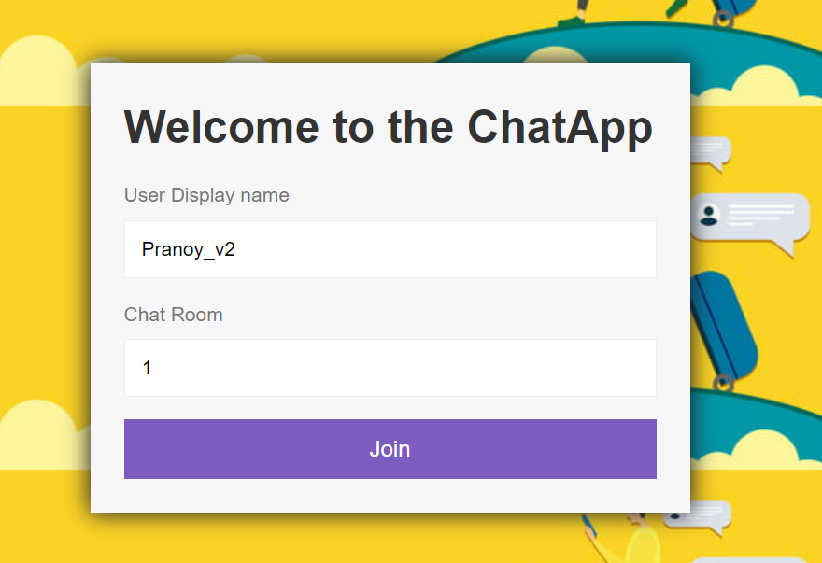  
  
2nd user’s UI: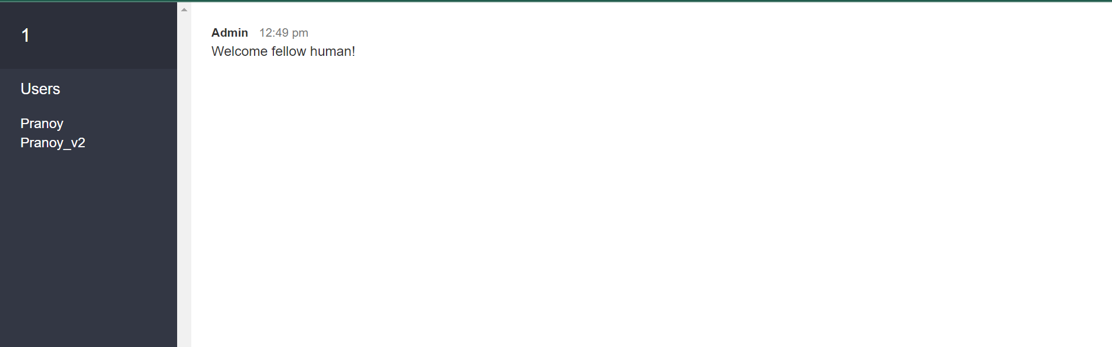  
  
1ST user’s UI:  
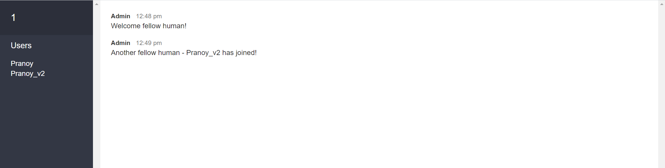

Messaging Experience:  
