INVENTION DISCLOSURE FORM
(Draft — for internal review prior to IPR/TBI cell submission)

1. Title of Invention
System and Method for Risk-, Cost-, and Cache-Aware Request Routing in Heterogeneous Cloud-Based AI Inference Serving Infrastructure

2. Inventors
[Your Full Name], [Your Friend's Full Name]
Affiliation: [College/University Name], Department of [Department]
Subject/Course context: Cloud Architecture Design

3. Field of the Invention
The present invention relates to the field of cloud computing architecture, and more specifically to systems and methods for securely and efficiently routing inference requests across heterogeneous serving infrastructure in cloud-hosted artificial intelligence (AI) and large language model (LLM) serving environments.

4. Background of the Invention
Cloud-hosted AI inference serving systems (e.g., systems deploying large language models across multiple GPU-backed instances) face three largely independent technical challenges that existing systems address in isolation:
- Cost inefficiency: heterogeneous GPU hardware has varying cost/performance profiles, and existing scheduling approaches (e.g., mixed-integer linear programming based schedulers) optimize placement for cost but do not account for cache-locality or security risk.
- Cache underutilization: systems such as prefix-caching engines (e.g., RadixAttention-based serving) reuse cached computation across requests sharing a prompt prefix, but operate on the assumption of a largely homogeneous, trusted request stream and do not factor cost-tiering or security risk into cache-aware placement.
- Security vulnerability: cloud-hosted inference endpoints are subject to (a) prompt injection / jailbreak attacks attempting to override system instructions, and (b) resource-exhaustion ("sponge") attacks that use adversarially long or repetitive inputs to exhaust GPU memory/compute and drive up cost or degrade availability. Existing defenses (e.g., prior art such as US 12,437,058, directed to binary classification and session-termination for indirect prompt injection in agentic tool-call pipelines) provide a binary allow/terminate decision and do not address resource-exhaustion-type attacks, nor do they integrate the security decision into the underlying tier/placement architecture of the serving infrastructure itself.
No known system unifies cost-awareness, cache-locality-awareness, and a graduated (non-binary) security risk assessment covering both content-based and resource-consumption-based threats into a single request-routing decision function integrated into the serving architecture.

5. Summary of the Invention
The invention provides a request-routing architecture comprising: (i) a pre-execution feature extraction component that derives cost-relevant, cache-relevant, and security-relevant signals from an incoming inference request prior to execution; (ii) a machine-learned risk classification component that produces a graduated (non-binary) risk score spanning both content-based threat indicators (e.g., prompt injection/jailbreak similarity) and resource-consumption-based threat indicators (e.g., predicted token generation length, repetition patterns indicative of resource-exhaustion attacks); (iii) a tier-selection/decision engine that computes a composite routing score from the cost, cache-locality, and risk signals and assigns the request to one of a plurality of differently-resourced and differently-isolated serving tiers (e.g., a full-resource tier, a rate-limited/sandboxed tier with hard resource caps, and a quarantine/reject tier); and (iv) a feedback component that logs routing outcomes and periodically updates the classifier and per-tenant thresholds.

6. Detailed Description

6.1 System Architecture
Figure 1 depicts the overall architecture comprising the following components, described in sequence of request processing:
- Request Feature Extractor: extracts prompt length, token-count estimate, prefix/embedding similarity to cached prompts, embedding similarity to known jailbreak/injection patterns, session-level repetition metrics, and requester/session metadata.
- ML Risk Classifier: a trained model (e.g., gradient-boosted decision tree or lightweight neural classifier) that maps extracted features to (a) a resource-cost class and (b) a security risk score spanning content-based and consumption-based threat categories.
- Cache-Locality Estimator: determines the probability that the request's prefix is already resident in the KV-cache of a given serving instance.
- Tier-Selection / Decision Engine: computes a composite score, illustratively of the form Score = w1*CostSignal + w2*CacheLocalitySignal - w3*RiskSignal, and routes the request to the tier maximizing expected efficiency subject to a risk threshold; requests exceeding a risk threshold are routed to a sandboxed tier with hard resource caps (bounded max tokens, bounded compute time, isolated execution) rather than the general serving pool, regardless of their cost/cache profile; requests exceeding a second, higher threshold are rejected/quarantined.
- Feedback Loop: logs the outcome of each routed request (actual resource consumption, confirmed/unconfirmed threat status where available) and uses this data to periodically retrain the classifier and adapt per-tenant or per-session thresholds.
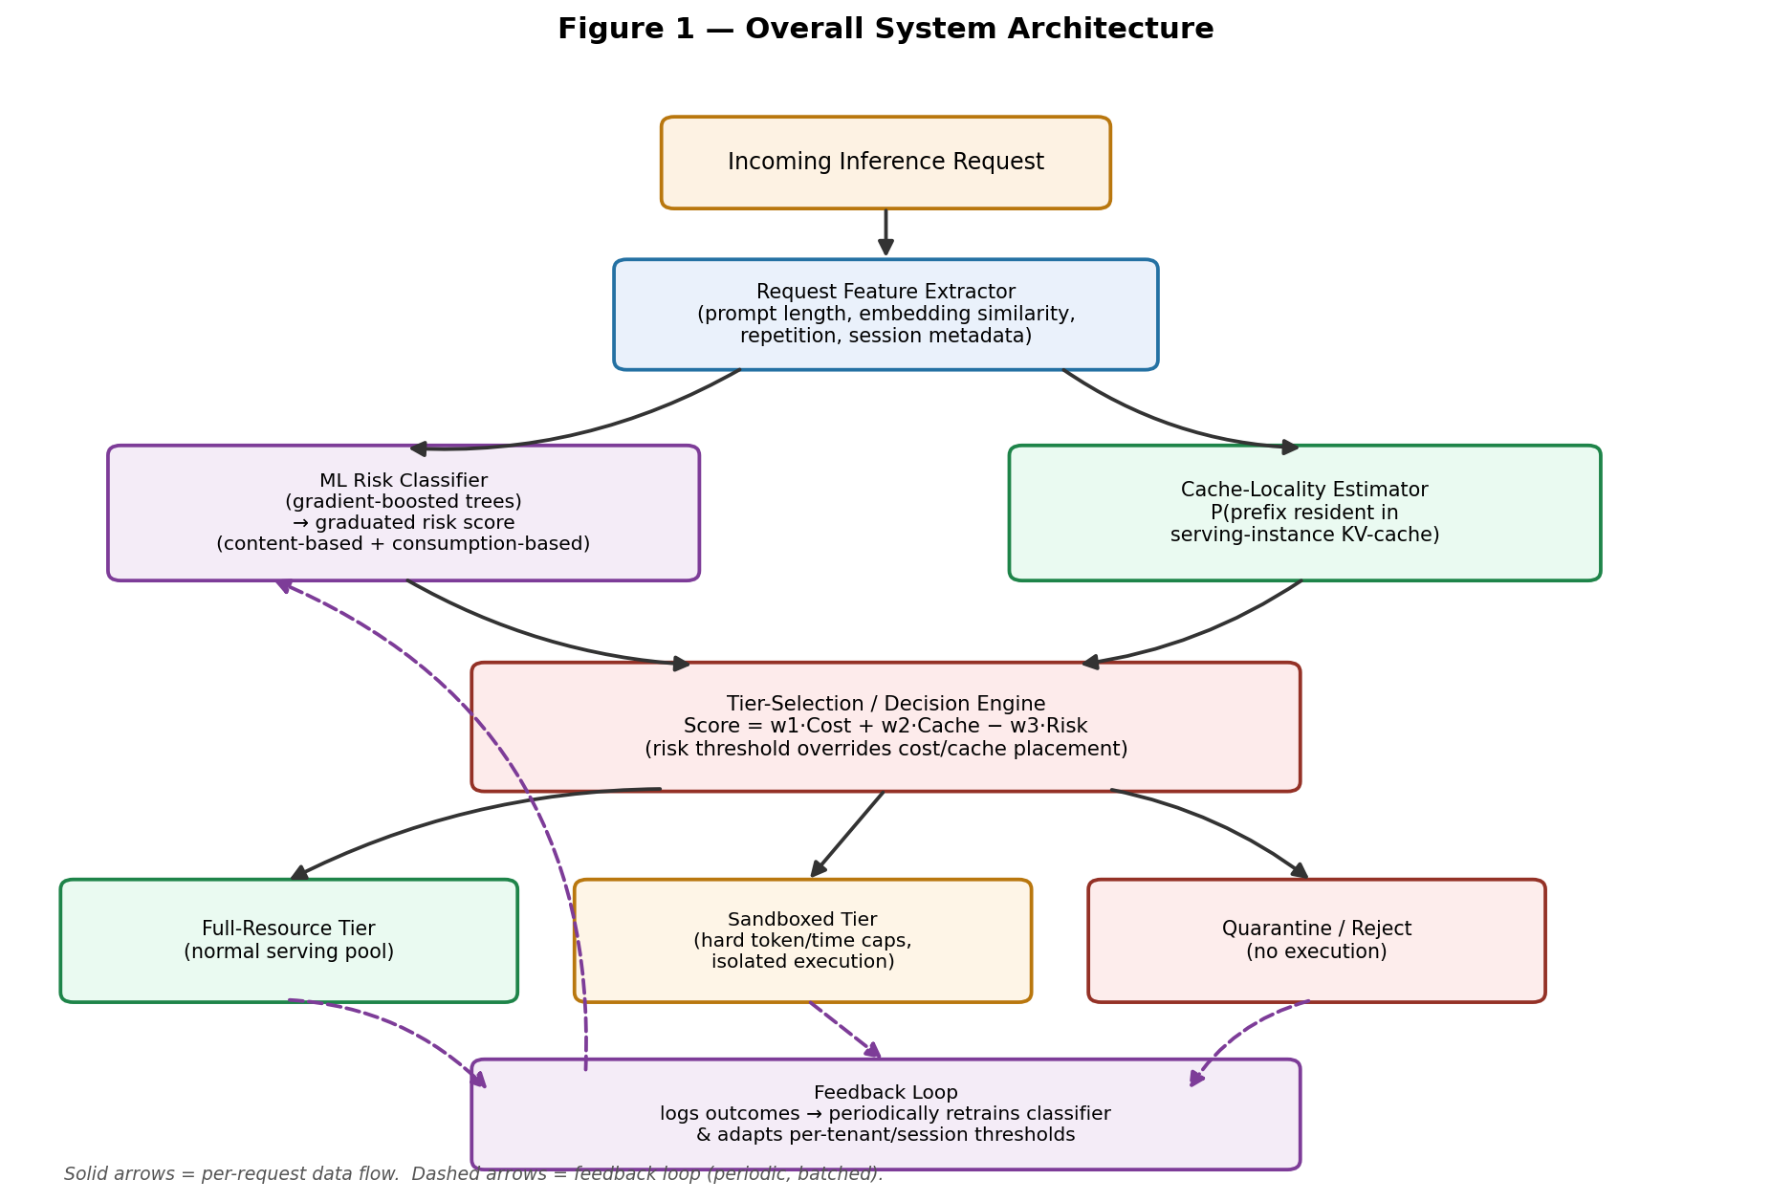
Figure 1. Overall system architecture block diagram.

6.2 Novel Aspects
- Unification of cost, cache-locality, and graduated security risk into a single composite routing decision, as opposed to treating these as independent subsystems.
- Coverage of resource-exhaustion ("sponge"/denial-of-wallet) attacks as a first-class input to the routing decision, rather than addressing only content-based threats (e.g., prompt injection) as in prior art.
- A graduated, multi-tier mitigation response (full tier / sandboxed tier / quarantine) integrated into the serving architecture's placement logic, as opposed to a binary allow/terminate gate implemented as a separate filtering layer.
- An adaptive feedback loop that updates both the classifier and the routing thresholds based on observed outcomes.

7. Distinction Over Known Prior Art
Prior Art | What it Covers | Key Difference from This Invention
US 12,437,058 (Amazon) | Binary classifier detects indirect prompt injection in agent tool-call results; terminates session on detection. | Binary allow/terminate only; no resource-exhaustion coverage; no integration with cost/cache-based serving-tier placement.
Cost-aware heterogeneous GPU schedulers (e.g., Jiang et al. 2025, Melange, BOute) | Optimize placement across heterogeneous GPUs for cost efficiency. | No security-risk signal considered in placement decision.
Resource-exhaustion defenses (e.g., SHIELD, PD3F) | Detect/mitigate sponge-style resource-exhaustion attacks via anomaly detection or resource-aware scheduling. | Operate as standalone defenses; not unified with cost/cache-aware tier routing or content-based threat detection.

8. Draft Claims (for attorney/IPR-cell refinement)
Claim 1 (independent — method):
A computer-implemented method for routing an inference request in a cloud-based AI serving system, the method comprising: receiving a request directed to an AI inference service; extracting, from the request, a set of features comprising at least one cost-related feature, at least one cache-locality-related feature, and at least one security-related feature, wherein the at least one security-related feature comprises both a content-based threat indicator and a resource-consumption-based threat indicator; computing, using a trained machine learning classifier, a risk score from the at least one security-related feature; computing a composite routing score from the cost-related feature, the cache-locality-related feature, and the risk score; and routing the request to a selected one of a plurality of serving tiers based on the composite routing score, wherein the plurality of serving tiers comprises at least a first tier having a first resource allocation and a second tier having a second, more restricted resource allocation.
Claim 2 (dependent): The method of claim 1, wherein the resource-consumption-based threat indicator comprises a predicted output token length or a session-level repetition metric.
Claim 3 (dependent): The method of claim 1, further comprising logging an outcome of the routed request and updating the trained machine learning classifier based on the logged outcome.
Claim 4 (dependent): The method of claim 1, wherein routing the request to the second tier comprises applying a bounded maximum token count and a bounded execution time distinct from the first tier.
Claim 5 (independent — system): A system comprising at least one processor and memory storing instructions that, when executed, cause the system to perform the method of claim 1.
Note: This is a preliminary draft for discussion with your IPR cell / patent agent, not final claim language.

9. Advantages
- Addresses resource-exhaustion attacks, an attack class largely unaddressed by existing content-focused security patents.
- Reduces false-positive impact on legitimate users compared to binary block/allow systems, via graduated tiering.
- Improves cost-efficiency by unifying security and cost/cache-aware placement in a single decision, avoiding redundant subsystems.
- Adapts over time via the feedback loop without requiring manual threshold tuning.

10. Reduction to Practice / Prototype Status
Status: a simulated / constructive reduction to practice has been completed. The core algorithmic components of the invention — feature extraction, the ML risk classifier, the cache-locality estimator, the composite tier-routing decision engine, and the adaptive feedback loop — have been implemented in a working Python prototype and evaluated against synthetically generated traffic. Real GPU-backed LLM serving infrastructure and real production traffic were not available at this stage; the routing algorithm and ML model are real and fully functional, but the requests they operate on are statistically realistic synthetic feature vectors rather than live traffic. This distinction is noted for the IPR cell's assessment of reduction-to-practice strength.

10.1 Prototype Components Built
- Request Feature Extractor — normalizes raw request signals (prompt length, jailbreak/embedding similarity, repetition ratio, predicted output tokens, session repeat count) into a model-ready feature vector.
- Cache-Locality Estimator — simulates KV-cache prefix-hit probability against a warm-prefix pool with configurable churn.
- ML Risk Classifier — an XGBoost gradient-boosted decision tree ensemble (200 trees, max depth 5) trained to predict {benign, injection, exhaustion}; graduated risk score computed as 1 − P(benign), spanning both content-based and resource-consumption-based threat categories in a single score.
- Tier-Selection / Decision Engine — implements the composite score Score = w1·Cost + w2·Cache − w3·Risk and graduated tier assignment (full / sandbox with hard 256-output-token and 5-second compute caps / quarantine), with risk-threshold override and an accompanying dollar-cost model (prefill + decode token pricing with cache-hit discount).
- Feedback Loop — retrains the classifier on a sample of newly logged, outcome-confirmed requests blended with historical data, simulating periodic adaptation.
- Baselines for comparison — (a) no protection, and (b) a naive keyword/embedding-similarity blocklist representative of binary allow/terminate prior art (e.g., US 12,437,058).

10.2 Dataset and Attack-Simulation Methodology
All results use synthetically generated traffic, since no production traffic exists yet. Each request is sampled from one of three feature distributions: benign (everyday prompts, moderate length/output, frequent cache reuse), injection (high jailbreak/embedding similarity to known attack patterns, otherwise normal-looking), and exhaustion (very long, highly repetitive, very large requested output). A second, deliberately evasive “low-and-slow” exhaustion variant — with features kept close to the benign range and an elevated session-burst rate as the main remaining signal — was used to test generalization under attacker adaptation (concept drift).
The classifier was trained on 6,000 requests (85% benign / 7.5% injection / 7.5% exhaustion) with a 75/25 train/validation split. Three held-out test batches (5,000 requests each, 12% attack traffic) were then routed through all three systems: Batch A (in-distribution), Batch B (drifted/evasive traffic, evaluated before feedback retraining), and Batch C (fresh drifted traffic, evaluated after the feedback loop retrained on a 40%-confirmed sample of Batch B's logged outcomes).

10.3 Quantitative Results
Batch | System | Overall Det. | Injection Det. | Exhaustion Det. | False Pos. | Total Cost | Cost Savings | Latency
A (in-dist.) | No Protection | 0.0% | 0.0% | 0.0% | 0.0% | $17.77 | — | 0 ms
A (in-dist.) | Keyword Blocklist | 49.5% | 99.0% | 0.0% | 0.05% | $17.13 | 3.6% | 0.8 ms
A (in-dist.) | Proposed Invention | 99.3% | 98.7% | 100.0% | 0.07% | $7.88 | 55.6% | 4.5 ms
B (drift, pre-retrain) | No Protection | 0.0% | 0.0% | 0.0% | 0.0% | $9.57 | — | 0 ms
B (drift, pre-retrain) | Keyword Blocklist | 49.0% | 98.0% | 0.0% | 0.07% | $8.92 | 6.8% | 0.8 ms
B (drift, pre-retrain) | Proposed Invention | 50.2% | 98.0% | 2.3% | 0.11% | $8.90 | 7.0% | 4.5 ms
C (drift, post-retrain) | No Protection | 0.0% | 0.0% | 0.0% | 0.0% | $9.51 | — | 0 ms
C (drift, post-retrain) | Keyword Blocklist | 49.3% | 98.7% | 0.0% | 0.05% | $8.87 | 6.7% | 0.8 ms
C (drift, post-retrain) | Proposed Invention | 95.7% | 99.3% | 92.0% | 0.32% | $7.84 | 17.5% | 4.5 ms

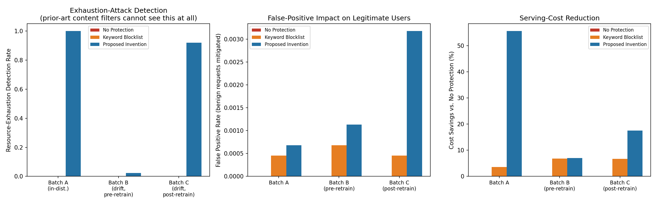
Figure 5. Exhaustion-attack detection, false-positive rate, and cost savings across all three systems and batches.
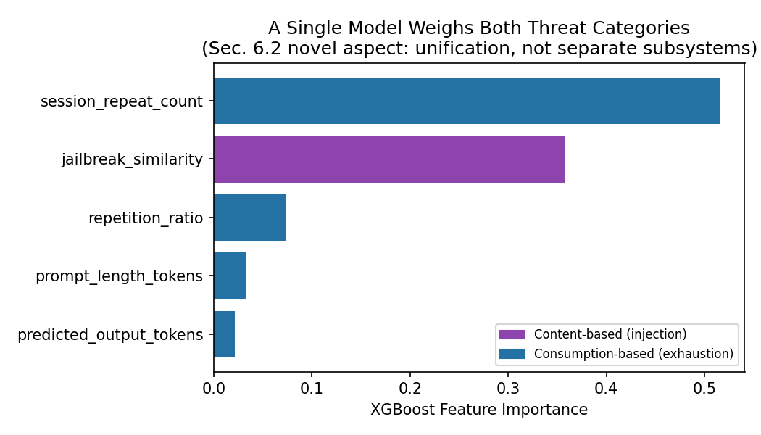
Figure 6. Trained-classifier feature importance, showing a single model drawing on both content-based (jailbreak similarity) and resource-consumption-based (session repeat count, repetition ratio, prompt length) signals — direct evidence of the unification claimed in Section 6.2.

10.4 Interpretation
- Resource-exhaustion coverage the keyword blocklist categorically lacks: across every batch, the keyword blocklist detects 0.0% of exhaustion attacks, while the proposed invention detects 100% in-distribution and recovers to 92.0% after adaptive retraining on a drifted/evasive variant it initially missed (2.3%).
- Unification, not two bolted-together subsystems: feature-importance analysis shows the same risk score is driven by both a content-based signal (jailbreak similarity, 35.7% importance) and consumption-based signals (session burst rate, repetition, length — combined over 60% importance).
- Adaptive feedback loop closes the drift gap: pre-retrain exhaustion detection on evasive Batch B was 2.3%; after retraining on a 40%-confirmed sample of logged outcomes, detection on fresh drifted traffic (Batch C) rose to 92.0%, with validation accuracy on the original distribution unchanged (no catastrophic forgetting).
- Cost efficiency from unified routing: simulated serving cost fell 55.6% vs. no protection on in-distribution traffic (vs. 3.6% for the keyword blocklist) and 17.5% on drifted traffic post-retrain, because exhaustion attacks are capped at the sandbox tier's resource limits rather than allowed to run to completion.
- Low false-positive impact: false-positive rate stayed under 0.35% for the proposed system across all batches.

10.5 Caveats for Final IPR Submission
- Traffic is synthetic; real prompts, a real embedding-similarity search, and real GPU cost telemetry should replace the simulated equivalents before submission if reviewers will expect production data.
- Cost constants are illustrative, not calibrated to a specific GPU SKU or cloud pricing; recommend re-deriving from real per-token serving cost figures.
- The classifier is an XGBoost gradient-boosted tree ensemble, matching the disclosure's “e.g., gradient-boosted decision tree” language; a lightweight neural classifier (the disclosure's other named option) could be benchmarked as an alternative.
- Latency-overhead figures (4.5 ms) are asserted constants representing feature extraction plus inference, not measured on real serving hardware.
- This is a simulated/constructive reduction to practice. The highest-value next step toward a stronger actual-reduction-to-practice claim is validating the same pipeline against a small local LLM (e.g., via vLLM) with a real public jailbreak-prompt dataset and real KV-cache telemetry.

11. Drawings
Figure 1. Overall system architecture block diagram.
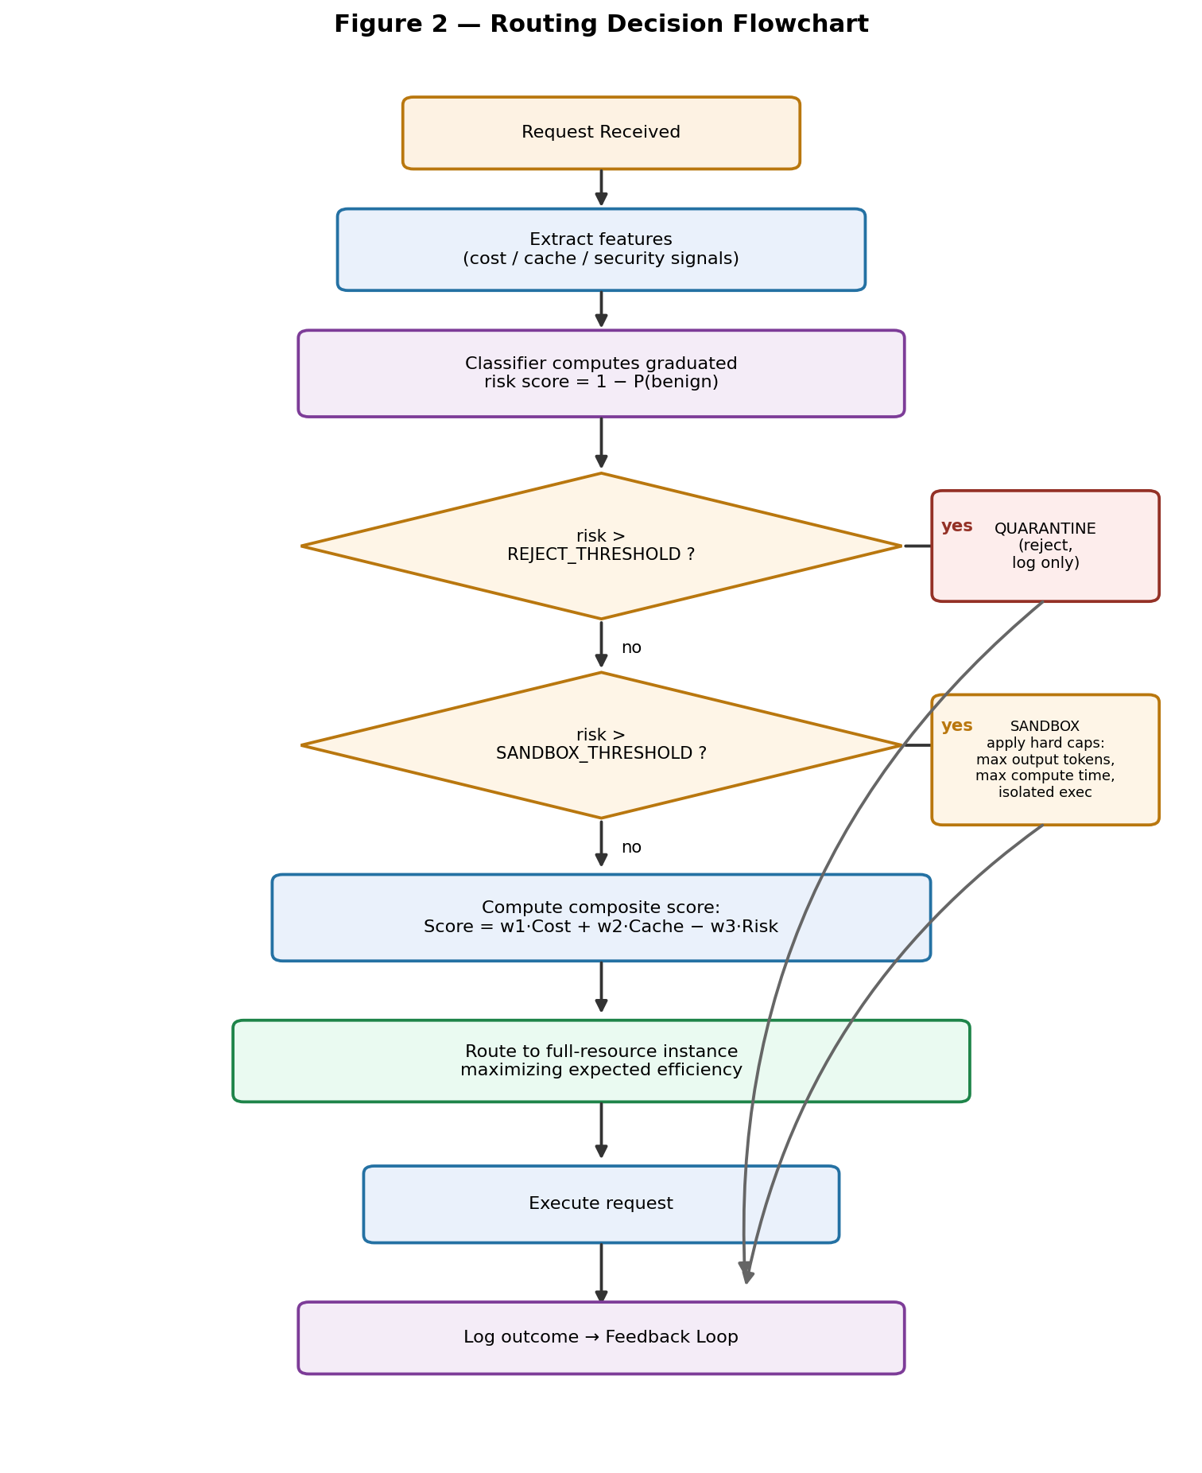
Figure 2. Flowchart of the routing decision process (feature extraction → classification → composite scoring → tier assignment).
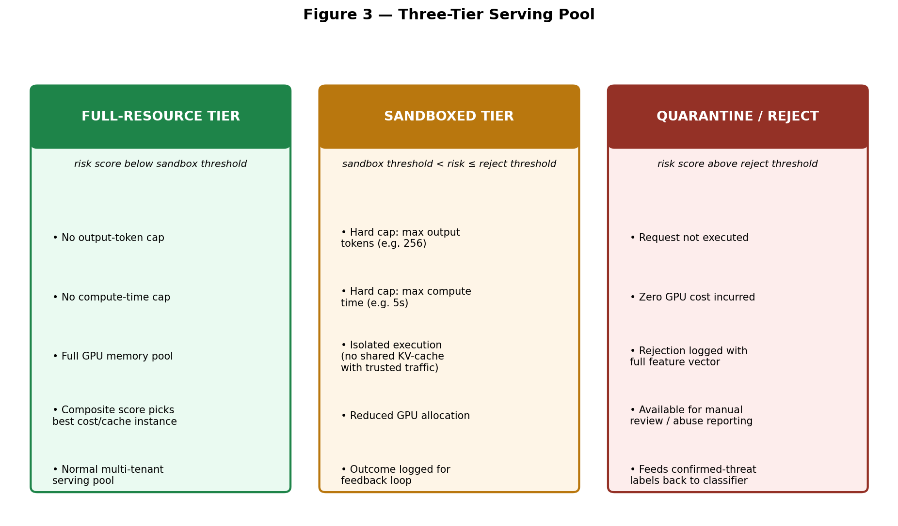
Figure 3. Example of the three-tier serving pool with associated resource caps.
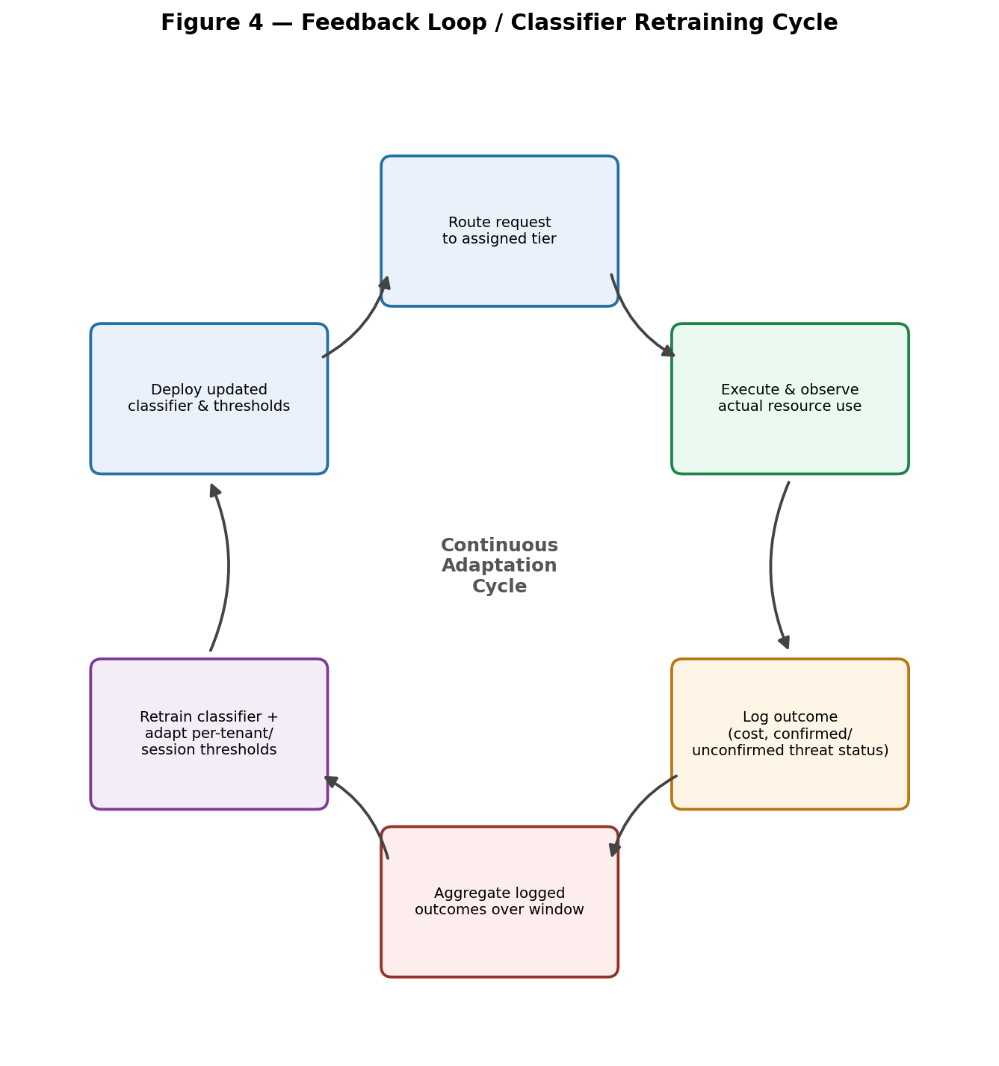
Figure 4. Feedback loop / classifier retraining cycle.

12. Disclosure Status
No public disclosure, publication, or offer for sale of this invention has been made as of the date of this document. [Confirm and update before filing — public disclosure prior to filing can affect patentability in some jurisdictions.]
Date of this disclosure: [Insert Date]

