**TASK 1:**

**Configuring Monitoring System:**

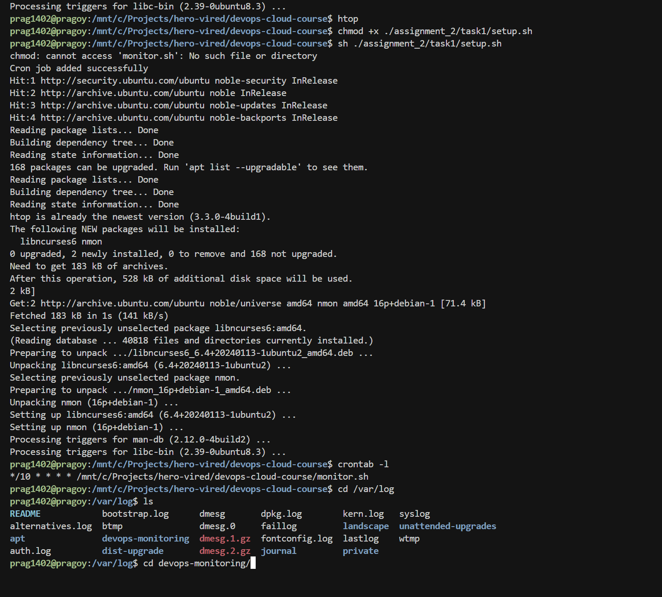

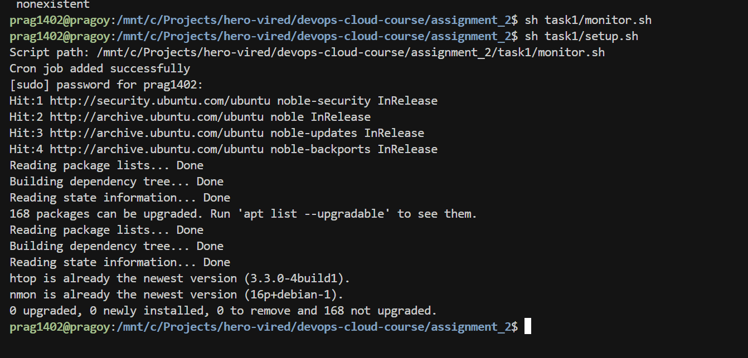

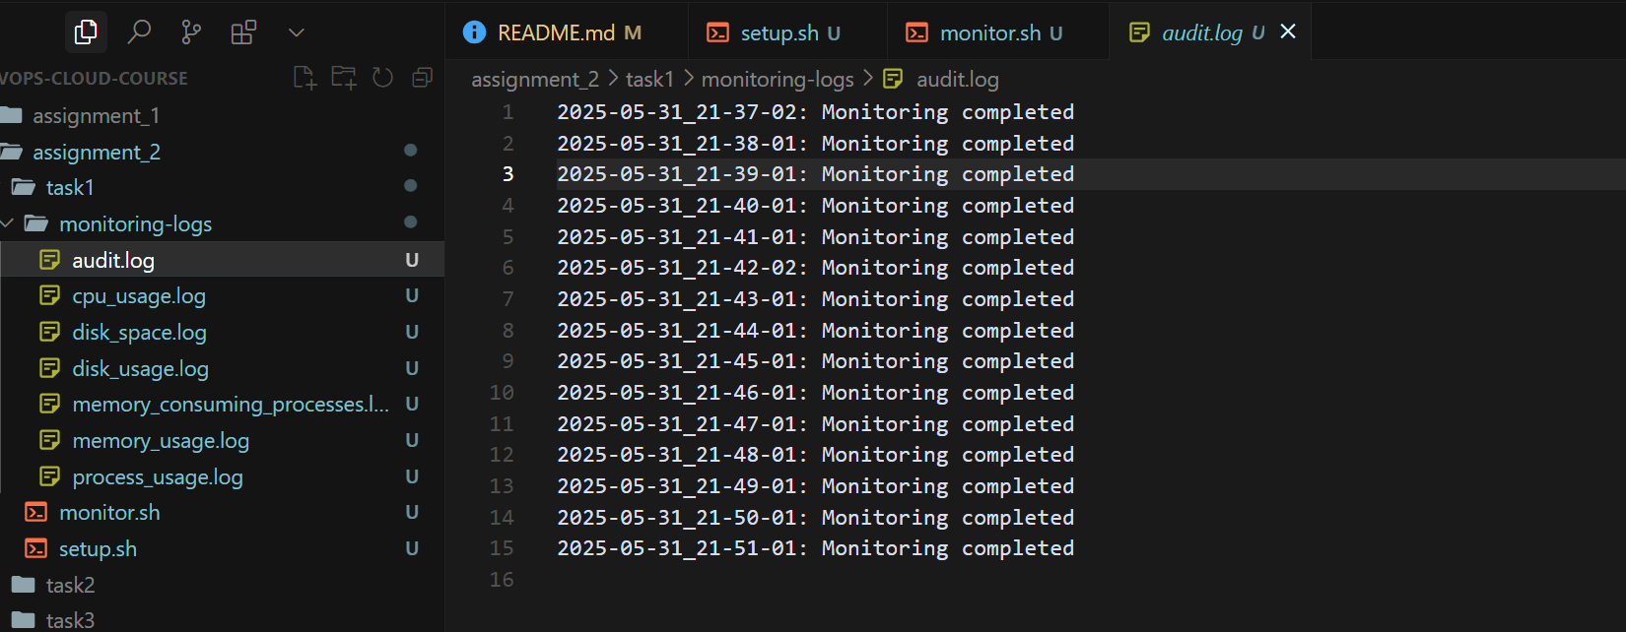

Issues faced while Task 1: Setting up bash scripts & cron for the same

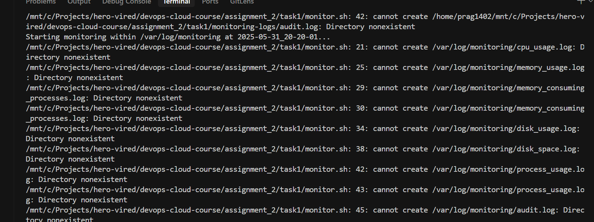

* Setting up bash scripts
* Finding & configuring the monitoring commands
* Running cron from wsl environment within windows
* Issue with paths

Solved the issues with continuous logging, and finally using absolute paths.   
Also had to do one workaround for navigating paths mentioned within monitor.sh when executed via cron i.e. It was having pwd as `/home/{user}` but when executing this script from bash/wsl terminal pwd was different. So I am retrieving & using the script’s working directory instead of pwd when pwd contains ‘/home’.

**TASK 1:**

User Management and Access Control

Created a generic bash script that takes username & password (optional) as inputs

& creates user along with their workspace directory

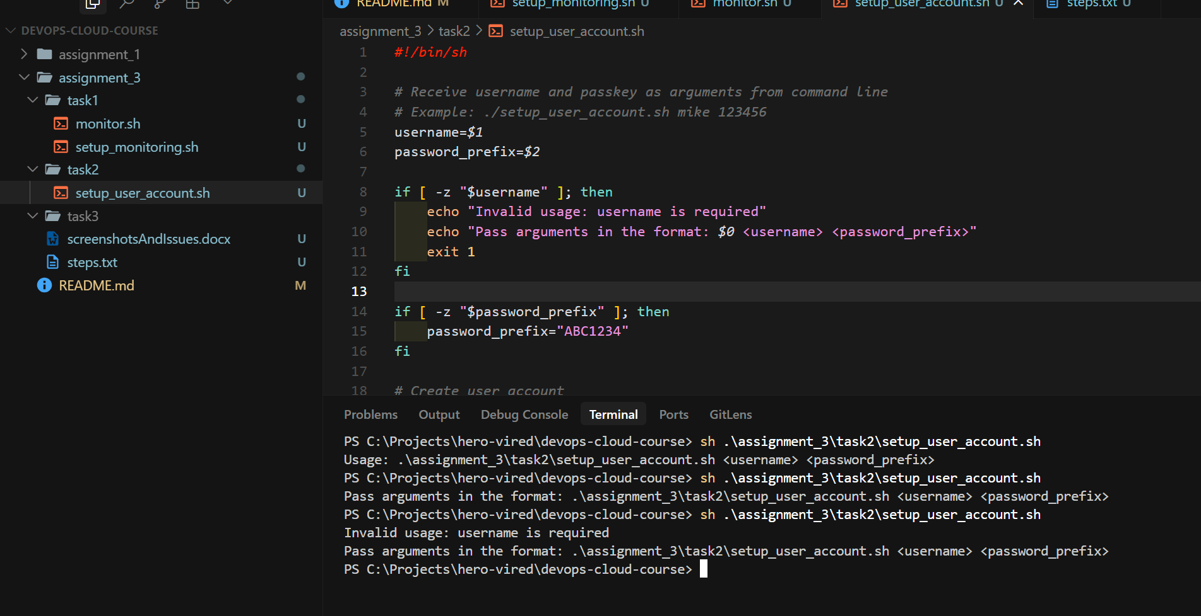

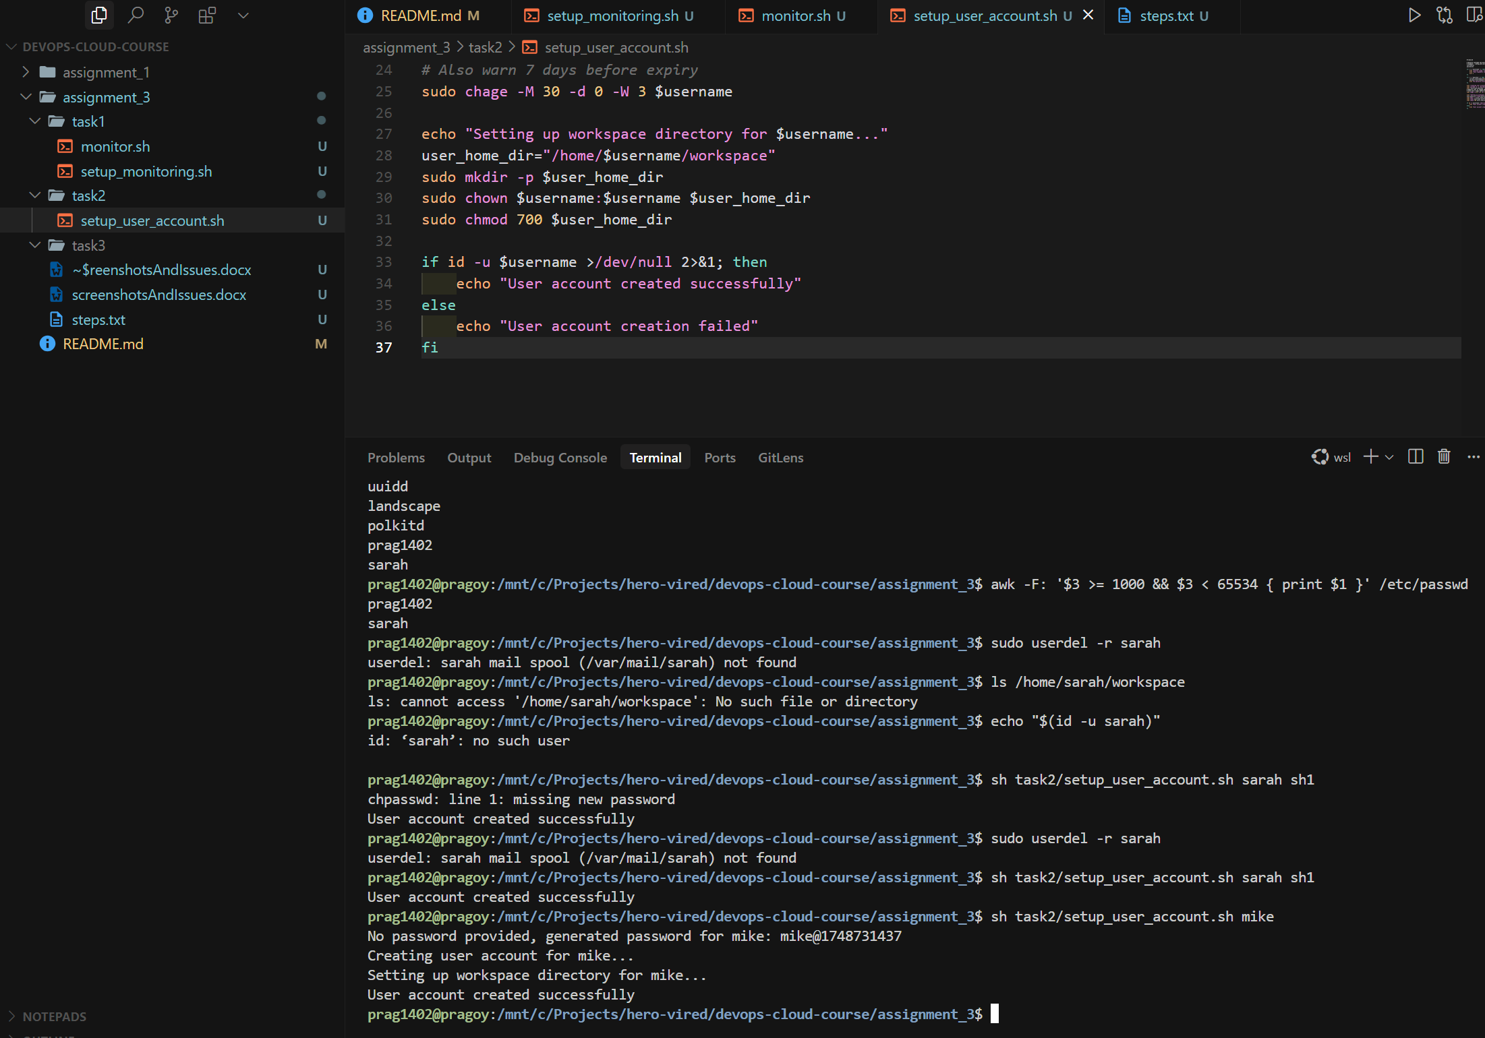

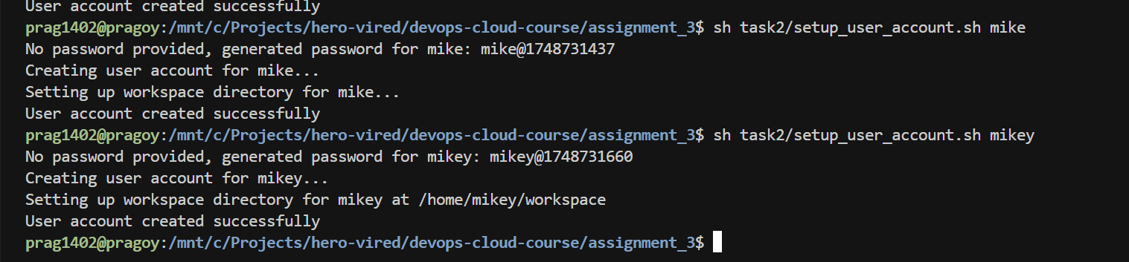

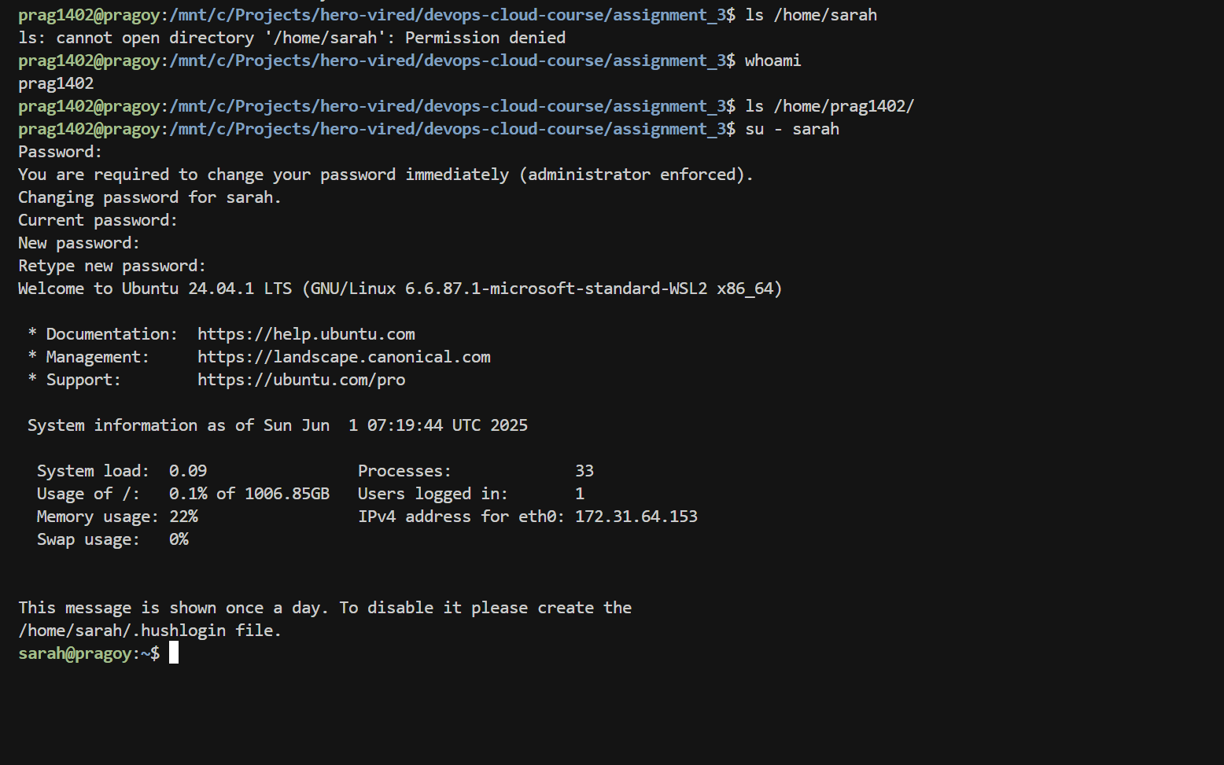

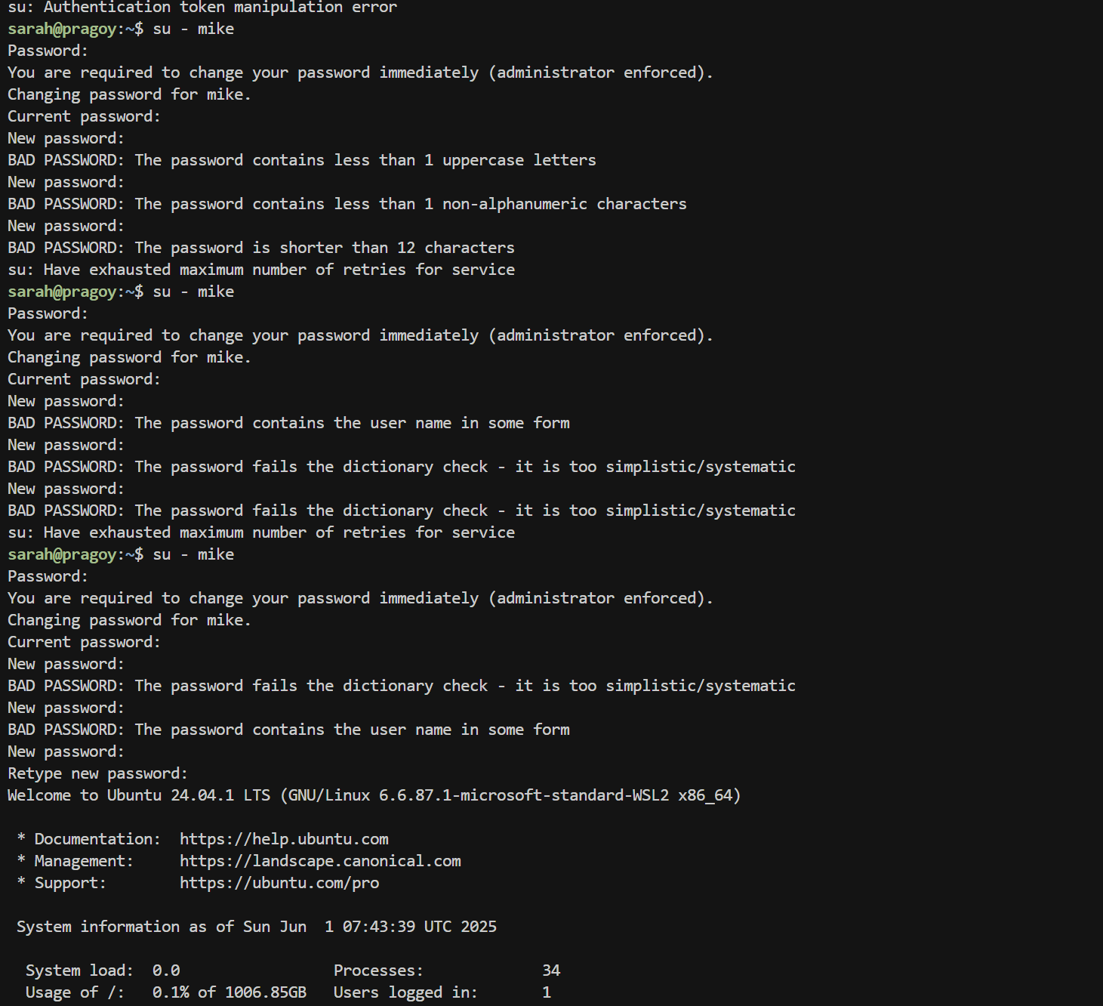

Issues:

* Got issues setting up password for the user
* Setting up password policy via bash

First Issue was around using correct format for setting up a user password, I was trying to generate a strong password combination by default, and it was messing up with system’s format for password. Finally generated default password with date timestamp, otherwise using password provided from cli while executing script.

Second was around setting up policy via bash

TASK 3:

Setup for user sarah:

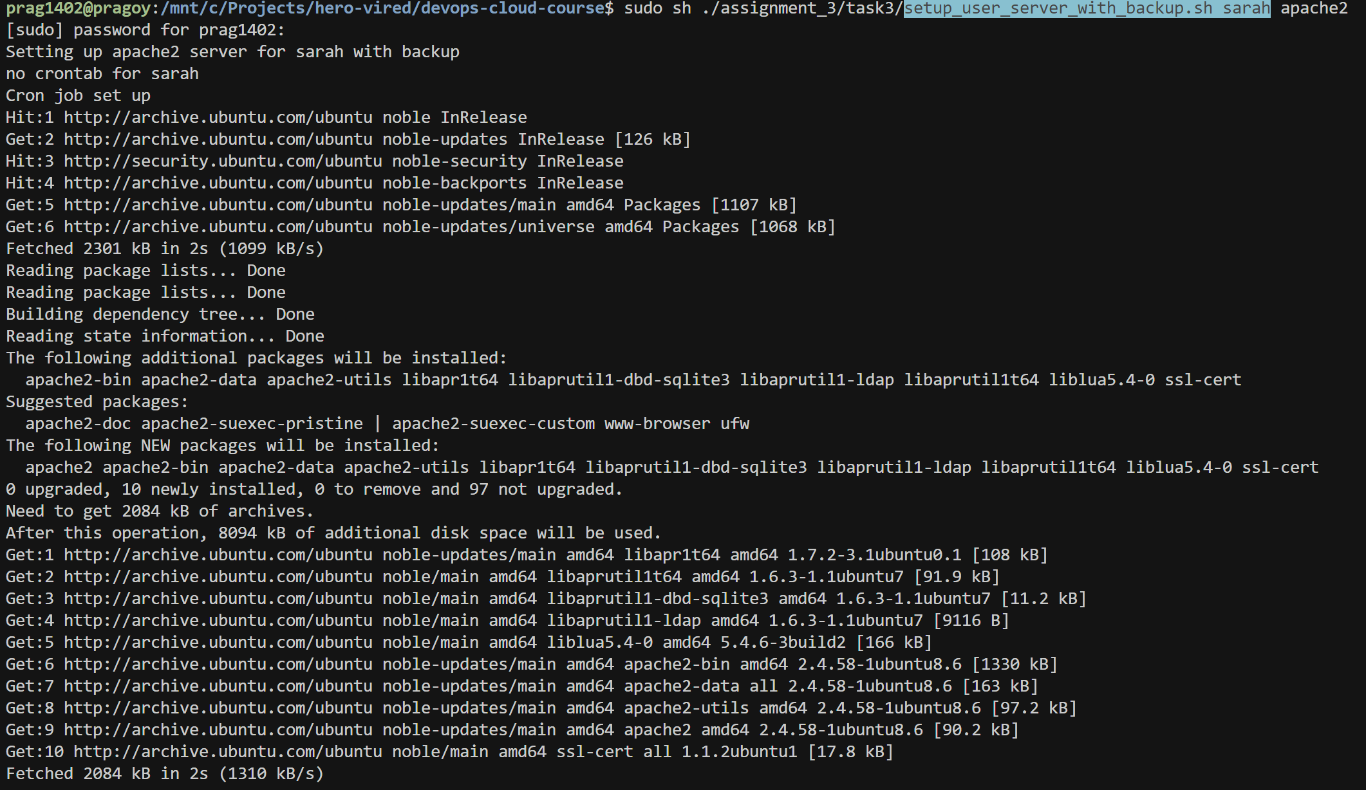





Setting nginx web server & backup crons for Mike:

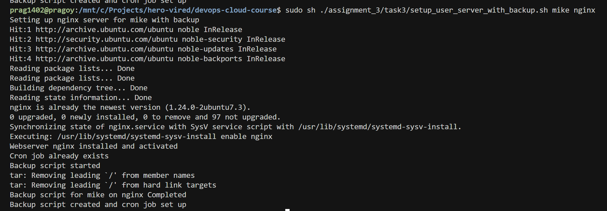



Command to manually trigger Backup script:

