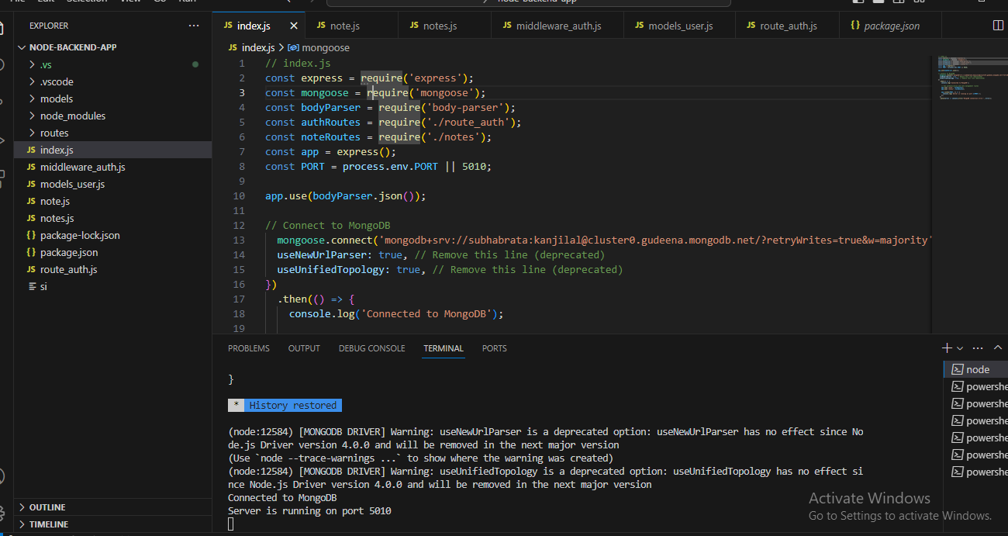

This is an index file which sets the port number to 5010 and connects the MongoDB using provided connection string

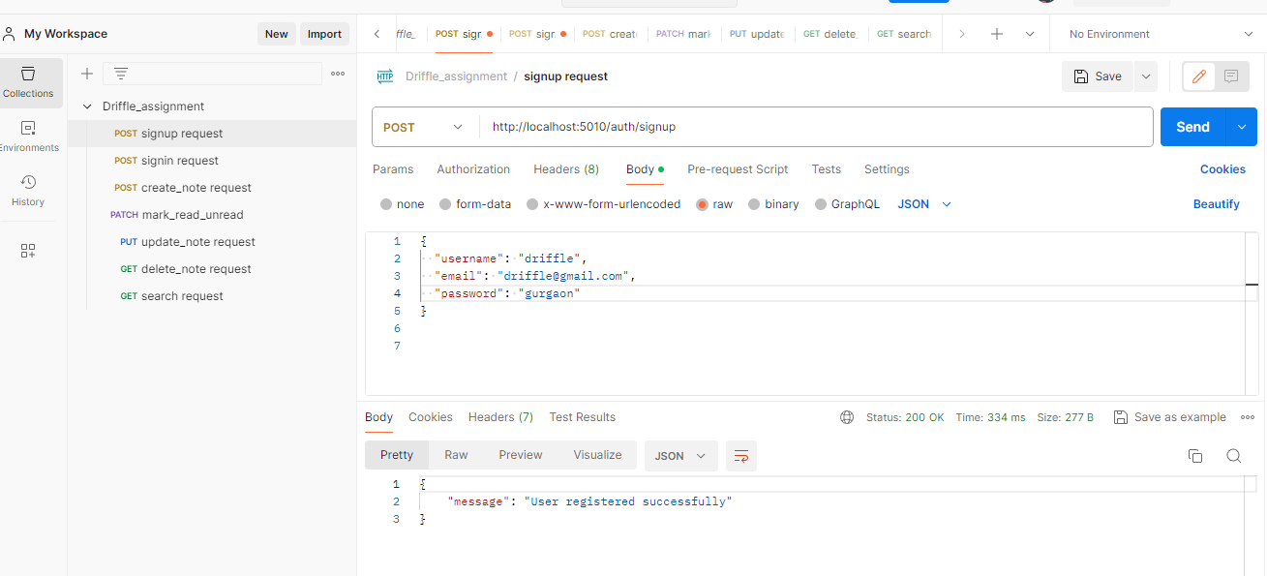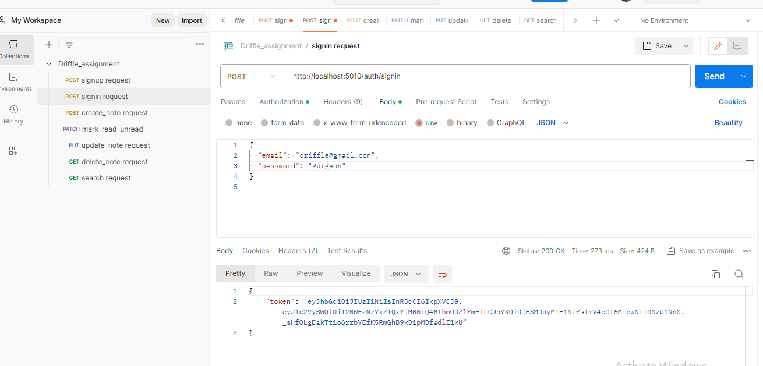

This is a sign up request Api to register the user.

This is sign in request which returns token in response

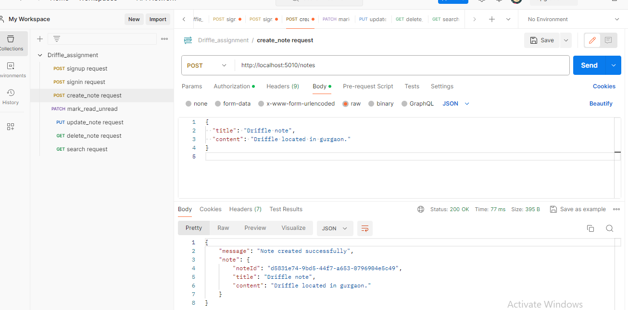

This is a note creation request

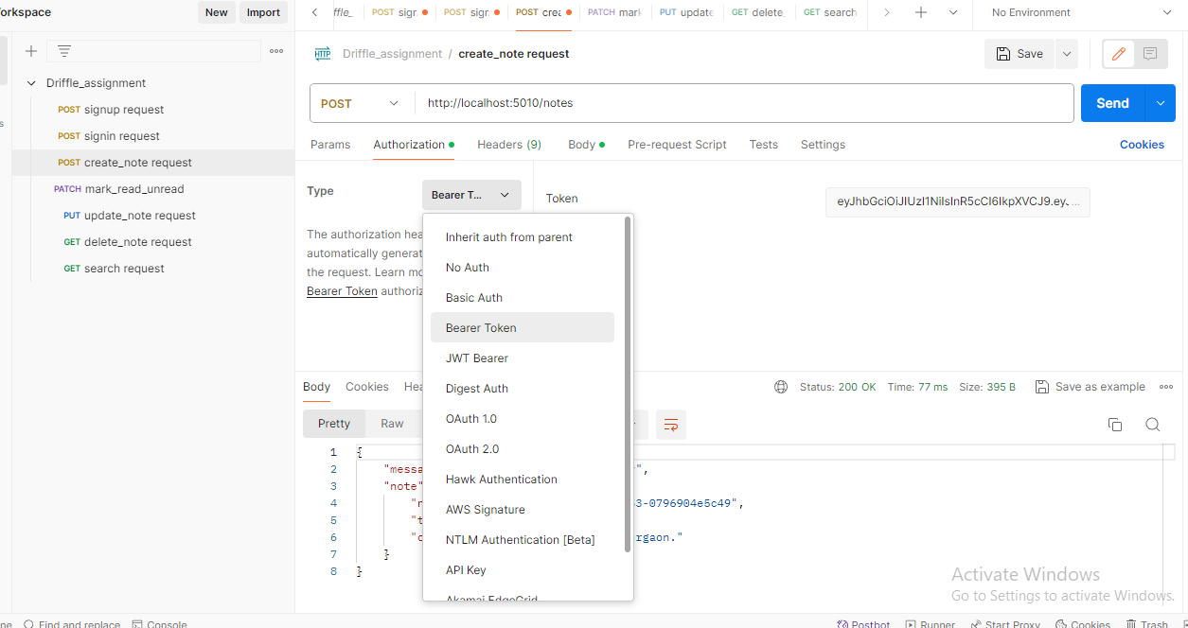

While sending note creation request, use authentication type as Bearer token and direclty copy paste the token in Token box.(Don’t use Bearer keyword in token box ,instead directly paste token only.)