**Functions used**-

1.**instalogin** – Login instagram

2. **openeid**- Opens the account of the provided userid

**3. profile_scrapper-** Scraps the profile of handles to find the number of followers

**4. top5handles-** Gets the top 5 most followed accounts in our search

**5. timepost-** Checks the timestamp of all the posts to find the posts of past 3 days

**6. word_counter-** stores and count the number of words and hashtags of the posts scraped

**7. followlikes-** compares the follow:like ratio of different handles

Q1. Below is a graph of the number of posts made by the top 5 most followed handles in the past 3 days

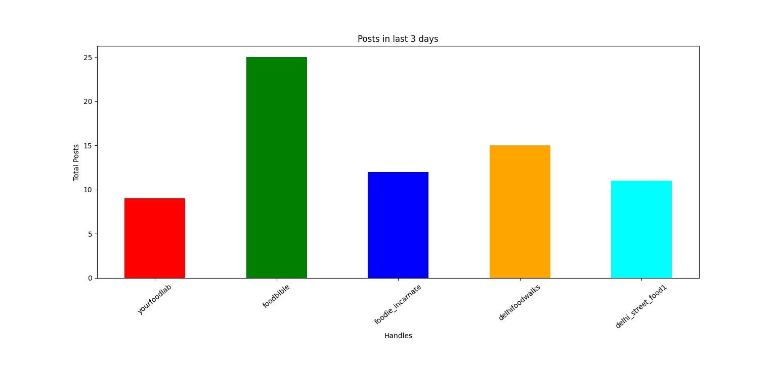

Q2 a. Below is the list of most occurring words in the posts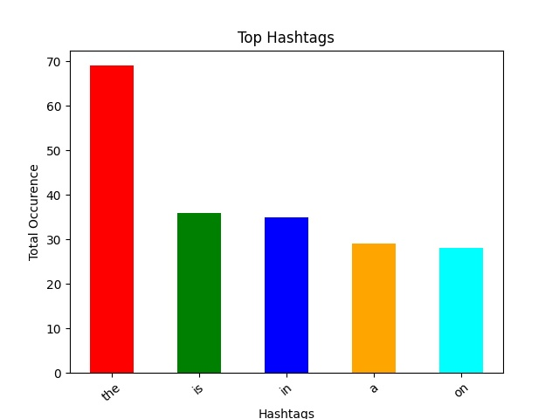

Q2 b.- Below is the list of most used hashtags in the posts 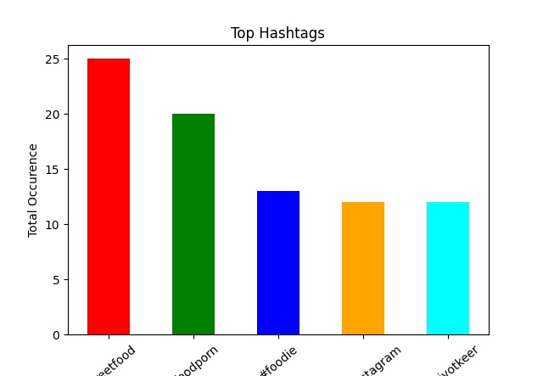

Q3 Below graph shows the ratio between the likes and followers of the 5 handles received in the first question 2523.

