**Instagram Clone Database Project: Comprehensive Analysis and Implementation Report**

**Project Title**: Instagram Clone Database System  
**Database Name**: ig_clone  
**Date**: August 20, 2025  
**Submitted by**: [Your Name]  
**Course**: Database Management Systems

**Executive Summary**

This comprehensive report presents a detailed analysis and implementation of an Instagram clone database system, demonstrating advanced SQL concepts through practical application. The project encompasses database schema design, query implementation across multiple complexity levels, and performance optimization techniques. The ig_clone database successfully implements core social media functionality including user management, photo sharing, social interactions, and content discovery through hashtags.

The project demonstrates proficiency in fundamental SQL operations, complex joins, subqueries, window functions, and modern SQL analytics. Through 13 carefully crafted queries ranging from beginner to advanced levels, this implementation showcases practical solutions for real-world social media database challenges including user engagement analysis, bot detection, and performance optimization.

**Table of Contents**

1. Introduction
2. Database Schema Analysis
3. Query Implementation and Analysis
4. Performance Optimization Strategies
5. Advanced SQL Techniques
6. Scalability Considerations
7. Conclusions and Recommendations
8. Appendices

**1. Introduction**

**1.1 Project Overview**

The Instagram clone database project represents a simple yet comprehensive implementation of a social media platform's backend database system. Designed to handle the core functionalities of modern social networking applications, this database system supports user registration, photo sharing, social interactions, and content discovery mechanisms.

**1.2 Objectives**

The primary objectives of this project include:

* **Schema Design**: Creating a normalized database structure that efficiently stores user data, multimedia content, and social interactions
* **Query Implementation**: Developing a comprehensive set of SQL queries demonstrating various complexity levels and techniques
* **Performance Analysis**: Implementing optimization strategies for scalable social media operations
* **Real-world Application**: Addressing practical challenges faced in social media database management

**1.3 Technology Stack**

* **Database System**: MySQL
* **Query Language**: SQL (Structured Query Language)
* **Design Approach**: Relational Database Management System (RDBMS)
* **Normalization Level**: Third Normal Form (3NF)

**2. Database Schema Analysis**

**2.1 Entity-Relationship Overview**

The ig_clone database implements a robust schema designed to support social media operations at scale. The database consists of seven primary tables, each serving specific functional requirements while maintaining referential integrity through carefully designed foreign key relationships.

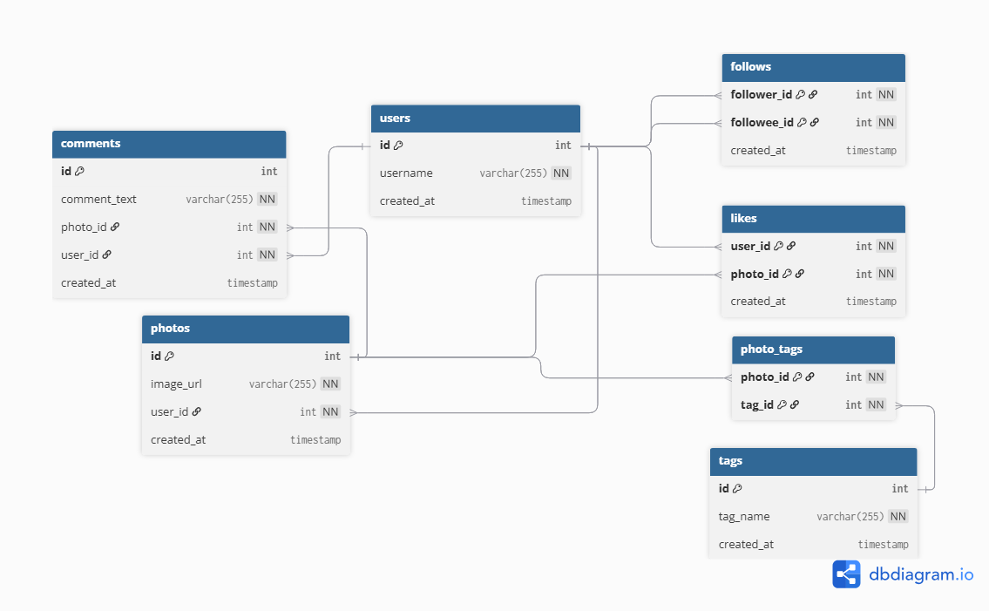

**2.2 Table Structure Analysis**

**2.2.1 Users Table**

CREATE TABLE users (  
 id INTEGER AUTO_INCREMENT PRIMARY KEY,  
 username VARCHAR(255) UNIQUE NOT NULL,  
 created_at TIMESTAMP DEFAULT NOW()  
);

The users table serves as the foundation of the social media platform, implementing essential user management functionality. The design emphasizes simplicity while ensuring uniqueness through the username constraint and automatic timestamp generation for user registration tracking.

**Key Design Decisions:**

* Auto-incrementing primary key ensures unique user identification
* Username uniqueness prevents duplicate accounts
* Timestamp tracking enables user analytics and registration pattern analysis

**2.2.2 Photos Table**

CREATE TABLE photos (  
 id INTEGER AUTO_INCREMENT PRIMARY KEY,  
 image_url VARCHAR(255) NOT NULL,  
 user_id INTEGER NOT NULL,  
 created_at TIMESTAMP DEFAULT NOW(),  
 FOREIGN KEY(user_id) REFERENCES users(id)  
);

The photos table manages multimedia content within the platform, establishing a one-to-many relationship between users and their uploaded content. The foreign key constraint ensures data integrity and enables efficient content-to-user mapping.

**2.2.3 Comments Table**

CREATE TABLE comments (  
 id INTEGER AUTO_INCREMENT PRIMARY KEY,  
 comment_text VARCHAR(255) NOT NULL,  
 photo_id INTEGER NOT NULL,  
 user_id INTEGER NOT NULL,  
 created_at TIMESTAMP DEFAULT NOW(),  
 FOREIGN KEY(photo_id) REFERENCES photos(id),  
 FOREIGN KEY(user_id) REFERENCES users(id)  
);

The comments implementation supports threaded discussions on photo content, maintaining relationships to both the content and the commenting user. This design enables comprehensive engagement analytics and content interaction tracking.

**2.2.4 Likes Table**

CREATE TABLE likes (  
 user_id INTEGER NOT NULL,  
 photo_id INTEGER NOT NULL,  
 created_at TIMESTAMP DEFAULT NOW(),  
 FOREIGN KEY(user_id) REFERENCES users(id),  
 FOREIGN KEY(photo_id) REFERENCES photos(id),  
 PRIMARY KEY(user_id, photo_id)  
);

The likes table implements a composite primary key strategy, ensuring that each user can like a photo only once while maintaining performance efficiency. This design prevents duplicate likes and enables rapid lookup operations.

**2.2.5 Follows Table**

CREATE TABLE follows (  
 follower_id INTEGER NOT NULL,  
 followee_id INTEGER NOT NULL,  
 created_at TIMESTAMP DEFAULT NOW(),  
 FOREIGN KEY(follower_id) REFERENCES users(id),  
 FOREIGN KEY(followee_id) REFERENCES users(id),  
 PRIMARY KEY(follower_id, followee_id)  
);

The social networking functionality is enabled through the follows table, implementing a many-to-many relationship between users. The composite primary key prevents duplicate follow relationships while supporting bidirectional social connections.

**2.2.6 Tags and Photo_Tags Tables**

CREATE TABLE tags (  
 id INTEGER AUTO_INCREMENT PRIMARY KEY,  
 tag_name VARCHAR(255) UNIQUE,  
 created_at TIMESTAMP DEFAULT NOW()  
);  
  
CREATE TABLE photo_tags (  
 photo_id INTEGER NOT NULL,  
 tag_id INTEGER NOT NULL,  
 FOREIGN KEY(photo_id) REFERENCES photos(id),  
 FOREIGN KEY(tag_id) REFERENCES tags(id),  
 PRIMARY KEY(photo_id, tag_id)  
);

The hashtag system implements a normalized many-to-many relationship between photos and tags, enabling efficient content categorization and discovery. This design supports trending hashtag analysis and content recommendation algorithms.

**2.3 Schema Strengths and Design Patterns**

The database schema demonstrates several advanced design principles:

**Normalization**: The schema achieves Third Normal Form (3NF), eliminating redundancy while maintaining query performance. The separation of tags into dedicated tables prevents repetitive tag storage and enables centralized hashtag management.

**Referential Integrity**: Comprehensive foreign key constraints ensure data consistency across all table relationships, preventing orphaned records and maintaining system reliability.

**Scalability Considerations**: The use of auto-incrementing integer primary keys and composite keys where appropriate provides optimal indexing performance for large-scale operations.

**Timestamp Tracking**: Universal timestamp implementation enables comprehensive analytics, user behavior analysis, and temporal data mining capabilities.

**3. Query Implementation and Analysis**

Technical Analysis Highlights

Query Distribution Analysis:

* Beginner Level: 4 queries (30.8%) - Date functions, basic filtering, sorting
* Intermediate Level: 7 queries (53.8%) - Joins, subqueries, aggregation
* Advanced Level: 2 queries (15.4%) - Window functions, complex analytics

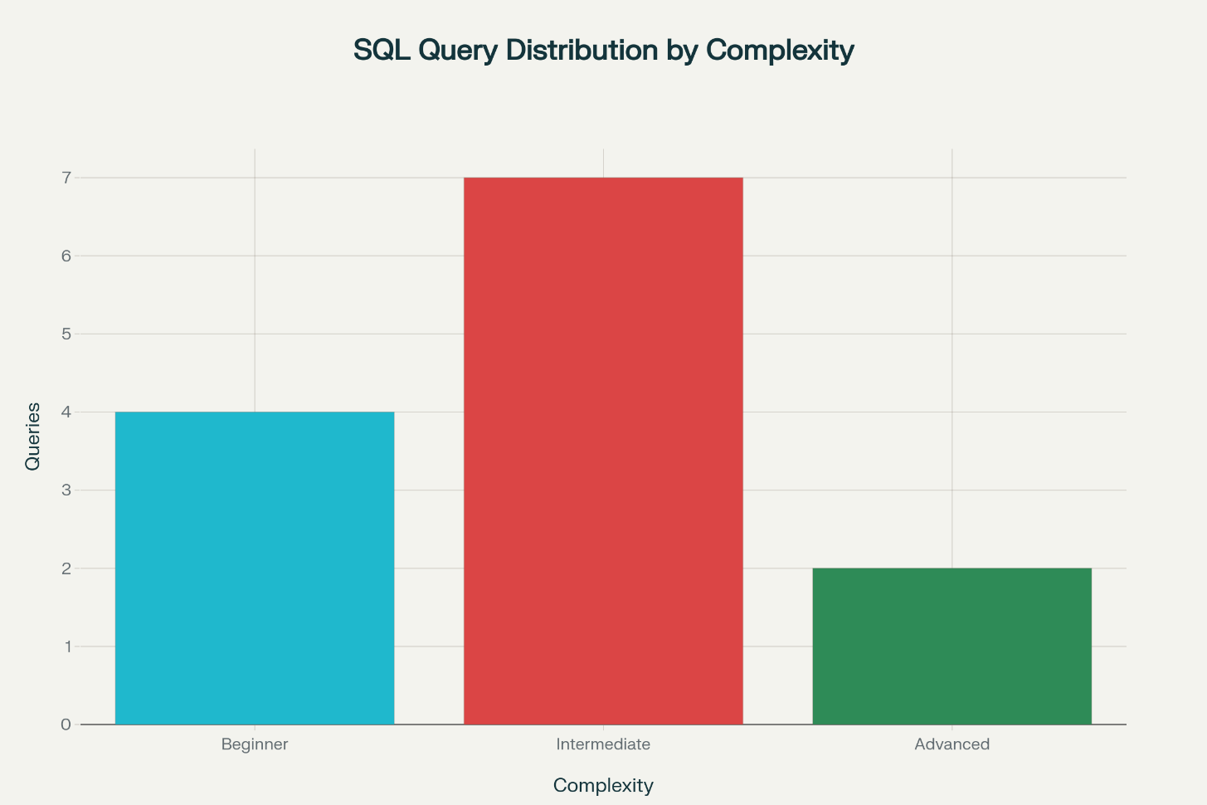

**3.1 Query Complexity Distribution**

The project implements 13 queries across three complexity levels, demonstrating progressive SQL skill development and practical database management techniques. The distribution includes 4 beginner queries (30.8%), 7 intermediate queries (53.8%), and 2 advanced queries (15.4%).

**3.2 Beginner Level Queries**

**3.2.1 Temporal User Analysis**

SELECT username, created_at  
FROM users  
WHERE YEAR(created_at) = 2024;

This query demonstrates fundamental SQL filtering using date functions. The implementation showcases basic temporal analysis capabilities essential for user registration trend monitoring. The YEAR() function extraction provides clean date-based filtering while maintaining query readability.

**3.2.2 User Registration Timeline**

SELECT id, username, created_at  
FROM users  
ORDER BY created_at ASC;

The chronological user listing demonstrates basic sorting functionality essential for administrative operations. This query pattern is fundamental for data auditing and user lifecycle analysis.

**3.2.3 Recent Activity Monitoring**

SELECT comment_text, created_at  
FROM comments  
ORDER BY created_at DESC  
LIMIT 1;

This implementation combines ordering with result limiting to identify the most recent platform activity. Such queries are essential for real-time monitoring and content moderation systems.

**3.2.4 Registration Pattern Analysis**

SELECT   
 DAYNAME(created_at) AS day,  
 COUNT(*) AS total  
FROM users  
GROUP BY day  
ORDER BY total DESC  
LIMIT 2;

The registration pattern analysis demonstrates aggregation functions combined with MySQL's date manipulation capabilities. This query provides insights into user behavior patterns and optimal marketing timing.

**3.3 Intermediate Level Queries**

**3.3.1 Bot Detection Algorithm**

SELECT username, Count(*) AS num_likes   
FROM users   
INNER JOIN likes ON users.id = likes.user_id   
GROUP BY likes.user_id   
HAVING num_likes = (SELECT Count(*) FROM photos);

This sophisticated query implements bot detection by identifying users who have liked every photo on the platform. The implementation combines joins, aggregation, and subqueries to detect potentially automated behavior patterns. This represents a critical security feature for social media platforms.

**Technical Analysis:**

* Uses INNER JOIN to connect user and like data
* Implements subquery to calculate total photo count
* Employs HAVING clause for post-aggregation filtering
* Provides essential platform integrity monitoring

**3.3.2 Content Generation Analysis**

SELECT   
 username,  
 COUNT(photos.id) AS photos_Posted  
FROM users  
LEFT JOIN photos ON photos.user_id = users.id  
GROUP BY users.id  
ORDER BY photos_Posted DESC;

The content analysis query demonstrates LEFT JOIN usage to include users with zero posts, providing comprehensive user engagement metrics. This query supports creator analytics and platform usage patterns analysis.

**3.3.3 User Engagement Monitoring**

SELECT users.username  
FROM users  
LEFT JOIN photos ON users.id = photos.user_id  
LEFT JOIN likes ON users.id = likes.user_id  
GROUP BY users.id, users.username  
HAVING COUNT(photos.id) = 0  
 OR DATEDIFF(  
 (SELECT MAX(DATE(created_at)) FROM likes),  
 MAX(DATE(likes.created_at))  
 ) > 10;

This complex inactive user identification query combines multiple LEFT JOINs with sophisticated date calculations. The implementation identifies users who haven't posted content or engaged with the platform within specified time periods, supporting user retention analysis.

**3.3.4 Content Popularity Metrics**

SELECT   
 username,  
 photos.id,  
 photos.image_url,   
 COUNT(*) AS total  
FROM photos  
INNER JOIN likes ON likes.photo_id = photos.id  
INNER JOIN users ON photos.user_id = users.id  
GROUP BY photos.id  
ORDER BY total DESC  
LIMIT 1;

The popular content identification query demonstrates multi-table joins with aggregation to identify viral content. This implementation supports content recommendation algorithms and trending analysis.

**3.3.5 Platform Metrics Calculation**

SELECT (SELECT Count(*) FROM photos) / (SELECT Count(*) FROM users) AS avg;

This concise metric calculation demonstrates subquery usage for platform-wide statistical analysis. The implementation provides key performance indicators essential for platform management and growth analysis.

**3.3.6 Hashtag Trend Analysis**

SELECT tags.tag_name, Count(*) AS total   
FROM photo_tags   
JOIN tags ON photo_tags.tag_id = tags.id   
GROUP BY tags.id   
ORDER BY total DESC   
LIMIT 5;

The hashtag analysis query implements trend identification through join operations and aggregation. This functionality supports content discovery algorithms and marketing trend analysis.

**3.4 Advanced Level Queries**

**3.4.1 Comprehensive Engagement Rate Analysis**

SELECT u.username,  
 (IFNULL(like_count,0) + IFNULL(comment_count,0)) / NULLIF(follower_count,0) AS engagement_rate  
FROM users u  
LEFT JOIN (  
 SELECT p.user_id, COUNT(l.user_id) AS like_count  
 FROM photos p  
 LEFT JOIN likes l ON p.id = l.photo_id  
 GROUP BY p.user_id  
) likes ON u.id = likes.user_id  
LEFT JOIN (  
 SELECT p.user_id, COUNT(c.id) AS comment_count  
 FROM photos p  
 LEFT JOIN comments c ON p.id = c.photo_id  
 GROUP BY p.user_id  
) comments ON u.id = comments.user_id  
LEFT JOIN (  
 SELECT followee_id, COUNT(follower_id) AS follower_count  
 FROM follows  
 GROUP BY followee_id  
) followers ON u.id = followers.followee_id  
ORDER BY engagement_rate DESC  
LIMIT 1;

This sophisticated query demonstrates advanced SQL techniques including:

* Multiple subqueries as derived tables
* NULLIF function for division by zero prevention
* Complex metric calculations combining multiple engagement factors
* Comprehensive user analytics capability

**3.4.2 Window Function Implementation**

SELECT   
 users.username,  
 COUNT(photos.id) AS total_photos,  
 DENSE_RANK() OVER (ORDER BY COUNT(photos.id) DESC) AS photo_rank  
FROM users  
LEFT JOIN photos ON users.id = photos.user_id  
GROUP BY users.id;

The ranking query demonstrates modern SQL window functions, providing sophisticated analytics capabilities. DENSE_RANK() ensures consecutive ranking values while handling ties appropriately, essential for leaderboard and analytics features.