Question 1:

Level 0:
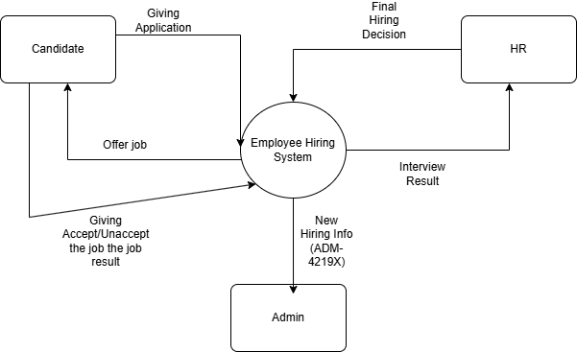

Level 1: 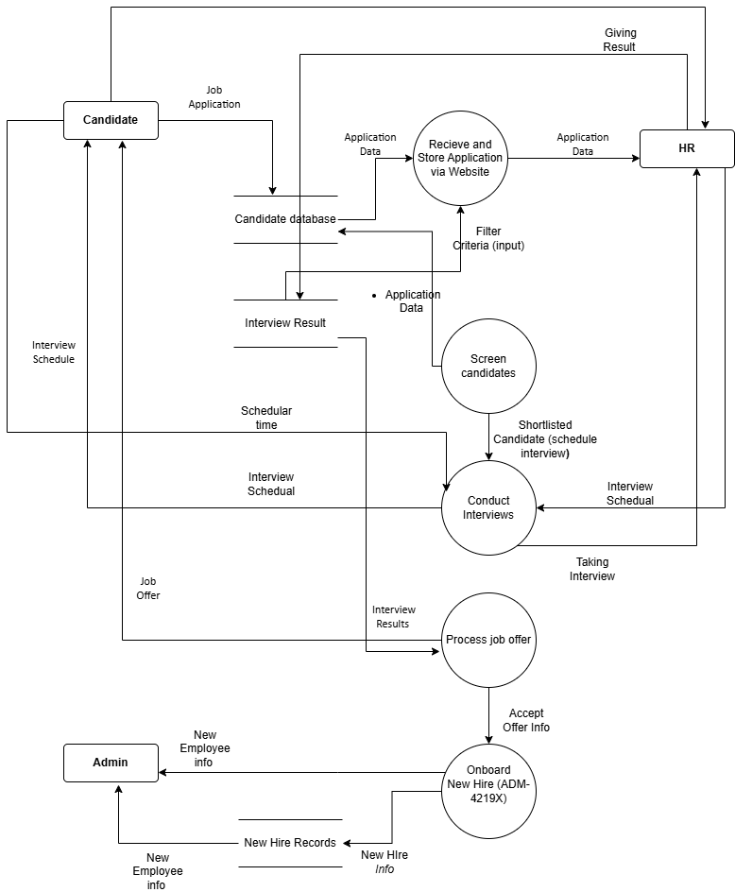

Answer 2,
There is insufficient in details for a company. A employee hiring company has much more details for hiring employee , otherwise a employee cant hire without sufficient info. There are also need extra documentation for , saleery widgets and clients data. By filling this information , this can help Employee management system.

